Name: ………………………………………………………………………………..
Session date: ………………………………………………………………………
Contents
Optional pre-reading 4
Teaching problem 12
I Do 14
We Do 17
Option A: Non-example 22
Option B: Practice task 26
Option C: I do (2) 29
Close 32
Appendix 33
Alternative I Do (1) 33
Alternative I Do (2) 36

Optional pre-reading

Implementing change

Teaching challenge
Mr Russel has realised that he is spending a lot of his time outside of working hours marking books and that he is not spending enough time on re-planning or adapting lessons based on what he is discovering from the marking itself. It is clear to Mr Russel that he needs to make a change to his teaching practice. But how can he go about implementing change?

Key idea
When we talk about implementation, we are referring to the process by which a change is delivered. Implementation is not a one-off event and requires careful planning and monitoring to ensure the vision for change leads to a real sustained change in teacher practice.

Evidence summary
What do we mean by implementation?
When we talk about implementation, we are referring to the process by which a change is delivered: how we introduce a new strategy in the classroom or tweak an existing routine. If teachers have department level responsibilities, the change could be around introducing a new strategy within their department. The change itself can be big or small, a tactical tweak or a strategic shift altogether. Either way, however grand or minute, gradual or urgent, teachers need to follow a process for implementation that helps them to embed the change in the long term and in a sustainable way.

Why does implementation matter?
The delivery of a strategy can often mean the difference between failure and success (Sharples et al., 2019). When we think hard about how we are going to deliver our changes, we give them the best chance of working. However, it is just as important to start with the right problem and the right solution: “It’s both what you do and the way that you do it” (Kime in Scutt & Harrison, 2019, pp.6-7).

The Education Endowment Foundation (EEF) has designed a useful a framework which informs a process for implementation.

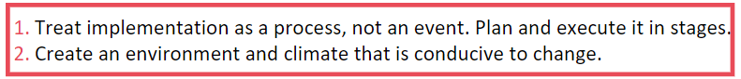

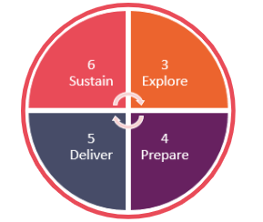

Explore
At the Explore stage Mr Russel needs to identify what problems exist that he can solve, what solutions exist to solve those problems, and work out the best fits for his class. Identifying the right problem and solution is critical: no amount of attention to the stages that follow can make an ineffective strategy effective or solve an unsolvable problem. By the end of this stage Mr Russel needs to know what he is doing and why he is doing it, if he wants to do anything at all. In this case, Mr Russel reflects and realises that pupils are not engaging with the marking or feedback which he is providing, and he is not able to respond to the misconceptions he is picking up in his marking. This means he is not adapting his lessons to address these misconceptions. Mr Russel therefore identifies that he wants to embed a change in the way he marks pupils’ work so that he can carry out marking and feedback more effectively.

Effective implementation begins by accurately diagnosing the problem. To start with, Mr Russel needs to get a clearer sense of the problem that he is trying to address. He therefore needs to ask himself the following questions:
- What problem am I trying to address?
- What evidence can I collect and analyse which suggests that this is the problem?
- What do I understand to be the root cause of the problem?
- How might I address this problem?
- Which subject or group will I focus on and why?

Thinking more deeply about these questions, he reaches the following conclusions:

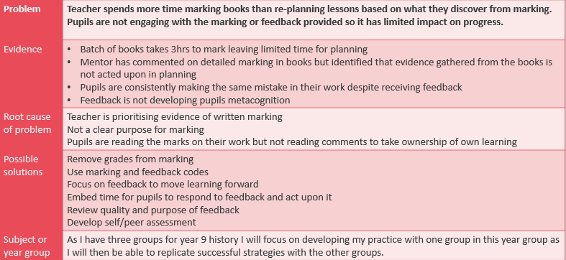

Within this stage, there are three key steps Mr Russel will want to bear in mind when answering the above questions:

Identify a key priority that is amenable to change
Mr Russel needs to ensure that the change he has identified is within his scope and influence. In this example, it is an area of his teaching practice which he is seeking to change and, while he needs to consider the wider school marking and feedback policy, it is within his scope to make changes to the way he marks, as long as his changes are within this wider school policy.

Systematically explore programmes or practices to implement
Mr Russel also wants to observe what other members of staff do to mark and provide feedback. He starts by asking his colleagues within his department but also reaches out to other colleagues in different subjects, to compare approaches. Mr Russel wants to delve further into the research around effective marking and feedback and decides to consult a few research papers cited in his initial training year. This provides him with further insight into the role that effective marking and feedback can have on pupil learning and shows him how important this change is to him and his pupils.

Examine the fit and feasibility within the context
Mr Russel needs to firstly consult the wider school marking and feedback policy to understand what is expected of him and how the change he has identified complements and fits in with the wider school approach to marking and feedback. If this change were to be implemented at a wider department level, he would also need to consider how the approach fits within the existing strategies which exist within the department.

Prepare
At the Prepare stage Mr Russel needs to create the conditions that mean that he can transform his idea on paper into something effective in practice. This is the longest phase, but which often is the most rushed. Mr Russel will want to articulate his thinking by creating a clear, logical and well specified implementation plan. Within this plan he will want to consider three main steps:
- Identify the active ingredients
- Assess if you are ready to implement the change
- Practically prepare

Identify the active ingredients
Now that Mr Russel has a clearer sense of the chosen area he wants to develop, he needs to then consider what success looks like for his implementation. What outcomes is he expecting as a result of addressing this problem? This process involves identifying “active ingredients” of his chosen area for development. The active ingredients are the key components which will make the strategy work (Sharples et al, 2017). In this example, Mr Russel wants his strategy to embody the following ingredients:

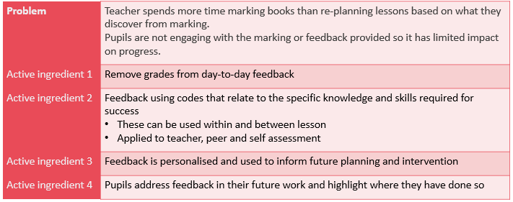
By having a clear understanding of these active ingredients, Mr Russel now has a set of outputs which he can use to ensure that he is embedding the change as planned. If Mr Russel were to implement this at a larger scale (e.g. at a department level), he would want to make sure his department were very clear on what these “active ingredients” are and why they are important.

Having identified these active ingredients, Mr Russel can then consider what strategies he will adopt in order to make those active ingredients a reality. He decides on the following:

Problem: Teacher spends more time marking books than re-planning lessons based on what he discovers from marking. Pupils not engaging with marking or feedback provided so has limited impact on pupil progress.
Active ingredient | Implementation strategies and required resources
Remove grades from day-to day feedback | Engage with research and evidence on marking and feedback, metacognition and self-regulation.  Start with EEF guidance.  Check marking policy to ensure this complies.
Feedback using codes that relate to specific knowledge and skills required for success.  These can be used within and between lessons and ppplied to teacher, peer and self-assessment | Seek out examples of good practice from other teachers in school or wider networks.  Collaborate with other colleagues to develop codes.
Feedback is personalised and used to inform future planning and intervention. | Co-plan with mentor to implement changes.
Pupils address feedback in their future work and highlight where they have done so. | Seek out examples of good practice from other teachers in school or wider networks of how their pupils respond to feedback.

Tight but loose
Although every project tends to adapt slightly over time – sometimes for the better – the more faithful the delivery is to the principles that make the strategy effective (its ‘Active Ingredients’) the better (Sharples et al., 2019). This approach is called ‘tight but loose’ (Sharples et al., 2019). It is therefore crucial for Mr Russel to consider before delivery which parts of a strategy might be open to adaptation (i.e. which ones can he be more “loose” on) and which need to be maintained throughout (i.e. which ones he needs to be more “tight” on).

For example, one of Mr Russel’s identified active ingredients was removing grades from day-to day feedback and he wants to be tight on this as he thinks that providing grades is detracting pupils’ attention from the feedback he provides on how they can improve their work. However, he uses online quizzes sometimes and with that particular quizzing platform, grades appear automatically. He therefore decides to review the platform settings to see if he can remove the grades appearing.

Having identified what strategies he will implement, Mr Russel then considers what success will look like if each of these active ingredients were successfully implemented. What is he hoping to achieve by the end of the implementation process and what will that look like in the classroom? After reflecting on what each strategy will look like when successfully implemented, he identifies the following outcomes:
- Reduced time spent on marking and focus more time on adapting lessons based on where pupils need further support.
- Pupils engaged with and acting upon marking and feedback to move their learning forward, as demonstrated in future classwork and assessments.
- Pupils developing strategies for self-regulation and metacognition which will support their learning in the future, as demonstrated by being able to plan, monitor and evaluate independent work.

Assess if you are ready to implement the change
Having established the strategies he will adopt, he needs to consider how ready he is to deliver the plan. He may want to consider the following:
- How will I develop my knowledge and expertise to ensure effective implementation?
- What resources will I need?
- What training or professional development do I need?
- Who will be impacted by my plans?

Once Mr Russel has considered and is able to answer these questions, he is ready and able to carry out the practical preparations to ensure that he is in a position of being able to start implementing or “delivering” the change. In this case, Mr Russel doesn’t need any external resources, but he has had to communicate with his colleagues around his planned change and arranged meetings with his colleagues.

Deliver
At the Deliver stage Mr Russel needs to make sure that he is putting into practice what he had originally planned. For a strategy to prove effective it needs to be delivered well. As Mr Russel knows from the coaching he has received over the past year, new strategies are rarely directly embedded into the classroom without considering the nuance of the strategy and how it fits with his pupils’ needs and contexts. Even strategies with a strong evidence base can be done well or done badly (Coe in Rose & Eriksson-Lee, 2017). Monitoring implementation is an essential tool in identifying, and acting on, problems and solutions.

In this stage Ms Russel will want to consider how he will monitor how effective his strategy is. It may well be that some of the strategies which Mr Russel had previously identified are not working as well as previously imagined. For example, Mr Russel identifies that he is struggling to deliver a strategy. He realises that one of the codes he uses as part of his marking is not being responded to by pupils as he expected. He therefore needs to reflect on why this may be the case and make tweaks to his coding system if necessary. Whilst it is important to prioritise and continue with the active ingredients of the strategy, over time teachers may want to adapt other aspects of the strategy.

Sustain
At the Sustain stage Mr Russel needs to evaluate the impact of his implementation so far and decide what steps to take to ensure the change has the greatest impact on his pupils. The evaluation he carries out will help him determine these next steps. Once a new strategy is integrated into the classroom, there is a risk of assuming that the implementation process requires no further review; however, to ensure that the changes can be sustained, we should continually reflect on its use. Sustaining implementation requires us to continually engage in implementation processes, seek purposeful support, and feedback where needed. It is at this stage where poor implementation can come back to bite: if a strategy has failed, Mr Russel needs to know why. Has it failed because the core idea was not sound (was the focus area not appropriate)? Or has it failed because the conditions were wrong (something went wrong with the implementation)? Could it have worked under the right conditions? Without answers to these questions, Mr Russel cannot reliably know if he is right to stop it or if he is abandoning a perfectly reasonable strategy unnecessarily (Proctor et al., 2011).

Why evaluate?
Mr Russel needed to carry out an evaluation in order to gather data around whether or not his intervention has been effective. By evaluating the effectiveness of his intervention, Mr Russel saves time in the long run as it will help him invest time and effort into the most effective strategies, rather than continuing to pursue approaches that weren’t working. Investing time at this stage will guide his future actions as it will better enable him to identify improvements he needs to make in the future.
- When evaluating the impact of his implementation, Mr Russel may want to consider the following questions:
- What did I set out to achieve?
- How did I get there?
- Did it work and should I continue?

Sustaining change
Having evaluated what is and isn’t working, Mr Russel has identified the strategies which he wants to continue to embed. Embedding practice requires a change in behaviour, which is hard to achieve and even harder to sustain. Contrary to popular belief, changing behaviour does not boil down to just having will power or the motivation to change. There is often a gap, known as the “Value action gap” which describes the difference between what people say they will do and what they actually do. This gap has been seen in a variety of contexts. For example, while over 40% of EU consumers claimed to be willing to pay more for ethical products, these products made up less than 1% of market share (Pelsmacker et al, 2005). In order to avoid this gap, Mr Russel may want to consider how he can embed the successful practices he has identified as habits. Habits are a proactive way that can help teachers to sustain changes to their classroom practice. For example, Mr Russel may want to continue to embed the practice of engaging with research on feedback and marking so that he feels up to date on the latest research. By automating this habit, Mr Russel is more likely to feel like the implementation is more manageable in the long term and may be better placed to sustain the changes he has implemented. He may plan out this habit in the following way:

- Cue: block out a weekly 30 minute slot
- Routine: read research for 30 minutes
- Reward: develop a better understanding of feedback approaches that impact workload

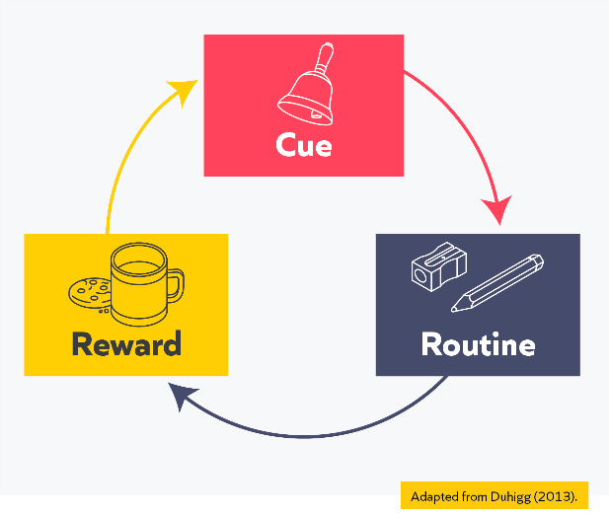

Planning for sustained behavioural change
If Mr Russel were rolling this out at a department level, he would need to consider how he can support not only his own change in behaviour but how he can support his colleagues to also adopt the intervention.
He may choose to adopt the EAST framework (Service et al, 2012) to support him to do this. Mr Russel may want to consider how he can make the intervention Easy, Attractive, Timely and Social so that his colleagues are more inclined to change their behaviours:

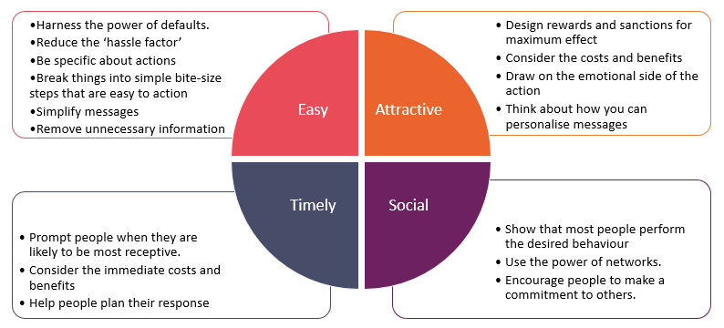

In Mr Russel’s case, he is collaborating with colleagues to develop codes. He decides to send just one weekly email at the same time so that it is easy for his colleagues to access the information. Within his emails he refers to successes using new marking codes and the impact this has had on pupils, so that all the colleagues are aware of the benefits this is having on pupils. He also sends the emails at a time of the day when he knows colleagues aren’t teaching and are likely to be more receptive to the message.
These stages of implementation can support teachers like Mr Russel to work through the implementation process in a deliberate, careful way. Whatever Mr Russel decides to do next, providing he has carefully managed the previous stages of implementation he can be confident in his decision.

Key takeaways
- Implementation is a process, with stages and activities carried out over time. It is not a one-off event.
- The process of implementation can be broken down into the stages Explore, Prepare, Deliver and Sustain (Sharples et al., 2019).
- Behaviour change is difficult and requires time in order to become embedded as a habit.

Nuances and caveats
The series of stages, as depicted in the EEF guidance, should not be interpreted as saying that implementation is a linear process. Implementation in the real-world is a messy process. Whilst some activities should always precede others – for example, exploring areas of need before implementing strategies as solutions to the need – other activities will be ongoing – for example, monitoring and making adaptations based on the data gathered.

Even successful strategies, which have been fully integrated, may one day be reversed. Teachers might find that if a strategy that proved successful in one class, is scaled-up, it becomes less effective as its reach grows. The effects of interventions in the social world are often context-dependent – rather than having a ‘true effect’, they will vary in impact depending on who they are aimed at (Bryan et al., 2021).

Further reading
Sharples, J., Albers, B., Fraser, S. & Kime, S. (2019). Putting evidence to work: a school’s guide to implementation. Education Endowment Foundation.

References
Bryan, C. J., Tipton, E., & Yeager, D. S. (2021). Behavioural science is unlikely to change the world without a heterogeneity revolution. Nature human behaviour, 5(8), 980-989.
De Pelsmacker, P., Janssens, W., & Mielants, C. (2005). Consumer values and fair-trade beliefs, attitudes and buying behaviour. International Review on Public and Non Profit Marketing, 2(2), 50-69.
Proctor, E., Silmere, H., Raghavan, R., Hovmand, P., Aarons, G., Bunger, A., Griffey, R. & Hensley, M. (2011). Outcomes for Implementation Research: Conceptual Distinctions, Measurement Challenges, and Research Agenda. Administration and Policy in Mental Health and Mental Health Services Research, 38(2) p65–76.
Rose, N. & Eriksson-Lee, S. (2017). Putting evidence to work: How can we help new teachers use research evidence to inform their teaching?. Teach First. https://www.teachfirst.org.uk/sites/default/files/2019- 08/Putting_Evidence_to_work_2017.pdf
Service, O., Hallsworth, M., Halpern, D., Algate, F., Gallagher, R., Nguyen, S., Ruda, S., & Sanders, M. (2012). East: Four Simple Ways to Apply Behavioural Insights. [Online] Available from: https://www.behaviouralinsights.co.uk/wp-content/uploads/2015/07/BIT-Publication-EAST_FA_WEB.pdf
Scutt, C. & Harrison, S. (2019). Teacher CPD: International trends, opportunities and challenges. Chartered College of Teaching. https://my.chartered.college/wp-content/uploads/2019/11/Chartered-College-International-Teacher-CPD-report.pdf
Sharples, J., Albers, B., Fraser, S. & Kime, S. (2019). Putting evidence to work: a school’s guide to implementation. Education Endowment Foundation.

Teaching problem
In today’s session, we will consider the following typical teaching problem:

How can teachers make effective, long-lasting changes to their teaching practice?

Paired discussion
Task: In your pair, discuss the following:
Reflect on your experience of introducing a change (e.g. new routine or teaching strategy) in your classroom which did not work as effectively as you hoped.
Questions:
- What was the change you were implementing into your classroom?
Notes:
- Why do you think it was less effective?
Notes:
- What did you do when it was less effective?
Notes:

EEF guidance on implementation
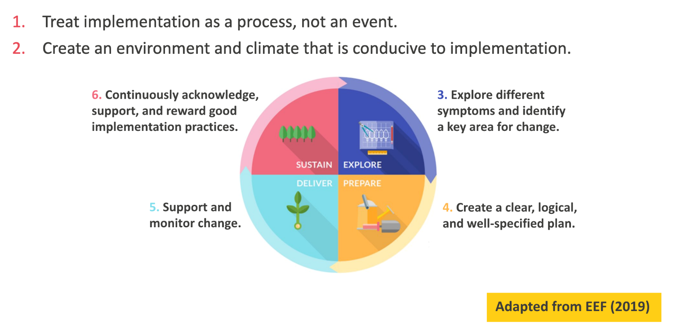
Education Endowment Foundation (EEF) (2021b) Putting evidence to work – a school’s guide to implementation. Available at: https://educationendowmentfoundation.org.uk/education-evidence/guidance-reports/a-schools-guide-to-implementation (accessed 11 November 2022).

What are underlying features?
Underlying features are the components of an approach that can be applied across all subjects, phases or settings. They serve as a guide for what good practice is likely to look like.

Underlying features in this clinic
Underlying Feature | Description
Needs-based | Take the time to understand and evaluate a high-priority area for change or development in classroom practice, which, if addressed, is likely to have a positive impact on pupils.
Evidence informed and context specific | With the support of a colleague, identify a solution that is based on the best available evidence and is well-matched to the classroom context.
Intentionally plan change | Consider the time, resources and actions needed to make a change and whether this is feasible, as well as any possible barriers to change.
Ongoing reflection | When a change is being implemented, reflect on progress made, recognise strengths and weaknesses and identify next steps for further improvement.
Intelligent adaptions | Keep in mind that implementation is an ongoing cycle, and successful change needs to be sustained over time through carefully considered adaptions.

I Do

Task: Read the scenario.
Scenario 1
‘I Do’ scenario
Mr Usmani is an early years teacher in a medium-sized primary academy. He is concerned that some pupils seem to have misconceptions around learning content that he is not picking up until observing pupil discussions during continuous provision activities. He discusses these pupils with his mentor. During the mentor’s next lesson drop in, she notes down the pupils who do not put their hand up to answer questions. It is the same pupils that Mr Usmani had concerns over- they have both noticed the same pattern of performance. Mr Usmani and his mentor discuss how they can motivate these pupils to think hard about the learning and answer questions. He also wants more pupils to answer questions regularly. The current reality is that only five or six pupils are confident enough to put their hands up and answer questions each lesson.

Mr Usmani’s mentor wonders whether this is a problem that other teachers are facing in their classrooms. He raises it with the teaching and learning lead, who agrees that all staff would benefit from a short sequence of professional development (PD) on cold-calling (Lemov, 2021). The concept of increasing the ratio of pupil thinking and participation through a no hands up policy is discussed. Mr Usmani engages fully with the PD and leaves excited about implementing cold calling and the potential impact on his pupils’ outcomes. He sees how it could improve pupil concentration and increase the number of pupils who answer questions. Mr Usmani also knows that developing speaking and listening skills are part of the statutory framework for the early years foundation stage (DfE, 2021), so wants to provide as many opportunities for pupils to develop these key skills as possible.

During their next phase meeting, Mr Usmani raises the idea of planning in cold call opportunities. One of his colleagues identifies story time as a good place to trial this. Contributing an idea to a story, especially when there is no definitive answer, lowers the stakes. This makes it a safe, supportive time to introduce cold calling. Another colleague raises the importance of verbal sentence starters- repeating the beginning of the answer to the pupil before they answer. This supports any pupil who is learning how to speak in full sentences with a framework for their answer, reducing their cognitive load.

After the meeting, Mr Usmani works with his mentor to plan for the changes he wants to implement. He focusses on a series of questions for his next story time. They plan out what the sentence starters would be for each question. He also scripts out how he will explain cold calling to his pupils and practises delivering this script with his mentor. At this stage, Mr Usmani is confident that he has the resources to be able to implement this change successfully.

The following week, Mr Usmani is ready to begin implementing this change. During story time, Mr Usmani explains that he’s going to ask pupils some questions but wants the class to keep their hands down. This is because Mr Usmani thinks ‘every voice in the class is important’ and cold-calling will give everyone the ‘chance to shine’. He explains that if a pupil is not sure of an answer, they will be given help. He begins his story time and cold calls several pupils to answer questions in response to the text.

Having begun to implement this change, Mr Usmani recognises it is important to reflect, monitor successes and identify possible challenges. Positively, pupils who do not normally speak are able to answer questions. However, he continues to seek feedback to improve his practice. In their next mentor meeting, Mr Usmani’s mentor provides notes from her latest drop-in. She noted down that more pupils answered questions, but some struggled to articulate their answers. Mr Usmani agrees. They look at Mr Usmani’s next book and plan in more ‘think time’ for pupils. They also discuss opportunities for more ‘partner talk’ before cold calling individual pupils.

Mr Usmani makes these adaptions during his next story time. On this occasion, pupils articulate their reasoning more fluently and confidently after talking to their talk partner. He also notices the conversations he is observing in the environment are much more accurate and higher quality. Mr Usmani attributes this, in part, to the increased support pupils have been given to process their thinking. After a few weeks, Mr Usmani is confident with how cold call is supporting a range of pupils to contribute during story time. At this point, he begins planning the use of the strategy across some other taught sessions.

Questions:
- Where can you see the underlying features in the scenario?

• Needs-based
• Evidence informed and context specific
• Intentionally plan change
• Ongoing reflection
• Intelligent adaptions

- What difference do you think the underlying features make to the teacher’s implementation of their changes?

Task: Take notes while the facilitator models how the underlying features appear in the first scenario.

Underlying feature | Response/suggestion
Needs-based

Evidence informed and context specific
Intentionally plan change
Ongoing reflection
Intelligent adaptions
Other notes:

We Do

Read and analyse

Underlying features for scenario 2 and 3
The underlying features you need to have in mind as you read these scenarios are below. They are the same as for scenario 1:
Underlying Feature | Description
Needs-based | Take the time to understand and evaluate a high-priority area for change or development in classroom practice, which, if addressed, is likely to have a positive impact on pupils.
Evidence informed and context specific | With the support of a colleague, identify a solution that is based on the best available evidence and is well-matched to the classroom context.
Intentionally plan change | Consider the time, resources and actions needed to make a change and whether this is feasible, as well as any possible barriers to change.
Ongoing reflection | When a change is being implemented, reflect on progress made, recognise strengths and weaknesses and identify next steps for further improvement.
Intelligent adaptions | Keep in mind that implementation is an ongoing cycle, and successful change needs to be sustained over time through carefully considered adaptions.

Task: Read both of the following scenarios.

Scenario 2

Mrs Ripoliez is a secondary teacher in her second year of the Early Career Teacher programme and has recently become a form tutor. One of the pupils in her year 7 form is autistic and is sometimes unable to regulate their behaviour, especially in physical education (P.E). The pupil’s P.E teacher meets with Mrs Ripoliez to outline their concerns. The pupil has received a high number of sanctions in recent weeks. The behaviour reports include incidents such as refusing to come into the sports hall and being disruptive at the start and end of lessons. Mrs Ripoliez reviews the pupils’ behaviour record and assessment data. She notices a pattern- the pupil’s lowest attaining subjects are currently P.E and the two subjects directly after the P.E lessons. Mrs Ripoliez suspects that the pupil may be struggling to regulate their emotions and behaviour after the behaviour incidents in P.E and that this is having a negative impact on their attainment in these lessons.
Mrs Ripoliez meets with the pupil, who explains they become overwhelmed and worried by P.E and believe they are ‘rubbish at it’. The pupil also does not cope well with the varied structure of the lessons, explaining that ‘our gymnastics lessons are so different to our hockey lessons.’ Mrs Ripoliez discusses her concerns with the SENCo, who recommends using ‘Now, Next’ boards. Mrs Ripoliez does some research about the boards and how they can support people with autism and people who experience difficulties in communicating. They are a reduced visual timetable which help pupils understand what is happening now and what will happen next. Visual cues are easier to follow than spoken instruction for many autistic people. They can be used to breakdown specific tasks into more manageable chunks, which reduces anxiety. Due to this, Mrs Ripoliez decides this would be a good fit for the pupil. When considering what the ‘next’ activity should be, she remembers the impact that extrinsic motivation, such as a desirable activity, can have on pupils. Mrs Ripoliez believes providing the pupil with time after the lesson to complete a desirable activity will help them to engage positively in P.E. She believes the board could support with this by providing a visual reminder of what the pupil’s reward will be for positive behaviour in P.E. This reminder will help the pupil stay calm, motivated and on task in lesson.
Before implementing this change, Mrs Ripoliez considers the possible barriers to implementation. She recognises that this change would benefit from being reinforced at home too. With this in mind, she meets with the pupil, their parents, the P.E teacher and the SENCo to explain this change. Each P.E sport has its own card with a symbol to signify the lesson focus. Mrs Ripoliez explains how before every P.E lesson a member of the learning support team will come to the pupil’s previous lesson and updating the ‘Now, Next’ board. For the ‘next’ reward to work, the pupil needs to be invested and motivated to earn this. The pupil’s parents suggest a puzzle. The P.E teacher explains what their expectations are and what success looks like.
The implementation of the ‘Now, Next’ board is successful. The pupil receives far fewer sanctions and behaviour reports. The pupils’ P.E teacher comments that the pupil is able to regulate their emotions and behaviour more successfully in their lessons. However, Mrs Ripoliez understands the importance of continual improvement.
Over the next few weeks, Mrs Ripoliez continues to reflect on the board’s effectiveness and adapt its use. Mrs Ripoliez reflects on how the pupil is becoming more successful at regulating their behaviour in P.E, but is sometimes reluctant to leave their puzzle and transition to the next lesson. Mrs Ripoliez asks for the SENCo’s advice on this, who suggests introducing a third box, ‘then’, to help the pupil transition to the next lesson. This is treated as a new implementation phase. The change is reintroduced to the pupil and explained to parents. It is framed as being a reflection of the pupil’s successes and something to celebrate.

Scenario 3
Ms Kanchelski is a year 3 teacher and in the first half term of her second year of the ECT programme. She used her new class’s year 2 SATS and teacher assessment results to group them into ability tables for literacy and maths. The rationale for this is so Ms Kanchelski can provide more support to the table with lower attaining pupils. This approach is commonplace at her school. Yet, Ms Kanchelski has noticed some disparities between the KS1 results and pupil performance, especially in maths. She begins to feel that this way of grouping is too constraining and is holding some pupils back. It is preventing her from being responsive to pupils needs each lesson. In the first couple of end of unit quizzes, some pupils have outperformed others who are on tables with pupils who performed better last year.

Ms Kanchelski remembers reading a research article on assessment for learning through her ECT programme and refers back to this. She reads that formative assessment gives in the moment information to the teacher about what pupils have understood. This helps the teacher decide what support or challenge pupils need. Ms Kanchelski doesn’t believe the current table arrangement is conducive to responsive teaching. She often feels ‘stuck’ working with one group but other pupils around the room also require support. Further, it seems to be affecting the motivation of her pupils. One pupil on the table with current lower attainers seems to complete the work quicker than the others and has asked, ‘Why do I always get the easy work?’ After raising this with her ECT mentor, Ms Kanchelski revisits B11 and does some further reading on flexible grouping. She decides that this might be a good next step for the pupils in her class.

Ms Kanchelski considers possible barriers to the change. She plans what resources she will need. First, Mrs Kanchelski rearranges her room and adds a table at the side of the class. This will help pupils transition quickly to the support table and minimise disruption to others. After getting to know her pupils, she knows they need tight routines and for the flexible grouping transition to be as simple as possible. Otherwise, some pupils will become unsettled and off task. Next, Ms Kanchelski plans how the routine will run. She decides that pupils will answer 1-2 quick questions based on the lesson on mini whiteboards. After identifying and noting down which pupils require additional support through the mini whiteboard formative assessment questions, Ms Kanchelski explains some pupils will work with her on the separate table. She calls out their names and then using her fingers counts ‘1,2,3’. This is in keeping with their current transition routine.

This change to flexible grouping provides much more responsive support to the pupils on the additional table. However, Ms Kanchelski notices some pupils who are not on the table struggle to work quietly. These are often the pupils who before flexible grouping would have someone sat next to them for the independent task. She decides that these pupils need the social norm of having a ‘role model’ partner model to them learning behaviours during independent working time. Ms Kanchelski adapts her routine to include a reshuffle of where the other pupils sit, so everyone has a seating partner where possible. She also notices some pupils complete work too quickly and come over to her asking for the work to be checked. This is challenging as she is still trying to support those on the additional table. Ms Kanchelski is unsure whether to continue with this change as it had not been as immediately successful as she had hoped. However, she speaks to the maths lead about this, who recommends adapting her approach by writing the answers on the board in a jumbled-up order, along with a challenge they can independently collect once completed. Pupils need to check their answers against those on the board once they have finished and then only once they have all the answers correct, can they chose the challenge task. Having made this adaption, Mrs Kanchelski can see that this provides those pupils with independence and encourages them to think about which answers are not correct, and why.

Task: Respond to the following questions independently.
Questions:
- Where can you see the underlying features in the two scenarios?

• Needs-based
• Evidence informed and context specific
• Intentionally plan change
• Ongoing reflection
• Intelligent adaptions

- What difference do you think the underlying features make to the teachers’ implementation of their changes?

Underlying feature | Response/suggestion
Needs-based
Evidence informed and context specific
Intentionally plan change
Ongoing reflection
Intelligent adaptions

Task: share in pairs.
Notes:

Task: share with the group.
Notes:
Reflect and record: Take a few minutes to reflect on the group discussion and record your final thoughts on scenarios 2 and 3.

Notes:

Option A: Non-example

Underlying features for scenario 4
The underlying features you need to have in mind as you read these scenarios are below. They are the same as the previous scenarios:
Underlying Feature | Description
Needs-based | Take the time to understand and evaluate a high-priority area for change or development in classroom practice, which, if addressed, is likely to have a positive impact on pupils.
Evidence informed and context specific | With the support of a colleague, identify a solution that is based on the best available evidence and is well-matched to the classroom context.
Intentionally plan change | Consider the time, resources and actions needed to make a change and whether this is feasible, as well as any possible barriers to change.
Ongoing reflection | When a change is being implemented, reflect on progress made, recognise strengths and weaknesses and identify next steps for further improvement.
Intelligent adaptions | Keep in mind that implementation is an ongoing cycle, and successful change needs to be sustained over time through carefully considered adaptions.

Task: Read the following scenario.

Scenario 4

Mrs Ripoliez is a secondary teacher in her second year of the Early Career Teacher programme (ECT) and has recently become a form tutor. One of the pupils in her year 7 form is autistic and is sometimes unable to regulate their behaviour, especially in physical education (P.E). The pupil’s P.E teacher meets with Mrs Ripoliez to outline their concerns. The pupil has received a high number of sanctions in recent weeks. The behaviour reports include incidents such as refusing to come into the sports hall and being disruptive at the start and end of lessons. Mrs Ripoliez reviews the pupils’ behaviour record and assessment data. She notices a pattern- the pupil’s lowest attaining subjects are currently P.E and the two subjects directly after the P.E lesson. Mrs Ripoliez can see the behavioural incidents in P.E are consequently having a negative impact on the pupil’s attainment in their next lesson as the pupil is unable to regulate their emotions and behaviour afterwards.
Mrs Ripoliez meets with the pupil, who explains they become overwhelmed and worried by P.E and believe they are ‘rubbish at it’. The pupil also does not cope well with the varied structures and seeming unpredictability of the lessons, explaining that ‘if the weather’s bad we end up playing all sorts of sports. I’m not sure what the lesson will even be half the time’. Mrs Ripoliez discusses her concerns with the SENCo, who recommends using ‘Now, Next’ boards. Mrs Ripoliez does some research about the boards. They are a reduced visual timetable which help pupils understand what is happening now and what will happen next. Visual cues are easier to follow than spoken instruction for many autistic people. They can be used to breakdown specific tasks into more manageable chunks, which reduces anxiety. Due to this, Mrs Ripoliez decides this would be a good fit for the pupil. She has a hunch that the best approach would be to break up the day into a small number of lessons at a time, so that the pupil is able to process when P.E takes place during the day and what lesson is afterwards. She has read that breaking the day into manageable chunks helps pupils stay calm, motivated and on task. It also reduces the pupil’s cognitive load as they are currently trying to process the fact that they will be attending several upcoming lessons.
Whilst planning for implementing the change, Mrs Ripoliez is confident she understands the process and feels ready to implement it. She notices that the boards can also come in three sections, ‘Now, Next and Then. She believes this would better reflect the age and maturity of the pupil. At the start of the day, Mrs Ripoliez speaks to the pupil during form time and introduces the board. The pupil seems happy and excited by this. Each lesson has its own card with a symbol to signify the lesson. For example, music has a musical note, and P.E a hockey stick and ball. Mrs Ripoliez also explains how every three periods, the pupil has a ‘pass’. This allows the pupil to go speak to a member of the learning support team and update the ‘Now, Next, Then’ board.
In the following weeks, the pupil still receives a similar amount of sanctions and behaviour reports in P.E and the lesson afterwards. Several of the pupils’ teachers, including the P.E teacher, comment they tried to support with the board but it did not make much difference. In some cases, the pupil threw the board on the floor and called it, ‘stupid’. Mrs Ripoliez herself reflects that the pupil seems frustrated during form time. Mrs Ripoliez speaks with the pupil, who explains that she ‘gets angry’ after break and despite trying, cannot ‘hold it in’. They mention that they did not fully understand the point of the board and that it was just ‘given to them’. The learning support team also commented that the check-ins to update the board several times a day were stretching their capacity.
Mrs Ripoliez speaks to the SENCo who recommends adapting its use and starting off with just two boxes, ‘Now and Next’. The SENCo also notes that the pupil’s regulatory issues are specifically regarding P.E. Therefore, there needs to be a more focussed approach which rewards the pupil for positive behaviours during the lesson.

Task: Respond to the following questions independently.
Questions:

- Which of the underlying features are not present in the scenario? (There may be one or multiple)
• Needs-based
• Evidence informed and context specific
• Intentionally plan change
• Ongoing reflection
• Intelligent adaptions

- What is the impact of these features not being present on the teacher’s implementation of their changes?

Missing underlying feature | Impact of feature not being present

Task: share in pairs.
Notes:

Task: share with the group.
Notes:

Reflect and record
Take a few minutes to reflect on the group discussion and record your final thoughts on scenario 4.
Notes:

Option B: Practice task
Reflection

Spend 3 minutes reflecting on areas for development or change in your current practice, or wider school life.
- Read the list of symptoms below. Do any of these apply to you? If not, can you think of any symptoms which are present in your classroom?
  - Pupils are slow to start any paired or independent tasks.
  - Pupils find it difficult to understand the essential information in lessons.
  - Pupils struggle to complete complex tasks with high levels of application or problem solving.
  - Pupils don’t have the prior knowledge they need to access new learning.
  - Pupils’ behaviour for learning is poor, they are often distracted during lessons.
  - I find it difficult to cover the curriculum in the time that I have to teach it.
  - When learning collaboratively (e.g. group or paired work), pupils often go off task.
  - Pupils are unable to retrieve learning from previous lessons.
  - My marking load is excessive and takes up a disproportionate amount of time in my workload.
- Consider your practice beyond teaching and learning. Can you think of any areas where you would like to implement a change, for instance building relationships or communicating effectively with parents, contributing to the wider school life etc.?

Identify your areas for need or desired changes.
Notes:

Identify a key priority for change
For each of the possible areas of need you have identified, ask yourself these questions:
- What evidence do I have that this is an area for need? How is the current issue impacting pupils?
- Is this problem within my remit of control and influence?
- What impact would implementing change in this area have on pupils?

Notes:

Underlying features
Underlying feature |  | Prompt questions
Needs-based | - What data or information do you need to gather to evaluate whether your chosen need is a high-priority area for change or development?  - How is your current practice impacting pupils and what evidence do you have to suggest that change is needed?  - Who can support you to identify or confirm this need?
Evidence informed and context specific | - Based on your self-study and wider reading so far, what further research will you need to do to establish exactly what your change might look like?  - Who can you speak to support you with this?  - Are there any context specific factors that you need to consider in relation to your change?
Intentionally plan change | - What might be a realistic timeframe for planning and implementing your change, if you decide to go ahead?  - What barriers or challenges do you already face, or anticipate that you might need to overcome?  - Identify 2-3 concrete actions that you will need to carry out in order to plan or implement this change.

Notes:
Underlying feature | Prompt questions
Needs-based
Evidence informed and context specific
Intentionally plan change
Paired discussion
As you listen to your partner’s plan for change, consider:
- Do you agree that your partner has identified an area of need in their practice? If not, what further evidence could you partner gather?
- Do you have any further suggestions for what change to implement in response to this area of need?
- Do you think that your partner’s next steps and actions are logical? Can you think of any further barriers, or support with any of the barriers your partner has already identified?

Notes:

Final reflection
- What are your next steps in terms of implementing your change?
- What are your key takeaways from today’s clinic?

Notes:

Option C: I do (2)

Task: Read the scenario.

Scenario 5
Mr Jenkinson is a physical education (P.E) teacher in his second year of the Early Career Teacher programme. He has reviewed the data from the most recent P.E assessments, focussing his attention particularly on prior knowledge and misconceptions and notices a trend. His year 10 pupils are at the beginning of their GCSE course. So far, they are excelling in their practical assessments but generally receive low marks in their theory element, particularly the long-answer questions. He notices the most common errors include misconceptions, particularly the incorrect use of technical vocabulary. This surprised Mr Jenkinson, who believed in class pupils were using the vocabulary well, particularly in class discussions. On reflection, he believes the scaffolding he used, such as word banks, may have allowed him to become too influenced by performance rather than long-term learning.
Mr Jenkinson considers the key barriers to this. He knows that pupils are not regularly and effortfully retrieving content. Recalling research and articles from his ECT programme, he decides that regular retrieval would support the development of fluency in some of the more technical aspects of the course, as well as supporting the correct identification of misconceptions. Mr Jenkinson believes effective revision practice is going to be crucial in supporting pupils here, as time is limited in lessons. Also, revision practice would support pupils to take increasing ownership of their learning. He considers the resources he might need to implement successful revision practice. In particular, he knows how useful parental support can be and has previously attempted to encourage this during parents evenings. Some have expressed surprise at the technical content pupils need to know at GCSE level, such as anatomy and nutrition. Mr Jenkinson now believes parents will be best placed to support by providing feedback on how the pupil is revising at home and what support they need, rather than trying to offer more in-depth support without the foundational knowledge.
After discussing retrieval practice with colleagues in other departments as part of a teaching and learning drop-in session, Mr Jenkinson decides to plan for supporting pupils with revision within P.E through a half termly revision booklet. He focusses initially on the use of flash cards to support spaced and interleaved retrieval practice. This approach is relatively simple to explain, but allows him to implement a research-based approach to revision. The revision booklet includes the unit knowledge organiser, but also provides a guide to effective use of flash cards. Knowing some pupils may not have access to paper at home, he provides the flashcards to pupils in a pack. The focus is on the technical vocabulary that pupils did not use (at all or correctly) during their previous test. Mr Jenkinson also sends parents a comment slip towards the end of the half term to complete and send back. Mr Jenkinson explains he will use the feedback to ensure the revision guides are helpful.
At the end of the half term, Mr Jenkinson reviews the weekly short quizzes he provides his GCSE class and reflects on the results. The majority of pupils have made improvements in the application of technical vocabulary. He also receives a large number of parental comment slips with useful feedback. However, he notices a small number of pupils have not improved their scores. He checks those parent comment slips. The comments have a clear commonality- the pupils are not doing the revision regularly or in some cases not at all. The main reason seems to be that those pupils struggle to structure their revision sessions over a half term. Mr Jenkinson also notices some parents have provided feedback that the revision is too easy and repetitive.
Mr Jenkinson reflects on the parental feedback and decides to make some adaptions. Firstly, to address those pupils who are not completing the homework, he provides a more detailed structure to the next revision booklet. Mr Jenkinson details what to revise each week and how long to spend on each topic. He also speaks to the parents of the pupils who are not completing the homework and agrees that he will call them halfway through the term to check in. He also provides those pupils with weekly verbal reminders and encouragement. Mr Jenkinson notices more engagement in class from these pupils and better use of the technical vocabulary in group discussions.
Based on the parental feedback about challenge, Mr Jenkinson also makes changes to the retrieval itself. He recalls reading in an ECT stretch module about desirable difficulties. One of these is varying the type of retrieval. Mr Jenkinson reviews the forms of retrieval he has included in his guides and plans in more variation of the revision activities pupils are given. The next half term, the pupil marks in their long answers are much improved, with more accurate application of technical vocabulary. This reflects the parental comments he reads, which are much more positive.
Questions:
- Where can you see the underlying features in the scenario?

• Needs-based
• Evidence informed and context specific
• Intentionally plan change
• Ongoing reflection
• Intelligent adaptions

- What difference do you think the underlying features make to the teacher’s implementation of their changes?

Task: Take notes while the facilitator models how the underlying features appear in the first scenario.

Underlying feature | Response/suggestion
Needs-based
Evidence informed and context specific
Intentionally plan change
Ongoing reflection
Intelligent adaptions
Other notes:

Close

Reflection

- Think of a change that you have made in your practice. Which of the underlying features do you already use to help you to implement change?
- Which of the underlying features do you think would be useful to discuss with your mentor or another experienced colleague?
- Is there a change that you think would be useful to discuss with your mentor or another experienced colleague?
- Know when your next clinic takes place.​
- Any questions?
Questions:
- Which of the underlying features were not present in this scenario?
  - Consistency
  - Clarity
  - Rationale
  - Checking that pupils are following instructions
  - Positive reinforcement
- What was the impact of the underlying feature not being present?

Record your next steps:

Appendix

Alternative I Do (1)

Scenario 6

Mr Getty is a music teacher in a large secondary academy. He is concerned that some pupils in his year 10 class seem to have misconceptions around learning content that he is not picking up until reading through the class exit tickets. He discusses these pupils with his mentor, who believes they should focus on planning the delivery of a formative assessment task as a step. During the mentor’s next lesson drop in, she notes down the formative assessment that Mr Getty conducts. It is the same strategy throughout the lesson: cold calling. Mr Getty and his mentor meet afterwards and discuss the impact of this. Mr Getty reflect that by only using cold calling, he is only getting a sample of responses. This means he is not able to gain a full understanding of the whole class’s understanding.

Mr Getty’s mentor wonders whether this is a problem that other teachers are facing in their classrooms. He raises it with the teaching and learning lead, who agrees that all staff would benefit from a short sequence of professional development (PD) on formative assessment. The PD focusses on the work of Black and Wiliam (1998). Mr Getty leaves the PD excited about implementing a particular formative assessment strategy- mini whiteboards. He sees how it could improve participation and increase the number of pupils who answer questions. This would enable him to get a more accurate picture of current understanding across the class.

During their next phase meeting, Mr Getty raises the idea of planning in mini whiteboard opportunities. One of his colleagues identifies retrieval starters as a good place to start. The content that pupils will be asked to write on their whiteboards and show the class will be previously taught, which lowers the stakes. This makes it a safe, supportive time to introduce mini whiteboards. Another colleague raises the importance of routines, explaining how they get pupils to ‘hold up’ the boards at the same time in front of their chest. This stops pupils from waving them around and for them to become a distraction.

After the meeting, Mr Getty works with his mentor to plan for the changes he wants to implement. He focusses on scripting out and practising his routine for mini whiteboards. He also ensures he has all of the resources needed, including whiteboard pens and rubbers. At this stage, Mr Getty is confident that he has the resources to be able to implement this change successfully.

The following week, Mr Getty is ready to begin implementing this change. During the lesson, Mr Getty explains that he’s going to ask pupils to write the answer to some retrieval questions on the whiteboards he has provided them. This is because he wants to ensure everyone still understands previous learning content and that revisiting content over time is vital for ensuring it stays in long term memory. He explains that he will not be collecting in scores and it is low stakes. He begins the retrieval quiz.

Having begun to implement this change, Mr Getty recognises it is important to monitor successes and possible challenges. Positively, he is able to identify some common errors and is able to address these straight away, providing instant feedback. However, some misconceptions were still present in pupils’ written work. In their next mentor meeting, Mr Getty’s mentor provides notes from her latest drop-in. She noted down that whilst Mr Getty responded well and gave good feedback to pupils, the questions were all closed. Mr Getty agrees. They look at Mr Getty’s next lesson and script out more probing questions to follow up on the mini whiteboard retrieval answers. To support with this, Mr Getty’s mentor works with him to plan out what common misconceptions Mr Getty will be looking for. This will support him to be responsive to pupil answers in the moment.

Mr Getty makes these adaptions during his next lesson. On this occasion, using follow-up probing questions provides him with the opportunity to understand his pupils’ thought processes and address misconceptions when they arise. After a few weeks, Mr Getty is confident with how mini whiteboards is supporting him to assess the understanding of all pupils more accurately, with follow-up questions providing further probing. At this point, he begins planning the use of the strategy across some other taught sessions.

Questions:
- Where can you see the underlying features in the scenario?

• Needs-based
• Evidence informed and context specific
• Intentionally plan change
• Ongoing reflection
• Intelligent adaptions

- What difference do you think the underlying features make to the teacher’s implementation of their changes?

Task: Take notes while the facilitator models how the underlying features appear in the first scenario.

Underlying feature | Response/suggestion
Needs-based

Evidence informed and context specific
Intentionally plan change
Ongoing reflection
Intelligent adaptions
Other notes:

Alternative I Do (2)

Scenario 7

Mr Usmani is a KS2 teacher in a specialist school. In lessons, he regularly gives pupils opportunities to share and discuss ideas as a class. However, he is concerned about some pupils' social interactions: some pupils don't always engage in these activities. This is having an effect on their learning, as they are missing out on opportunities to deepen their understanding, build on others’ ideas and connect concepts together. It also seems to be affecting their enjoyment of lessons, as these pupils seem disengaged and withdrawn during discussion activities. Mr Usmani thinks this reluctance to engage in discussion is ultimately due to their anxieties with regards to communication, particularly when at a whole-class level. He recognises that he needs to think hard about how else to support pupils to engage more actively with others in the classroom. He discusses this with his mentor. During the mentor’s next lesson drop in, she notes down the pupils who are not engaging in the class discussion. It is the same pupils that Mr Usmani had concerns over. Mr Usmani and his mentor discuss how they can support and scaffold these pupils to be able to interact with adults and peers in lessons without feeling they have to communicate in front of the whole class.

Mr Usmani’s mentor wonders whether this is a problem that other teachers are facing in their classrooms. She raises it with the teaching and learning lead, who agrees that all staff would benefit from a short sequence of professional development (PD) on collaborative learning within small groups. Mr Usmani engages fully with the PD and leaves excited about implementing small-group collaborative learning and the potential impact on his pupils’ confidence and interactions. He sees how it could improve communication and increase engagement in lessons in the short term – and might scaffold identified pupils towards engaging in whole-class interactions in the long term. More generally, Mr Usmani knows that developing pupils’ communication and interactions skills is part of all their EHCPs, so wants to provide as many opportunities for pupils to develop these key skills as possible.

During their next phase meeting, Mr Usmani raises the idea of where and how small-group collaborative learning opportunities could be planned into the day, building from this PD. One of his colleagues identifies circle time as a good place to trial this, with discussion activities focused around shared interests. Contributing to a discussion about a shared interest, especially when it draws on personal experiences and opinions, will hopefully feel relatively low-stakes for pupils. Another colleague reiterates the importance of providing visual reminders of roles. This is because the roles will change in each round of discussion, so reminders will help manage pupils’ cognitive load. Together, the team identify roles that are likely to be appropriate for a discussion in their key stage (such as time-keeper, speaker and listener), and design the visual supports they will use.

After the meeting, Mr Usmani works with his mentor to plan for the changes he wants to implement. He first plans the topic he wants pupils to discuss. He then carefully considers the groups he will put pupils in, being mindful of pupil dynamics for each group. Finally, he scripts out how he will explain this small group exercise, including the different roles pupils will have, and practises delivering this script with his mentor. At this stage, Mr Usmani is confident that he has the resources to be able to implement this change successfully.

The following week, Mr Usmani is ready to begin implementing this change. During circle time, Mr Usmani explains that the class are going to be having a discussion in small groups but wants the class to work in predetermined groups. This is because Mr Usmani thinks ‘every opinion in the class is important’ and collaborating in small groups will give everyone the ‘chance to shine’. He explains that there will be multiple rounds to the discussion, and in each round, pupils will have a different role. He reminds pupils that if they are not sure of their role within the group, they will be given help. He groups the pupils and provides them with their first roles.

Having begun to implement this change, Mr Usmani recognises it is important to reflect, monitor successes and identify possible challenges. Positively, pupils who do not normally engage in whole class collaboration have successfully contributed to a small-group discussion where they have been given a clear role within the group. However, he continues to seek feedback to improve his practice. In their next mentor meeting, Mr Usmani’s mentor provides notes from her latest drop-in. She noted down that some pupils still continue to dominate the groups, as they interrupt quieter pupils when they are contributing. They look at Mr Usmani’s next topic and plan in more time to model the different roles to pupils. They decide to give each role an action (such as fingers on lips for the pupil in role as the listener).

Mr Usmani makes these adaptions during his next circle time. On this occasion, pupils continue to engage in the task but groups are not dominated by key individuals. He also notices a slight increase in interactions between pupils during unstructured times. Mr Usmani attributes this, in part, to the increased confidence pupils have working alongside others. After a few weeks, Mr Usmani is confident with how collaborative learning is supporting a range of pupils to contribute during circle time. At this point, he begins planning to roll out small-group collaborative tasks as part of some lessons.

Questions:
- Where can you see the underlying features in the scenario?

• Needs-based
• Evidence informed and context specific
• Intentionally plan change
• Ongoing reflection
• Intelligent adaptions

- What difference do you think the underlying features make to the teacher’s implementation of their changes?

Task: Take notes while the facilitator models how the underlying features appear in the first scenario.

Underlying feature | Response/suggestion
Needs-based

Evidence informed and context specific
Intentionally plan change
Ongoing reflection
Intelligent adaptions
Other notes:

References

Black, P. and Wiliam, D., 1998. Inside the black box: Raising Standards Through Classroom Assessment. London: Kings College.

Department for Education (2021) Statutory framework for the early years foundation stage. Available at: https://www.gov.uk/government/publications/early-years-foundation-stage-framework--2 (Accessed: 10 November 2022).
Lemov, D. (2021) Teach like a Champion 3.0 : 63 Techniques That Put Students on the Path to College. San Francisco :Jossey-Bass.

