Contents
Introduction to Year 2 4
Importance of Professional Development 10
Sustaining Wellbeing (part 1) 22
Sustaining Wellbeing (part 2) 33
Reflections and next steps 40
References 41

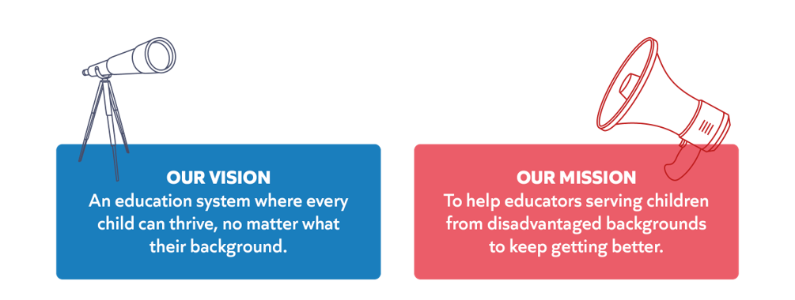
“Teachers are the foundation of the education system – there are no great schools without great teachers… The Early Career Framework (ECF) underpins an entitlement to a fully funded, two-year package of structured training and support for early career teachers linked to the best available research evidence. ​”
Early Career Framework, 2019

Conference 3: Ongoing professional development and sustained wellbeing
Session aims
Understand:​
- What Year 2 of the programme entails. ​
- How the programme supports you to develop your expertise. ​
- The importance of protecting time for rest and recovery in order to manage your wellbeing in year 2 of the programme and beyond. ​
Reflect on:​
- How developing your practice can support your wellbeing in the longer term. ​

Every teacher needs to improve, not because they are not good enough, but because they can be even better.
Dylan Wiliam, 2019

Introduction to Year 2
Programme journey so far

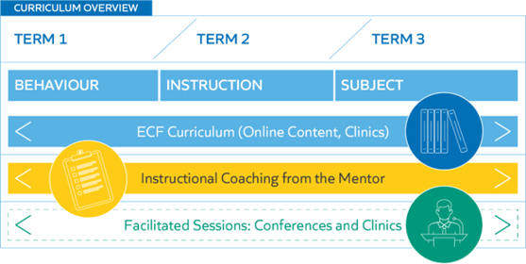

Self-study and coaching
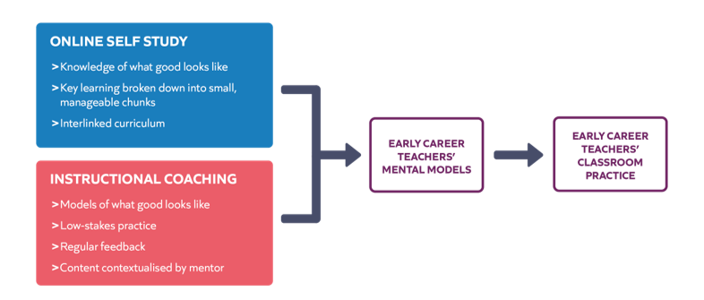

Reflecting on the first year
What has gone well?
- Identify 2-3 things that have gone well in your first year.

What do you want to change or develop?
- Identify one element of your practice you would like to develop further.

What can I expect from Year 2?
- Fortnightly instructional coaching with mentor
- Access to all year 1 self-study modules
- Access to a diagnostic tool on Steplab
- Access to self-study stretch modules
- One conference and three clinics

The programme journey:
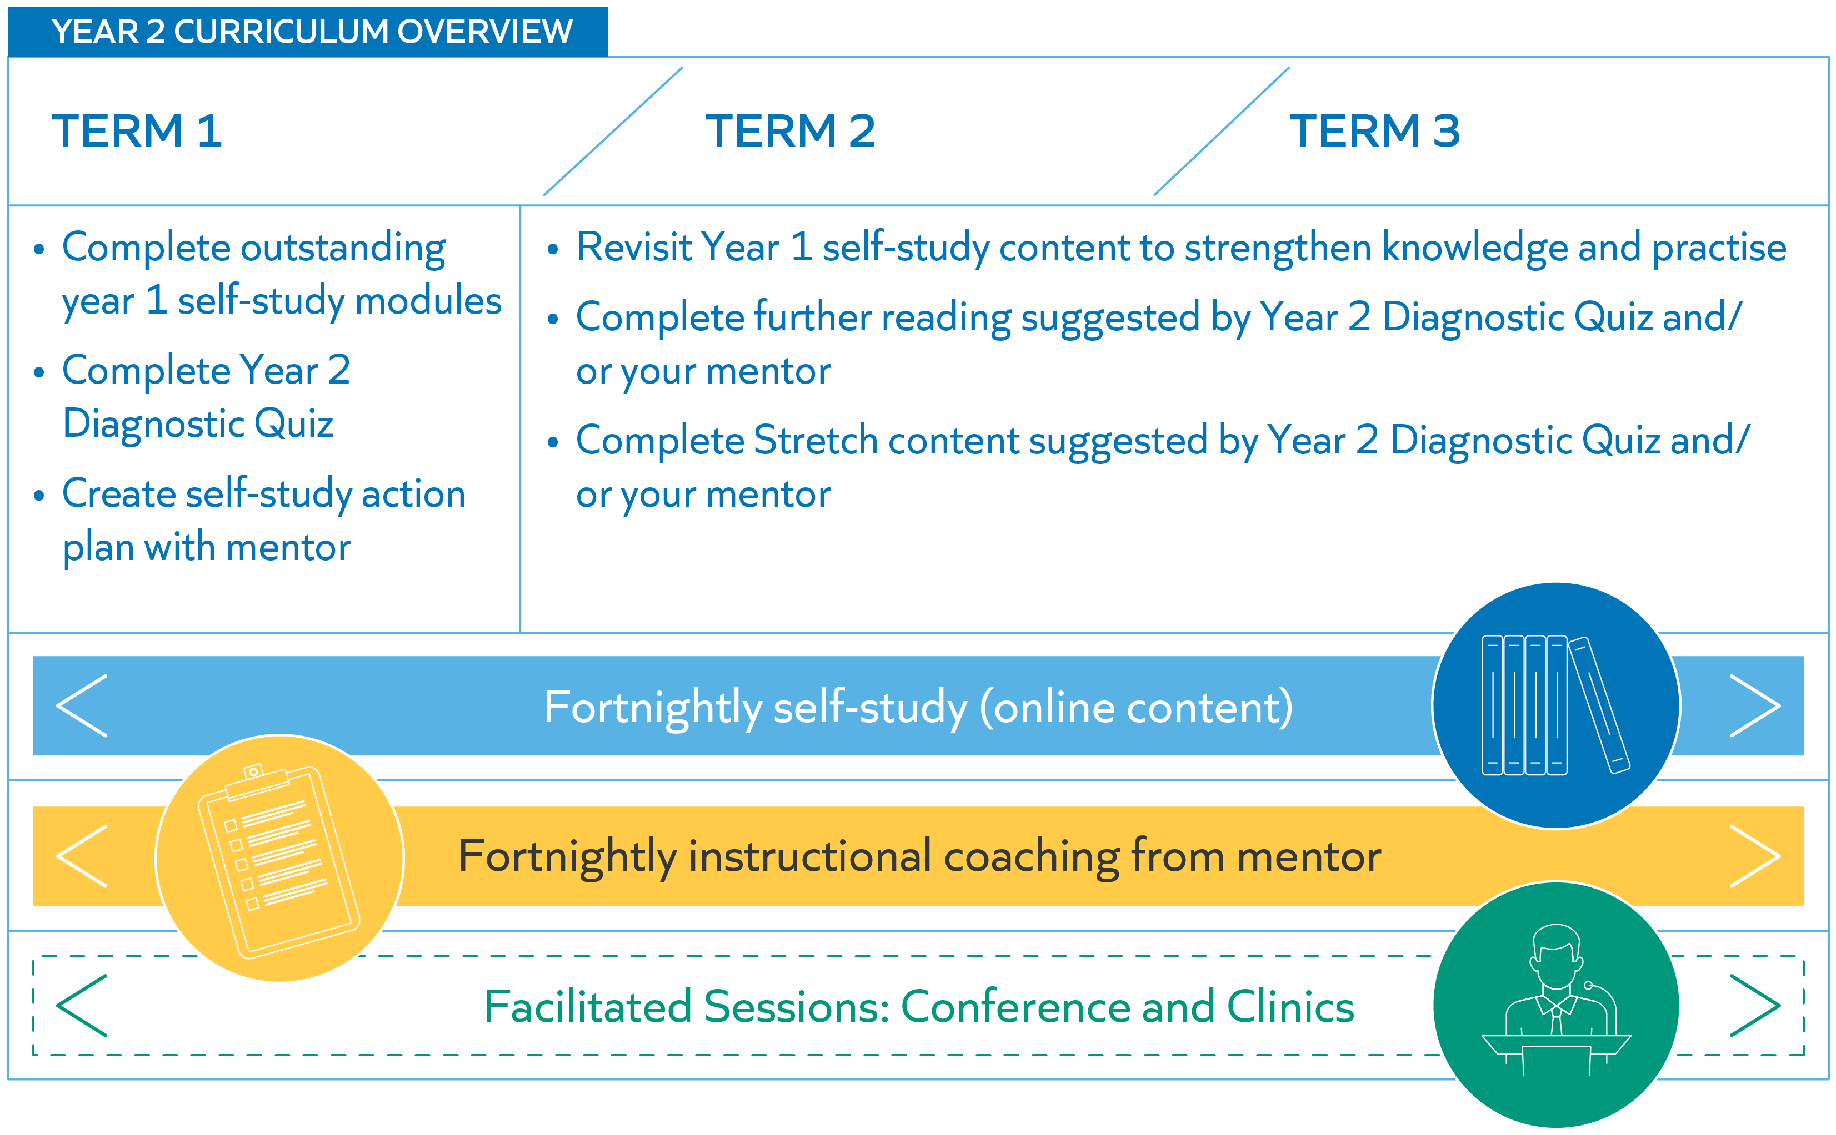

Your Entitlements
- ECTs will receive a 5% timetable reduction in the second year of induction.
- This time off timetable should be used to specifically enable ECTs to undertake activities in their induction programme.
See the statutory guidance for further information.

Continued Professional Development
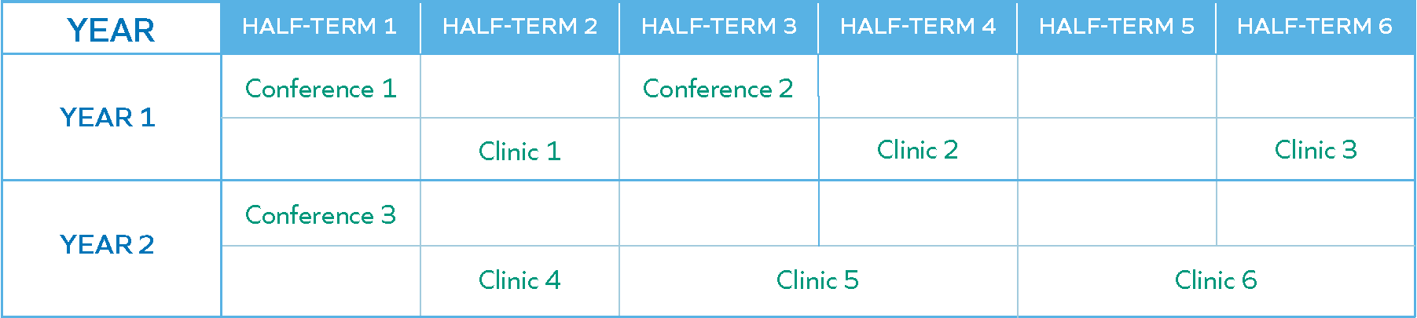

Year 2 content
- Conference 3: Continued professional development and sustained wellbeing
- Clinic 4: Working with others
- Clinic 5: Literacy
- Clinic 6: Implementation

Year 2 Self-study
- Fortnightly self-study
- Complete any outstanding Year 1 modules
- Engage with Y2 diagnostic tool
- Revisit modules to deepen knowledge and address misconceptions
- Engage in further reading or stretch content

Diagnostic tool
- A set of diagnostic questions for each strand (behaviour, instruction, subject)
- Can be completed over a series of weeks
- Supports you and your mentor to identify areas of strength and areas for further development
- Supports your self-regulation

“…our intuitions and introspections appear to be unreliable as a guide to how we should manage our own learning activities… learners can easily be misled as to whether learning has been achieved, typically resulting in overconfidence.”
Bjork, R. A., Dunlosky, J., & Kornell, N. (2013)

Diagnostic tool case studies
Read the case studies below and consider:
- How does the completion of diagnostic quizzes support the teacher to develop their mental models?
- What are the benefits of revisiting modules which have already been completed?
- How did the teachers apply self-regulation to support their professional development on the programme?

Case study 1
Alex is about to start year 2 of the programme. In year 2, he knows that he will be coached fortnightly by his mentor and has discussed when this coaching will take place. Alex also knows that he is entitled to fortnightly self-study during his second year. To ensure that he uses this time productively, Alex needs to identify where his areas for development lie.

He starts by reviewing whether there is any year 1 content that he is yet to cover. By looking on Steplab, Alex identifies that he hasn’t managed to complete the following modules: Behaviour 12, Instruction 12 and Subject 12. Alex knows that it is better to space out his learning, so plans to complete one module per fortnight.

Alex knows that completing the outstanding modules will take approximately 1 half term of his allocated self-study time, leaving him with 5 half terms of self-study time remaining. He therefore uses the diagnostic tool to help him decide what to focus on during this time. These low stakes quizzes reveal that Alex has struggled to answer a question which is linked to effective questioning. Based on his responses, the tool advises him to revisit the following modules: Behaviour 11, Instruction 10 and Subject 10. It also suggests that Alex may want to engage in further reading related to other aspects of the behaviour, instruction and subject strands, for instance in areas such as managing cognitive load.

Once Alex has completed the outstanding year 1 modules, he discusses with his mentor how to prioritise the modules and further reading suggested by the diagnostic tool. Alex’s mentor agrees that questioning is an area for development. Together they agree that Alex will study Instruction 10 prior to their next coaching session and that his mentor will make sure to look out for how Alex questions pupils in the next observation. After this, Alex will revisit Behaviour 9 and Subject 10 before moving on to the suggested stretch module.

Notes:

Case study 2
Having looked through the list of study modules on Steplab, Joanna is sure that she completed all of these during year 1 of the programme. However, she feels that, particularly for the early subject modules, she can’t remember very clearly the content. She knows that she was unwell for a period of the last academic year and thinks that she might have studied these modules during this time.

To give her a better sense of what gaps in knowledge she may have, Joanna completes the diagnostic tool. Unsurprisingly, the content on planning to develop pupil knowledge has been flagged as an area for development. She has been encouraged to revisit Subject 2 (planning backwards from learning goals) and Subject 3 (Types of knowledge and breaking them down).

Joanna discusses the results of the diagnostic tool with her mentor. She is teaching a different year group this academic year and is therefore less familiar with the medium and long terms planning for these lessons. Joanna therefore asks her mentor for support with developing her expertise with lesson planning. She will complete her the self-study modules during term one and use her coaching sessions to discuss and apply this knowledge.

The diagnostic tool revealed that, aside from the early subject modules, Joanna’s understanding of the self-study content is good. At the beginning of term two, she therefore decides to engage with some of the stretch materials. She is particularly interested in the stretch module on increasing challenge, as she thinks this will complement her thinking around the planning process. Joanna’s mentor agrees with this. When Joanna has finished reading this stretch module, Joanna’s mentor uses the steps identified at the end of the module to help Joanna practise using the knowledge she has built from this module in her classroom.

Notes:

Importance of Professional Development

“Teachers are the largest non-student effect on achievement variance, at c.30%. Schools and principals have >10% effect.​”
Hattie, 2003

Teacher impact on pupil academic outcomes
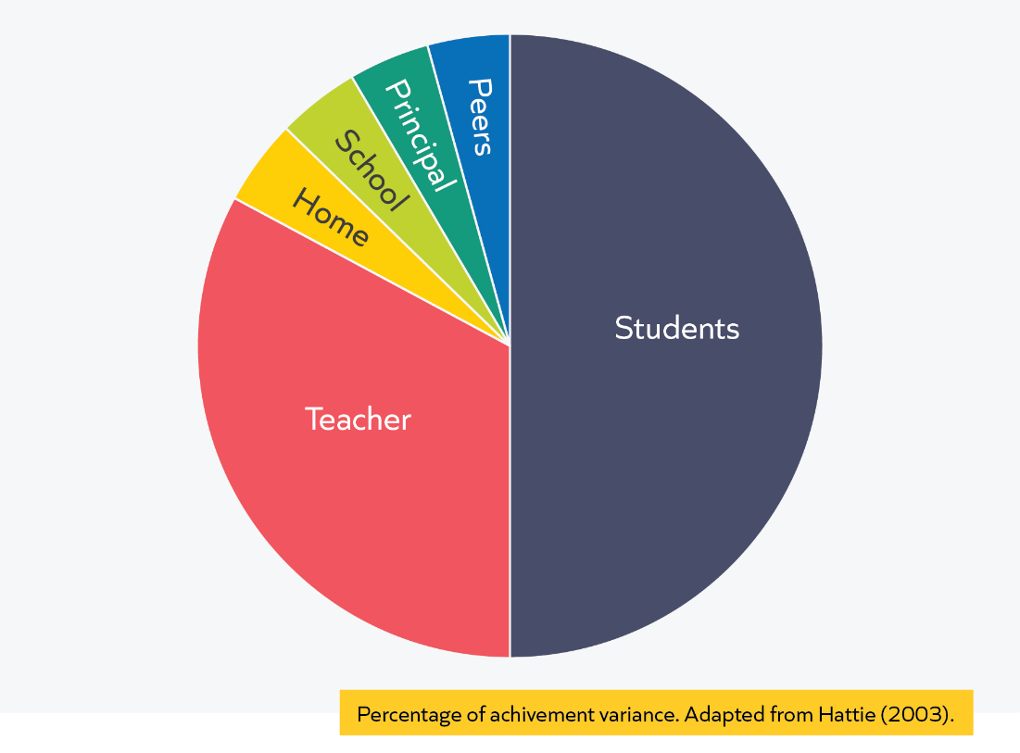

​In this 2003 study Hattie sought to focus on the extent to which teachers contribute to pupil academic outcomes and how expert teachers differ from novice and experienced teachers. In doing so, he synthesised over 500,000 studies to identify the above influences on student achievement. The home factor looks small but, as Hattie states, the major effects of the home are already accounted for by the attributes of the student. Teachers are the largest non-student effect on achievement variance, at c.30%. Schools and principals have >10% effect.
Hattie, 2003

Why is professional development important?

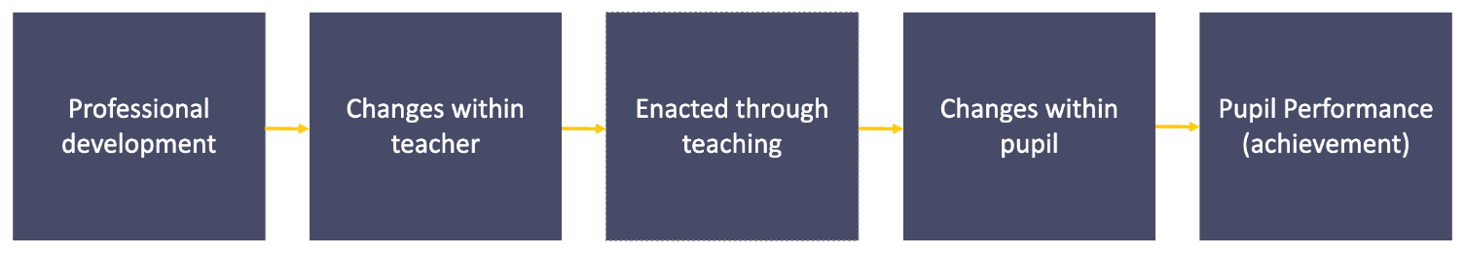

Impact of PD on pupil outcomes:

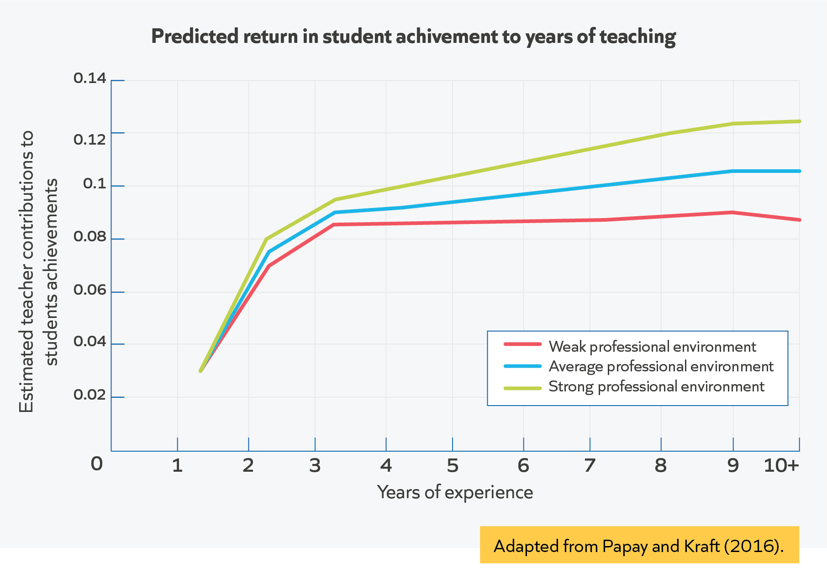

Developing expert mental models

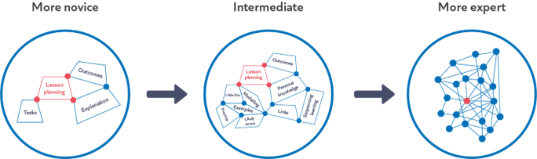

Efrat Furst, 2018

Read and reflect: Expert teaching
Read the extract from Mccrea (2018) Expert Teaching: What is it, and how might we develop it? Then answer the reflection questions which follow:
Expertise as Action
The following four aspects of behaviour enable expert teachers to have great impact:
- Perception: Expert teachers see their classrooms in a qualitatively different way (Glaser, 1996). Like the football goalie who focuses on an attacker’s posture to anticipate where they will kick, expert teachers are adaptively attuned to the most critical movements of their classrooms. They perceive events at a deeper level of abstraction, focusing almost exclusively on cues that allow them to make inferences about student progress (Findell, 2009). They can be distinguished as much by what they do not attend to as what they do (Miller, 2011).
- Simulation: Expert teachers are able to accurately simulate the consequences of various actions and events across a range of familiar situations. This enables them to anticipate what might happen well in advance, and so to make the most effective professional judgement (Westerman, 1991). They are constantly several steps ahead of their pupils (and others), and as a result, their lessons often appear to just happen (Berliner, 2004).
- Execution: Although they tend to do less than their colleagues (Schempp, 2002), and sometimes take longer to arrive at a diagnosis (Sternberg & Horvath, 1995), expert teachers consistently select the most impactful interventions across a wide range of situations (Ball et al., 2008). They are often more flexible and opportunistic in their choice of action (Berliner, 2004), and execute routinely with fluency and precision (Hattie, 2003).
- Conservation: Expert teachers conduct much of their practice on ‘automatic pilot’, enabling them to: devote significant mental resources toward monitoring the complex, chaotic environment of the classroom (Miller, 2011); focus executive control towards the most important teaching processes (Sternberg & Horvath, 1995); and tackle unexpected problems as they arise. As a result, they are highly sensitive to, and can keep track of (and better remember) multiple changes in the tasks and behaviours of pupils, even when engaging with individuals (Clarridge & Berliner, 1991; Woolf et al., 2017).
Expertise as Mental Models
Appreciating what expert teachers do differently is helpful in some ways. It makes it easier to recognise expertise when we see it. However, an action definition still doesn’t give us the secure footholds we need to develop expertise. For that, we need to look deeper still, towards one of the root causes of teacher behaviour: their mental models. Mental models refer to what people know and how this knowledge is organised to guide decision and action (Schempp, 2002).
What do expert teachers know?
As teachers move from novice to expert, they develop increasingly powerful mental models in the following broad domains:
- Path: Knowledge of the pathway towards mastery of a curriculum, including: the concepts and process that pupils need to know at different stages of their journeys; how these are best represented and sequenced (Hattie, 2003; Westerman, 1991); as well as common obstacles to progress (Sadler, 2016).
- Pupil: Knowledge of what their pupils know and don't know, what motivates and concerns them, and how these things change over time (Berliner, 2004, Schempp, 2002). The development of pupil knowledge is produced (and limited) by teacher assessment knowledge (Christodoulou, 2017; Wiliam, 2016).
- Pedagogy: Knowledge of how learning works and how to catalyse it. This area draws on fields such as cognitive and behavioural science (Deans for Impact, 2015) as well as personal experience, to help teachers build a mental model of the learner (Willingham, 2017b). It encompasses cognitive, emotional, social and cultural dimensions of learning.
- Self-Regulation: Knowledge of how to analyse, evaluate and iterate their own knowledge and action towards increasing impact (Ericsson, 2015; Hattie, 2012). This includes an awareness of their own cognitive biases and how to mitigate them. Reduce the power of any of these domains and teacher impact declines accordingly. For example, if you ask an expert to teach a different subject (Sternberg & Horvath, 1995) or year group (Kini & Podolsky, 2016), or even give them a new group of pupils (Berliner, 1994), they are no longer likely to enable exceptional outcomes. Expertise is highly domain-specific. Even the PE teacher who is proficient at teaching fitness may be woefully lacking when it comes to teaching racket sports (Berliner, 2004).
How is expert teacher knowledge organised?
Expertise is a result of not just what teachers know, but how that knowledge is organised to guide perception, decision and action. The mental models of expert teachers are:
- Extensive: They have a comprehensive, connected and evidence-informed understanding of the domains outlined above (Ericsson & Pool, 2016).
- Actionable: This knowledge is knitted together with an appreciation of their local context, alongside the cues they routinely encounter through pupil interaction (Schmidt, 2007).
- Fluent: The vast majority of this knowledge can be accessed and employed rapidly, and with minimal effort 6 (Findell, 2009).
- Meaningful: Expert teacher knowledge is threaded with their personal and professional values. They care deeply about their craft, and about elevating the life chances of their pupils (Schempp, 2002). As a result, they take full responsibility for their actions (Berliner, 2004), and are driven to continually improve their practice (Hattie, 2003).
Combined, these organisational features of mental models enable teachers to act in the ways described in previously, and effectively tackle the most persistent problems they face in everyday practice.
Developing Expert Mental Models
Developing teacher expertise is largely a process of helping teachers build their mental models in the domains outlined above. Certain aspects of this knowledge unfold fairly naturally through experience (Allen & Sims, Forthcoming). These tend to be behaviours which have a longstanding role in our evolutionary history as a species (Geary, 2007), are easy to imitate (Kini & Podolsky, 2016), and offer fairly immediate and tangible feedback. For example, building trusting relationships with pupils. However, there are also aspects of expert mental models that we are much less likely to develop through experience alone. Particularly those that are unintuitive, hard to measure, and demand judicious use (Rohrer & Pashler, 2016). For example, interleaving practice (Brown et al., 2014) and delayed feedback (Fletcher-Wood, 2017). To develop these kinds of models, our best bet is to be intentional in supporting teachers to:
- Study – Build an evidence-informed understanding of how these things work.
- Practise – Put this evidence to work in their context, and repeatedly implement towards fluency and fidelity (Schmidt & Rikers, 2007).
- Iterate – Continually evaluate (against pupil impact) and improve their mental models and actions. Not all study, practice and iteration is equal. Crafting professional learning experiences that have an impact on what teachers know and how they act, and that have an impact on pupil learning is rare to achieve (Coe et al., 2014; IES, 2016).

Expert teaching
- What do expert teachers do?
- What do expert teachers know?
- How can we develop expert mental models?
Notes:

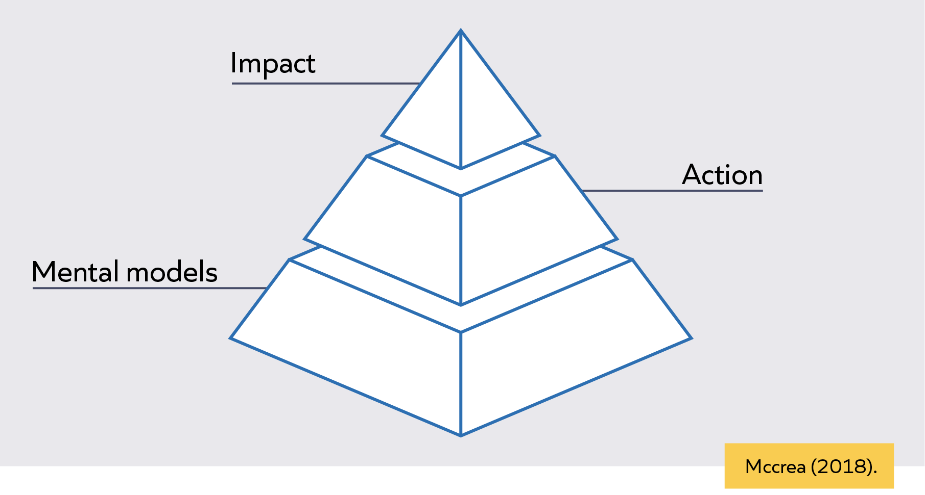

Reflection: Motivation and PD
Reflect on the following questions in relation to your PD experiences so far:
- Reflect on a time when you have not invested the time and energy into professional development that you would have liked to. What barriers did you experience?
- What motivates you to invest in your own professional development?
- What examples do you have of times when engaging in high-quality professional development has had a clear impact on your practice?
- What conditions were in place to allow you to engage in the professional development?

Notes:

Motivation
Read the extract from the National Foundation for Educational Research on Teacher Autonomy and consider the following questions:

- What drives your motivation to invest in your own professional development?
- Reflect on a time where you may have not invested the time and energy into your own professional development as much as you would have liked. What barriers might have caused this to happen? ​
- Which of the psychological needs do you feel is most important to you when it comes to engaging with professional development?
Self-determination theory (Deci and Ryan, 2008) provides a theoretical framework for understanding motivation and its implications for staff. The theory hypothesises that while both forms of motivation [intrinsic and extrinsic motivation] can drive job performance, they have different implications for staff well-being and job satisfaction. Staff working in conditions that emphasise a greater reliance on intrinsic motivation are thought to be more likely to have high well-being and job satisfaction and be more likely to stay. Conversely, greater reliance on extrinsic motivation is thought to risk undermining staff members’ sense of feeling trusted and their own intrinsic motivation, potentially leading to disengagement, burnout and leaving. Deci and Ryan outline three basic psychological needs that underpin intrinsic motivation:
- Competence – skills to perform well in one’s job.
- Autonomy – direction over one’s own decisions and actions.
- Relatedness – connection with, and support from, colleagues.
The theory suggests that these needs are interdependent. In other words, intrinsic motivation is likely to increase more if you have all three (competence, autonomy and relatedness) at the same time. One implication of this interdependence is that too much autonomy for novices risks overwhelming them, as they are early in the process of establishing their competence and forming working relationships.
This theory of motivation underlies our interest in the professional autonomy of teachers and our findings support the theory that there is a positive relationship between autonomy, job satisfaction and retention.

Notes:

Exploring self-determination theory

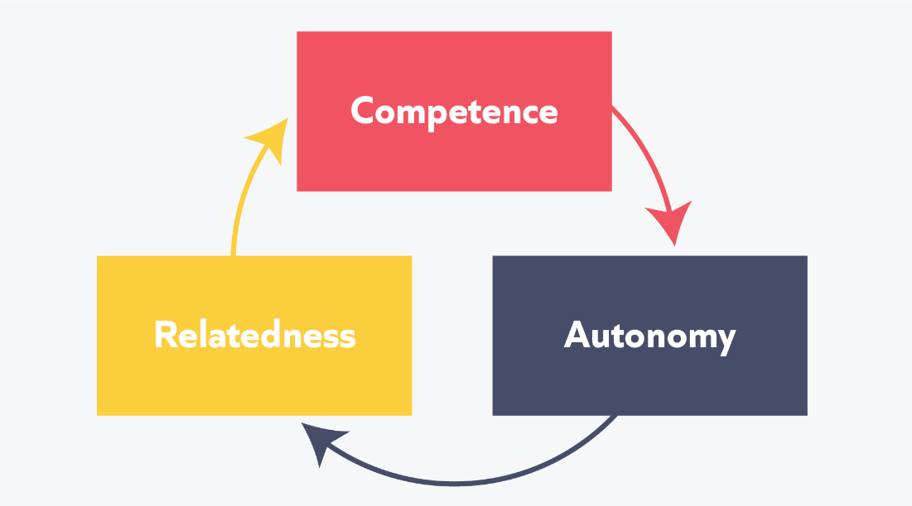

Resources for professional development
- EEF guidance reports
- DfE Documents
- Reading lists from self-study modules
- Colleagues
- PD networks

‘Teachers and schools are being encouraged to become more evidence-based or evidence informed, the aim being to use evidence to improve teaching practice. By acting on the best evidence, it increases the likelihood that we will make better decisions.’
Institute for effective education, 2019

‘We recognise that being a good doctor, or teacher, or manager, isn’t about robotically following the numerical output of randomised trials; nor is it about ignoring the evidence, and following your hunches and personal experiences instead. We do best, by using the right combination of skills to get the best job done.’
Ben Goldacre, 2013, p.19

Different sources of information
Academic sources
- Experiments
- Case studies
- Surveys
- Data analysis
- Systematic reviews
- Meta-analyses
Non-academic sources
- Blogs and social media (e.g. Edutwitter)
- Newspapers and magazines (e.g. Times Education Supplement)

Reflection
Read the scenario and consider the following:
- Why is it beneficial for Anna to look in a little more detail at the theory underpinning the suggested approach?
Anna, an ECT in the second year of the programme, has spoken to her colleagues and her mentor. She has gathered evidence of her pupils’ behaviour and she thinks that the key symptom is that pupils are slow to start paired or group tasks. At this point she wants to find out more about motivating pupils to start a task efficiently. She chooses to engage with literature around potential strategies around increasing pupil motivation to help her. She starts by finding an article on TES which refers to pupil motivation. Having read the article, she gets to gist of the approach but wants to understand in more detail the theory underpinning the suggestions in the article. She looks at the reference list within the article and engages with an academic paper cited there because she knows that this type of literature may be more reliable.
Notes:

Questions to consider as you engage with evidence
- What is the focus of the research (or the research question)?
- Is there evidence of the author’s values/beliefs about education? If so, what are they?
- Who might agree and who might disagree with the research? Is there a consensus?
- How does it link to other research you have read (does it precede/build upon other theory)?
- Are there any studies in the reference list that you would like to investigate further?
Notes:

‘Teachers’ autonomy over their professional development goal-setting is particularly low, and is the most associated with higher job satisfaction. Increasing teachers’ autonomy, particularly over their professional development goals, therefore has great potential for improving teacher job satisfaction and retention.’
NFER Report (2020)

‘[Self-regulated] learners are proactive in their efforts to learn because they are aware of their strengths and limitations and because they are guided by personally set goals and task-related strategies. They monitor their behaviour in terms of their goals and self-reflect on their increasing effectiveness. This enhances their self-satisfaction and motivation to continue to improve.’
Zimmerman (2010)

Developing wider networks
- Pedagogical
- Subject
- Professional
- ‘Grassroots’
Discuss:
- Have you heard of any wider networks that fit the categories above?
- Have you engaged with any wider networks so far in your career?
- If so, what help or support does the network provide to educational professionals and how have they helped you to develop?

Notes:

Effective professional development
- Builds knowledge
- Motivates teachers
- Develops teaching techniques
- Embeds practice
Notes:

“Mechanisms are the core building blocks of professional development. They are observable, can be replicated, and could not be removed without making PD less effective.”
EEF, 2021

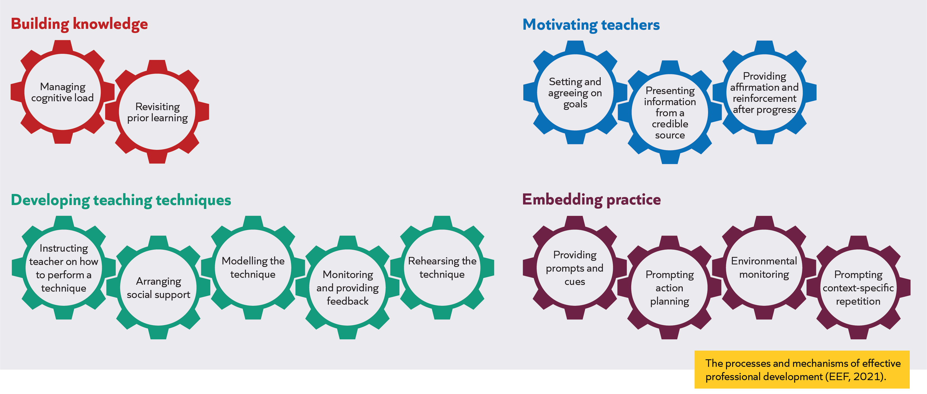

Reflect
Which of the mechanisms can you identify as being present in the ECT programme?
Notes:

Sustaining Wellbeing (part 1)
What is wellbeing?
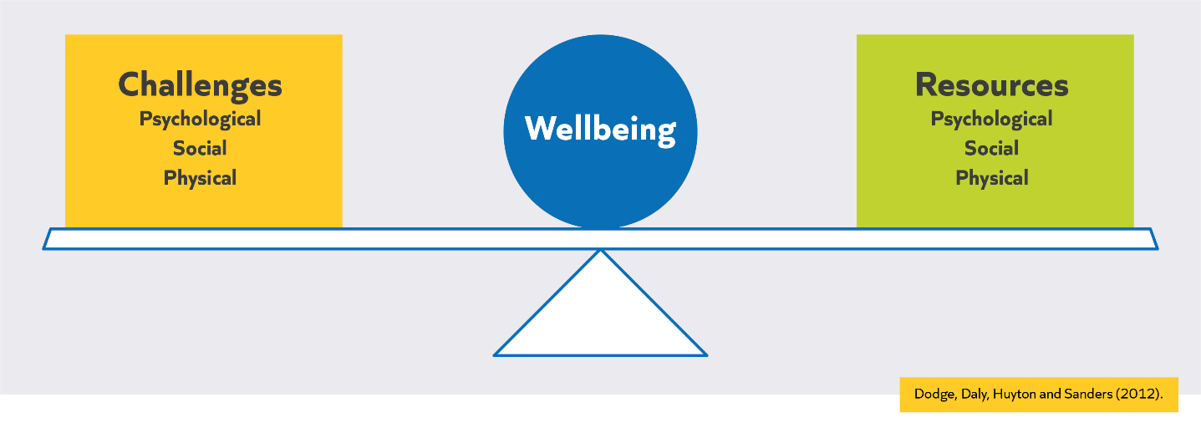
“So, wellbeing at work is more than just liking your own job. Occupational well-being is like an eco-system. It consists of inter-related elements and is shaped by an individual as well as those around them. Levels of low or high wellbeing are rarely due to just one factor.”
Ofsted, 2019

Reflection
- Reflect on the factors which affect your wellbeing, both positive and negative.
Notes:

Factors influencing wellbeing
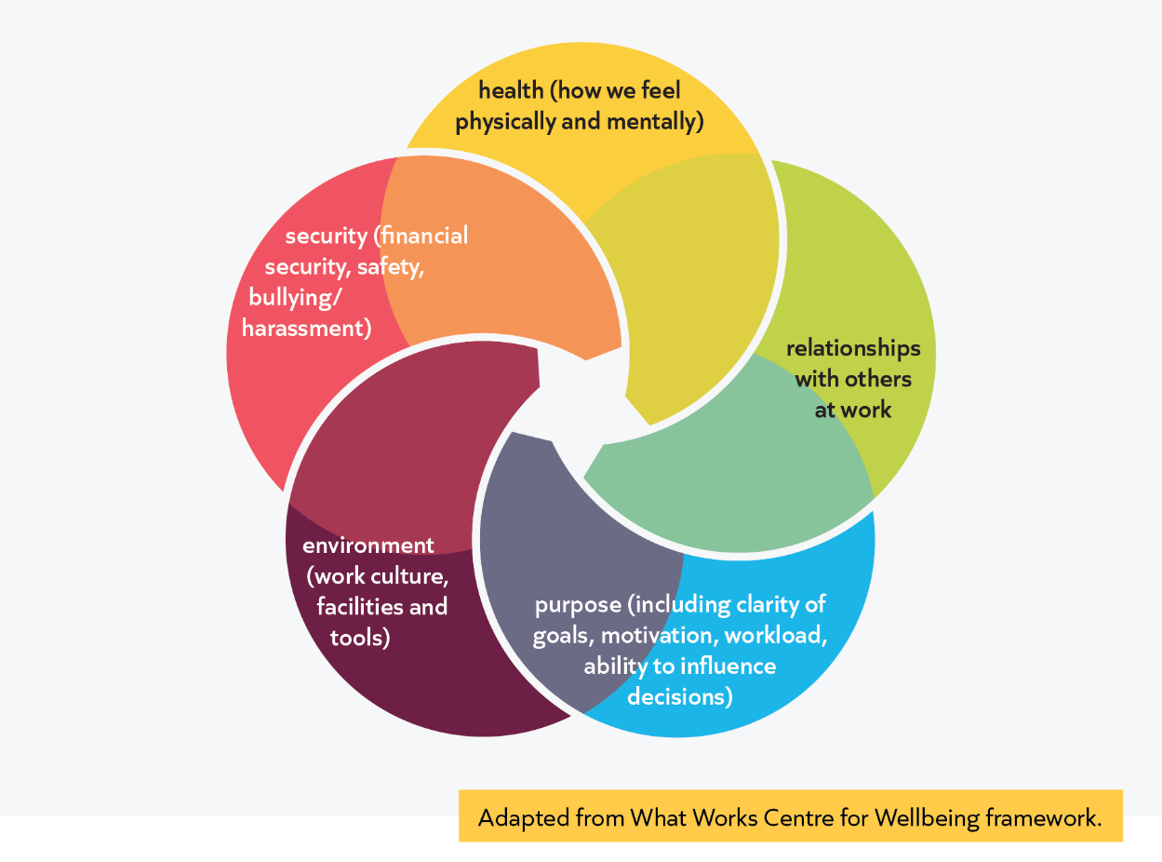
Notes:

Why is wellbeing important?
- Teacher sickness and burnout
- Teacher wellbeing and student wellbeing are linked
- It is not just teacher’s individual responsibility but also the responsibility of the government and of your school leaders to help support you in maintaining your wellbeing and prevent burnout

Notes:

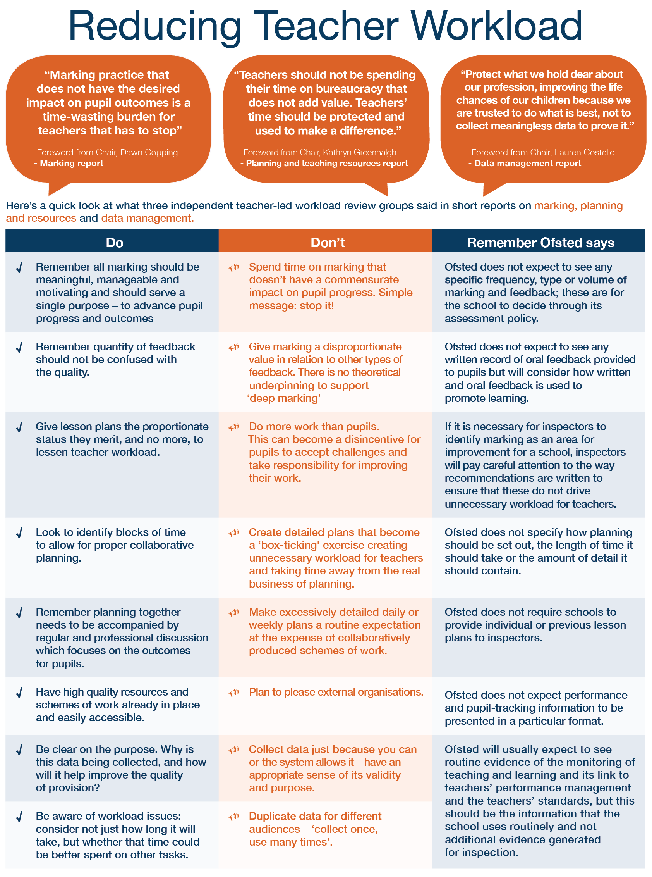

Read and reflect
- How do these statements align with your current marking, planning and data management practices?
Notes:

“Tackling workload should improve recruitment and retention rates in schools, improve work-life balance for teachers and leaders, and enable them to focus on their own development.”
Department for Education, 2019

Managing workload and time
- What systems and routines do you currently have in place to help manage your time and the tasks you need to do?
- How (if at all) have these systems and routines changed over the past year?
- Prompts:
  - How do you manage marking and feedback?
  - How do you manage planning?
  - How do you manage preparing resources?
  - How do you manage unexpected demands on time?

Notes:

Workload management strategies
- Prioritising tasks
- Calendars
- Keep a record of amount of time spent on different tasks and tracking which tasks are taking up most time.

Read and discuss
Read the adapted extract from Harry Fletcher Wood’s blog “A strategy for managing time”. At the point of writing this, Harry had both teaching and leadership responsibilities. Therefore, some of the responsibilities discussed below may differ slightly from yours but others will hopefully resonate with your current role. As you read, consider the reflection questions below:
- To what extent does Harry’s experience resonate with your own?
- What factors help you decide if a task is important or not?
- What do you feel might be the strengths and weaknesses of the quadrant approach?
…Managing time as a teacher seems similar to using language effectively: it’s a teachable skill which is often left untaught…. You can find dozens of such ideas online, many of them useful; I can think of embarrassing moments searching for worksheets or students’ reports that such tips might have prevented. The starting point for this post, however, is that none of this solves the underlying problem: this tinkering frees you to move on to the next task, but the list of tasks remains infinite. Must we be left like the White Rabbit, on the run just to keep still? …. Over the last couple of years, I adopted a kind of system to manage my time. I rotated between tasks (mostly because I found it hard to maintain my interest in marking through a whole class set, so I would mark five books, then do a bit of planning, then do something else, then go back to marking). If I had a couple of frees on a particular day, I would try to make time for something extra, beyond the run of the mill. Most essential things got done in time; occasionally I managed some important extra things, like working on my professional development.... The second year working in a new school seems harder than the first, so it is this year I have had to fix my shoddy time management.

A strategy for managing time
Needs are infinite… in the classroom, teachers learn not just to rush around helping those who clamour for support, but also those who do not ask – that is to choose who to help depending on their assessment of need and priority. What about outside the classroom?
Covey’s writing on time management builds on his earlier chapters, which invite the reader to identify their principles and values (something I tried to do at the start of term). It is then possible to identify the actions which are most important in pursuing those principles. Covey suggests using four quadrants, a strategy I suspect most readers will know:
I Urgent and important
II Not urgent and important
III Urgent and unimportant
IV Not urgent and unimportant
Covey argues that the most successful people spend most of their time working on things found in Quadrant II. The more time spent in Quadrant II – working on long-term issues which build towards success, the less it is necessary to ‘firefight’ unexpected problems and crises.
I would rather not dwell on how much of my career has been spent in Quadrant I; I suspect that may be true of many teachers. Thankfully, Covey has a mechanism for putting these principles into practice.

Principles into practice
1) List roles

I stuck within my professional life and listed teacher, head of department and head of CPD; this could equally be holistic and include aspects of life outside school: partner, parent, friend, volunteer? Blogger?

2) Identify three goals for each role, each week

A recent week for me looked something like this:
Teacher: teaching lessons…, responding to Year 7 reflection sheets, planning extensions to current Year 8 unit.
Head of Department: planning upcoming trip, responding to my curriculum review, planning the next Year 7 unit
Head of CPD: planning the next Teacher Learning Community, checking details for CPD for the rest of term, working out ways to improve CPD for support staff.

3) Block out time for each goal across the week

This looks far easier in Covey’s imaginary example than for a teacher, who begins the week with twenty or twenty-five unavoidable obligations rather than a blank easier. All I do, however, is write into each of my frees one of the tasks I’ve given myself for this week.

4) Stick to the schedule

Then you just follow the week’s plan… Easy?

Does it work?

Yes. And/but:

Resisting short-term pressures – getting the important things done
I use my time much better: more important stuff gets done, to a higher quality. I can sit for an hour focused on my intended task and avoid frittering half the time on emails, incidental tasks or last-minute changes to the next lesson. I’m sometimes a little less clear about what I’m teaching until I walk into the room (because it was planned earlier in the week, not the lesson before), but lessons are better because they are thought through in advance. I get more things done comfortably ahead of deadlines; I even complete tasks which are important but have no deadline. I also feel in charge of my work: instead of waiting for a colleague to set a deadline for something I know I’ll have to do, I now find myself chasing them to get the process started, because I’ve set time aside for the task and intend to complete it. And I’m better at resisting surprises, because I believe pretty firmly that whatever I don’t know about on Monday morning, when I make the week’s plan, is unlikely to be that important; if it’s truly critical, the school will have to consider reducing my workload elsewhere to get it done.

Resisting external pressures – how do I keep space for my priorities?
We did an exercise choosing words to describe ourselves and each other recently at school and the word most commonly applied to me was ‘strong-willed.’ My instinctive reaction to authority is bolshie, so pushing back on external pressures comes pretty naturally to me. This is a different kind of resistance, a more principled one. Before, my resistance to an idea, policy or task would be because either a) it seemed a bad idea or b) I didn’t have time. There is no change to (a) but with (b) I am much clearer in my own mind as to the consequences of the time lost with additional, last minute tasks than I was before and of the sacrosanct nature of the goals I have chosen for the week. I have priorities and a schedule, so I will have to be convinced that an additional, imposed task is more important and more urgent than what I have planned to do. This is a more useful conversation than simply claiming that I’m busy: everyone’s busy.

Reconsidering my principles – what do I value?
This exercise helped shed new light on my values and how I use my time. Perhaps the most profound and most useful realisation, certainly the most pleasant, related to taking breaks. Last Thursday (the heaviest day of the fortnight, although not by much), I taught five hours, ran an hour’s enrichment, supervised lunchtime detentions and had a half-hour meeting; that left one free, in the middle of the day. As anyone who has ever taught a full teaching day will know, by 5pm I was invariably less patient with my students than I would have wished. The treadmill mentality of getting as much as possible done had me using that one free hour to complete another task or two. Considering what mattered, rather than a list of tasks, helped me to recognise that actually, to be the teacher I’d like to be, that time is best used taking a break – if the weather’s nice, I go for a walk – and I feel rested and refreshed by the time I’m back at school.

Reconciling myself with Quadrant V – how do I deal with unavoidable tasks?
Stephen Covey never grappled with Quadrant V, unimportant but unavoidable. Mostly, these are accountability-focused things that I can’t escape but which seem unlikely to significantly affect my students’ learning; sometimes they are things I don’t want to do but should. Covey might argue that you should pursue your principles and enter into debate on the need or the execution of each task, but time and stamina for this discussion is limited. I began by ignoring these tasks and then having to fit them in around my priorities. Now, instead, I set myself one ‘unavoidable’ action each week – and allot a slot to it too. By ensuring that it is only one action a week and the unavoidable tasks are done, I maintain the underlying integrity of managing my time effectively.

The conclusion?
I’ve habituated this now: the first thing I do on Monday morning is now plan my tasks and block out the week for them. Frequently, as in India, I fail to meet my goals. However, with an achievable, meaningful list of tasks, I get more done and I have a clear conscience about the tasks I’m not getting done – they were never that important anyway.

The line which has stuck with me most strongly from Good to Great is this: “The enemy of great is not bad, it’s good.” I wasn’t sitting around all day checking Facebook and bad-mouthing students all day before and I’m not super-teacher now. I was doing good things: marking, teaching, planning… but as Covey says: “Keep in mind that you are always saying ‘No’ to something.” By prioritising differently, by saying ‘No’ to some of those tasks in the short term, I have more time for great things: finding ways to mark more effectively, planning further in advance more effectively and more precious time to make longer-term investments in my own learning which will help make me a better teacher.

The crux – I am a professional: I choose how I spend my time
This is not just reorganising my diary, it’s bigger and bolder; it increases both the power and the pressure I feel in doing my job. In choosing only three tasks within each role, I am accepting that I will not do – will never do – a vast array of other things. If I say I will resist external pressures to meet my priorities, I’d better be certain they are right. To me, this represents another small piece in the jigsaw of professionalising teaching: professionals do not implement the directives imposed upon them, they use their judgement to decide where they will focus their efforts.

Notes:

Prioritisation Example
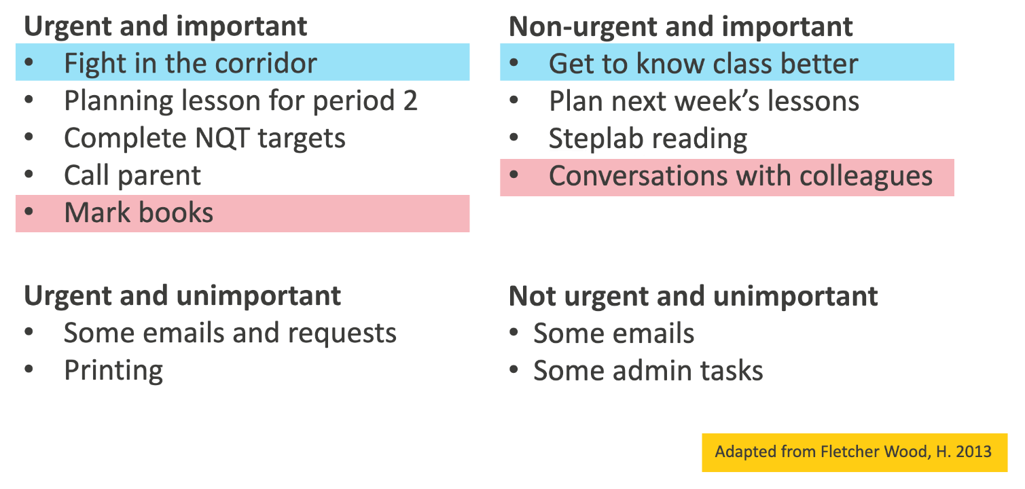

Principles into practice

Urgent and important​ | Non-urgent and important​
Urgent and unimportant​ | Non-urgent and unimportant​

Time Blocking
- Time-blocking is creating a finite amount of time for a specific task.
- Time-blocking can also be used for “movable” tasks such as exercise time or your weekly independent task for the programme.
- This strategy is especially useful for stopping activities ‘expanding to fit’ the time you have free.

Managing energy reflection
Consider 5-6 tasks that you need to complete tomorrow/this week. (You might include all or some of the goals you have previously identified.)
- What activities/tasks may be more helpful to carry out when your energy is low?
- What activities/tasks may be more helpful to do when you are feeling more refreshed/energised?

Notes:

Reflection
Consider the following:
- What regular blocks of time could you protect for personal professional development?
- What blocks of time could you use for one or more of the goals you identified in the previous activity?
- What blocks of time could you use for other urgent but less important tasks?
Notes:

Sustaining Wellbeing (part 2)
Rest and recovery
- How do you use the time below?
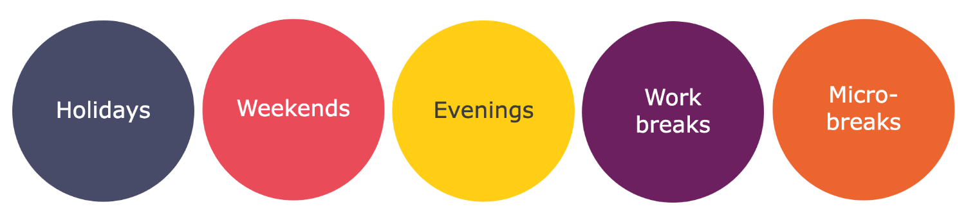
- What do you most enjoy in those times? What feels most restorative?
- What barriers are there to you benefitting from these chunks of time?
Notes:

Recover time activities:
- Having a sense of mastery helps build up new and restore threatened internal resources e.g. energy, self-efficacy, positive mood.
- Completely ‘switching off’ – not just physically, but mentally is important for recovery.
- Having control over your out of work activities helps increase your sense of self-efficacy* and feelings of competence.
Reflection
- What blocks of time could you protect for rest and recovery activities?
- How can you make sure that these activities don’t expand into other blocks of times?
- Thinking about your school timetable, when in the school day could you block out time for other urgent tasks, so that you have the time and space to engage in rest and recovery activities through the week?
Notes:

Developing positive habits
Read and reflect
Read the extract from Peps Mccrea's Motivating Teaching (2020) and reflect on the questions below:​
- Why, according to the article, do we find it difficult to motivate ourselves to make good decisions?​
- How might a motivational architecture help us to make good decisions/self-regulate?​
- Which of the core-drivers in Peps’ motivational architecture do you feel would be most helpful to you? Why?

Motivating ourselves

“Success is a science – if you have the conditions, you get the results.” – Oscar Wilde

We’ve talked a lot about motivating our pupils. But what about motivating ourselves? Are we any different? Do we need help to achieve our goals, or can we just rely on willpower?

Whilst we certainly can bring willpower to bear, lapses in self-regulation are a standard feature of life for all but the most self-disciplined adult.

This is perfectly normal. Whether it’s eating that biscuit or watching just one more episode, most people struggle to act in their own best interests in some way or other, particularly when we’re faced with more immediately satisfying options.

One reason behind this is our poor ability to forecast how we will feel in the future.

We consistently anticipate that we’ll make better decisions tomorrow, despite continually crumbling today. This false optimism persists even when we begin to notice it in others.

This situation is compounded by our tendency to retrofit narratives to explain our past action. No matter how tenuous, we nearly always have a reason for our responses, which only makes it even harder to recognise and learn from prior decisions.

The challenge of self-regulation is ever more prescient given the increasing abundance of immediately satisfying options in modern life.

From chocolate by the check-out to video on demand, these temptations can easily trigger failures in self-regulation and in doing so, deprive us of achieving important life goals and even direct us towards a variety of health ailments.

So, what can we do beyond applying willpower? How can we better manage our motivation in the moment?

…

For the busy professional, we need something that can deliver reliable results without taking loads of time. We need motivational architecture.

Motivational architecture

Motivational architecture is about recognising the power of our unconscious and modifying our environment to get it working for us, not against us.

Whilst we might not be able to beat our unconscious in the moment, we can outsmart it with some advance notice. Deleting twitter from your phone or putting your alarm at the far side of the room is about planning, not willpower.

…

To illustrate how, let’s consider a scenario. Imagine you wanted to get better at motivating your pupils. You have the knowledge, now you just need to make the change. What can you do?

[Below] is an example of the kinds of strategies we might consider if we thought about this problem through the lens of the 5 drivers:

Core drivers:

Secure success – start with one tiny, achievable change and ram up gradually; define success, track your progress and plan for failure; the more you succeed, the more you will want to do it again.

Run routines – choose a change you can practise daily; replace a routine, don’t add; design a cue you can’t miss, make it easy to get started and then ‘show up’ consistently to ingrain the habit.

Nudge norms – surround yourself with people who are doing the same things and are passionate about it; in real life or virtually; join a club or just set one up.

Build belonging – get to know others doing similar things and share your own experiences; align your work around a purpose and assign yourself a title or identity (e.g. ‘research geek’).

Boost buy-in – carve out regular opportunities to clarify why you are doing this; publicly declare your intentions and commit to doing a course, or even just a blog or school presentation.

…

Envisage using the above approach to secure your New Year’s resolutions rather than relying on willpower. Imagine the difference in results.

Not only is this an efficient way to achieve your goals, but it can also slash the need for on-going self-regulation and so free us to focus more on the moment.

Motivational architecture enables us to live with both more intention and attention. Which is why for me, it’s the ultimate human superpower.

Notes:

Developing positive habits
“[A habit is] a process by which a stimulus automatically generates an impulse towards action, based on learned stimulus-response associations”
Gardner, 2015

How are habits created?
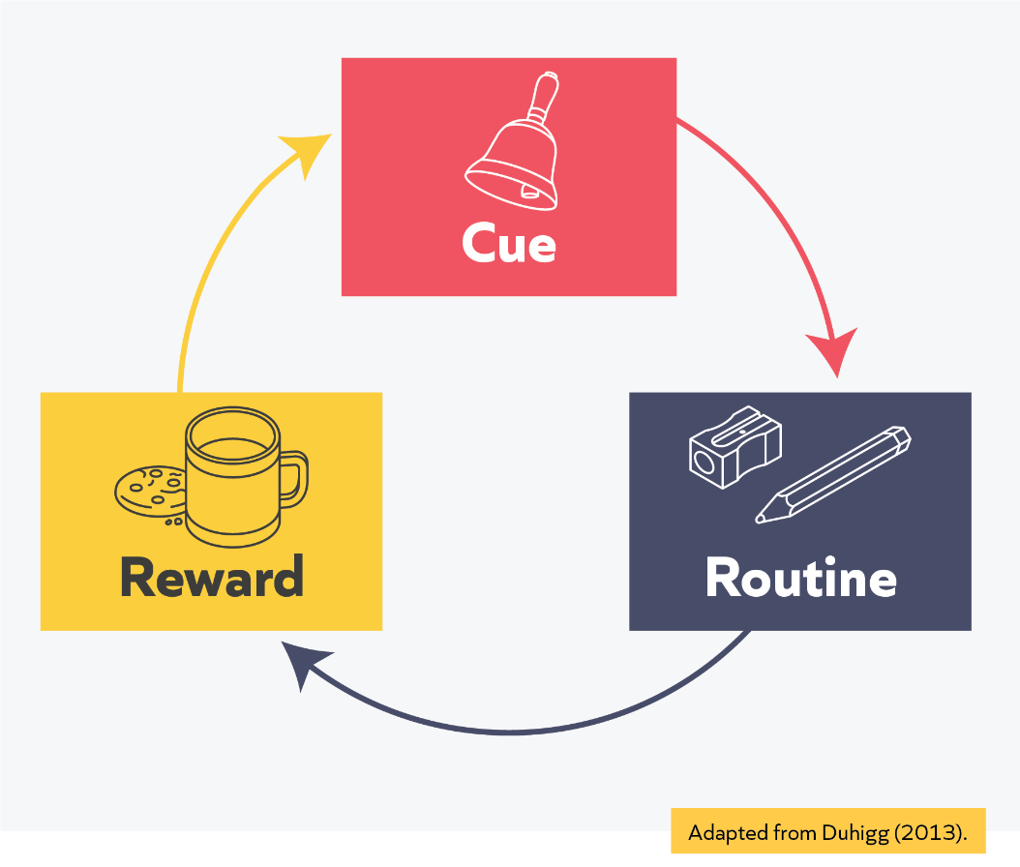

How can you actively create a new habit?
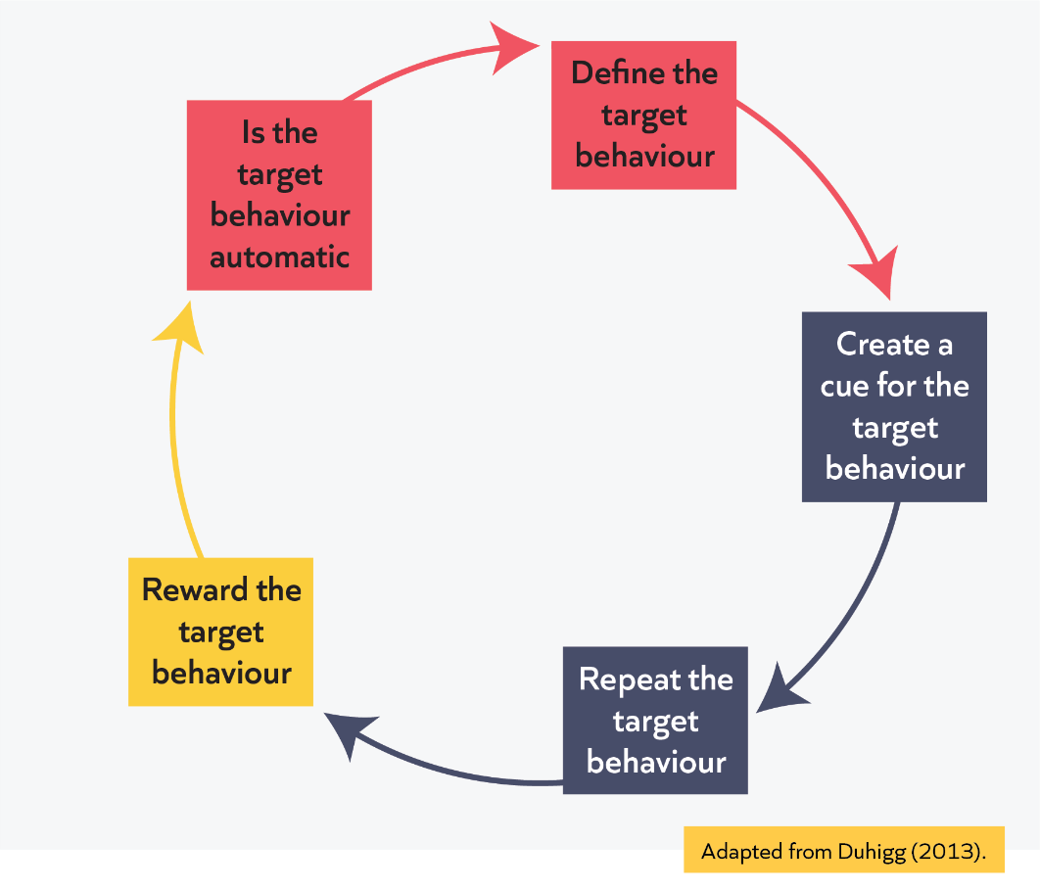
Example: Developing a new habit
What is the challenge? | Even though I have blocked out time every week, I’m still worried that I won’t be motivated or have the energy to complete my personal professional development.
What is your target behaviour? | I will complete my personal professional development every Tuesday after school.
What will be your cue for the target behaviour? | - I will block a chunk of time in my weekly planner every Tuesday.  - I will leave school early every Tuesday to complete my personal professional development.
How do you plan to repeat this target behaviour? | I will self-regulate - every Tuesday morning I will mentally organise my day and rearrange any priorities, so that I can make sure I leave early.
How will you reward your target behaviour? | - I will get home early from school and treat myself to cake and coffee whilst I am completing personal professional development.  - I will finish on time which will give me some time for a recovery activity.
How will you monitor whether the target behavior is automatic? | I will self-evaluate and self-regulate after the first half-term: How have I developed as an educator and improved my practice? How routine is my habit? Do I need to adapt the cue or reward?

Your plan to develop a new habit
What is the challenge?
What is your target behaviour?

What will be your cue for the target behaviour?

How do you plan to repeat this target behaviour?

How will you reward your target behaviour?

How will you monitor whether the target behavior is automatic?

Further support
- Colleagues and mentors.
- Shared resources, such as textbooks.
- Wellbeing teams in school.
- Friends and/or family.
- https://youngminds.org.uk/ A charity that provides information and advice to young people, parents and carers to support your peoples to look after their mental health.
- https://www.educationsupport.org.uk/ Charity dedicated to supporting the mental health and wellbeing of teachers and education staff.
- https://www.annafreud.org/schools-and-colleges/ Charity providing a wide range of tools and research around how to best support young people’s mental health and wellbeing
- https://schools.au.reachout.com/teacher-wellbeing An Australian website which provides tools and resources to support teacher wellbeing.
Notes:

Reflections and next steps
Reflection
Consider the following questions:​
- Thinking about the strategies explored for managing your workload, which do you think may be most helpful to you in the coming year? ​
- What might you need to stop doing to create the space, time, and effort for you to engage in professional development throughout this year on the programme, and beyond?

Notes:

Next steps:
Clinic 4: Working with others​
Clinic 5: Literacy

References
Bjork, R. A., Dunlosky, J., & Kornell, N. (2013). Self-regulated learning: Beliefs, techniques, and illusions. Annual review of psychology, 64, 417-444.
Deci, E. and Ryan, R. (2008). Self-determination theory: A macrotheory of human motivation, development, and health. Canadian Psychology, 49, 182–185
Department for Education. (2022). School Workload Reduction Toolkit.
Department for Education. (2023). Induction, training and support for Early Career Teachers (ECTs).
Dodge, R., Daly, A., Huyton, J. & Sanders, L. (2012). The challenge of defining wellbeing. International journal of wellbeing, 2(3).
Duhigg, C. (2013). The Power of Habit: Why we do what we do and how to change. Random House.
Education Endowment Foundation. (2021). Effective Professional Development: Guidance Report.
Fletcher Wood, H. (2013). Accepting failure: managing time better as a teacher.
Furst, E. (2022, February). Learning in the brain.
Gardner, B. (2015). A review and analysis of the use of ‘habit’in understanding, predicting and influencing health-related behaviour. Health psychology review, 9(3), 277-295.Goldacre, B. (2013). Building evidence into education.
Geurts, S. and Sonnentag, S. (2006) Recovery as an Explanatory Mechanism in the Relation between Acute Stress Reactions and Chronic Health Impairment. Scandinavian Journal of Work, Environment & Health, 32, 482-492.
Hattie, J. (2003, October). Teachers make a difference: What is the research evidence? Paper presented at the Building Teacher Quality: What does the research tell us ACER Research Conference, Melbourne, Australia.
Institute for Effective Education. (2019). Engaging with evidence. York: Institute for Effective Education.
Mccrea, P. (2018). Expert Teaching: What is it, and how might we develop it?
Mccrea, P. (2020). Motivated Teaching: Harnessing the science of motivation to boost attention and effort in the classroom. Create Space Independent Publishing.
National Foundation for Educational Research. (2020). Teacher autonomy: How does it relate to job satisfaction and retention?
Ofsted. (2019). Summary and recommendations: teacher well-being research report.
Papay, J., & Kraft, M. (2016). The Myth of the Performance Plateau. Educational Leadership, 73(8), 36-42.
Sharples, J., Albers, B., & Fraser, S. (2018). Putting evidence to work: a school's guide to implementation.
Sims, S., Fletcher-Wood, H., O'Mara-Eves, A., Cottingham, S., Stansfield, C., Van Herwegen, J., & Anders, J. (2021). What are the characteristics of teacher professional development that increase pupil achievement? A systematic review and meta-analysis.
What Works Centre for Wellbeing. (n.d.). What affects our wellbeing.

Worth, J., & Van den Brande, J. (2020). Teacher Autonomy: How Does It Relate to Job Satisfaction and Retention?. National Foundation for Educational Research.

My key takeaways from today:

Extra space for notes:

