

Early Career Training Programme
ECT Conference 1

Introduction
Welcome to Conference 1 on the Early Career Training Programme. This workbook will accompany the facilitated session and help you build on your learning from your orientation.

Session aims
To understand:
- The importance of, and features of, high-quality professional development
- The principles, structure and design of the Early Career Training Programme
- How the Early Career Training programme will support you to develop your expertise
- Ways you can manage your wellbeing and workload
- The underlying features that support high-quality planning

Sections
- Welcome and setting norms
- The Early Career Training Programme
- Enabling conditions: wellbeing and workload
- Experiencing a clinic: high-quality lesson planning
- Reflections and next steps
- References
- Appendices

Welcome and setting norms
The disadvantage gap
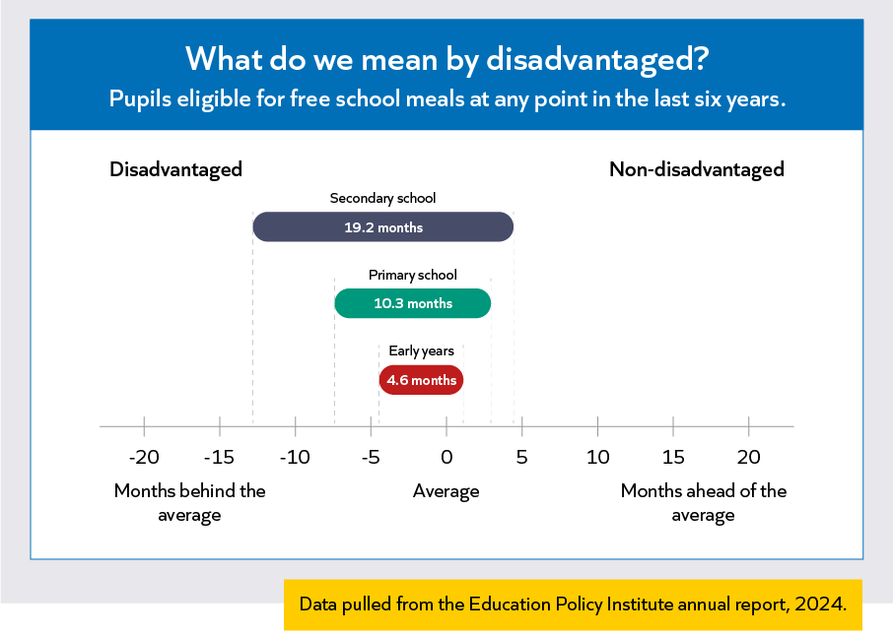
Notes:

“Teachers make a difference. No matter the phase or school setting, it is the quality of teaching that can make the biggest difference to children’s learning and to their ultimate success in school”
Education Endowment Foundation, 2021

Notes:

Reflect
Motivation is an important part of your career as a teacher. We need to consider what motivates us before motivating our pupils to learn.
- Where does your inspiration for being a teacher come from?
- What drives your motivation to teach?
Notes:

The Early Career Teacher Entitlement (ECTE)
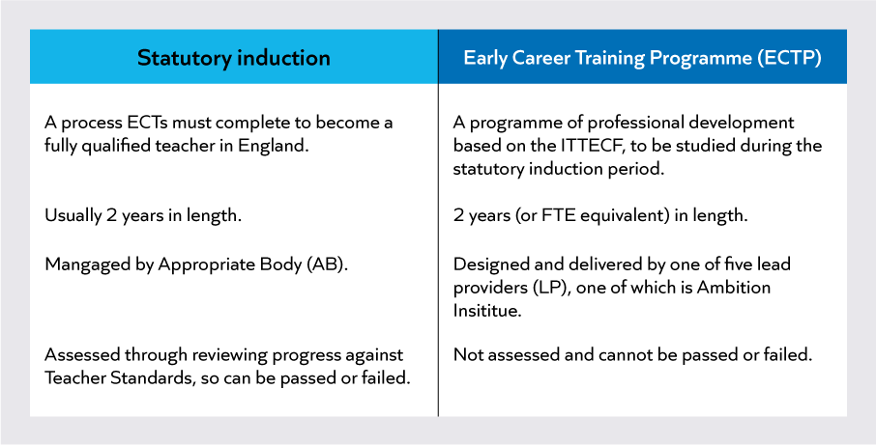
Entitlements
- Access to high quality professional development through a training programme
- A dedicated mentor and induction tutor to guide them through their training programme
- A 10% timetable reduction in year 1 and 5% off-timetable in year 2, providing you protected time for your professional development

Terminology
- ECTE = Early Career Teacher Entitlement, an entitlement to training and support
- Induction = two-year statutory induction process
- ECTP = Early Career Training Programme
- ITTECF = Initial Teacher Training and Early Career Framework
- Orientation is the online introduction (via Steplab) to Ambition’s ECTP

Notes:

Initial Teacher Training and Early Career Framework (ITTECF)
“The ITTECF sets out the entitlement of every trainee and early career teacher (ECT) to the core body of knowledge, skills and behaviours that define great teaching, and to the mentoring and support from expert colleagues they should receive throughout the three or more years at the start of their career.”
Initial Teacher Training and Early Career Framework, 2024

Notes:
A high-quality professional development offer
“Teachers make a difference. No matter the phase or school setting, it is the quality of teaching that can make the biggest difference to children’s learning and to their ultimate success in school… What’s more, the quality of teaching is not fixed: teachers can be improved, and they can be improved via effective professional development.”
Education Endowment Foundation, 2021

Notes:

Teacher expertise
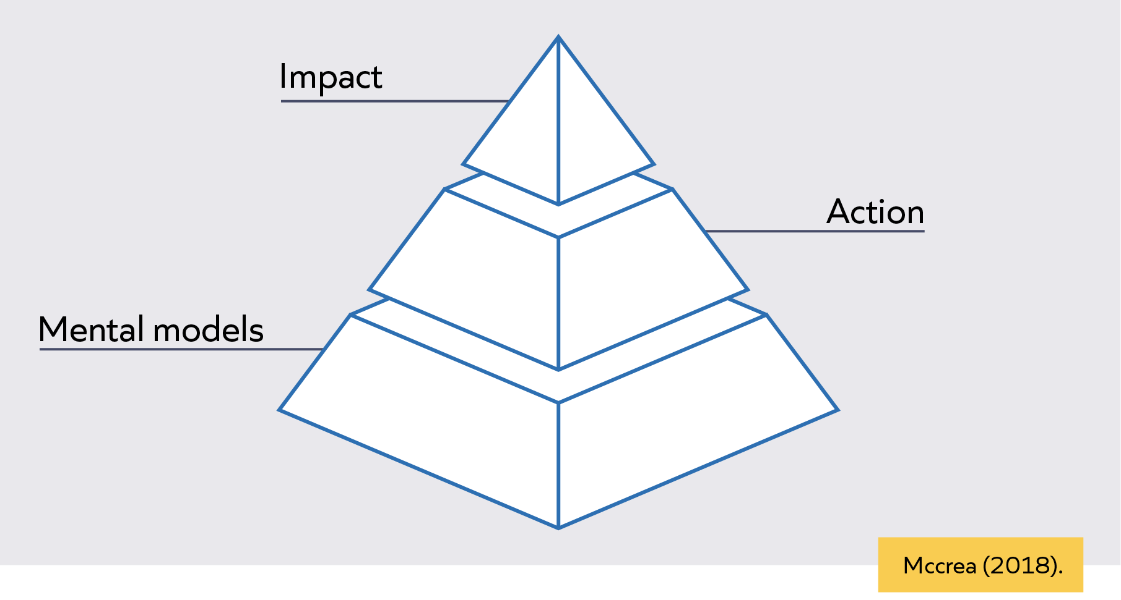
Notes:

Mental models
A mental model is the knowledge you have about a particular topic and the way it is organised to guide action.
Notes:
Expert mental models
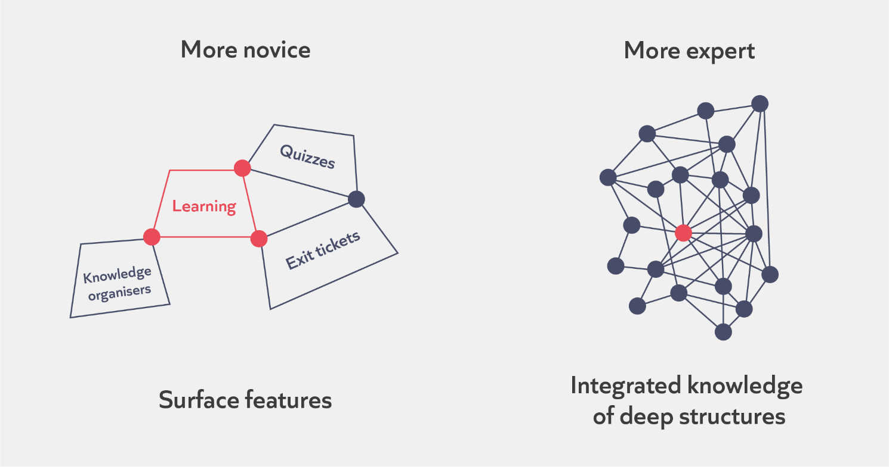
Notes:

Reflect and discuss
Reflect on a time where you have seen expert teaching.
- What was the teacher doing? What decisions did they make?
- Why do you think they made the decisions they did?
- What was the impact on pupils?
Notes:

How do we develop expertise?
Notes:

High-quality professional development
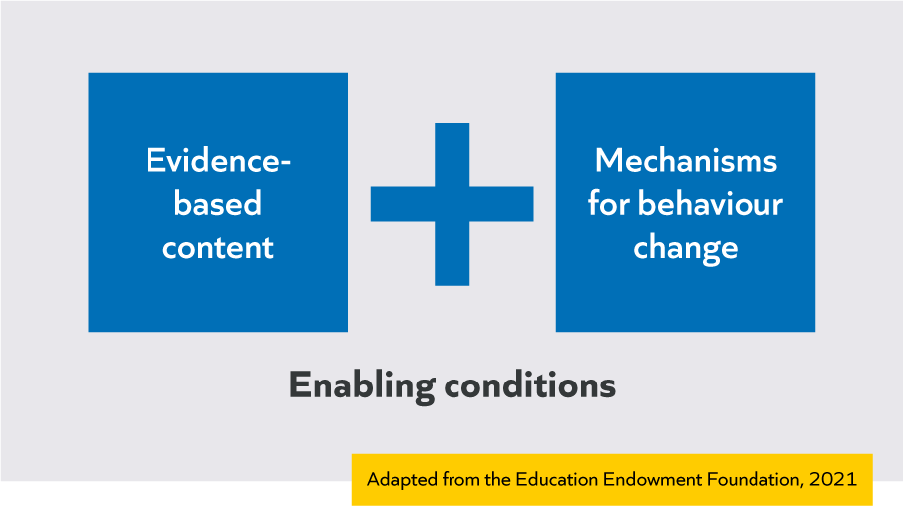
Notes:

Curriculum and sequencing
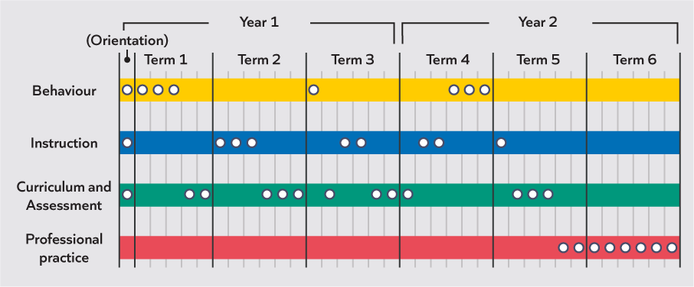
Notes:

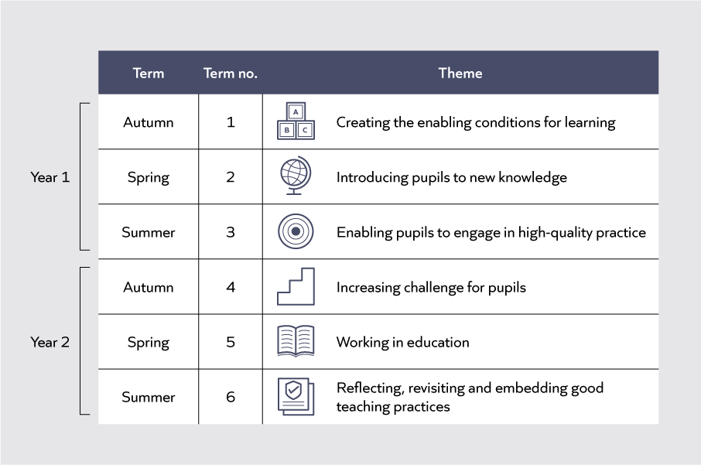
Notes:

Mechanisms for behaviour change
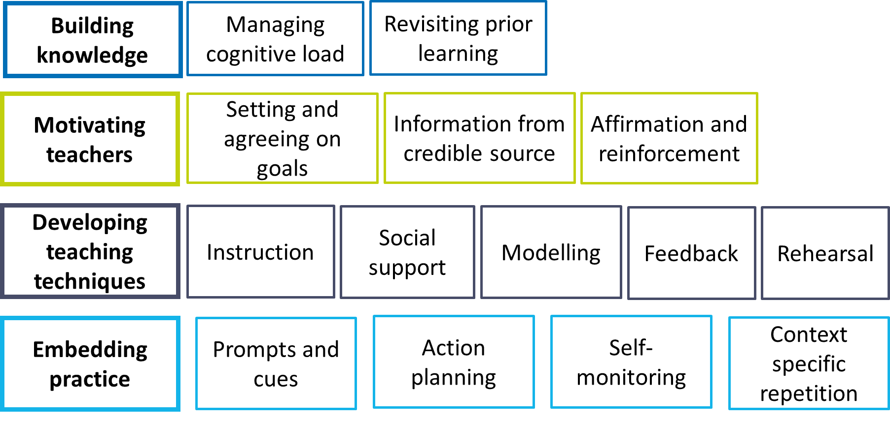 Education Endowment Foundation [EEF]. (2021). Effective Professional Development. Guidance Report.

Notes:

Mechanisms for behaviour change on the ECTP
Programme component | Mechanisms | Notes
Self-study | Building knowledge: Managing cognitive load, revisiting prior learning  Motivating teachers: Information from a credible source  Developing teaching techniques: Instruction, Modelling  Embedding practice: Self-monitoring
Mentor meetings | Building knowledge: Managing cognitive load, revisiting prior learning  Motivating teachers: Setting and agreeing on goals, Affirmation and reinforcement  Developing teaching techniques: Instruction, Social support, Modelling, Feedback, Rehearsal  Embedding practice: Prompts and cues, Action planning, Context-specific repetition.
Clinics and conferences | Building knowledge: Managing cognitive load, revisiting prior learning  Motivating teachers: Information from a credible source  Developing teaching techniques: Instruction, Social support, Modelling  Embedding practice: Action planning, Self-monitoring

Programme overview
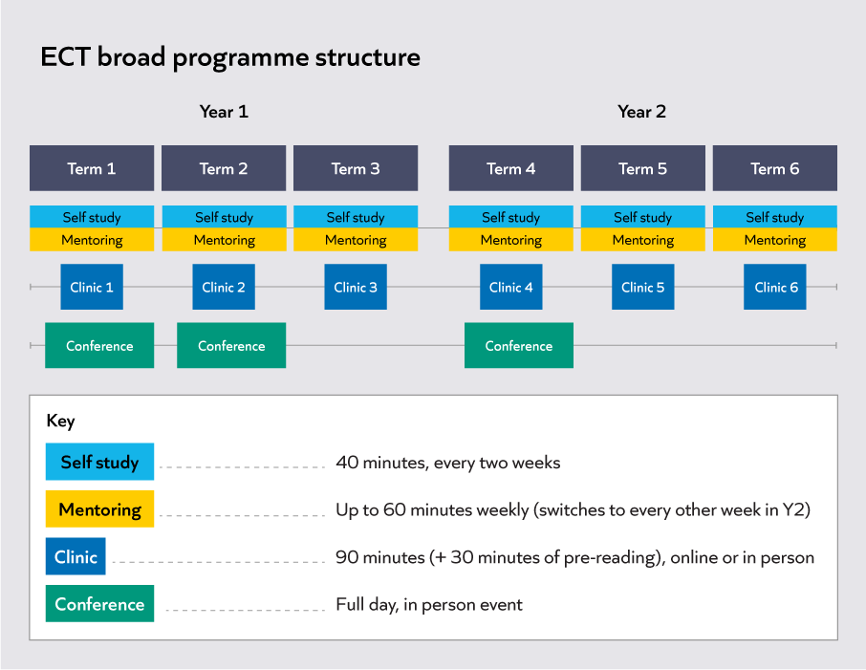
Reflect and discuss
- What do you want to get out of your ECTP?
- What are your strengths already?
- What are you most looking forward to?
- Any questions so far?

Notes:

A self-study module in practice
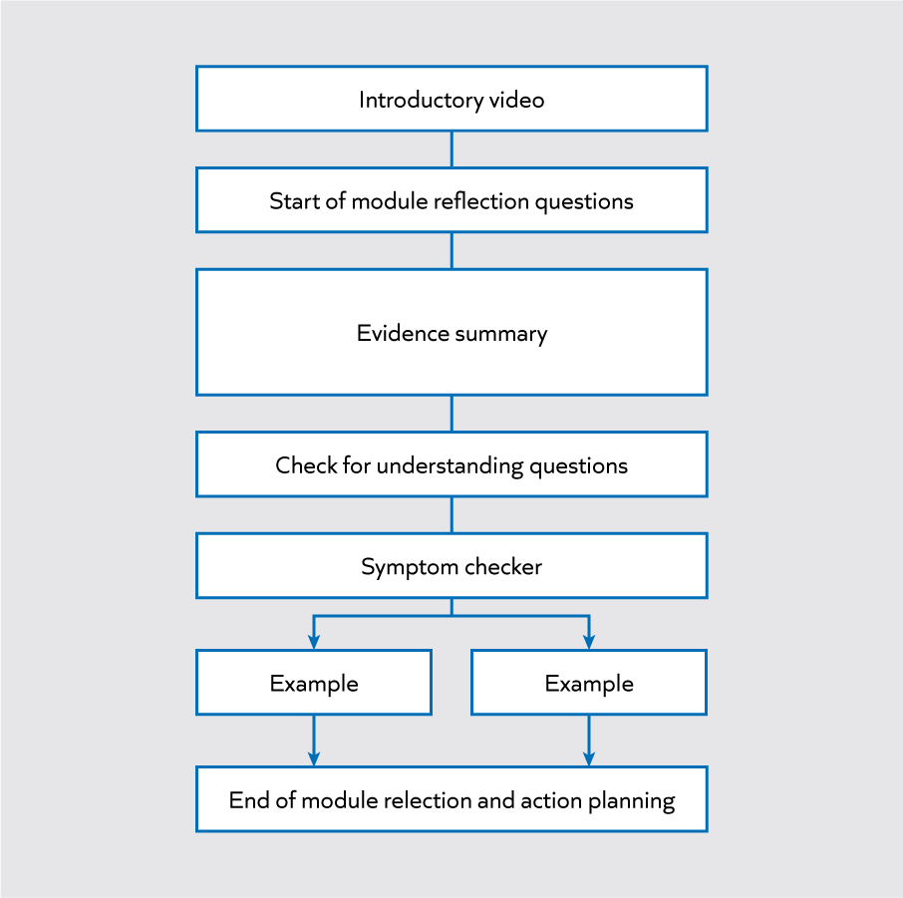

Component | Notes
Introductory video
Start of module reflection questions
Evidence summary
Check for understanding questions
Symptom checker
Examples
End of module reflection and action planning
Online systems training
Watch the videos introducing MyECT and Steplab. Consider:
- Do you have any questions or reflections on using these systems?
Notes:

Enabling conditions: wellbeing and workload
Wellbeing
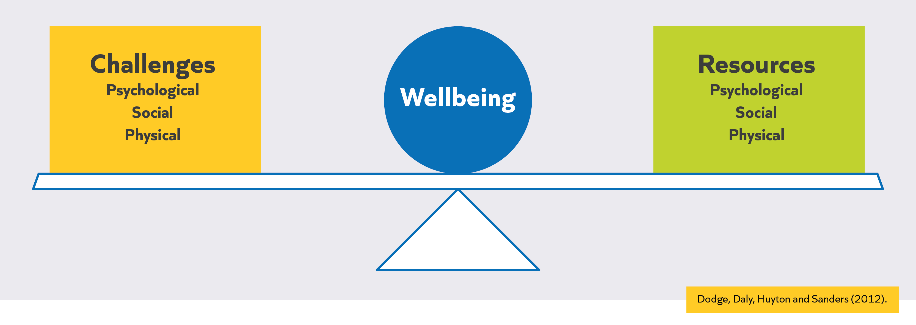
Notes:

Reflection
- Reflect on the factors which affect your wellbeing, both positive and negative.

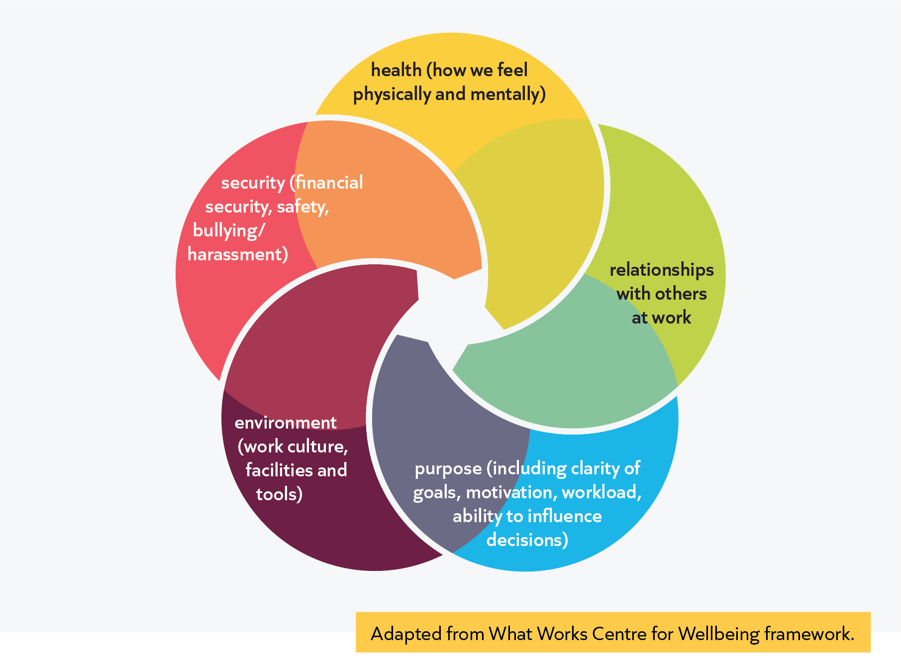

Why is this important?
Notes:
Reflection
- What systems and routines do you currently have in place to help manage your time and the tasks you need to do?
Prompts
- How do you manage marking and feedback?
- How do you manage planning?
- How do you manage preparing resources?
- How do you manage unexpected demands on time?
- How is spending time on professional development going to help with workload and wellbeing in the longer term?
Workload management strategies
Strategy 1: Prioritisation example
Urgent and important  - Conflict between two pupils  - Planning lesson for period 2  - Complete ECT self-study module  - Call parent  - Mark books | Non-urgent and important  - Get to know class better  - Plan next week’s lessons  - Steplab reading  - Conversations with colleagues  - Professional development
Urgent and unimportant  - Some emails and requests  - Printing | Non-urgent and unimportant  - Some emails  - Some admin tasks
Adapted from Fletcher-Wood (2013)

Prioritisation in practice
Urgent and important | Non-urgent and important
Urgent and unimportant | Non-urgent and unimportant

Strategy 2: Time-blocking
- Time-blocking is creating a finite amount of time for a specific task.
- Time-blocking can also be used for “movable” tasks such as exercise time or your weekly independent task for the programme.
- This strategy is especially useful for stopping activities ‘expanding to fit’ the time you have free.
Notes:

Reflection
- What regular blocks of time could you protect for personal professional development?
- What blocks of time could you use for one or more of the goals you identified in the previous activity?
- What blocks of time could you use for other urgent but less important tasks?

Strategy 3: protecting time for rest and recovery
Holidays
Micro-breaks
Evenings
Weekends
Work breaks
External recovery time (outside of work)
Internal recovery time (within work)

Geurts, S. A., & Sonnentag, S. (2006). Recovery as an explanatory mechanism in the relation between acute stress reactions and chronic health impairment. Scandinavian journal of work, environment & health, 482-492.

Reflection
- How do you use the different rest and recovery times?
- What do you most enjoy in those times? What feels most restorative?
- What barriers are there to you benefitting from these chunks of time?
- Thinking about your school timetable, what blocks of time could you protect for rest and recovery throughout the day or week?

Strategy 4 and 5: Planning, preparation, marking and feedback
Notes:

Reflection
- What planning and preparation resources are available within your school or trust?
- Where might you collaborate with colleagues to support with planning or finding shared resources that can help you save time in the longer term?
- What types of feedback do you tend to use?

Habits
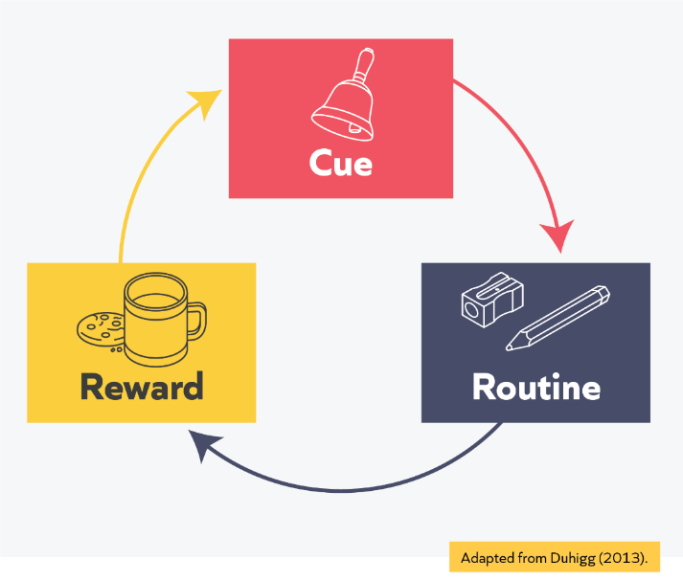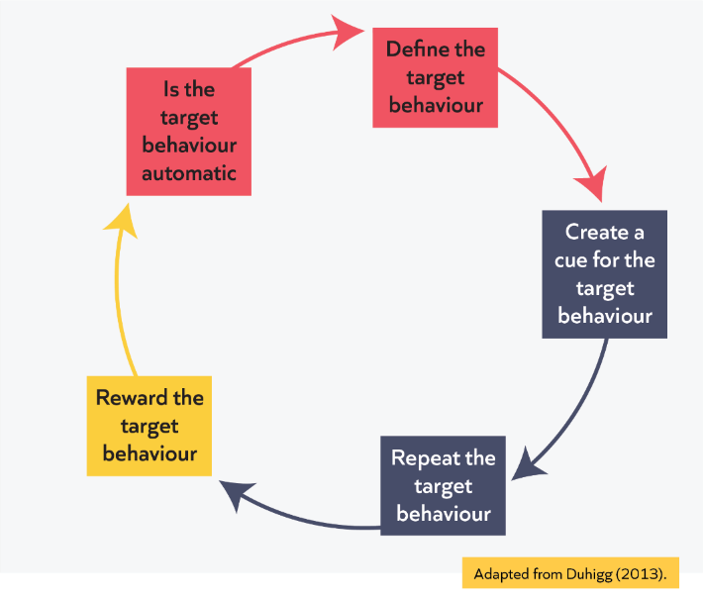
Notes:

Planning to develop a new habit
What is your target behaviour? | I will complete my personal professional development every Tuesday after school.
What will be your cue for the target behaviour? | I will block a chunk of time in my weekly planner every Tuesday.  I will leave school early every Tuesday to complete my personal professional development.
How does you plan to repeat this target behaviour? | I will self-regulate - every Tuesday morning I will mentally organise my day and rearrange any priorities, so that I can make sure I leave early.
How will you reward your target behaviour? | I will get home early from school and have a cup of tea whilst I am completing personal professional development.  I will finish on time which will give me some time for a recovery activity.
How will you monitor whether the target behavior is automatic? | I will self-evaluate and self-regulate after the first half-term: Have I managed to use this time on a Tuesday consistently for my personal professional development? How routine is my habit? Do I need to adapt the cue or reward?

Reflection and practice
Use the following prompts to consider how you might embed a habit in your classroom practice, or for completing an important task:
What is your target behaviour?

What will be your cue for the target behaviour?

How does you plan to repeat this target behaviour?

How will you reward your target behaviour?

How will you monitor whether the target behavior is automatic?

Experiencing a clinic: high-quality lesson planning
Purpose of a clinic
Clinics will:
- Build on content covered in self-study modules
- Cover statements set out in the ECF
- Provide the opportunity to look at content which isn’t as ‘coachable’
- Provide the opportunity to discuss with peers and develop networks
- Use a range of fictional but realistic scenarios to explore how the same 4-5 module principles might be used in all contexts to overcome a typical teaching problem

Structure of a clinic
Clinics will last 1.5 hours and will follow the structure below:
- Introduce typical teacher problem
- Briefly review relevant research/evidence
- Introduce module principles
- I do scenario
- We do scenarios
- Non-example scenario
- Reflections and close

Typical teaching problem
How can teachers plan lessons that support pupils to understand key content, apply knowledge and make progress over time?

Reflection
Reflect on your experiences of planning so far:
- What was your experience of planning during your ITT year?
- Think back to a lesson or sequence of lessons you planned that you feel went well. What do you think made them successful?
- What did you find challenging when planning individual lessons and lesson sequences?

Notes:

Challenges when planning
“The curse of knowledge: when we are given knowledge, it is impossible to imagine what it’s like to lack that knowledge.”
Heath & Heath (2007)

Read the extract below from Mccrea's book ‘Lean Lesson Planning: a practical approach to doing less and achieving more in the classroom’ (2016)
What are the key messages?

Backwards design
I have worked with many teachers who have become frustrated by the planning habits they’re developed over time. In some cases, this is because they have fallen unawares into one or both of the following classic traps.
- Activity-focused planning starts by trying to find a good activity, and then reverse engineering the lesson intentions to match the likely outcomes of the activity. Over time, this approach can end up becoming an exercise in keeping students busy.
- Coverage-focused planning begins with a set of lesson intentions that have been crafted by someone else (e.g. a colleague or a textbook), rather than taking the time to construct aims around your student needs. Over time, teaching can become an exercise in getting through the curriculum.
It is possible to experience some short-term gains with both of these approaches. They offer easy and compelling solutions to the problem of planning. However, they are economically flawed, and over time, are likely to stifle professional creativity and generate poor levels of return on student learning.
Starting with the end in mind
In his recent meta-analysis, John Hattie argues that one the best ways to optimise learning is to use backwards design. In the context of lean lesson planning this means two things.
- Start your planning with the question: what do I want my students to have learned by the end of the lesson?
- Spending more time on this activity than you think you should.
Doug Lemov observed that effective teachers spend more time identifying outcomes and less time selecting activities than their colleagues. The clearer you are about where you want to go, the better chance you have of getting there. This logic may seem obvious, but in practice, it is frequently prone to abuse.
Backwards design is about striving for excessive clarity about what you want your students to be able to do as they progress through the lesson. This involves mapping out, breaking down and thinking hard about how the various parts of the learning trajectory hang together.

Extract from Mccrea, P. (2016). Lean Lesson Planning: a practical approach to doing less and achieving more in the classroom.

Notes:

Module principles of effective planning

Identify knowledge | Teachers need to consider what they want pupils to know and be able to do by the end of a lesson or sequence of lessons. Teachers can do this by identifying the critical knowledge needed to reach the end goal, and breaking this knowledge down into small steps.
Sequence knowledge | Sequencing knowledge well supports pupils to learn more effectively as teachers can develop their mental models deliberately. Teachers should link new content to pupils’ prior knowledge and sequence broken down knowledge so that it builds logically.
Check pupil understanding | Pupils need to have correctly understood new knowledge before they practise using it and build on it further. Teachers should consider potential misconceptions and gaps in learning and plan when and how to check pupils’ understanding.
Secure knowledge | It is important pupils remember key knowledge in the long-term. Teachers should ensure lesson activities support pupils to think hard about the critical knowledge pupils need to learn and build in opportunities for practice and retrieval.
Support transfer of knowledge | Teachers can develop pupils’ mental models so that they are able to use and apply knowledge increasingly flexibly. To do so, teachers should give pupils opportunities to apply their knowledge across varied contexts.

Scenario 1
I do
Ms Riaz is a secondary English teacher. This half term, she is teaching Romeo and Juliet to year 9. She has already familiarised herself with the department’s mid-term plan for the unit. Pupils will focus on the theme of relationships in the play. At the end of the unit, they will write an analytical essay.
Ms Riaz is currently planning the fourth lesson of the unit. In lesson three, pupils read, discussed and annotated Act 1 Scene 3. In lesson four, she would like pupils to write an analytical paragraph, building the knowledge and skills they will need for their final assessment.
Ms Riaz starts by considering what pupils need to know to write a successful paragraph. She knows that pupils will have written analytically in years 7 and 8 and, having consulted a colleague, has learned that most pupils should be familiar with the ‘what, how, why’ paragraph structure. However, it is some time since this knowledge has been applied in practice, so it will first need to be reviewed and activated.
Ms Riaz plans a retrieval activity for the start of the lesson. She will frame her question by reminding pupils of the last time they completed a piece of analytical writing. She will ask pupils what they think an analytical paragraph needs to include, then give them two minutes to jot down their ideas, before coming together to share these as a class.
By prompting pupils to think of a previous unit, Ms Riaz connects past and current learning. By asking an open-ended question, Ms Riaz hopes to gain a better insight as to where her pupils have gaps in knowledge, or misconceptions, about what they have learned on paragraph writing so far. She will therefore be able to address these gaps and misconceptions both during the discussion and as she models the writing task later in the lesson.
From discussion with her mentor, Ms Riaz has learned that there are a few common misconceptions that arise in relation to analytical writing. For instance, key stage 3 pupils often confuse the register of analytical and creative writing, thinking that analytical writing must also include a range of linguistic devices. Ms Riaz therefore plans a few follow-up questions designed to address specific misconceptions, if these do not arise naturally.
Next, Ms Riaz plans for pupils to deconstruct a model paragraph. She writes a pre-prepared model, to ensure that she includes a range of features of effective analytical writing. She will ask pupils to identify the components discussed during the retrieval activity, as well as any additional features. This will encourage pupils to think hard about how generalised components identified earlier in the lesson might look in the context of this specific play. Ms Riaz will also use this time to further address any misconceptions pupils have, for instance highlighting the simple but formal register of the writing.
Ms Riaz then plans to write a live model with the help of the class, prompting pupils to share ideas for the content of the response as she writes under the visualiser. She will use a combination of cold call and interrogative questioning to gather input from the class. This will help her to both assess what pupils have understood and to stretch their thinking.
After this, Ms Riaz plan for pupils to write their own paragraph independently. As it has been some time since they have written in this style, she plans some sentence starters for pupils to use should they need support. Pupils will also use the quotations that they selected, discussed and annotated in the previous lesson, to ensure that their focus remains on constructing the paragraph.

Module principle | Where can you see this module principle in the scenario? | What impact does the module principle have on pupils' understanding of key content and application of knowledge?
Identify knowledge
Sequence knowledge
Check pupil understanding
Secure knowledge
Support transfer of knowledge

Scenario 2
We do
Mr Oliver has just started a unit on the topic of time with his year 2 class. Before teaching the first lesson, Mr Oliver met with the key stage 1 maths lead, to discuss what pupils will likely have covered on this topic in year 1 and to talk through the mid-term plan for the upcoming unit. From this, he learned that most pupils should know that an hour is made up of 60 minutes and should be able to tell and write the time to an hour and half an hour. This half term, they will therefore be focusing on telling and writing the time to five minutes. By the end of the unit, pupils should be confident comparing and sequencing intervals of time.
Having retrieved and consolidated last year’s learning in the first lesson of the unit, Mr Oliver is now planning lesson two. By the end of the lesson, he would like pupils to know that each number of the clock face represents an increment of 5 minutes, up to a total of 60, and be able to apply this knowledge by independently telling the time on multiple clock faces. Mr Oliver anticipates that some pupils may not be familiar with analogue clocks, so will build an explanation of different types of clocks into his initial exposition, to ensure the gap is addressed.
Mr Oliver knows that to access the new content, pupils will need to know their 5x tables. Whilst most of the class can recite their tables confidently, Mr Oliver is not sure that they will be able to immediately apply their knowledge to this new context without prompting. He therefore starts by planning a 5x tables retrieval activity for the beginning of the lesson.
Mr Oliver then plans to model telling the time to five minutes with pupils sitting on the carpet. He will explain that each segment represents five minutes of time and use call and response for pupils to practise saying the time as the minute hand moves to each five-minute increment. From his discussion with the key stage 1 maths lead, Mr Oliver knows that one likely misconception for pupils will be confusing the numbers marking each hour (1, 2, 3...) with the number of minutes (5, 10, 15...). For this lesson, he therefore plans to keep the hour hand at 12, so that pupils can focus on the movement of the minute hand.
After this initial exposition, Mr Oliver will ask pupils to identify the time on the clock face independently, as he moves the minute hand to different places. Pupils will have 20 seconds to think about their responses before writing them on their mini whiteboards. By surveying the mini whiteboards, Mr Oliver will be able to assess which pupils seem to be feeling more and less confident and address any misconceptions they have.
For the final section of the lesson, Mr Oliver creates a worksheet for pupils to work through independently. The worksheet includes several clock faces, each displaying a different time for pupils to identify. Knowing that some pupils will quickly feel confident with this, there are also some blank clock faces for pupils to fill in according to the time stated above each one. This stretch task will encourage pupils to deepen their understanding of this new content if they are ready, by encouraging them to apply their knowledge flexibly.

Scenario 3
We do
Mrs Danquah teaches at a specialist school for pupils aged 14 to 19 with moderate learning difficulties. This year, she has been working with a pupil in her class, Daniel, on one of his preparing-for-adulthood targets: ‘to be able to cross the road independently’.
Over the course of the year, Daniel has built his knowledge of where and when to cross the road and, last week, Mrs Danquah covered the etiquette for waiting to cross when another pedestrian is present. In their upcoming lesson, Mrs Danquah will focus on what to do if the fellow pedestrian crosses the road without following the guidelines for safe crossing that Daniel has learned so far. It is likely that they will spend at least two lessons on this, or as long as it takes for Daniel to demonstrate a secure understanding consistently.
Mrs Danquah plans to start the lesson by explaining to Daniel that they will be covering how to respond when he sees a fellow pedestrian crossing the road. Having consulted with colleagues, Mrs Danquah knows that a likely misconception for Daniel will be to assume that it is safe for him to cross, just because he can see another pedestrian doing so. She will therefore explain the potential danger of doing this during this first exposition, then further check Daniel’s understanding of this misconception later in the lesson.
Earlier in the unit, Mrs Danquah prepared a tick list of actions for Daniel to complete before stepping from the pavement onto the crossing. The laminated tick list uses words and images to identify steps such as waiting at the crossing without becoming distracted, looking left and right, using body language to indicate his intention to cross and waiting for cars to stop. After she has introduced the focus of the lesson, she will review the tick-list with Daniel and explain that they will be using this at the road to identify why following another pedestrian might be dangerous.
Mrs Danquah will then take Daniel to the same road and crossing point they have used throughout the lesson sequence. She will start by prompting Daniel to retrieve his learning from last week. Daniel will enact a real-life scenario, in which he approaches a second pedestrian, played by Mrs Danquah’s teaching assistant (TA), at the crossing. This will give Mrs Danquah the chance to check that Daniel has understood and remembered the guidelines set out for this situation, such as ensuring that he stands an appropriate distance from the other pedestrian, before moving on to the new content.
Once this content has been securely retrieved, Daniel will move to the next step: assessing whether his fellow pedestrian is following safety guidelines before crossing the road. Each time he approaches the crossing, Daniel is to watch the TA’s actions and use his tick-list to assess whether she has completed all preparatory actions before moving. In role, the TA will model dangerous behaviours, such as playing with her phone, or not looking both ways, to see whether Daniel can identify the steps she is missing and explain why these might be problematic. Mrs Danquah will ask Daniel to approach the TA 3-4 times so that she can model a different non-example of good road crossing practice each time. Through this activity, Mrs Danquah plans for Daniel to secure his understanding of safe road crossing behaviours, so that he understands thoroughly why he is not to blindly follow the lead of another pedestrian. This will also give Mrs Danquah the opportunity to address any misconceptions Daniel has about ‘safe’ behaviours.
For the final activity, Mrs Danquah plans for Daniel to practise how he should act when another pedestrian starts to cross. This will involve ignoring the behaviour of the other pedestrian and carrying out the actions on the tick list as he would if he were alone.

Reflections
- Where can you see the module principles in the scenarios?
- What impact do the module principles have on pupils' understanding of key content and application of knowledge?
Module principle | Scenario 2 | Scenario 3
Identify knowledge
Sequence knowledge
Check pupil understanding
Secure knowledge
Support transfer of knowledge

Reflection and next steps
Next steps and key takeaways
Notes:

References
Ball, D., Thames, M. H., & Phelps, G. (2008). Content knowledge for teaching: What makes it special? Journal of Teacher Education, 59(5), 389-407.
Bandura, A. (1982). Self-efficacy mechanism in human agency. American Psychologist, 37(2), 122.
Barker, J., & Rees, T. (2023). The persistent problems of school leadership. Ambition Institute. Available from: https://www.ambition.org.uk/blog/persistent-problems-school-leadership/
Bereiter, C., & Scardamalia, M. (1993). Surpassing ourselves: An inquiry into the nature and implications of expertise. Open Court.
Cambridge Assessment. (2017). A Cambridge approach to improving education: Using international insights to manage complexity. Available from: https://www.cambridgeassessment.org.uk/Images/cambridge-approach-to-improving-education.pdf
Cordingley, P., Higgins, S., Greany, T., Buckler, N., Coles-Jordan, D., Crisp, B., Saunders, L., & Coe, R. (2015). Developing great teaching: Lessons from the international reviews into effective professional development. Available from: https://tdtrust.org/wp-content/uploads/2015/10/DGT-Full-report.pdf
Covey, S. R. (2020). The 7 habits of highly effective people. Simon & Schuster.
Department for Education. (2024). Initial teacher training and Early Career Framework. Available from:https://assets.publishing.service.gov.uk/media/661d24ac08c3be25cfbd3e61/Initial_Teacher_Training_and_Early_Career_Framework.pdf
Department for Education (2023, June 15) Reducing school workload. https://www.gov.uk/government/collections/reducing-school-workload
Duhigg, C. (2013). The Power of Habit: Why we do what we do and how to change. Random House.
Dodge, R., Daly, A. P., Huyton, J., & Sanders, L. (2012). The challenges of defining wellbeing. International journal of wellbeing, 2(3), 222-235.
Education Policy Institute. (2024). Annual report 2024: Disadvantage. Available from: https://epi.org.uk/annual-report-2024-disadvantage-2/
Education Endowment Foundation (2016). A marked improvement? A review of the evidence on written marking. https://educationendowmentfoundation.org.uk/public/files/Presentations/Publications/EEF_Marking_Review_April_2016.pdf.
Education Endowment Foundation [EEF]. (2021). Effective Professional Development. Guidance Report. Available from: https://d2tic4wvo1iusb.cloudfront.net/production/eef-guidance-reports/effective-professional-development/EEF-Effective-Professional-Development-Guidance-Report.pdf?v=1749027814
Ericsson, A., & Pool, R. (2016). Peak: Secrets from the new science of expertise. Random House.
Feldon, D. F. (2007). Cognitive load and classroom teaching: The double-edged sword of automaticity. Educational Psychologist, 42(3), 123-137.
Fletcher-Wood, H. (2013, December 1). Accepting failure: Managing time better as a teacher. Improving Teaching. Available from: https://improvingteaching.co.uk/2013/12/01/accepting-failure-managing-time-better-as-a-teacher/
Gardner, B. (2015). A review and analysis of the use of ‘habit’ in understanding, predicting and influencing health-related behaviour. Health psychology review, 9(3), 277-295.
Geurts, S. A., & Sonnentag, S. (2006). Recovery as an explanatory mechanism in the relation between acute stress reactions and chronic health impairment. Scandinavian journal of work, environment & health, 482-492.
Heath, C., & Heath, D. (2007). Made to stick: Why some ideas survive and others die. Random House.
Hobbiss, M., Sims, S., & Allen, R. (2021). Habit formation limits growth in teacher effectiveness: A review of converging evidence from neuroscience and social science. Review of Education, 9(1), 3-23.
Jerrim, J., Sims, S., & Allen, R. (2021). The mental health and wellbeing of teachers in England. Quantitative Social Science-UCL Social Research Institute, University College London: London, UK.
Kennedy, M. (2016). Parsing the practice of teaching. Journal of Teacher Education, 67(1), 6-17. Available from: https://journals.sagepub.com/doi/abs/10.1177/0022487115614617
Kraft, M. A., & Papay, J. P. (2014). Can professional environments in schools promote teacher development? Explaining heterogeneity in returns to teaching experience. Educational Evaluation and Policy Analysis, 36(4), 476-500. Available from: https://pmc.ncbi.nlm.nih.gov/articles/PMC4392767/pdf/nihms634223.pdf
Lazowski, R. A., & Hulleman, C. S. (2015). Motivation interventions in education: A meta-analytic review. Review of Educational Research, 86(2), 602–640. Available from: https://www.researchgate.net/publication/285544567_Motivation_Interventions_in_Education_A_Meta-Analytic_Review
Martin, K., Classick, R., Sharp, C., & Faulkner-Ellis, H. (2023, October). Supporting the recruitment and retention of teachers in schools with high proportions of disadvantaged pupils: Understanding current practice around managing teacher workload (Practice review). Education Endowment Foundation. Available from: https://d2tic4wvo1iusb.cloudfront.net/production/documents/projects/Review-of-teacher-workload-management-approaches.pdf?v=1744039908
Mccrea, P. (2015). Lean lesson planning: a practical approach to doing less and achieving more in the classroom. John Catt Educational.
Mccrea, P. (2018). Expert teaching: what is it and how might we develop it? Institute for Teaching. Available from: https://www.ambition.org.uk/documents/1219/What_is_Expert_Teaching_-_Peps_Mccrea_1.pdf
Ofsted. (2019). Teacher well-being at work in schools and further education providers. Available from: https://assets.publishing.service.gov.uk/media/5fb41122e90e07208d0d5df1/Teacher_well-being_report_110719F.pdf
Rathmann, K., Herke, M. G., Hurrelmann, K., & Richter, M. (2018). Perceived class climate and school-aged children's life satisfaction: The role of the learning environment in classrooms. PLOS ONE, 13(2). Available from: https://www.researchgate.net/publication/323061878_Perceived_class_climate_and_school-aged_children's_life_satisfaction_The_role_of_the_learning_environment_in_classrooms
Shulman, L. S. (1986). Those who understand: Knowledge growth in teaching. Educational Researcher, 15(2), 4-14.
Slater, H., Davies, N. M., & Burgess, S. M. (2012). Do teachers matter? Measuring the variation in teacher effectiveness in England. Oxford Bulletin of Economics and Statistics, 74(5), 629–645. Available from: https://www.researchgate.net/publication/242721723_Do_Teachers_Matter_Measuring_the_Variation_in_Teacher_Effectiveness_in_England
Valdebenito, S., Eisner, M., Farrington, D. P., Ttofi, M. M., & Sutherland, A. (2018). School-based interventions for reducing disciplinary school exclusion: a systematic review. Campbell Systematic Review, 2018:1. Available from: https://files.eric.ed.gov/fulltext/ED586236.pdf
What works wellbeing. (n.d.). What affects our wellbeing? Available from: https://whatworkswellbeing.org/about-wellbeing/what-affects-wellbeing/

Appendices
A full overview of the Early Career Training Programme structure, including a termly structure for year 1 and year 2 ECTs is provided in this section. 

