

Early Career Training Programme
Mentor Conference 2

Introduction
Welcome to Conference 2 of the Early Career Teachers mentor training programme. This workbook will accompany the facilitated session.

Session aims
To understand:
- Your role on the ECTP
- How teachers build more expert mental models
- How to adapt instructional coaching as early career teachers develop expertise

Today’s session
Section 1: Programme overview 3
Section 2: Developing teacher expertise 4
Section 3: Adapting the coaching model 15
Section 4: Adapting the coaching model – in practice 24
Section 5: Implementation 34
Bibliography 36
Space for additional notes 40

Section 1: Programme overview

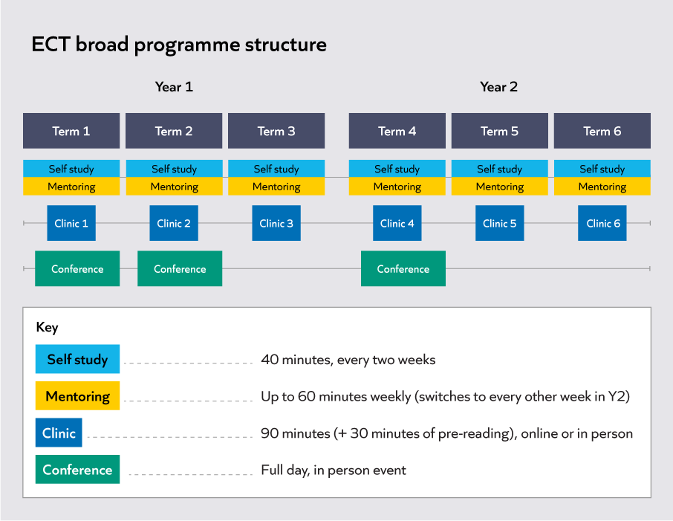
Notes

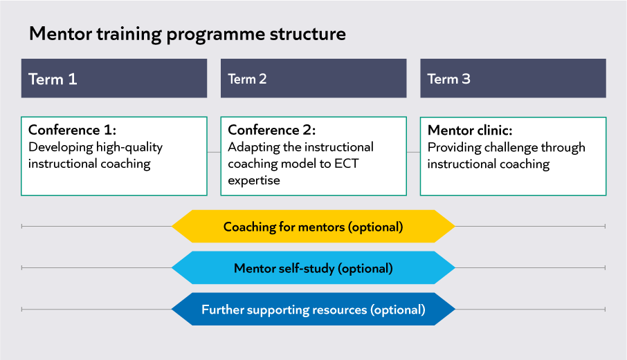

Notes

Consider your questions or reflections on:
- Your role and responsibilities as a mentor: is there anything you want to clarify?
- The package of training and support available: what do you find most useful?

Notes

Section 2: Developing teacher expertise

Reflection
Think about what you can recall about the concepts of teacher expertise and expertise development from earlier mentor training and wider experiences.
Notes

Building expertise over time

Scenario 1 | Scenario 2
Anthony has just begun his second term on the ECTP. Last term, he thought carefully about how to identify and sequence knowledge for the lessons he was teaching.  His mentor, Azalia, notices in an observation at the start of the term that Anthony’s lessons, now on new topics, seem less precisely broken down and structured. She is surprised by this – this was a step for improvement last term and Anthony significantly developed his practice. | Sienna has just moved into her second year on the ECTP. She is a secondary science teacher. She has new classes, but is teaching the same topics as last year.  Her mentor, Chaim, notices that Sienna is using formative assessment tasks in and between lessons, but is not meaningfully using the data collected to move pupils on.  Chaim considered this an area of strength for Sienna last year, particularly with a class that she had taught in her ITT year.

Notes

Expert teacher knowledge
As teachers move from novice to expert, they develop increasingly powerful mental models in the following broad domains:
Path – Knowledge of the pathway towards mastery of a curriculum, including: the concepts and process that pupils need to know at different stages of their journeys; how these are best represented and sequenced (Hattie, 2003; Westerman, 1991); as well as common obstacles to progress (Sadler, 2016).
Pupil – Knowledge of what their pupils know and don't know, what motivates and concerns them, and how these things change over time (Berliner, 2004, Schempp, 2002). The development of pupil knowledge is produced (and limited) by teacher assessment knowledge (Christodoulou, 2017; Wiliam, 2016).
Pedagogy – Knowledge of how learning works and how to catalyse it. This area draws on fields such as cognitive and behavioural science (Deans for Impact, 2015) as well as personal experience, to help teachers build a mental model of the learner (Willingham, 2017b). It encompasses cognitive, emotional, social and cultural dimensions of learning.
Self-Regulation – Knowledge of how to analyse, evaluate and iterate their own knowledge and action towards increasing impact (Ericsson, 2015; Hattie, 2012). This includes an awareness of their own cognitive biases and how to mitigate them.
Reduce the power of any of these domains and teacher impact declines accordingly.
(Mccrea, 2018)

What is teacher expertise?
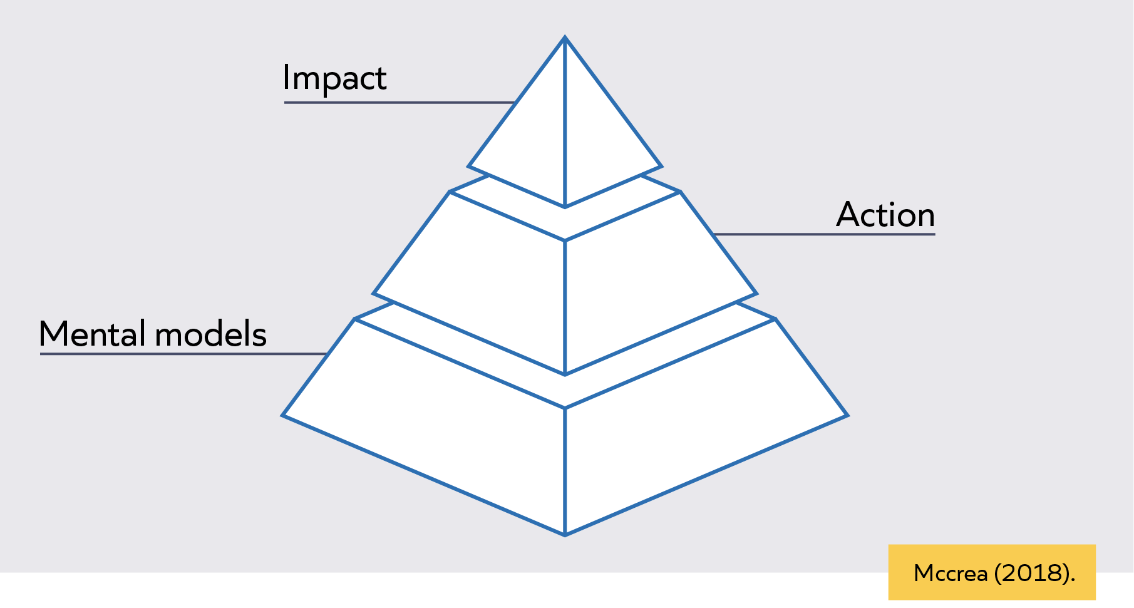

Building mental models
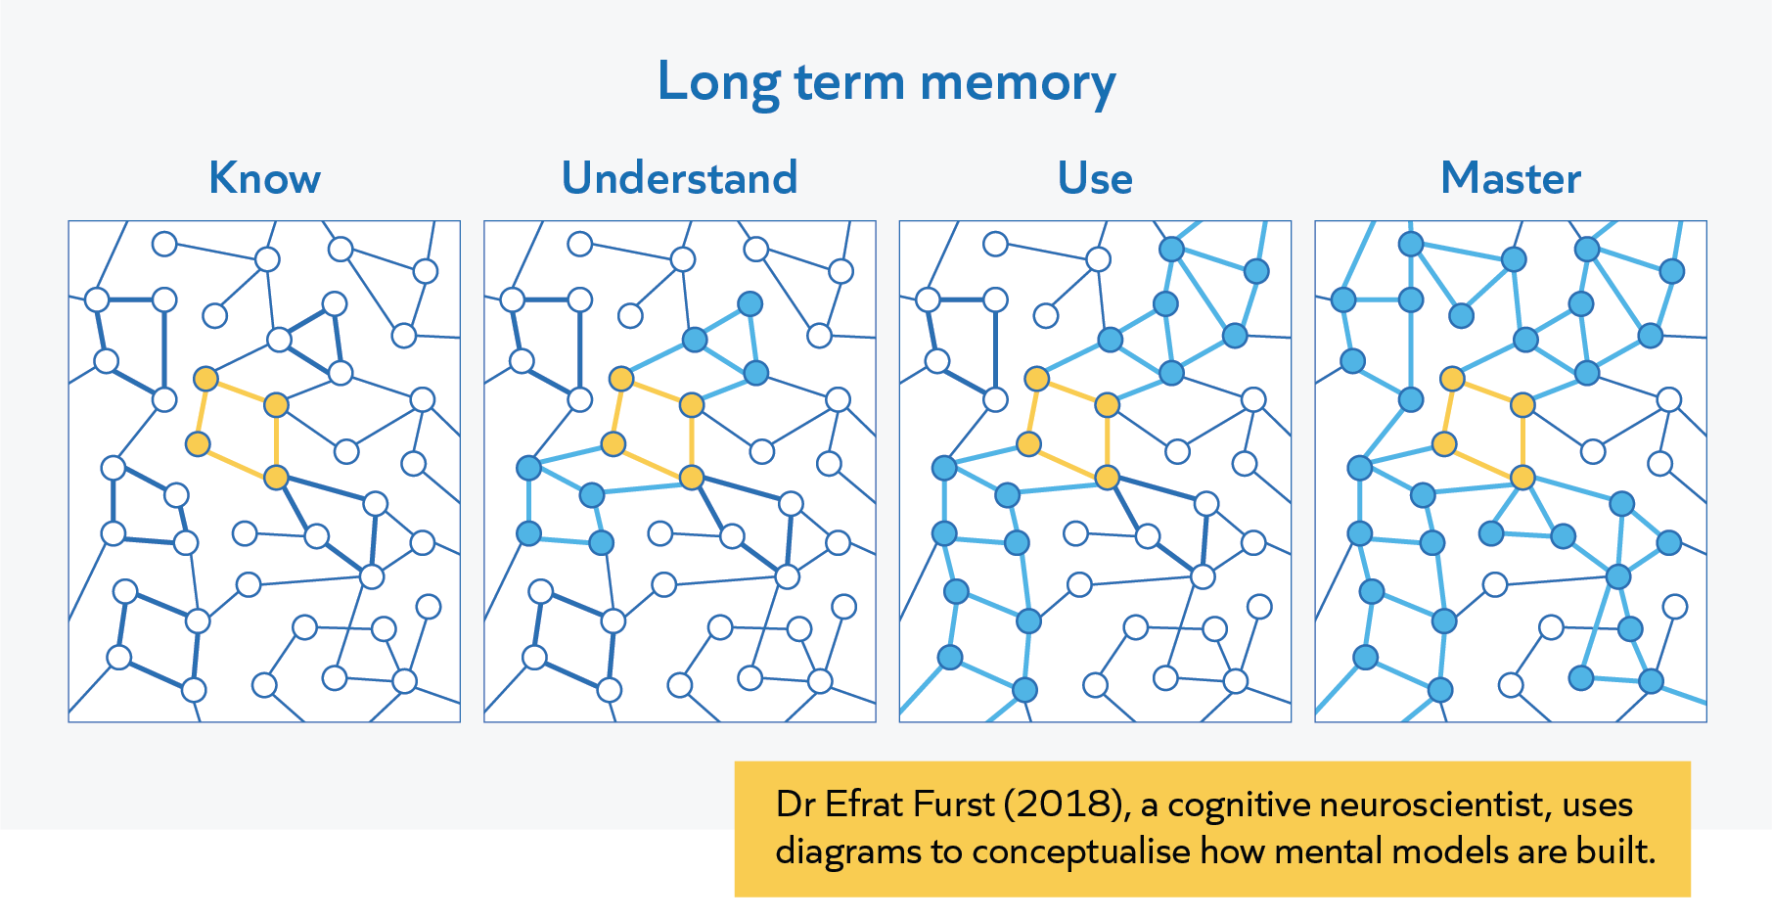
(Adapted from Furst, 2018. Available at: https://sites.google.com/view/efratfurst/learning-in-the-brain)
Notes

Flexible and inflexible knowledge
- Inflexible knowledge is meaningful, but narrow; it's narrow in that it is tied to the concept's surface structure
- Knowledge is flexible when it can be accessed out of the context in which it was learned and applied in new contexts
(Willingham, 2002)
Scenario | Inflexible knowledge | Flexible knowledge
Kamara has learnt about questioning to check for understanding in ‘Formative assessment’.  In his mentoring meeting, he practices writing some end of lesson questions to check for understanding for his upcoming year 2 science lesson. In the following lesson, he implements this successfully using mini whiteboards. | Kamara is regularly successful at planning check for understanding questions for the end of lessons, particularly in science lessons.  However, his mentor notices:  - He does not use check for understanding questions in other subjects, such as English and history  - He does not use check for understanding questions at other points in the lesson  - He always uses mini-whiteboards to check for understanding | Kamara is regularly successful at planning check for understanding questions across subjects, at important points during a lesson, and using a variety of tools.  This is because Kamara understands the following principles:  - All subjects have important knowledge, and teachers should check pupils have understood this  - Teachers should consider what knowledge is key in a lesson, and check this before moving on  - Teachers should aim to collect a wide sample of answers, but the way this is done might vary
Notes

Reflection
Think about one of the ECTs you work with.
- What contextual changes might your ECT be experiencing, and when? E.g. change of classes, year group, subject or topic.
Notes

Reading activity
Carbonell, K. B., Stalmeijer, R. E., Könings, K. D., Segers, M., & van Merriënboer, J. J. (2014). How experts deal with novel situations: A review of adaptive expertise. Educational research review, 12, 14-29.
Extract 1
1. Introduction
Today’s work environments are characterized by increasing complexity due to higher levels of required knowledge and task volatility (Howard, 1995; Molloy & Noe, 2009; Tannenbaum, 2001). It is no longer sufficient to be an expert in one domain, but employees need to be able to combine different specializations (Pink, 2006), adapt to changes in their domain (Smith, Ford, & Kozlowski, 1996), and develop their expertise and become proficient in other domains (van der Heijden, 2002). In short, they must be able to deal effectively with novel situations and problems. Therefore, flexibility at the workplace becomes a critical ingredient for career success (van der Heijden, 2002). While some people quickly overcome changes in work requirements by inventing new procedures and using their expert knowledge in novel ways (Hatano & Inagaki, 1986; Holyoak, 1991), others do not possess this ability and find themselves thrown back performing as a novice. This ability to quickly get accustomed to change has been called adaptive expertise (Hatano & Inagaki, 1986).
Adaptive expertise is generally seen as important, but its characteristics and development are ill understood. Achieving a better understanding of the concept of adaptive expertise is necessary to design learning activities that contribute to its development. Therefore, the aim of this systematic review is to establish what the characteristics of adaptive expertise are and with which training and task characteristics it flourishes. By analyzing the characteristics that distinguish adaptive expertise from routine expertise, it will become possible to deduct what learning activities lead to it.
Hatano and Inagaki (1986) first coined the term adaptive expertise and contrast it with routine expertise. They conceptualize that both types of expertise comprise the same extent of domain knowledge and the ability to perform flawless in familiar situations. However, the difference becomes apparent once confronted with an unfamiliar situation: A situation in which the task, method or desired results are not known in advance (Ellström, 2001). While individuals with routine expertise struggle with the new demands, adaptive expertise allows for easily overcoming the novelty and quickly regaining a high level of performance thanks to a knowledge representation which allows for flexibility (Schwartz, Bransford, & Sears, 2005). In contrast to routine expertise, individuals with adaptive expertise possess the knowledge of why and under which conditions certain methods have to be used or new methods have to be devised.
Various authors studying adaptive expertise have provided numerous descriptions with features that fall apart in three groups. First, adaptive expertise entails all the basic components of routine expertise (e.g., Fisher & Peterson, 2001; Hatano & Oura, 2003; Martin, Rivale, & Diller, 2007; Mylopoulos & Woods, 2009; Varpio, Schryer, & Lingard, 2009). Second, adaptive expertise is marked by better developed meta-cognitive skills than routine expertise (e.g., Crawford, Schlager, Toyama, Riel, & Vahey, 2005; Martin, Petrosino, Rivale, & Diller, 2006). Third, adaptive expertise is set apart through abilities such as flexibility, ability to innovate, continuous learning, seeking out challenges, and creativity (e.g., Barnett & Koslowski, 2002; Crawford et al., 2005; Hatano & Oura, 2003; Martin et al., 2006, 2007; Mylopoulos & Scardamalia, 2008; Varpio et al., 2009). These characteristics point to two important facets of adaptive expertise. Firstly, it develops out of routine expertise. This is based on the first characteristic and implies that both forms of expertise are observable through accurate and efficient performance on domain-relevant and familiar tasks. It is postulated that individuals with routine expertise maintain their performance but halt their learning (Chi, 2011) and thus do not further develop into the stage of adaptive expertise. Secondly, Hatano and Inagaki (1986) suggest that adaptive expertise is after all domain-dependent because it is through accumulated experiences that adaptive expertise develops. In line with this conceptualization, researchers typically define the situation in which adaptive expertise is beneficial over routine expertise as changes in work and/or job task requirements (Allworth & Hesketh, 1999; Blickle et al., 2011; Griffin & Hesketh, 2003), changes in the complexity of situations (Chen, Thomas, & Wallace, 2005), changes from usual to unusual situations (Joung, Hesketh, & Neal, 2006), or changes from common to exceptional situations (Neal et al., 2006).
…
Starting from our preliminary description of adaptive expertise and how research on adaptive expertise differs from expert performance research, a systematic literature review was conducted to detail characteristics of adaptive expertise and the environments in which individuals with a high level of adaptive expertise excel. We aim to answer four research questions. To create a well-founded conceptual understanding of adaptive expertise, the aim of the first two questions is to pinpoint which learning and personality-related factors are characteristic for adaptive expertise and not for routine expertise:
- What learner characteristics (knowledge, skills, regulation processes, and past experience) influence adaptive expertise?
- What personality factors influence adaptive expertise?
- The goal of the latter questions is to discover which environmental factors benefit behaviors indicating adaptive expertise:
- What task and training characteristics (e.g., instruction, task complexity) influence adaptive expertise?
- What characteristics of the learning climate (e.g., tolerance of mistakes, supervision) influence adaptive expertise?
Extract 1 questions:
- How is adaptive expertise defined, and how is it different to routine expertise?
Notes

- Why is adaptive expertise likely to be important for teachers to increasingly develop?
Notes

Extract 2
3.2. What learner characteristics influence adaptive expertise?
The learner characteristics identified in the reviewed articles refer to four categories: domain knowledge, skills, regulation processes, and past experience […].
3.2.1. Domain specific knowledge and skills
Domain knowledge refers to declarative knowledge (knowing that), procedural knowledge (knowing how) and conditional knowledge (knowing when and where) individuals need to possess in order to perform in a specific domain (Alexander, 1992). Experts and novices have different knowledge representation (extent, organization, abstraction, and consolidation) which influence how they retrieve information (Chi, 2006) and thus solve problems (Schwartz et al., 2005).
…
The following conclusions regarding domain specific knowledge and skills can be made: Firstly, knowledge extent is important for adaptive expertise. Secondly, the manner in which this body of knowledge is organized plays an even greater role for adaptive expertise. Adaptive expertise results in the organization of knowledge, which makes it easy to be applied to various situations. Thus, the knowledge representation, in terms of organization, abstraction, and consolidation, is decontextualization, weakening the link between situation and solution. Through this, it is easier for individuals to apply a known solution to a new situation. Therefore, declarative knowledge has a stronger impact on adaptive expertise than contextual knowledge.
3.2.2. Domain-independent skills
Several studies report on domain-independent skills such as cognitive flexibility and analogical problem solving.
…
The findings presented in the above section supports the hypothesis that analogical problem solving skills and abstract reasoning skills positive relate to adaptive expertise. The ability to represent problems in such a way that analogies between domains can be made makes it possible to find solutions for novel problems.
…
3.2.3. Regulation processes
Regulation encompasses cognitive, affective and behavioral processes through which learners monitor their learning processes and the progress they make (Cannon-Bowers & Bowers, 2009). The investigated regulation processes in the context of adaptive expertise are self-efficacy, goal-setting and goal achievement, and regulation of emotions.
…
The reviewed studies provide evidence that a number of regulation processes are important for adaptive expertise. Self efficacy for the task as well as goal-setting and achievement seem to have a positive impact on the ability to deal with novel problems. Emotional regulation needs to be further researched before the results can be generalized.
3.2.4. Past experience
…
The results regarding past experience indicate that unpredictable situations and experience with learning activities are beneficial for adaptive expertise, whereas experience with other people do not influence adaptive expertise. Other forms of experiences have not been sufficiently studied to draw conclusions.
Extract 2 question:
- What factors seem to have a positive impact on learners developing adaptive expertise? What are the implications of these for supporting ECTs?

Notes:

Extract 3
4. Discussion
…
The original conceptualization of adaptive expertise can be refined in the following point, addressed by the first two research questions: Adaptive expertise has similar, but not the same, basic components than routine expertise. They share the same extent of domain knowledge and skills, but differ in their knowledge representation. These representational differences have been shown to lie within the organization and abstraction of knowledge. Only partial support could be found for the other two points, higher meta-cognitive skills and specific abilities, mentioned in the definition of adaptive expertise: Some regulative processes have been addressed, but apart from self-efficacy to perform a task, no other factors has shown consistent result or researched often enough to allow generalization. Regarding specific abilities, the review has shown that general cognitive abilities and analogical problem solving are important elements of adaptive expertise. New characteristics of adaptive expertise not mentioned previously are the importance of being confronted with novel situations and learning new tasks. Past experience related to dealing with other people and their viewpoints does not relate to adaptive expertise.
Research questions 3 and 4 dealt with task, training, and environmental factors relevant for adaptive expertise. The review provides clear evidence that adaptive expertise is related to asking individuals to develop their own solution strategy. This may take the form of unguided exploration or other forms of active learning styles. In such learning formats the possibilities for making errors is great, which further benefits adaptive expertise if a link is made between the errors and the to-be-learned knowledge. Establishing this link leads to deeper understanding of the domain, resulting in a knowledge representation beneficial for adaptive expertise. Lastly, the findings indicate that adaptive expertise is related to supportive supervisors.
…
While analyzing the studies, it became clear that adaptive and routine expertise should be related to different knowledge representations. These differences in representation result in the superior performance in novel situations. Routine expertise is limited by its lack of awareness of the context-specificity of its knowledge. In addition, they may lack cognitive and/or analogical problem solving abilities. This results in individuals with routine expertise not knowing how to deal with novel situations. This assumption is supported by the evidence presented in the third research question on task and training characteristics. Activities should stimulate learners to explore the topic and encourages errors. This allows individuals to try out different solution methods and thus gain a better understanding of the domain (Hatano & Inagaki, 1986). Variety in practice aids the creation of a flexible knowledge base and is thus related to adaptive expertise (Hatano & Inagaki, 1986; Van Merriënboer, Jelsma, & Paas, 1992). In the same manner, a work environment which provides a variety of tasks also leads to a flexible knowledge base.
Extract 3 question:
- What tasks or activities seem to positively influence adaptive expertise?

Notes:

Check for understanding
Which of the following statements are true?
- Teachers who have been initially introduced to a new idea will be able to easily use it in a variety of contexts
- Once an idea is understood in long-term memory, it can be easily drawn on in a variety of contexts
- Teachers who have built expertise in one context will be able to apply it in other contexts
- Practicing using knowledge or skills in different contexts can make it easier to use in other contexts

Reflection
Think again about one of the ECTs you work with.
Consider:
- Areas where they appear to have more limited mental models
- Areas where they appear to have developed some expertise in a particular context but struggle to apply it to other contexts
- Areas where they appear to demonstrate expertise in a range of contexts
Notes

Section 3: Adapting the coaching model

Aims of adapting the coaching model
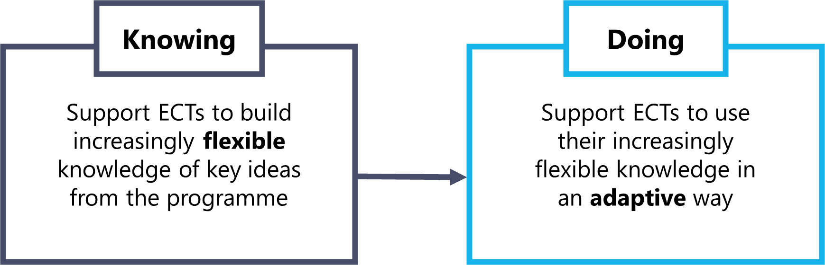

Instructional coaching model
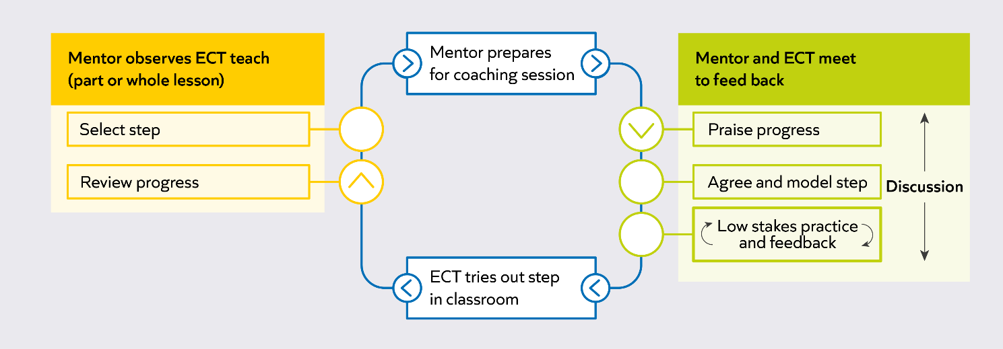
Notes

Success criteria
- Consider prior knowledge
- Be intentional about purpose
- Draw attention to deep structures
- Ensure multiple rounds of practice and feedback
Notes

Increasing variation
- Visible symptom: an ECT is struggling to apply their knowledge across different contexts, such as to a different class, subject, topic or lesson moment.
Their understanding is perhaps closely tied to the context through which they first learnt this knowledge.
- Variation of context is where ECTs are supported to practice in a range of contexts, in order to ‘decontextualise’ their understanding from the context it was first introduced in.
- Includes:
  - Varying the context of a step: asking ECTs to repeat or revisit a step in a different context, such as in a different class, subject or time of day, after they have successfully applied a step in a previous context.
  - Varying the conditions of practice: During practice, asking ECTs to apply their understanding from one context to another.
Varying the conditions of practice
Example 1 | Example 2
Chynia is a history teacher in her second year. As it is the start of the year, her mentor decides to set her a step on how she diagnoses and responds to pupil emotions as they enter the classroom. Her mentor asks her to focus on her year 10 class, who sometimes appear stressed.  Chynia had strong entry routines last year, and so, during practice, meets the step success criteria quickly. Chynia appears unsure about how she could adapt this step though, so her mentor asks her to practise this step with her year 8 class, who are more boisterous. Her mentor focuses Chynia’s attention on the success criteria for the step, and gets her to practise until she is repeatedly successful in this context too. | Wade is a primary teacher in his first year. He is relatively confident at modelling for pupils during practical lessons such as PE, does not always apply this knowledge in other lessons. His mentor wants Wade to develop his knowledge of this step further.  During practice, his mentor asks Wade to plan how he will model in an upcoming art lesson where pupils will be drawing a still life, using the success criteria attached to the step. He is successful with this, so his mentor then asks him to plan a model for an upcoming English lesson, where pupils will be writing a letter. Wade’s mentor reminds him of the success criteria attached to the step, and after a first draft, gets him to re-draft part of his model to meet one of these criteria.

Success criteria | Notes
Consider prior knowledge
Be intentional about purpose
Draw attention to deep structures
Ensure multiple rounds of practice and feedback

Adding complexity

- Incorporating additional success criteria into the selected step can make it more challenging for the ECT and help them to develop a more flexible understanding of how to apply it in their practice.
  - Aligned: consider the broad area of practice that the ECT has currently been working on and use the step selector in Steplab.
  - Builds on prior knowledge: consider the ECT's prior knowledge or current area of self-study when selecting a step.
  - Prioritise: within this step, consider which success criteria will have the greatest impact on the ECT’s practice and pupils at this stage.
  - Appropriate: select a step and success criteria which target a small and challenging area for development. This may involve more practice on the current target area or moving onto a new step. The level of challenge needs to manageable, whilst moving on the ECT's practice.

Read this model and make notes in the table as to how the mentor meets the success criteria.

Anna is mentoring Joel, a year 5 teacher who has built strong, positive relationships with his pupils over the year. Earlier in the year, they focused on the step ‘Build positive relationships: show warmth, interest, empathy and emotional consistency when interacting with pupils to support the creation of positive relationships.’ They focused on these success criteria:
- Build gradually: acknowledge that it takes time and persistence to build relationships and intentionally plan when and how you will do this.
- Listen and empathise: take the time to listen to pupils at appropriate times, and display warmth and empathy during interactions with them.
- Give compliments: use moments of informal exchange to compliment pupils, e.g. 'Miss Shah tells me you were very helpful in her lesson earlier', or 'I hear that you played well in last night's match'.
Joel now greets pupils warmly, uses their names, and offers genuine compliments in lessons. Anna has seen the positive impact on classroom culture and on pupils’ sense of belonging.
After the recent half-term break, Anna has noticed that, while Joel’s classroom remains welcoming, some interactions with pupils have become a little more surface-level. Pupils respond politely, but Joel seems to have fewer meaningful conversations with them about their interests or how they are feeling. Anna thinks that, as the term has progressed and routines have become established, there has been less focus on intentionally nurturing relationships and classroom culture.
Anna and Joel agree that it is a good time to revisit this earlier step, not because anything has gone wrong, but because strong teacher–pupil relationships need ongoing attention. Anna knows that returning to this step will help Joel continue to build relationships with pupils, and build on the good work from earlier on in the year. Now that they are revisiting the step, Anna considers what success criteria to use, to add complexity and to build challenge for Joel.

Anna’s planning process:
- Anna reflects on Joel’s strengths: he is warm, genuine, and attentive in the classroom, and has created a positive, respectful atmosphere.
- She notices that Joel’s interactions have become more focused on day-to-day logistics, and that there are further opportunities to connect with pupils on a more personal level, especially in informal moments.
- Anna decides to revisit the step, using more challenging success criteria to help Joel be more intentional and strategic about building trust and rapport with pupils, both in and beyond the classroom.
- She selects the following success criteria:
  - Build gradually: acknowledge that it takes time and persistence to build relationships and intentionally plan when and how you will do this.
  - Seek opportunities for informal exchanges: make time to interact with pupils in corridors, as they enter and exit lessons and during break and lunch duties.
  - Build knowledge: get to know pupils by taking an interest in their lives and hobbies, to facilitate genuine interactions.
- Anna chooses these criteria because, as the term goes on, pupils may benefit from renewed attention to the personal connections that make them feel seen and valued. This helps to maintain a positive classroom climate and supports pupils’ wellbeing.

Anna’s script for introducing the step to Joel:
“Joel, I’ve really noticed the positive relationships you’ve built with your class. Your warmth, encouragement, and attention to each pupil have had a real impact. As we move into this part of the year, I’ve observed that your interactions with pupils, while always friendly, have sometimes become a bit more focused on the day-to-day. This is really common as things get busy, but it’s also a great opportunity to revisit some of the strategies we looked at earlier in the year.
You’ve built a strong foundation, so I’d like us to focus now on being even more intentional about deepening those relationships throughout the school day. Here are the specific success criteria I’d like us to work on:
- Build gradually: acknowledge that it takes time and persistence to build relationships and intentionally plan when and how you will do this.
- Seek opportunities for informal exchanges: make time to interact with pupils in corridors, as they enter and exit lessons and during break and lunch duties.
- Build knowledge: get to know pupils by taking an interest in their lives and hobbies, to facilitate genuine interactions.
I’ve chosen these because you’re already strong in showing warmth and giving compliments in lessons, and now I think you’re ready to take this further by making the most of informal moments across the school day. By planning when and how to build relationships, and by learning more about your pupils’ interests, you’ll be able to continue to build strong relationships and have an even greater impact on their sense of belonging. Let’s think together about some specific opportunities you might use over the next week, and how you might find out more about your pupils’ interests outside of lessons.”

Success criteria | How does this support the mentor to select an aptly challenging step?
Aligned
Builds on prior knowledge
Prioritise
Appropriate

Make any additional notes based on your facilitator’s analysis.
Use of questioning
- Visible symptom: an ECT is improving their practice, or is able to demonstrate effective practice with a step.
However, it is unclear whether they have a secure understanding of the purpose that sits behind the step, which would inform their understanding of how they might use or apply the step in a range of contexts.

Questioning is an important part of instructional coaching. The types of questions that mentors ask can support ECTs to reflect on the purpose of a step, and how it might be used or adapted for an identified outcome.

Questioning
- Encourage ECTs to reflect on their current and target practice
  - I noticed that… what can you tell me about it? What impact did this have on pupil learning?
  - What is the difference between my model and your current practice?
  - Why do you think pupils responded in this way?
  - Can you use the criteria to explain what was effective about my model?
- Encourage ECTs to make connections in their knowledge
  - How did your practice help you to meet the success criteria of the step?
  - Where and when else might you use this step?
  - When might this step not be appropriate to use?

Success criteria | Notes
Consider prior knowledge
Be intentional about purpose
Draw attention to deep structures
Ensure multiple rounds of practice and feedback

Reflection
- Can you think of examples in your existing mentoring when you have already adapted the coaching model?
- Think about one of the ECTs you are working with. Are they developing expertise in certain domains? If so, how could you adapt the coaching model in response?

Notes

Section 4: Adapting the coaching model – in practice

Instructional coaching quiz
- Which of the following are key features of instructional coaching?
  - Roleplay
  - Bite-sized steps for improvement
  - A regular routine
  - Low-stakes practice & feedback

- What are the key elements of deliberate practice?
Notes

- Explain how instructional coaching helps build teachers’ mental models.
Notes

Case study 1 background: Katie and Sarah
Sarah is coaching Katie. Katie is coming to the end of her first year on the ECTP. Katie has made strong progress, and her classroom practice is becoming increasingly assured. Katie has recently studied the self-study module ‘Scaffolding’. In this module, Katie has reflected on the principles of scaffolding and how to support pupils to access independent practice tasks. From talking to Katie and watching her teach this term, Sarah can see that she has learned to plan effective scaffolds that still require pupils to think hard. However, sometimes pupils struggle to remember and follow classroom routines that they have seen before.
Sarah decides to observe a segment of the lesson where Katie is giving instructions and reminding pupils of the routines they should follow; this will give him a good opportunity to identify how Katie introduces routines and helps to make them stick.
In the lesson, Sarah notices that when Katie has explained routines, pupils are eager to do the right thing and usually follow these routines correctly to begin with. However, they then start to follow instructions less closely and seem to forget the routine. Katie’s instructions were clear and she checked that pupils understood them. Katie has previously been set a step about giving clear instructions, where she focused on making instructions specific and concise, and putting the steps of her instructions into a sequence. She has incorporated this into her practice successfully.
However, in this lesson she was less clear about the purpose for the routine, so Sarah decides to revisit a step from a previous module in the programme. She selects the module ‘Expectations and routines’, and the module principle ‘Guide attention’. She chooses the following step: ‘Plan and explain purpose: when introducing a behaviour or routine, clearly state what you expect and explain why it matters, so pupils understand both the action and its value.’
She decides to start with the following success criteria, as these feel most appropriate for what she wants Katie to practise. She knows he can always select more success criteria, or add more challenge into practice. The success criteria he selects are:
- Explain the behaviour: Clearly state and model what the expected behaviour or routine looks like, for example, “We raise our hands when we want to contribute.”
- Explain the purpose: Explicitly share the rationale for the behaviour or routine, for example, “This helps everyone have a chance to share their ideas and feel listened to.”
- Use accessible language: Explain the behaviour and its purpose using language and examples that match pupils’ age and stage.

Notes

Case study 1 (Katie and Sarah): ‘agree and model’ stage
Mentoring step | Success criteria | Met? (Y/N)
Where relevant, adapt the coaching model | Consider prior knowledge: Ensure that the ECT is successfully implementing the step in the original context before making any adaptations. This might include reflecting on ECTs’ practice, or asking questions to build a picture of their current understanding
Where relevant, adapt the coaching model | Be intentional about purpose: Consider why it might be valuable to made adaptations to the coaching model, and communicate this thinking with the ECT.
Where relevant, adapt the coaching model | Draw attention to deep structures: Emphasises the importance of the success criteria as the features or structures underpinning success during any adaptation of practice.
Adaptation: use of questioning
- What questions did the mentor ask to provide stretch?
- What made them effective? (Consider the success criteria for adapting the coaching model)
- What was the impact on the ECT?

Case study 2 background: Shifa and Frank
We will use a similar case study to practise, but with a different step. This time we will consider Shifa who is mentoring Frank, an ECT. Their context is similar to that of Katie and Sarah from earlier.
Shifa is coaching Frank. Having completed his ITT in the same school, Frank has considerable knowledge of the school routines and culture. Frank is currently studying a module on ‘Disruption, consistency and relationships’. As part of his diagnostic reflections for this module, Frank has identified that although he feels that he is able to respond to disruption effectively, he’d like to get better at pre-empting disruption before it has the chance to arise. This helps Shifa focus on a particular aspect of Frank’s practice when she watches his lesson.
In the lesson, Shifa notices that when Frank gives instructions, he gives clear instructions and encourages positive relationships by acknowledging positive behaviours and delivering appropriate acknowledgement and praise. Shifa agrees with Frank that some pupils tend to engage in low-level disruption during independent practice. She thinks that he might benefit from working on the module principle, ‘be proactive’. She chooses the following step: ‘use physical presence: consider how you position yourself and move around the classroom to monitor behaviour and minimise disruption’.
The success criteria for the step are:
- Stand centrally: when at the front of the classroom, stand in a central position so that it is easy to see, and be seen by, all pupils. Ensure that your stance is open and approachable.
- Scan the room: stand still and scan the room exaggeratedly, so that pupils can see that you are monitoring them.
- Circulate: when appropriate, circulate the room so that you can monitor all pupils and easily identify when support might be needed.
- Ensure visibility at all times: when circulating or working with individual pupils, keep as much of the class as possible in eyesight.
- Use non-verbal signals: use a non-verbal signal or physical presence to support individuals to uphold expectations, for instance holding a finger to the lips, mimicking writing, making eye contact with an individual or moving to stand by an individual.
Shifa starts by selecting the success criteria. This is the first time that Shifa is introducing this step, so she wants to focus on the most important aspects, and prioritise the criteria which will make the most impact on his practice, on top of what he has learned about giving clear instructions. She also anticipates that she might want to add more challenge later in the coaching conversation if appropriate, so starts with the following:
- Stand centrally: when at the front of the classroom, stand in a central position so that it is easy to see, and be seen by, all pupils. Ensure that your stance is open and approachable.
- Scan the room: stand still and scan the room exaggeratedly, so that pupils can see that you are monitoring them.
- Circulate: when appropriate, circulate the room so that you can monitor all pupils and easily identify when support might be needed.

Case study 2 (Shifa and Frank): ‘Agree and model’ stage
Step
Use physical presence: consider how you position yourself and move around the classroom to monitor behaviour and minimise disruption.
Success criteria
- Stand centrally: when at the front of the classroom, stand in a central position so that it is easy to see, and be seen by, all pupils. Ensure that your stance is open and approachable.
- Scan the room: stand still and scan the room exaggeratedly, so that pupils can see that you are monitoring them.
- Circulate: when appropriate, circulate the room so that you can monitor all pupils and easily identify when support might be needed.
Steplab practice tasks
- Decide on an appropriate, central position in the classroom where you can be seen and see all pupils.
- Identify which pupils might need accountability and positive reinforcement quickly if they are to remain focused.
- Plan a route for circulating the room so you can check these pupils’ behaviour first but also get to every pupil.
- Stand up in role and practise scanning, circulating and returning to this position, using non-verbal signs.
- Consider how you will support individual pupils whilst maintaining a good view of the rest of the class.
- With support from a colleague, check your practice against the success criteria and refine if necessary.

Planning: ‘agree and model’ stage
Plan a model to support Frank with the step outlined in case study 2, and plan the questions you might ask to support him to reflect on his practice and make connections in his knowledge (using case study 1 as a model).
Space to plan your model:
Notes

Space to plan questions you might choose to ask in the meeting, and why:
Notes

Note to person acting as the teacher, use the case study to guide your answers to the questions.
Default prompts:
- I noticed that… what can you tell me about it? What impact did this have on pupil learning?
- What is the difference between my model and your current practice?

Practice: ‘agree and model’ stage
Timing: approx. 8-10 minutes per round
- 4-5 minutes: Person A as the mentor shares the step and the model and leads the analyse conversation with person B as the teacher
- 1-2 minutes: Person B provides feedback to person A based on the mentoring step’s success criteria
- 3 minutes: Person A re-practises the relevant section based on the feedback to improve
- Swap roles

Mentoring step | Success criteria | Met? (Y/N)
Mentoring step | Success criteria | Round 1 | Round 2
Where relevant, adapt the coaching model | Consider prior knowledge: You consider ECTs’ prior knowledge before making any adaptations. This might include reflecting on ECTs’ practice, or asking questions to build a picture of their current understanding
Where relevant, adapt the coaching model | Be intentional about purpose: You identify the purpose for any adaptations to the coaching model, and, where possible, communicate this to your ECT
Where relevant, adapt the coaching model | Draw attention to deep structures: You intentionally draw your ECT’s attention to the success criteria of a step during any adaptation of practice
What went well –
Next time try –

Case study 1 (Sarah and Katie): ‘low stakes practice and feedback’ stage
Mentoring step | Success criteria | Met? (Y/N)
Where relevant, adapt the coaching model | Consider prior knowledge: The mentor considers ECTs’ prior knowledge before making any adaptations. This might include reflecting on ECTs’ practice, or asking questions to build a picture of their current understanding
Where relevant, adapt the coaching model | Be intentional about purpose: The mentor identifies the purpose for any adaptations to the coaching model, and communicates this to their ECT
Where relevant, adapt the coaching model | Draw attention to deep structures: The mentor draws their ECT’s attention to the success criteria of a step during any adaptation of practice
Where relevant, adapt the coaching model | Ensure multiple rounds of practice and feedback: the mentor ensures that ECTs have time to practise, receive feedback, and re-practise
Adaptation: using success criteria to build challenge
- How did the mentor add success criteria to the practice?
- What made this effective? (Consider the success criteria for adaptations)
- What was the impact on the ECT?

Case study 2 (Shifa and Frank): ‘low stakes practice and feedback’ stage
Shifa’s introduction to this stage of the coaching cycle (for context)
“Firstly, you’re going to plan how to use physical presence effectively, during and after giving instructions. We’re building this on top of what you’ve already learned about giving effective instructions, so we’re starting with some specific success criteria. After that I’ll ask you to read through your plan and check it against the success criteria. Then I’ll ask you to deliver it in role as a teacher.
I’ll give you feedback based on the success criteria and you’ll re-practise based on the feedback.
The success criteria are:
- Stand centrally: when at the front of the classroom, stand in a central position so that it is easy to see, and be seen by, all pupils. Ensure that your stance is open and approachable.
- Scan the room: stand still and scan the room exaggeratedly, so that pupils can see that you are monitoring them.
- Circulate: when appropriate, circulate the room so that you can monitor all pupils and easily identify when support might be needed.
Any questions? Great – I will let you start planning now then.”
The instructions that Frank scripts (to be played by the person in-role as the ECT)
“In a moment, you’re going to answer a set of questions about today’s science experiment. This will help you practise what we’ve just learned and check your understanding.
- Open your exercise book
- Read the instructions at the top of your worksheet.
- Answer the questions in full sentences.
- You have four minutes to answer all the questions.
- Okay, when we are ready [scan]… off we go.”
[Begin to circulate the room, starting from the front left desk.]

Planning: ‘low stakes practice and feedback’ stage
Plan the adaptations you might make to subsequent rounds of practice, if Frank demonstrates secure practice quickly (using case study 1 as a model)
Adaptations covered in detail earlier in the conference:
- Varying the conditions of practice
- Adding complexity
- Questioning
Notes:
Practice: ‘low stakes practice and feedback’ stage
When in role as the ECT, aim to demonstrate secure practice relatively quickly so the person in role as the mentor can practise adapting the coaching model in response.
Timing: approx. 10 minutes per round
- 6 minutes: Person A will be the mentor, and person B will be the ECT. Begin the practice with the mentor (person A) asking the ECT (person B) to practise (using the script on the previous page). Person B should demonstrate secure practice relatively quickly, and person A should practise adapting the coaching model in response, using their planning.
- 1 minute: Person B provides feedback to person A based on the mentoring step’s success criteria
- 3 minutes: person A re-practises the relevant section based on the feedback to improve
- Swap roles

Success criteria
Mentoring step | Success criteria | Met? (Y/N)
Mentoring step | Success criteria | Round 1 | Round 2
Where relevant, adapt the coaching model | Consider prior knowledge: You consider ECTs’ prior knowledge before making any adaptations. This might include reflecting on ECTs’ practice, or asking questions to build a picture of their current understanding
Where relevant, adapt the coaching model | Be intentional about purpose: You identify the purpose for any adaptations to the coaching model, and, where possible, communicate this to your ECT
Where relevant, adapt the coaching model | Draw attention to deep structures: You intentionally draw your ECT’s attention to the success criteria of a step during any adaptation of practice
Where relevant, adapt the coaching model | Ensure multiple rounds of practice and feedback: You ensure that ECTs have time to practise, receive feedback, and re-practise
What went well –

Next time try –

Section 5: Implementation

Enabling conditions
- Mentor/teacher relationship
- Time
- Leadership support
- School culture
- ECT subject/phase knowledge
- Effective habits and routines for coaching (and ECT study)
Enabling conditions: review
What might your next steps be to ensure that the enabling conditions are in place in school?
 | Definitely in place? | If not, action needed?
Has time been protected for you and your ECT to meet at least fortnightly?
Is this on both your timetables?
Is support for ECTs prioritised by school leadership?
Is regular coaching already a well-developed habit? If not, what are your next steps towards embedding it as a habit? For you? For your ECT?
Are you aware of any additional support your ECT is likely to need, such as additional subject knowledge support?
Any other reflections:

How have you overcome any challenges around enabling conditions so far?
Space for notes:

(Re-)contracting
- Did you use the contracting process to set up your ways of working when you first started working with your ECT? Have you re-contracted at any point since?
- How did addressing the contracting questions (see workbook) in advance set the relationship up effectively?
- If you didn’t make use of the contracting structure, what did you do to successfully build a relationship with your teacher?
- Is there anything you would do differently, or plan to address, moving forwards?
Notes

Discussion
- What areas of classroom practice might your ECT be able to take greater ownership of?
- What areas are they still likely to need a greater degree of scaffolding and support?
Notes

Key takeaways
Notes

Bibliography

Allen, R. and Sims, S., 2018. The Teacher Gap. 1st ed. Abingdon: Routledge.
Darling-Hammond, L. and Sykes, G., 2003. Wanted, A National Teacher Supply Policy for Education: The Right Way to Meet The "Highly Qualified Teacher" Challenge. education policy analysis archives, 11, p.5.Hanushek (2011:467)
Department for Education. 2020. Reporting Year 2019: School workforce in England. https://explore-education-statistics.service.gov.uk/find-statistics/school-workforce-in-england
Department for Education. 2019. Teacher Recruitment and Retention Strategy https://assets.publishing.service.gov.uk/government/uploads/system/uploads/attachment_data/file/786856/DFE_Teacher_Retention_Strategy_Report.pdf
EEF. 2019. Staff Deployment & Development. [online] Available at: <https://educationendowmentfoundation.org.uk/school-themes/staff-deployment-development/>
Fletcher-Wood, H. (2018) Between novice and expert: complex tasks and intermediate learning. Available here: https://improvingteaching.co.uk/2018/03/11/between-novice-to-expert-complex-tasks-and-intermediate-learning/
Foster, D., 2019. Teacher Recruitment And Retention In England. [online] House of Commons Library. Available at: <https://commonslibrary.parliament.uk/research-briefings/cbp-7222/>
Hanushek, E., 2011. The economic value of higher teacher quality. Economics of Education Review, 30(3), pp.466-479
Hollis, E (2018). Early career framework; what might this mean for recruitment and retention? Available here: https://edexec.co.uk/early-career-framework-what-might-this-mean-for-recruitment-and-retention/
Kraft, M.A. & Blazer, D. (2018). Taking Teacher Coaching To Scale. Education Next. 18, No. 4. Available at: https://www.educationnext.org/taking-teacher-coaching-to-scale-can-personalized-training-become-standard-practice/
Kraft M.A. & Papay J.P. (2014) Can Professional Environments in Schools Promote Teacher Development? Explaining Heterogeneity in Returns to Teaching Experience. Educational Effectiveness and Policy Analysis. 2014;36 (4) :476-500. Available at: https://scholar.harvard.edu/files/mkraft/files/kraft_papay_-_prof_env_teacher_development_eepa_full.pdf
Papay J.P. & Kraft M.A. (2016) The Myth of the Teacher Performance Plateau. Educational Leadership. 2016;73 (May) :36-42. Available at: https://scholar.harvard.edu/files/mkraft/files/papay_and_kraft_-_ed_leadership_-_may_2016.pdf
Mccrea, P. (2018). Expert Teaching What is it, and how might we develop it? Available at:
https://www.researchgate.net/publication/324759008_Expert_Teaching_What_is_it_and_how_might_we_develop_it_Peps_Mccrea/download
Sharples, J., Albers, B. and Fraser, S., (2018) ‘Putting Evidence to Work’ [online] Dera.ioe.ac.uk. Available at: <https://dera.ioe.ac.uk/31088/1/EEF-Implementation-Guidance-Report.pdf>
Timperley, H. (2008). Teacher professional learning and development. Educational Practices (18). International Academy of Education
Science of learning
Agarwal, P. K., & Roediger III, H. L. (2018). Lessons for learning: How cognitive psychology informs classroom practice. Phi Delta Kappan, 100(4), 8-12.PDF,
Berliner,D. (1988). The development of expertise in pedagogy. American Association of Colleges for Teacher Education, Washington, D.C. Available at: https://files.eric.ed.gov/fulltext/ED298122.pdf
Bohle-Carbonell, K., Stalmeijer, R. E., Könings, K. D., Segers, M., & van Merriënboer, J. J. (2014). How experts deal with novel situations: A review of adaptive expertise. Educational research review, 12, 14-29. Available at: https://cris.maastrichtuniversity.nl/ws/portalfiles/portal/73014428/merrienboer_2014_how_experts_deal_with_novel.pdf
Clark, R., Kirschner, P. & Sweller, J. (2012). Putting students on the path to learning: The case for fully guided instruction. American Educator, 36(1): 6-11. Available at: https://files.eric.ed.gov/fulltext/EJ971752.pdf
Clarridge, P.B. & Berliner, D.C. (1991) Perceptions of student behaviour as a function of expertise. Journal of Classroom Interaction, 26, p. 1–8.
Deans for Impact (2017) Practice with Purpose: The Emerging Science of Teacher Expertise. Available at: https://goo.gl/jh8N4Z
Deans for Impact (2018). Building Blocks. [online] Available at: https://deansforimpact.org/wp-content/uploads/2017/11/Building-Blocks_Framework.pdf
EEF. 2018. Metacognition and self-regulated learning. [online] Available at: https://educationendowmentfoundation.org.uk/tools/guidance-reports/metacognition-and-self-regulated-learning/
Findell, C.R. (2009) What Differentiates Expert Teachers from Others? The Journal of Education, 188(2), p. 11–24.
Furst, E. (2018). From neuroscience to the classroom. ResearchEd 1, no. 2 (September): 30-33
Furst, E. (2018). Learning in the Brain. https://sites.google.com/view/efratfurst/learning-in-the-brain
Loewenberg Ball, D., Thames, M. and Phelps, G., 2008. Content Knowledge for Teaching. Journal of Teacher Education, 59(5), pp.389-407.
Roediger, H. & Karpicke, J. (2006) “Test-Enhanced Learning: Taking Memory Tests Improves Long-Term Retention.” Psychological Science 17, no. 3 (March 2006): 249–55.
Roediger, H.L. III, Nestojko, J.F. & Smith, N. (2019). Strategies to improve learning and retention during training. In M.D. Mathews & D.M. Schnyer (Eds.), The Cognitive and Behavioral Neuroscience of Human Performance in Extreme Settings. New York: Oxford University Press. PDF
Schempp, P., Tan, S. & McCullick, B. (2002) The practices of expert teachers. Teaching and Learning, 23(1), p. 99–106.
Sternberg, R.J. & Horvath, J.A. (1995) A prototype view of expert teaching. Educational Researcher, 24(6), p. 9–17.
Sweller, J. (1988). Cognitive load during problem solving: Effects on learning. Cognitive Science, 12(2), 257-285
Westerman, D.A. (1991) Expert and Novice Teacher Decision Making. Journal of Teacher Education, 42(4) p. 292–305.
Deans for Impact (2015) The Science of Learning. Available at: https://goo.gl/VpUw1y
Willingham, D. (2002). Ask the Cognitive Scientist: Inflexible Knowledge: The First Step to Expertise. American Educator. AFT. Available at: https://www.aft.org/periodical/american-educator/winter-2002/ask-cognitive-scientist-inflexible-knowledge
Willingham, D., 2009. Why Don't Students Like School?. San Francisco, CA: Jossey-Bass.
Wolff, C.E., Jarodzka, H. & Boshuizen, H.P.A. (2017) See and tell: Differences between expert and novice teachers’ interpretations of problematic classroom management events. Teaching and Teacher Education, 66, p. 295–308
Teacher change
Grossman, P., Compton, C., Igra, D., Ronfeldt, M., Shahan, E., & Williamson, P. W. (2009). Teaching practice: A cross-professional perspective. Teachers college record, 111(9), 2055-2100. Available at: http://tsl-public.s3.amazonaws.com/threeflows/grossman-et-al-2009.pdf
Hobbiss, M., Sims, S., & Allen, R. (2020). Habit formation limits growth in teacher effectiveness: A review of converging evidence from neuroscience and social science. Review of Education, rev3.3226.
Hood, M. (2016). Beyond the Plateau: The case for an institute of advanced teaching. IPPR. Available at: https://www.ippr.org/files/publications/pdf/beyond-the-plateau_July2016.pdf
Lally, P., Van Jaarsveld, C. H. M., Potts, H. W. W., & Wardle, J. (2010). How are habits formed? Modelling habit formation in the real word. European Journal of Social Psychology, 40, 998–1009. Available at: https://www.researchgate.net/publication/32898894_How_are_habits_formed_Modeling_habit_formation_in_the_real_world
Adapting the model
Bohle-Carbonell, K., Stalmeijer, R. E., Könings, K. D., Segers, M., & van Merriënboer, J. J. (2014). How experts deal with novel situations: A review of adaptive expertise. Educational research review, 12, 14-29. Available at: https://cris.maastrichtuniversity.nl/ws/portalfiles/portal/73014428/merrienboer_2014_how_experts_deal_with_novel.pdf
Hill, Heather & Charalambous, Charalambos & Kraft, Matthew. (2012). When Rater Reliability Is Not Enough: Teacher Observation Systems and a Case for the Generalizability Study. Educational Researcher. 41. 56-64. Available at https://www.researchgate.net/publication/254088727_When_Rater_Reliability_Is_Not_Enough_Teacher_Observation_Systems_and_a_Case_for_the_Generalizability_Study
Schmidt H.G., Rikers R.M. How expertise develops in medicine: knowledge encapsulation and illness script formation. Medical Education. 2007 Dec;41(12):1133-9. Link
Willingham, D. (2002). Ask the Cognitive Scientist: Inflexible Knowledge: The First Step to Expertise. American Educator. AFT. Available at: https://www.aft.org/periodical/american-educator/winter-2002/ask-cognitive-scientist-inflexible-knowledge
Instructional coaching
Berliner, D. (2001). Learning about and learning from expert teachers. International Journal of Educational Research 35, pp.463–482.
Deans for Impact (2017) Practice with Purpose: The Emerging Science of Teacher Expertise. Available at: https://goo.gl/jh8N4Z
Grossman, P., Compton, C., Igra, D., Ronfeldt, M., Shahan, E., & Williamson, P. W. (2009). Teaching practice: A cross-professional perspective. Teachers college record, 111(9), 2055-2100. Available at: http://tsl-public.s3.amazonaws.com/threeflows/grossman-et-al-2009.pdf
Kraft M.A., Blazar D., Hogan D. The Effect of Teacher Coaching on Instruction and Achievement: A Meta-Analysis of the Causal Evidence. Review of Educational Research [Internet]. 2018;88 (4) :547-588.
Implementation
EEF. 2019. Putting Evidence to Work: A School’s Guide to Implementation. [online] Available at: https://educationendowmentfoundation.org.uk/public/files/Publications/Implementation/EEF_Implementation_Guidance_Report_2019.pdf [Accessed 06 May 2021].
Glei, J., 2013. Maximize Your Potential: Grow Your Expertise, Take Bold Risks Build An Incredible Career. 1st ed. Amazon publishing

Space for additional notes

