Early Career Training Programme

Clinic 3: Effective Feedback
Participant Workbook
(Primary Pack)
Name: ………………………………………………………………………………..
Session date: ………………………………………………………………………

Pre-clinic tasks 3
Teaching problem 8
I Do 12
We Do 15
Option A: Non-example 20
Option B: Planning/Practice task 22
Option C: I Do 2 28
Close 31
References 32

Pre-clinic tasks
The following tasks are to be completed before you attend Clinic 3. This should take no longer than 30 minutes
In Clinic 3, you will read and analyse 3-4 scenarios that consider the following teaching problem across a range of contexts:

How can teachers give timely and high-quality feedback that supports pupil progress and is considerate of workload?

The scenarios will exemplify the five module principles below, demonstrating how teachers can hold meaningful conversations with a range of people to provide appropriate support for pupils.
Module principle | Description
Give feedback to move learning forward. | Pupils need to know specifically how to improve. Ensure feedback is accurate and specific, and that pupils have time and capacity to act on feedback, so they can close the gap between their current performance and the desired goal. Consider context when deciding on the appropriate time to give feedback - factors such as the task, pupils and whole-class understanding (EEF, 2021).
Promote positive engagement. | Pupils are the recipients of feedback and will ideally be motivated to use it to improve. Give pupils the support to process and respond to purposeful feedback that requires them to think hard. Adapt feedback by thinking about the social and emotional factors that may affect pupils’ responses to it.
Encourage long-term progress. | Feedback can take place on three levels: task, process and self-regulation. Feedback on personal traits is unlikely to be useful. Whichever level is used, ensure feedback goes beyond the single output, is linked to pupils' progression and, where relevant, linked to their long-term goals. Over time, use feedback to help pupils monitor and regulate their own learning.
Balance impact and effort. | Feedback can be beneficial for pupil learning but it must not disproportionately impact teachers’ time and workload. Aim to strike a balance between the benefit feedback has on pupil learning and the resources and time dedicated to providing it, reducing the opportunity cost of giving feedback. Work with colleagues to ensure the onus is on the progress pupils make as a result of the feedback as opposed to the work the teacher does to provide the feedback.

These module principles are relevant to all teachers and can be applied across all contexts, regardless of phase, subject or setting. For instance, high-quality feedback may include written marking in some circumstances, but it might also look like verbal feedback, self-assessment or code marking – depending on the task, subject, age and stage of pupils, or wider context such as time available. While feedback may look different on the surface, the module principles are the underlying features that stay the same.
The following two tasks will help you to familiarise yourself with the module principles before you attend the clinic. During the clinic, you will build on this prior knowledge by exploring the module principles in greater depth with the support of your facilitator, before applying these to your own practice.

Task 1
- Read the scenario below.
- Answer the questions, using the module principle as a guide.

Mr Ridge’s reception class are sat on the carpet practising forming the letter ‘b’ in both capital and lower case on their whiteboards. Mr Ridge has modelled the letter formation for pupils and is now circulating while they are forming their own letter ‘b’s. As is circulates he notices that a small number of pupils are forming their lowercase ‘b’ with the semi-circle to the left of the line instead of the right of the line, so it appears more like a ‘d’. He quickly moves round the room and puts a small blue card with a star on the carpet next to every pupil that he sees making this error. Pupils haven’t all finished the task, but he can see which pupils are consistently forming the letter correctly, and which are not. Mr Ridge gets his pupil’s attention using a call and response clap, as per his classroom routine.
‘I have had a look at the letter ‘b’s on our whiteboards and I am really impressed with how we have picked this up! Just like my model I am seeing a lot of nice long straight lines down from the top of our handwriting line, we have then brought our pen back up to the middle and drawn a curved line to the bottom of our long line.’ He models this with his pen on the flipchart paper as he speaks, looking over his shoulder and scanning the room to ensure pupil’s attention is on his paper. ‘If I put a blue card next to you, when I say go, head over to the yellow table with your whiteboard and pen to work with Miss Thom. Go.’
Mr Ridge has asked Miss Thom to re-model the letter formation to the five pupils who had a blue card, highlighting how to correct the persistent error in their letter formation. For the pupils that have remained on the carpet Mr Ridge moves them on to practicing writing the letter ‘b’ on paper with pencil. He had noticed that one pupil in this group was making a small error when forming their letter so as the pupils practice, Mr Ridge moves to this pupil, bends to their level, and corrects the error:
‘You have been getting the shape right on this letter, with a nice wide loop at the bottom. Well done. Be careful when you are drawing your long line down, it needs to be straight. Practise for me on the whiteboard now, draw me 5 long straight lines nice and spaced out. Take your time, don’t rush them.’
The pupil practises the line, and it is much straighter than in the previous practice.
‘Fantastic, those lines are so much straighter! Make sure they stay super straight when you are practising in your book with pencil. You can do that now.’

After reading the scenario, reflect on the following questions and respond, using the table below:

Module Principle | Question(s) | Response
Give feedback to move learning forward. | Where does the teacher use visual cues to help him give feedback? What specific guidance does he give pupils about how to improve? Where does the teacher prompt pupils to think hard and make improvements based on the feedback? How is the task structured to ensure pupils have time and support to respond?
Promote positive engagement. | How does the teacher frame feedback in a way that is considerate of pupils’ feelings?
Encourage long-term progress. | How does the teacher give feedback which helps to develop pupil understanding and put this knowledge into practice? How does he link it to long-term goals?
Balance impact and effort. | How does the teacher plan for and provide feedback that is beneficial for pupils, but is considerate of his time and workload?

Task 2
- Take a moment to reflect on the module principles for this clinic.
- Consider some recent feedback you have provided for pupils.
- Complete the table on the following page, reflecting on your experience.

Example: This is completed example for the first two module principles to support your thinking.
Module principle | Do you feel that you applied this module principle? | If yes, how did this module principle support your practice? | If no, what might you do next time to use this module principle?
Give feedback to move learning forward | Yes | Marked a Y5 task and wrote a code on each which corresponded to a piece of clear and specific feedback for improvement. This meant pupils knew exactly what to do to improve and could spend the time in lesson thinking carefully about how to put the feedback into practice.
Promote positive engagement | No |  | When framing the task, I focused more on how to use the codes, rather than also taking the time to acknowledge the effort pupils put in. I could pre-plan how I want to introduce feedback and then put 3 bullet points on the board to prompt me in the lesson.

Module principle | Do you feel that you applied this module principle? (Y/N) | If yes, how did this module principle support your practice? | If no, what might you do next time to use this module principle?
Give feedback to move learning forward.
Promote positive engagement.
Encourage long-term progress.
Balance impact and effort.

Teaching problem

In today’s session we will consider the following typical teaching problem:

How can teachers give timely and high-quality feedback that supports pupil progress and is considerate of workload?

Paired discussion
Task: Reflect on your knowledge of the principles of feedback, and your own experiences with this so far. In your pair, discuss the following questions:
- What is the purpose of giving pupils feedback?
- What forms can this feedback take?

Notes:

Adaptive teaching
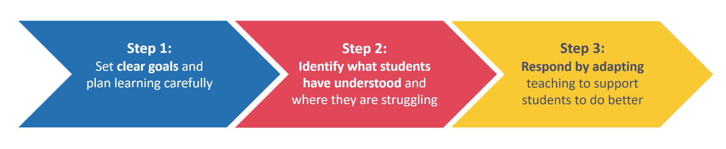
Notes:

Self-regulated learning
“The concept of self-regulated learning is based on the premise that students should take responsibility for their own learning and should play an active role in the learning process.”
(Zimmerman (2001) cited in Mujis & Bokhove, 2020)
Notes:

How can we help pupils achieve self-regulated learning?
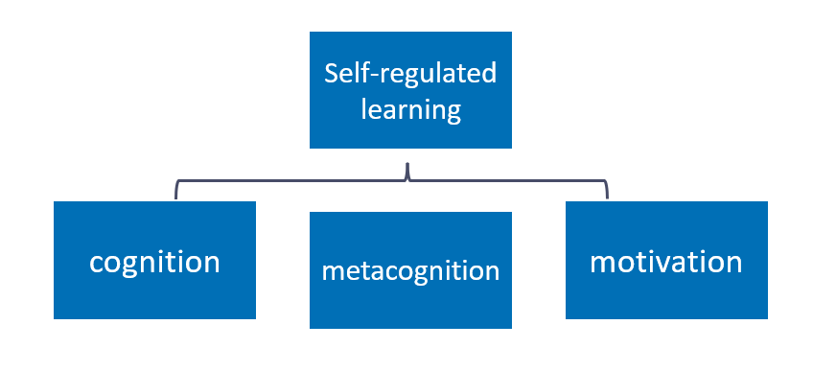
Notes:

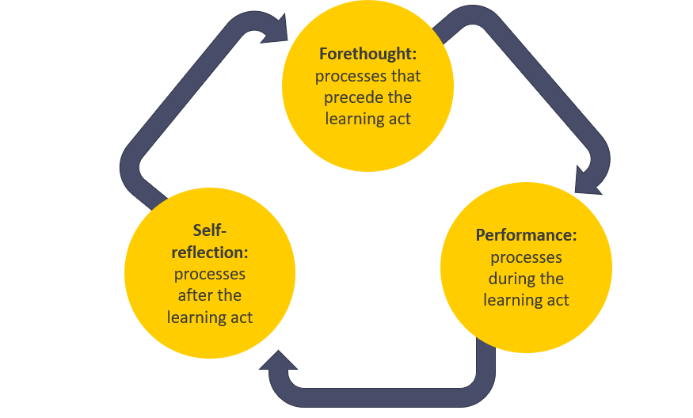
Feedback supports self-regulation

Notes:

High-quality feedback
- Where am I going? What does success look like in this problem or area?
- How am I doing? Relative to success, where am I?
- Where to next? What practical steps can I take to close the gap?
(Hattie & Timperley, 2007)

Notes:

What are module principles?
Module principles are the components of an approach that can be applied across all subjects, phases or settings. They serve as a guide for what good practice is likely to look like.
Module principle | Description
Give feedback to move learning forward. | Pupils need to know specifically how to improve. Ensure feedback is accurate and specific, and that pupils have time and capacity to act on feedback, so they can close the gap between their current performance and the desired goal. Consider context when deciding on the appropriate time to give feedback - factors such as the task, pupils and whole-class understanding (EEF, 2021).
Promote positive engagement. | Pupils are the recipients of feedback and will ideally be motivated to use it to improve. Give pupils the support to process and respond to purposeful feedback that requires them to think hard. Adapt feedback by thinking about the social and emotional factors that may affect pupils’ responses to it.
Encourage long-term progress. | Feedback can take place on three levels: task, process and self-regulation. Feedback on personal traits is unlikely to be useful. Whichever level is used, ensure feedback goes beyond the single output, is linked to pupils' progression and, where relevant, linked to their long-term goals. Over time, use feedback to help pupils monitor and regulate their own learning.
Balance impact and effort. | Feedback can be beneficial for pupil learning but it must not disproportionately impact teachers’ time and workload. Aim to strike a balance between the benefit feedback has on pupil learning and the resources and time dedicated to providing it, reducing the opportunity cost of giving feedback. Work with colleagues to ensure the onus is on the progress pupils make as a result of the feedback as opposed to the work the teacher does to provide the feedback.

I Do
Scenario
Mr Patel has been working on single digit addition with his year 2 class. They have progressed to using the ‘make the next ten’ strategy to solve problems which bridge ten. This strategy involves pupils using ten frames and counters to represent the sum. The pupils have been using the strategy over a series of lessons and are consistently answering questions which bridge ten correctly. Now, they are learning to transfer their working out from the ten frames to a written representation in their books. For the final 15 minutes of the lesson Mr Patel has given his pupils five questions to complete. Pupils can use the ten frames and counters to support them. They are expected to work through these questions independently and to write their working out in their books. At the end of the lesson, Mr Patel asks them to pile up their books on the end of each table, open on the page they have done the questions on. This makes it quicker and easier for him to mark the books as he does not need to find the page he is intending to mark in each book.
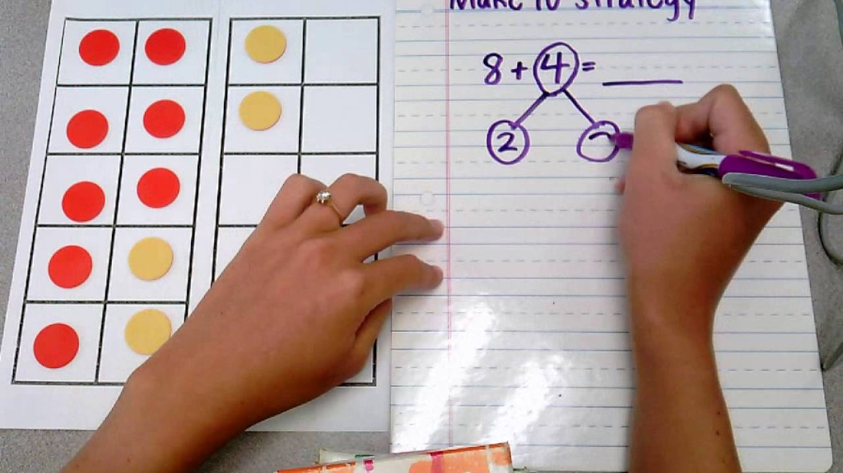
After school, Mr Patel has planned in 20 minutes to mark the five questions in each of his 30 pupils’ books and then 20 minutes to plan his feedback portion of his next maths lesson. Mr Patel selects 5 books as a starting point; two pupils who he knows grasped this quickly when they started working on it, two pupils who he knows struggle to remember mathematical processes and a final book at random. He reviews these books without adding written feedback, reading the working out and answers, scanning for common errors. He finds he can divide the work he has seen into three categories of next steps and common errors.
- Pupils who got both the working out and the answers wrong on three or more of the questions.
- Pupils who got all the questions correct with the correct working out
- Pupils who got all the final answers correct, but their working out isn’t consistently correct. When they were writing their working out, they split the second number into two parts where the first part didn’t always add up to ten.
Now he is confident that he has excavated the common errors that pupils are making in their work, he marks all the pupils’ books by using the following marking codes:
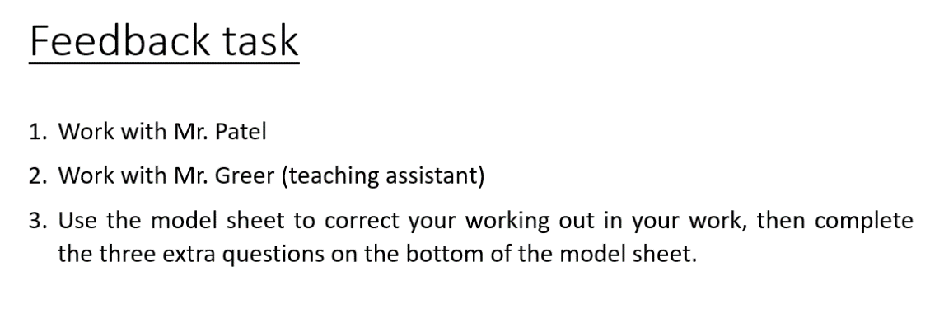
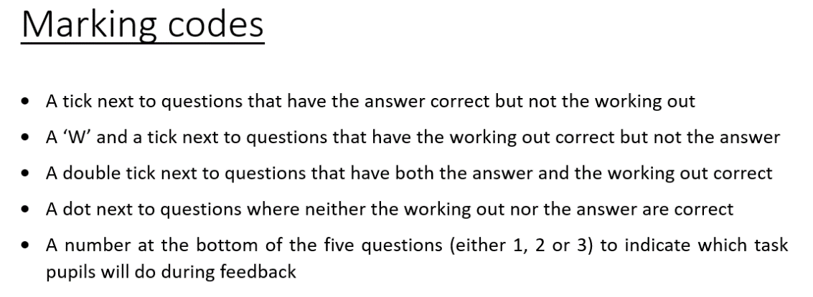
This approach to marking is familiar to pupils as it is routine in the way they receive feedback. While the pupils are responding to his feedback, he puts the marking codes on the board along with three different instructions for each of the three groups of feedback.
At the beginning of the next maths lesson Mr Patel sets up the feedback task:
“Thank you all for your hard work yesterday on those five addition problems. We are doing a great job of using our ten frame to add to make the nearest ten. We are going to respond to feedback now to support us to move to our long-term learning goal: subtracting through ten. In your books I have used the marking codes that we normally use in maths to let you know where you got the working out correct and where you got the answer correct. You will see that I have put a number on your page. You need to follow the instruction for your number, but don’t move until after I have given you the instruction. If you have a 1 on your page you will be working with me. If you have got a two on your page you are going to move to the back to work with Mr. Greer. If you have a three on your page, then you need to use the model sheet which shows you the correct answers and working out to correct anything incorrect in your work. Then you need to complete the three additional questions in your book. Off you go.”

Task: Take notes while the facilitator models how the module principles appear in the first scenario. As this scenario was used for the pre-clinic task, you may also want to compare your own notes and reflections.

Module principle | Response/suggestion
Give feedback to move learning forward.
Promote positive engagement.
Encourage long-term progress.
Balance impact and effort.
Other notes:

We Do
There are two ‘We do’ scenarios. Read and analyse each scenario with the following questions in mind. Use the table below the scenarios to write your response.
- Where can you see evidence of the module principles in the scenario?
- What impact do the module principles have on the teacher’s actions and practice?

We do – Scenario 1

Mr Ridge’s reception class are sat on the carpet practising forming the letter ‘b’ in both capital and lower case on their whiteboards. Mr Ridge has modelled the letter formation for pupils and is now circulating while they are forming their own letter ‘b’s. As is circulates he notices that a small number of pupils are forming their lowercase ‘b’ with the semi-circle to the left of the line instead of the right of the line, so it appears more like a ‘d’. He quickly moves round the room and puts a small blue card with a star on the carpet next to every pupil that he sees making this error. Pupils haven’t all finished the task, but he can see which pupils are consistently forming the letter correctly, and which are not. Mr Ridge gets his pupil’s attention using a call and response clap, as per his classroom routine.
‘I have had a look at the letter ‘b’s on our whiteboards and I am really impressed with how we have picked this up! Just like my model I am seeing a lot of nice long straight lines down from the top of our handwriting line, we have then brought our pen back up to the middle and drawn a curved line to the bottom of our long line.’ He models this with his pen on the flipchart paper as he speaks, looking over his shoulder and scanning the room to ensure pupil’s attention is on his paper. ‘If I put a blue card next to you, when I say go, head over to the yellow table with your whiteboard and pen to work with Miss Thom. Go.’
Mr Ridge has asked Miss Thom to re-model the letter formation to the five pupils who had a blue card, highlighting how to correct the persistent error in their letter formation. For the pupils that have remained on the carpet Mr Ridge moves them on to practicing writing the letter ‘b’ on paper with pencil. He had noticed that one pupil in this group was making a small error when forming their letter so as the pupils practice, Mr Ridge moves to this pupil, bends to their level, and corrects the error:
‘You have been getting the shape right on this letter, with a nice wide loop at the bottom. Well done. Be careful when you are drawing your long line down, it needs to be straight. Practise for me on the whiteboard now, draw me 5 long straight lines nice and spaced out. Take your time, don’t rush them.’
The pupil practises the line, and it is much straighter than in the previous practice.
‘Fantastic, those lines are so much straighter! Make sure they stay super straight when you are practising in your book with pencil. You can do that now.’

We do – Scenario 2
Mr Edmunds is a teacher in a complex needs school. He is currently teaching science to his year 4 class. In this lesson, he is teaching the pupils about properties of materials, specifically, the difference between the feeling of rough and smooth. Mr Edmunds has a range of items and materials for pupils to manipulate and investigate. Pupils then need to organise them into two groups depending on whether they think the item is rough or smooth.

Mr Edmunds has asked his support staff to work with individual children while he works with the group of pupils who use signing to communicate. This means that all pupils can receive focused support, and, where needed, additional feedback on how to progress.

The pupils in his group are engaging in the task; they are picking up the items to explore them independently. Mr Edmunds praises the students by saying and signing: “well done, I can see you are thinking hard about these items”. Mr Edmunds encourages the pupils to begin grouping the items, by modelling the activity of feeling the item and placing it in the correct group. As he places the item in the correct group, he signs and says the words rough and smooth.

Mr Edmunds notices that one pupil, Oskar, is mixing the two descriptions and placing smooth items under the word rough and vice-versa. He can see that Oskar needs some additional support to correct this misconception. While the rest of the group continue independently, he signs and says to Oskar directly: “Well done Oskar. You have tried hard to sort these items. Feel for bumps to help you find rough items.” Mr Edmunds knows that using visuals as well as signs helps Oskar, so he provides two visuals from Communication in Print that show the concepts of ‘rough’ and ‘smooth’. To reinforce this feedback, he models exploring one more rough item, placing it in the correct group, and signing the word ‘rough’. Mr Edmunds knows that he may need to remodel identifying rough and smooth items if Oskar continues to struggle, but is aware that this may be enough support for Oskar to progress.

Mr Edmunds then gives Oskar time to process and respond to this feedback. He gives Oskar four items, one at a time, to manipulate and place into the correct group. Oskar practises this and puts the items in the correct groups. Mr Edmunds reinforces this by saying and signing “Yes, that one is rough/smooth. Well done, Oskar.”

The following week, Mr Edmunds gives pupils a new set of items to sort into ‘rough’ and ‘smooth’ groups. During this task, he can see that Oskar is accurately and more confidently sorting items. Mr Edmunds knows that it is important to revisit new ideas in increasing intervals to support learning over time. However, he is increasingly confident that Oskar and the class securely understand the distinction between these two concepts.

Analysis
Module principle | We do scenario 1 | We do scenario 2
Give feedback to move learning forward.
Promote positive engagement.
Encourage long-term progress.
Balance impact and effort.
Other notes:

Task: share in pairs.
Notes:

Task: share with the group.

Reflect and record: Reflect on the group discussion and record your final thoughts on the ‘we do’ scenarios.
Notes:

Option A: Non-example
Mr Patel has been working on doing single digit addition with his Year 2 class, they have progressed to doing this addition where the number problem ‘bridges ten’ using the ‘make the next ten’ strategy. To do this his pupils have been using ten frames and counters to represent the sum to support them to find the answer. His pupils have been working on this for a while and are all able to consistently get to the correct answer most of the time in this way. Now, they are learning to transfer their working out from the ten frames to a written representation in their books. Maths is the last lesson of the day today, so for the final 15 minutes of the lesson Mr Patel has given his pupils five questions to complete. Pupils can use the ten frames and counters to support them, but they are expected to work through these questions independently and to write their working out in their books. Once pupils have completed their questions and are ready to pack up, Mr Patel asks them to pile up their books on the end of each table open on the page they have done the questions on. This makes it quicker and easier for him to mark the books as he does not need to find the page he is intending to mark in each book.
His pupils have gone home, he sits down to mark their work. He ticks and crosses answers where pupils are answering correctly and incorrectly. He spots that about half of pupils have been splitting up the second number in the problem incorrectly and it appears to be inhibiting them from reaching to correct answer. He stops marking the books halfway through the set of 32 and decides that he will need to re-teach the written working out method which pupils are clearly struggling to grasp.
At the beginning of the next maths lesson Mr Patel addresses pupils before he re-teaches the process of representing their working out in written form.

“I have marked some books and think we need to have a look together at how we can write our working out so we can move away from using out ten-frames. We are going to look at this question on the board together.”

Mr Patel has re-modelled the working out process, breaking it down into smaller steps and exposing his thinking at each point to pupils. He then uses mini whiteboards to give pupils a few practice questions that they hold up and he checks. By the third practice question all pupils appear to have written the working out and the answer correct. He then puts a further five practice questions on the board for pupils to attempt independently. He circulates whilst pupils are completing their work and for the pupils whose books he didn’t mark yesterday, he quickly ticks or crosses their answers. He finds that around 10 of these books contained all correct answers and working out. For these pupils he decides that when they have finished doing the five questions that he had set everyone to do today he will give them an extension task which focuses on begin to work backward to ‘subtract through ten’.

Answer the following questions:

1. Which of the module principles are not present in this scenario? (there may be more than one)
  - Give feedback to move learning forward.
  - Promote positive engagement.
  - Encourage long-term progress.
  - Balance impact and effort.
Provide your reasoning for the missing module principle(s):

Notes:

What impact does the missing module principle have on the scenario?
Notes:

Option B: Planning/Practice task

Task:
Either: Identify an upcoming lesson in which you will need to provide feedback in response to a piece of work that pupils have already completed.
Or: Identify an upcoming lesson in which you will be providing feedback on an on-going task that pupils have been working on.
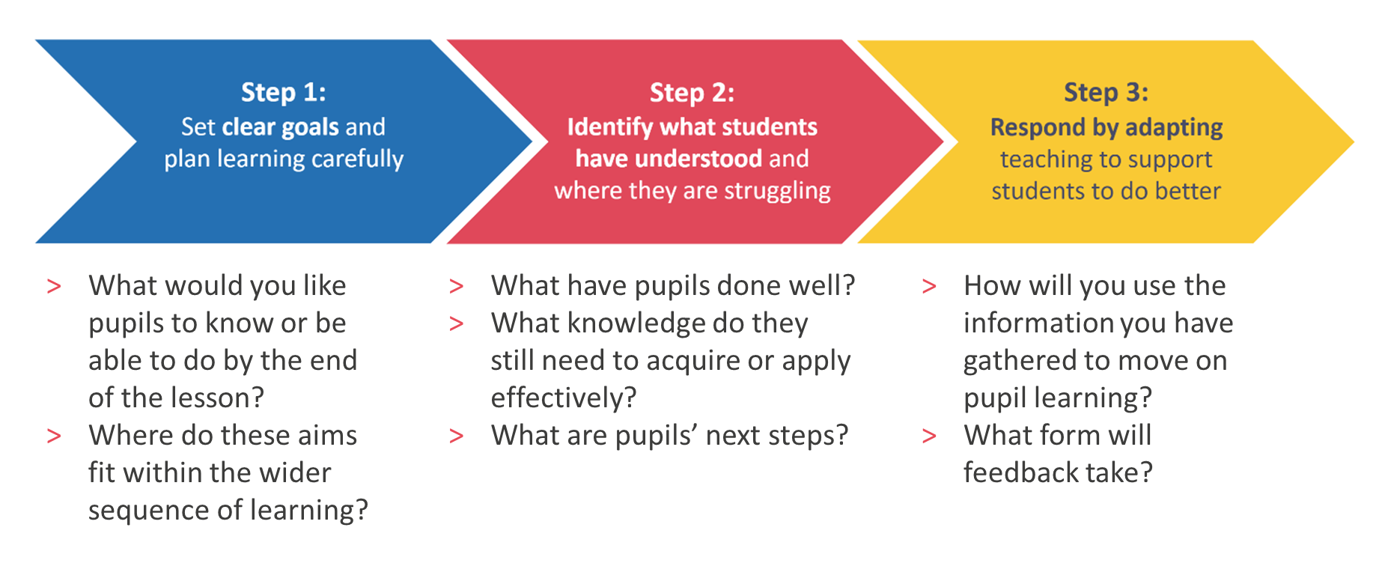

Notes:

Task: Plan your feedback task, using the question prompts to help you address each of the module principles in your planning.

Module principle | Question prompts:
Give feedback to move learning forward. | What knowledge do you need to impart during your feedback? What do pupils need to do to improve and how can you communicate these next steps concisely? What activities will pupils complete during, or in response to, your feedback? How do these activities encourage pupils to think hard about critical knowledge? How will they apply the knowledge you have imparted?
Promote positive engagement. | How can you use praise to acknowledge pupil effort and progress so far? Are there any pupils with specific needs that need to be considered in the feedback process? If so, how will you respond to these needs? What might be some social and emotional factors that may affect pupils’ responses to feedback?
Encourage long-term progress. | What level is the feedback taking place on: task, process or self-regulation? How will this feedback support pupils to achieve their long-term learning goals? How does the feedback help pupils monitor and regulate their own learning? What critical knowledge are pupils acquiring or applying? What misconceptions are you addressing?
Balance impact and effort. | What critical knowledge are pupils acquiring or applying? What resources will you need to create to deliver your feedback and support pupils to respond to it? Is the progress pupils make going to be greater than the work taken to provide the feedback? Are any resources created directly impacting pupil progress?

Module principle | Notes
Give feedback to move learning forward.
Promote positive engagement.
Encourage long-term progress.
Balance impact and effort.

Applying the module principles: Model

Module principle | Notes
Give feedback to move learning forward. | I need some pupils to work on their stride length during their run up and others to work on using their arms and legs to launch themselves forward when jumping. I will explain that pupils have been organised into small groups to work on one of these two phases of the jump. I will give pupils a recorded version of their phase to support them when practising.  Before pupils break off into new groups, I will ask them to recall the key components of the phases they are working on. I will then explain that these components are identified in the videos they will be using to support them. This will ensure that pupils are focusing on the underlying features that will support them with their run up and launch.
Promote positive engagement. | I will emphasise that each phase of the long jump is challenging and praise pupils for their progress with stages one and two so far. I will place pupil X with pupil Y, as I know that pupil Y has previously worked well with pupil X to build his confidence.
Encourage long-term progress. | When pupils have recalled the key components of the phases they are working on, I will use questioning to prompt them to consider why these components are important and how they contribute to the overall success of the jump. This links the specific skill they are working on to their wider aim of completing a successful long jump.
Balance impact and effort. | The only physical resource I will need is the recordings of each phase of the long jump, which I already have from previous lessons. This resource can be used across the sequence of lessons and in following years, so was a useful investment of time.

Reflection
- Of the module principles we have looked at today, which do you already feel most confident with?
- Which module principles do you find more challenging and why?
- What are you next steps in response to this clinic? What or who will support you to achieve these?

Notes:

Option C: I Do 2

Ms Jama’s year 5 class are working on a unit about athletic field events in PE. Today’s lesson focuses on improving their long-jump technique. Ms Jama has broken the technique down into three parts – the run-up, the launch and the landing – and has modelled each part to the class. Pupils then practise each part individually before putting all three parts together for a full long jump.
As her pupils practise in small groups, Ms Jama circulates with a clipboard, making notes on technique and spotting any common errors. This helps her quickly identify patterns in how pupils are performing. While observing one group, she notices a mistake that she wants to address straight away. She stops the group and asks, “Let’s take a closer look at our launching foot. Should we be launching from a flat foot or on our toes?”
Ms Jama picks a pupil she has seen launching on their toes, as she wants to check if this is a misunderstanding or just a slip. The pupil responds that the launch should be from a flat foot, which is correct. Ms Jama then asks another pupil, “Why do we launch from a flat foot?” The pupil answers correctly. Ms Jama explains, “Exactly – launching from a flat foot helps our hips move forward more quickly, so we can jump further. Keep practising with that flat launch foot in mind.”
She keeps back the pupil who had been launching from their toes and gives some targeted feedback: “Your run-up is really improving, but you’re losing some momentum because of how you’re using your foot when you launch. Watch my foot as I show you.” Ms Jama demonstrates the correct launch, then asks the pupil to try again. The pupil attempts the flat-footed launch. “That’s much better. For your next few goes, focus on keeping that foot flat. Well done.”
Ms Jama continues to circulate and notices a few pupils making their strides too long, too early in their run-up. She also sees that no one is yet able to launch with both arms and legs in front of their body, which would help stop them from landing with their hands behind them. Ms Jama brings the class together and shares her observations. She reshuffles the small groups and gives each group a specific phase of the long jump to focus on. Each group uses a tablet with a pre-loaded video showing the phase they are practising. As Ms Jama visits each group, she continues to offer tailored feedback to help pupils refine their techniques.

Task: Take notes while the facilitator models how the module principles appear in this scenario.

Module principle | Response/suggestion
Give feedback to move learning forward.
Promote positive engagement.
Encourage long-term progress.
Balance impact and effort.
Other notes:

Close

Reflection:

- Of the module principles, which do you already use to help you to use effective feedback?
- Which of the module principles will you use more in order to support you to:
  - Give effective feedback
  - Manage your workload
  - Support your pupils to develop self-regulation

Notes:

References
Barker, J., & Rees, T. (2020). Persistent problems in school leadership. Ambition Institute. https://www.ambition.org.uk/blog/persistent-problems-school-leadership/
Boekaerts, M. (1999). Self-regulated learning: Where we are today. International Journal of Educational Research, 31(6), 445–457. https://citeseerx.ist.psu.edu/document?repid=rep1&type=pdf&doi=1b7d78491d148bde29d9d1bdb6017706b87c2b08
Dinsmore, D. L., Alexander, P. A., & Loughlin, S. M. (2008). Focusing the conceptual lens on metacognition, self-regulation, and self-regulated learning. Educational Psychology Review, 20(4), 391–409. https://nschwartz.yourweb.csuchico.edu/Dinsmore.metacognition.pdf
Fletcher-Wood, H. (2018). Responsive teaching: Cognitive science and formative assessment in practice. Routledge.
Fletcher-Wood, H. (2018, June 3). What is responsive teaching? Improving Teaching. https://improvingteaching.co.uk/2018/06/03/what-is-responsive-teaching/
Hattie, J., & Timperley, H. (2007). The power of feedback. Review of Educational Research, 77(1), 81–112. RER298487.qxd
Kennedy, M., (2016). Parsing the Practice of Teaching. Journal of Teacher Education. SAGE Publications, 67(1) pp. 6–17. https://journals.sagepub.com/doi/abs/10.1177/0022487115614617
Muijs, D., & Bokhove, C. (2020). Metacognition and self-regulation: Evidence review. Education Endowment Foundation. https://educationendowmentfoundation.org.uk/education-evidence/evidence-reviews/metacognition-and-self-regulation
Ward, A. F., Duke, K., Gneezy, A., & Bos, M. W. (2017). Brain drain: The mere presence of one’s own smartphone reduces available cognitive capacity. Journal of the Association for Consumer Research, 2(2), 140–154. https://doi.org/10.1086/691462
Zimmerman, B. J. (2000). Self-efficacy: An essential motive to learn. Contemporary Educational Psychology, 25(1), 82–91. https://ssrlsig.org/wp-content/uploads/2018/01/zimmerman-2000-self-efficacy-an-essential-motive-to-learn.pdf
Zimmerman, B. J. (2001). Becoming a self-regulated learner: An overview. Theory Into Practice, 41(2), 64–70. http://mathedseminar.pbworks.com/w/file/fetch/94760840/Zimmerman%20-%202002%20-%20Becoming%20a%20SelfRegulated%20Learner%20An%20Overview.pdf

