Early Career Training Programme

Clinic 3: Effective Feedback
Participant Workbook
(Secondary Pack)
Name: ………………………………………………………………………………..
Session date: ………………………………………………………………………

Pre-clinic tasks 3
Teaching problem 8
I Do 12
We Do 15
Option A: Non-example 20
Option B: Planning/Practice task 22
Option C: I Do 2 28
Close 31
References 32

Pre-clinic tasks
The following tasks are to be completed before you attend Clinic 3. This should take no longer than 30 minutes
In Clinic 3, you will read and analyse 3-4 scenarios that consider the following teaching problem across a range of contexts:

How can teachers give timely and high-quality feedback that supports pupil progress and is considerate of workload?

The scenarios will exemplify the five module principles below, demonstrating how teachers can hold meaningful conversations with a range of people to provide appropriate support for pupils.
Module principle | Description
Give feedback to move learning forward. | Pupils need to know specifically how to improve. Ensure feedback is accurate and specific, and that pupils have time and capacity to act on feedback, so they can close the gap between their current performance and the desired goal. Consider context when deciding on the appropriate time to give feedback - factors such as the task, pupils and whole-class understanding (EEF, 2021).
Promote positive engagement. | Pupils are the recipients of feedback and will ideally be motivated to use it to improve. Give pupils the support to process and respond to purposeful feedback that requires them to think hard. Adapt feedback by thinking about the social and emotional factors that may affect pupils’ responses to it.
Encourage long-term progress. | Feedback can take place on three levels: task, process and self-regulation. Feedback on personal traits is unlikely to be useful. Whichever level is used, ensure feedback goes beyond the single output, is linked to pupils' progression and, where relevant, linked to their long-term goals. Over time, use feedback to help pupils monitor and regulate their own learning.
Balance impact and effort. | Feedback can be beneficial for pupil learning but it must not disproportionately impact teachers’ time and workload. Aim to strike a balance between the benefit feedback has on pupil learning and the resources and time dedicated to providing it, reducing the opportunity cost of giving feedback. Work with colleagues to ensure the onus is on the progress pupils make as a result of the feedback as opposed to the work the teacher does to provide the feedback.

These module principles are relevant to all teachers and can be applied across all contexts, regardless of phase, subject or setting. For instance, high-quality feedback may include written marking in some circumstances, but it might also look like verbal feedback, self-assessment or code marking – depending on the task, subject, age and stage of pupils, or wider context such as time available. While feedback looks different on the surface, the module principles are the underlying principles that stay the same.
The following two tasks will help you to familiarise yourself with the module principles before you attend the clinic. During the clinic, you will build on this prior knowledge by exploring the module principles in greater depth with the support of your facilitator, before applying these to your own practice.

Task 1
- Read the scenario below.
- Answer the questions, using the module principle as a guide.

Ms Jama Y8s are working on a unit on athletic field events. Today’s focus is perfecting the technique required for long-jump. Ms Jama has broken the technique down into three parts (run, launch and landing) and modelled these to pupils, who then practised each part individually. Next, pupils practise their full long jump by putting the three parts together. As her pupils work in small groups, Mrs Jama circulates with a clipboard, noting down feedback on technique and common errors. This method allows her to easily see patterns in pupil performance. As she watches one group, she notices an error that she wants to correct immediately. She stops the group and intervenes: “I’d like us to just take a closer look at our launching foot. Should we be launching from a flat foot, or on our toes?”
Ms Jama selects a pupil that she saw launching with toes, as she wants to establish whether this is a misunderstanding or an incorrect application of knowledge. The pupils responds that the launch should be from a flat foot, which is correct. Ms Jama moves to another pupil. “Why are we launching with a flat foot?”. They respond correctly. Ms Jama says, "okay, so we know that we are launching with a flat foot because it helps our hips to move forward quicker, enabling us to jump further. Keep practising with that flat launch foot in mind.” She holds back the pupil who she had seen jumping from their toes; “Your run up has a good rhythm to it now, but you are losing momentum because of the angle of your foot when you launch. Watch my foot here as I launch”. Ms Jama demonstrates the launch. “Now you show me.” The pupil attempts the flat-footed launch. “That’s much better. For your next few practices, I want your focus to be on keeping that foot flat. Well done”.
Ms Jama continues to circulate. She notices a few pupils shifting their strides into longer steps too early in their run up and can see that no pupils are yet able to launch themselves forward with both their arms and legs in front of their body, to stop them from putting their hands behind their body when they land. Ms Jama brings the class together and tells them what she has noticed. In response to her observations, she has reshuffled the small groups and allocated a specific phase of the long jump for each group to focus on. Each group has a tablet with a pre-loaded video that models the phase of the long jump they are working on. As Ms Jama moves around the groups, she continues to give tailored feedback where appropriate to support pupils to refine their techniques.

After reading the scenario, reflect on the following questions and respond, using the table below:

Module Principle | Question(s) | Response
Give feedback to move learning forward. | Where does the teacher use visual cues to help her give feedback? What specific guidance does she give pupils about how to improve? Where does the teacher prompt pupils to think hard and make improvements based on the feedback? How is the task structured to ensure pupils have time and support to respond?
Promote positive engagement. | How does the teacher frame feedback in a way that is considerate of pupils’ feelings?
Encourage long-term progress. | How does the teacher give feedback which helps to develop pupil understanding and put this knowledge into practice? How does she link it to long-term goals?
Balance impact and effort. | How does the teacher plan for and provide feedback that is beneficial for pupils, but is considerate of her time and workload?

Task 2
- Take a moment to reflect on the module principles for this clinic.
- Consider some recent feedback you have provided for pupils.
- Complete the table on the following page, reflecting on your experience.

Example: This is completed example for the first two module principles to support your thinking.
Module principle | Do you feel that you applied this module principle? | If yes, how did this module principle support your practice? | If no, what might you do next time to use this module principle?
Give feedback to move learning forward | Yes | Marked a Y9 task, and wrote a code on each which corresponded to a piece of clear and specific feedback for improvement. This meant pupil knew exactly what to do to improve, and could spend the time in lesson thinking carefully about how to put the feedback into practice.
Promote positive engagement | No |  | When framing the task, I focused more on how to use the codes, rather than also taking the time to acknowledge the effort pupils put in. I could pre-plan how I want to introduce feedback and then put 3 bullet points on the board to prompt me in the lesson.

Module principle | Do you feel that you applied this module principle? (Y/N) | If yes, how did this module principle support your practice? | If no, what might you do next time to use this module principle?
Give feedback to move learning forward.
Promote positive engagement.
Encourage long-term progress.
Balance impact and effort.

Teaching problem

In today’s session we will consider the following typical teaching problem:

How can teachers give timely and high-quality feedback that supports pupil progress and is considerate of workload?

Paired discussion
Task: Reflect on your knowledge of the principles of feedback, and your own experiences with this so far. In your pair, discuss the following questions:
- What is the purpose of giving pupils feedback?
- What forms can this feedback take?

Notes:

Adaptive teaching
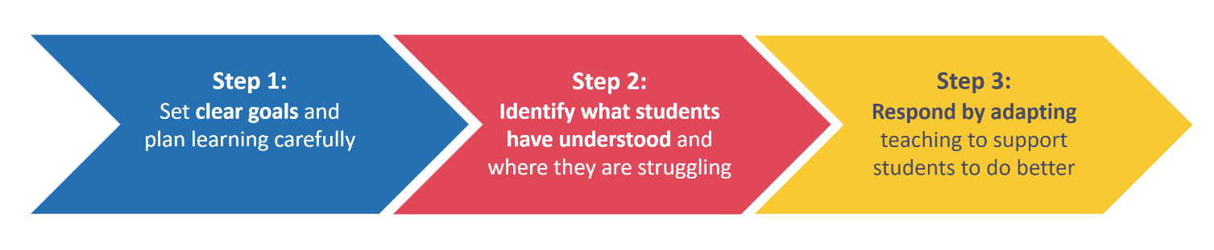
Notes:

Self-regulated learning
“The concept of self-regulated learning is based on the premise that students should take responsibility for their own learning and should play an active role in the learning process.”
(Zimmerman (2001) cited in Mujis & Bokhove, 2020)
Notes:

How can we help pupils achieve self-regulated learning?
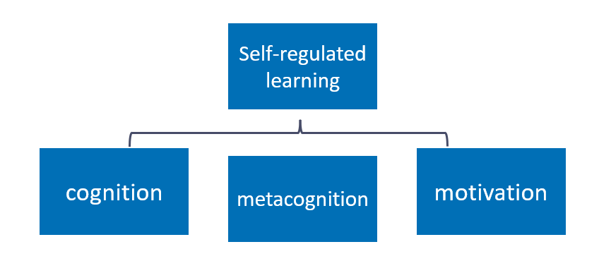
Notes:

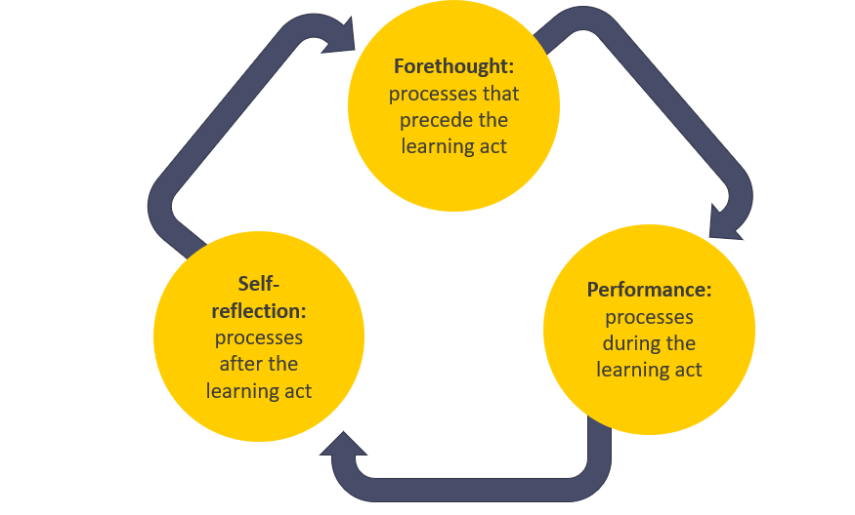
Feedback supports self-regulation

Notes:

High-quality feedback
- Where am I going? What does success look like in this problem or area?
- How am I doing? Relative to success, where am I?
- Where to next? What practical steps can I take to close the gap?
(Hattie & Timperley, 2007)

Notes:

What are module principles?
Module principles are the components of an approach that can be applied across all subjects, phases or settings. They serve as a guide for what good practice is likely to look like.

Module principles | Description
Give feedback to move learning forward. | Pupils need to know specifically how to improve. Ensure feedback is accurate and specific, and that pupils have time and capacity to act on feedback, so they can close the gap between their current performance and the desired goal. Consider context when deciding on the appropriate time to give feedback - factors such as the task, pupils and whole-class understanding (EEF, 2021).
Promote positive engagement. | Pupils are the recipients of feedback and will ideally be motivated to use it to improve. Give pupils the support to process and respond to purposeful feedback that requires them to think hard. Adapt feedback by thinking about the social and emotional factors that may affect pupils’ responses to it.
Encourage long-term progress. | Feedback can take place on three levels: task, process and self-regulation. Feedback on personal traits is unlikely to be useful. Whichever level is used, ensure feedback goes beyond the single output, is linked to pupils' progression and, where relevant, linked to their long-term goals. Over time, use feedback to help pupils monitor and regulate their own learning.
Balance impact and effort. | Feedback can be beneficial for pupil learning but it must not disproportionately impact teachers’ time and workload. Aim to strike a balance between the benefit feedback has on pupil learning and the resources and time dedicated to providing it, reducing the opportunity cost of giving feedback. Work with colleagues to ensure the onus is on the progress pupils make as a result of the feedback as opposed to the work the teacher does to provide the feedback.

I Do
  - Scenario
Mr Carchek teaches a Year 7 Religious Studies class with a small number of pupils. Since last week he has managed to read of all their written work about how the parables in the Bible have been interpreted in different ways by Christians. He didn’t write comments in books as he just wanted to establish how successful this writing activity had been and to check for any misconceptions he can address in the next lesson. He notices a common misconception that pupils often have when studying the Bible in this Christianity unit: Jesus wrote the Bible. Although this group have been taught the difference between the New and Old Testaments, this misconception clearly still pervades. When pupils were writing, they were using a writing frame to support them as this is a scaffold that they all needed to enable them to complete this longer piece of writing. This writing frame didn’t give a sentence starter for how they should quote from the Bible but just said ‘add evidence from the Bible’ and consequently pupils have written phrases like: “In the Bible Jesus says…”.
This class needs lots of support when working independently but Mr Carchek knows that if he breaks the task down into small, guided steps they will be able to correct their own work.
Mr Carchek has created a quiz which he has printed for pupils to complete when they enter the classroom where they need to select the correct answer by circling one of the two options within the sentence.
- The Old Testament of the Bible was written before / after Jesus was born.
- The New Testament of the Bible was written before / after Jesus was born.
- Both Testaments of the Bible were written by Jesus / lots of different people inspired by the Holy Spirit.
At the beginning of the lesson pupils complete this quiz independently and they mark it as a class. Mr Carchek uses a hands up strategy to establish how many pupils answered correctly. He discovers that nearly all pupils answered all three questions correctly. He thinks that it is likely when given a 50/50 answer option pupils can more easily and successfully retrieve and connect what they have been taught previously about the Bible than when they needed to apply it to their writing. So, he moves the focus of the lesson to correcting the common errors in pupils’ writing from last lesson:
“I noticed when I read our work we had written things like this when you were quoting the bible:
In the Bible Jesus says that ‘For God loved the world so that he gave his one and only Son.’
Why is it incorrect to use the phrase ‘Jesus says’?”
Pupils raise their hands, keen to answer the question. Mr Carchek cold calls a pupil:
“Because Jesus wasn’t alive until after the Old Testament so he couldn’t have said it”
Mr Carchek responds:
“You’re right, that’s one reason that we can’t say ‘Jesus says’ when writing about the Old Testament. But the other reason is that we already know who wrote the Bible…who was it? Use your quiz from the beginning of the lesson to help you”
He cold calls a pupil:
“Lots of different people inspired by the Holy Spirit”.
Mr Carchek: “Exactly, I am going to ask you a question you can all answer aloud together. If I say ‘Jesus says in the Bible’ would I be correct or incorrect?”
Pupils respond ‘incorrect’ in unison.
Mr Carchek: “Why would I be incorrect?” He holds his hand up to signal to pupils that this time he isn’t looking for an answer in unison.
He cold calls a pupil: “Because the Bible was written by lots of different people inspired by the Holy Spirit”.
Mr Carchek: “Great stuff Y7, I have got three phrases on the board that you can use when you want to quote the Bible. I want you to go through your work. Anywhere you have written ‘Jesus says’, change it to one of these phrases. Off you go.”
‘In the Bible it says…’
‘The Bible teaches that…’
‘According to the Bible…’

Task: Take notes while the facilitator models how the module principles appear in the first scenario. As this scenario was used for the pre-clinic task, you may also want to compare your own notes and reflections.

Module principle | Response/suggestion
Give feedback to move learning forward.
Promote positive engagement.
Encourage long-term progress.
Balance impact and effort.
Other notes:

We Do
There are two ‘We do’ scenarios. Read and analyse each scenario with the following questions in mind. Use the table below the scenarios to write your response.
- Where can you see evidence of the module principles in the scenario?
- What impact do the module principles have on the teacher’s actions and practice?

We do – Scenario 1

Ms Jama Y8s are working on a unit on athletic field events. Today’s focus is perfecting the technique required for long-jump. Ms Jama has broken the technique down into three parts (run, launch and landing) and modelled these to pupils, who then practised each part individually. Next, pupils practise their full long jump by putting the three parts together. As her pupils work in small groups, Mrs Jama circulates with a clipboard, noting down feedback on technique and common errors. This method allows her to easily see patterns in pupil performance. As she watches one group, she notices an error that she wants to correct immediately. She stops the group and intervenes: “I’d like us to just take a closer look at our launching foot. Should we be launching from a flat foot, or on our toes?”
Ms Jama selects a pupil that she saw launching with toes, as she wants to establish whether this is a misunderstanding or an incorrect application of knowledge. The pupils responds that the launch should be from a flat foot, which is correct. Ms Jama moves to another pupil. “Why are we launching with a flat foot?”. They respond correctly. Ms Jama says, "okay, so we know that we are launching with a flat foot because it helps our hips to move forward quicker, enabling us to jump further. Keep practising with that flat launch foot in mind.” She holds back the pupil who she had seen jumping from their toes; “Your run up has a good rhythm to it now, but you are losing momentum because of the angle of your foot when you launch. Watch my foot here as I launch”. Ms Jama demonstrates the launch. “Now you show me.” The pupil attempts the flat-footed launch. “That’s much better. For your next few practices, I want your focus to be on keeping that foot flat. Well done”.
Ms Jama continues to circulate. She notices a few pupils shifting their strides into longer steps too early in their run up and can see that no pupils are yet able to launch themselves forward with both their arms and legs in front of their body, to stop them from putting their hands behind their body when they land. Ms Jama brings the class together and tells them what she has noticed. In response to her observations, she has reshuffled the small groups and allocated a specific phase of the long jump for each group to focus on. Each group has a tablet with a pre-loaded video that models the phase of the long jump they are working on. As Ms Jama moves around the groups, she continues to give tailored feedback where appropriate to support pupils to refine their techniques.

We do – Scenario 2

Mrs McKay is a teacher at a specialist school. She is currently working with her Year 11 GCSE history group, which is made up of 8 pupils. In a previous lesson, pupils practised some questions from a GCSE paper. Mrs McKay has marked these, and so today’s lesson is focused on reviewing and improving their responses. The class are used to having verbal feedback from the adults in the class but understand that for GCSE practise the teacher will have marked their work and will provide written feedback. This is now part of their end of topic routine.
In her preparation for this lesson, Mrs McKay was mindful of pupils’ individual needs. When she marked pupils’ responses, she wrote short, concise comments to allow pupils to process and understand her feedback. She then identified five pupils who would need verbal feedback alongside written feedback. She was also mindful that this verbal feedback would need to be one-to-one, as whole class feedback could cause anxiety and impact pupil confidence.
In the feedback lesson, Mrs McKay starts by giving pupils an independent revision task. This is a familiar routine, so pupils are quick to start. This gives Mrs McKay time to set all pupils up for the lesson. The three pupils who are able to respond independently to written feedback are directed to move onto this when they finish their first task. Mrs McKay and her support staff then begin working with individual pupils to provide them focused, verbal support.
Mrs McKay works with Reece. She starts by highlighting where he has answered well. She then verbally gives Reece two specific, actionable next steps to improve his responses that she knows will require him to think hard. While doing this, she intentionally uses the same phases that she has written on his paper. Mrs McKay then live models an example to show Reece her thought process for writing an improved response using this feedback. Finally, she checks Reece’s understanding of what she has said by prompting him to briefly explain how he is going to improve his responses and why. When she is confident that he has understood, she asks him to read her written feedback as a reminder and prompt, and to attempt improve one question. She explains that she will work with Reece again before the end of the lesson to give him verbal feedback on his improvements, and moves to work with another pupil who is finishing her independent revision task.
Before the end of the lesson, Mrs McKay goes back to work with Reece to review his improvements. He has been able to improve a question based on the feedback Mrs McKay provided. Mrs McKay is confident he has developed his understanding of these two areas for improvement, though she knows that these are areas to monitor when Reece completes similar questions. Finally, Mrs McKay knows that Reece responds well to praise so she invites over the teaching assistant to celebrate his work.

Analysis
Module principle | We do scenario 1 | We do scenario 2
Give feedback to move learning forward.
Promote positive engagement.
Encourage long-term progress.
Balance impact and effort.
Other notes:

Task: share in pairs.
Notes:

Task: share with the group.

Reflect and record: Reflect on the group discussion and record your final thoughts on the ‘we do’ scenarios.
Notes:

Option A: Non-example
Scenario
Mr Carchek teaches a Year 7 Religious Studies class with a small number of pupils. Since last week he has managed to read all their written work about how the parables in the Bible have been interpreted in different ways by Christians.
He notices a common misconception that pupils often have when studying the Bible in this Christianity unit: Jesus wrote the Bible. Although this group have been taught the difference between the New and Old Testaments, this misconception clearly still pervades. When pupils were writing, they were using a writing frame to support them as this is a scaffold that they all needed to enable them to complete this longer piece of writing. This writing frame didn’t give a sentence starter for how they should quote from the Bible but just said ‘add evidence from the Bible’ and consequently pupils have written phrases like: “In the Bible Jesus says…”.
This class needs lots of support when working independently but Mr Carchek knows that if he breaks the task down into small, guided steps they will be able to correct their own work. He has therefore written individual comments in each pupil’s book, explaining why the use of the phrase “Jesus says” is incorrect with a model for how pupils might re-phrase, and has highlighted the sentences pupils need to change.
To prepare to reteach this idea in the lesson, Mr Carchek has also created a quiz which he has printed for pupils to complete when they enter the classroom where they need to select the correct answer by circling one of the two options within the sentence.
- The Old Testament of the Bible was written before / after Jesus was born.
- The New Testament of the Bible was written before / after Jesus was born.
- Both Testaments of the Bible were written by Jesus / lots of different people inspired by the Holy Spirit.
At the beginning of the lesson pupils complete this quiz independently and they mark it as a class. Mr Carchek uses a hands up strategy to establish how many pupils answered correctly. He discovers that nearly all pupils answered all three questions correctly. He thinks that it is likely when given a 50/50 answer option pupils can more easily and successfully retrieve and connect what they have been taught previously about the Bible than when they needed to apply it to their writing. So, he moves the focus of the lesson to correcting the common errors in pupils’ writing from last lesson:
“I noticed when I read our work we had written things like this when you were quoting the bible: In the Bible Jesus says that ‘For God loved the world so that he gave his one and only Son.’ Why is it incorrect to use the phrase ‘Jesus says’?”
Pupils raise their hands, keen to answer the question. Mr Carchek cold calls a pupil: “Because Jesus wasn’t alive until after the Old Testament so he couldn’t have said it.”
Mr Carchek responds: “You’re right, that’s one reason that we can’t say ‘Jesus says’ when writing about the Old Testament. But the other reason is that we already know who wrote the Bible…who was it? Use your quiz from the beginning of the lesson to help you.”
He cold calls a pupil: “Lots of different people inspired by the Holy Spirit”.
Mr Carchek: “Exactly, I am going to ask you a question you can all answer aloud together. If I say ‘Jesus says in the Bible’ would I be correct or incorrect?”
Pupils respond ‘incorrect’ in unison.
Mr Carchek: “Why would I be incorrect?” He holds his hand up to signal to pupils that this time he isn’t looking for an answer in unison.
He cold calls a pupil: “Because the Bible was written by lots of different people inspired by the Holy Spirit”.
Mr Carchek: “Great stuff Y7, I have got three phrases on the board that you can use when you want to quote the Bible. I want you to go through your work. Anywhere you have written ‘Jesus says’, change it to one of these phrases. Off you go.”
‘In the Bible it says…’ ‘The Bible teaches that…’ ‘According to the Bible…’
At the end of the lesson, Mr Carchek collects the books in. He reads pupil’s work, and highlights where pupils have improved their work. He then writes one further, more individual area for development.

Answer the following questions:

1. Which of the module principles are not present in this scenario? (there may be more than one)
  - Give feedback to move learning forward.
  - Promote positive engagement.
  - Encourage long-term progress.
  - Balance impact and effort.

Provide your reasoning for the missing module principle(s):

Notes:
What impact does the missing module principle have on the scenario?
Notes:

Option B: Planning/Practice task

Task:
Either: Identify an upcoming lesson in which you will need to provide feedback in response to a piece of work that pupils have already completed.
Or: Identify an upcoming lesson in which you will be providing feedback on an on-going task that pupils have been working on.
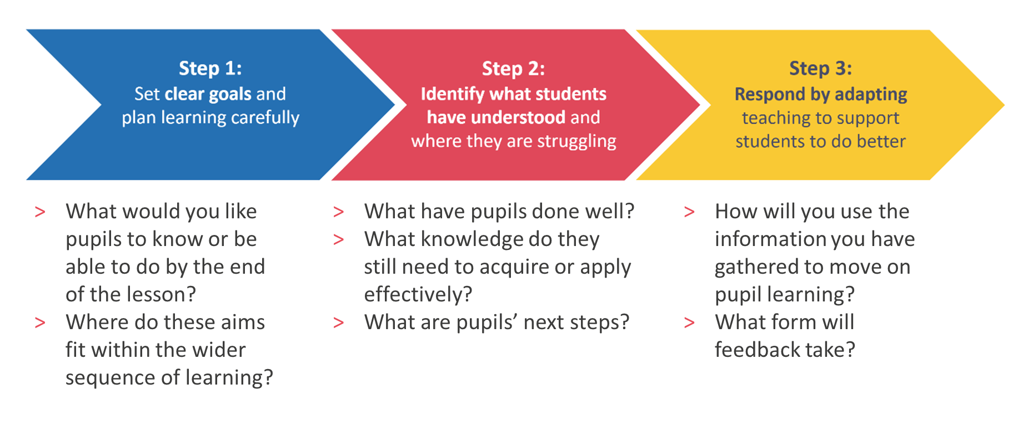

Notes:

Task: Plan your feedback task, using the question prompts to help you address each of the module principles in your planning.

Module principle | Question prompts:
Give feedback to move learning forward. | What knowledge do you need to impart during your feedback? What do pupils need to do to improve and how can you communicate these next steps concisely? What activities will pupils complete during, or in response to, your feedback? How do these activities encourage pupils to think hard about critical knowledge? How will they apply the knowledge you have imparted?
Promote positive engagement. | How can you use praise to acknowledge pupil effort and progress so far? Are there any pupils with specific needs that need to be considered in the feedback process? If so, how will you respond to these needs? What might be some social and emotional factors that may affect pupils’ responses to feedback?
Encourage long-term progress. | What level is the feedback taking place on: task, process or self-regulation? How will this feedback support pupils to achieve their long-term learning goals? How does the feedback help pupils monitor and regulate their own learning? What critical knowledge are pupils acquiring or applying? What misconceptions are you addressing?
Balance impact and effort. | What critical knowledge are pupils acquiring or applying? What resources will you need to create to deliver your feedback and support pupils to respond to it? Is the progress pupils make going to be greater than the work taken to provide the feedback? Are any resources created directly impacting pupil progress?

Module principle | Notes
Give feedback to move learning forward.
Promote positive engagement.
Encourage long-term progress.
Balance impact and effort.

Applying the module principles: Model

Module principle | Notes
Give feedback to move learning forward. | I need some pupils to work on their stride length during their run up and others to work on using their arms and legs to launch themselves forward when jumping. I will explain that pupils have been organised into small groups to work on one of these two phases of the jump. I will give pupils a recorded version of their phase to support them when practising.  Before pupils break off into new groups, I will ask them to recall the key components of the phases they are working on. I will then explain that these components are identified in the videos they will be using to support them. This will ensure that pupils are focusing on the underlying features that will support them with their run up and launch.
Promote positive engagement. | I will emphasise that each phase of the long jump is challenging and praise pupils for their progress with stages one and two so far. I will place pupil X with pupil Y, as I know that pupil Y has previously worked well with pupil X to build his confidence.
Encourage long-term progress. | When pupils have recalled the key components of the phases they are working on, I will use questioning to prompt them to consider why these components are important and how they contribute to the overall success of the jump. This links the specific skill they are working on to their wider aim of completing a successful long jump.
Balance impact and effort. | The only physical resource I will need is the recordings of each phase of the long jump, which I already have from previous lessons. This resource can be used across the sequence of lessons and in following years, so was a useful investment of time.

Reflection
- Of the module principles we have looked at today, which do you already feel most confident with?
- Which module principles do you find more challenging and why?
- What are you next steps in response to this clinic? What or who will support you to achieve these?

Notes:

Option C: I Do 2
Scenario
Miss Smith’s Y11 English Literature class are practising a poetry comparison question. The class has worked on this question across this unit of work and are now at a point where they are practising independently. However, Miss Smith has found when she has taught this in the past that although pupils do understand all the success criteria they need to incorporate in their extended answers to this question, they often forget or struggle to apply at least one of them to their answers. She is confident from formative assessment in previous lessons that pupils in this class do understand the success criteria and have been able to apply it to their writing in small chunks. However, she feels they probably haven’t yet developed the automaticity in using the criteria in their answers without any support. Therefore, she is going to use a set of marking codes to live mark pupil work whilst they are writing to ensure that her feedback can act as a scaffold for pupils as they work. This is something that she has done with this class since they begun the GCSE course with her in Y10.
“As you are writing I am walking the room, on this first circulation I am looking at your introductions and looking for an insightful and accurate similarity between your two poems. If I see you are missing a similarity in your introduction I will put a dot in your margin, if I see that your similarity isn’t accurate, I will put a dash in your margin and if I see that your similarity meets the insightful and accurate criteria, I will put a tick in your margin. You will need to ensure you make any necessary changes based on my feedback.” As Miss Smith circulates, she annotates pupil books with these marking codes, she notices that most pupils are including an accurate similarity between the poems but that the comparison is not insightful enough to meet the criteria at the top end of the mark scheme that she wants her pupils to be aiming for.
“I am just stopping you here as I want to discuss something that I think is missing from our introductions. We know to hit the top end of the mark scheme we need to be insightful in the similarity we identify between the poems. Which similarities might not be considered insightful between these two poems, but would still be considered accurate? I will give you two minutes to come us with a list of at least two similarities with your partner that are accurate but not insightful.”
She cold calls a pupil that she knows had an accurate similarity in their introduction: “I think saying that both poems are written in an alternative (ABAB) rhyme-scheme is accurate but not insightful”.
Miss Smith: “Okay, great, I would agree but why isn’t it insightful and what could we do to make that an insightful comparison?”.
She now moves to a pupil who she knows had an insightful and accurate similarity in their work; “Maybe you could say the impact of the similar rhyme scheme on the meaning of the poem, or on the reader?”
Miss Smith: “Yes, I think that would make it more insightful. Can someone give me an example of how that would sound in your writing?”.
She selects a pupil with their hand up: “In both poems there is an alternative rhyme-scheme which mirrors the patterns that are found in nature, which both poems are emphasising.”
Miss Smith: “Fantastic, that example is really insightful and accurate because it gives us a similarity right at the beginning of the writing that we can use as a theme and argument throughout the rest of the essay. Really impressed with the thoughtfulness I am seeing in the similarities you are drawing between the poems and how hard we are working to get this right, take three minutes now to re-read your introduction and make any changes you need to ensure that you are drawing insightful and accurate similarities.”
Task: Take notes while the facilitator models how the module principles appear in this scenario.

Module principle | Response/suggestion
Give feedback to move learning forward.
Promote positive engagement.
Encourage long-term progress.
Balance impact and effort.
Other notes:

Close

Reflection:

- Of the module principles, which do you already use to help you to use effective feedback?
- Which of the module principles will you use more in order to support you to:
  - Give effective feedback
  - Manage your workload
  - Support your pupils to develop self-regulation

Notes:

References

Barker, J., & Rees, T. (2020). Persistent problems in school leadership. Ambition Institute. https://www.ambition.org.uk/blog/persistent-problems-school-leadership/
Boekaerts, M. (1999). Self-regulated learning: Where we are today. International Journal of Educational Research, 31(6), 445–457. https://citeseerx.ist.psu.edu/document?repid=rep1&type=pdf&doi=1b7d78491d148bde29d9d1bdb6017706b87c2b08
Dinsmore, D. L., Alexander, P. A., & Loughlin, S. M. (2008). Focusing the conceptual lens on metacognition, self-regulation, and self-regulated learning. Educational Psychology Review, 20(4), 391–409. https://nschwartz.yourweb.csuchico.edu/Dinsmore.metacognition.pdf
Fletcher-Wood, H. (2018). Responsive teaching: Cognitive science and formative assessment in practice. Routledge.
Fletcher-Wood, H. (2018, June 3). What is responsive teaching? Improving Teaching. https://improvingteaching.co.uk/2018/06/03/what-is-responsive-teaching/
Hattie, J., & Timperley, H. (2007). The power of feedback. Review of Educational Research, 77(1), 81–112. RER298487.qxd
Kennedy, M., (2016). Parsing the Practice of Teaching. Journal of Teacher Education. SAGE Publications, 67(1) pp. 6–17. https://journals.sagepub.com/doi/abs/10.1177/0022487115614617
Muijs, D., & Bokhove, C. (2020). Metacognition and self-regulation: Evidence review. Education Endowment Foundation. https://educationendowmentfoundation.org.uk/education-evidence/evidence-reviews/metacognition-and-self-regulation
Ward, A. F., Duke, K., Gneezy, A., & Bos, M. W. (2017). Brain drain: The mere presence of one’s own smartphone reduces available cognitive capacity. Journal of the Association for Consumer Research, 2(2), 140–154. https://doi.org/10.1086/691462
Zimmerman, B. J. (2000). Self-efficacy: An essential motive to learn. Contemporary Educational Psychology, 25(1), 82–91. https://ssrlsig.org/wp-content/uploads/2018/01/zimmerman-2000-self-efficacy-an-essential-motive-to-learn.pdf
Zimmerman, B. J. (2001). Becoming a self-regulated learner: An overview. Theory Into Practice, 41(2), 64–70. http://mathedseminar.pbworks.com/w/file/fetch/94760840/Zimmerman%20-%202002%20-%20Becoming%20a%20SelfRegulated%20Learner%20An%20Overview.pdf

