ECTP:
CONFERENCE 1

Workbook

Introduction
Welcome to Conference 1 of the Early Career Teachers mentor training programme. This workbook will accompany the facilitated session and help you build on your learning from the orientation.

Session aims
To understand:
- The importance of Early Career Teacher (ECT) development.
- How the Early Career Framework and Early Career Training programme will help support you and your Early Career Teacher.
- The principles underpinning Ambition Institute’s Early Career Training programme.
- Your role as mentor within the programme.
- The basics of instructional coaching.

Sections
- The value of mentors
- Programme overview
- The role of the mentor
- Instructional coaching : in practice
- Online systems training
- Next steps
- References
- Appendices

Introduction
Teachers make a difference
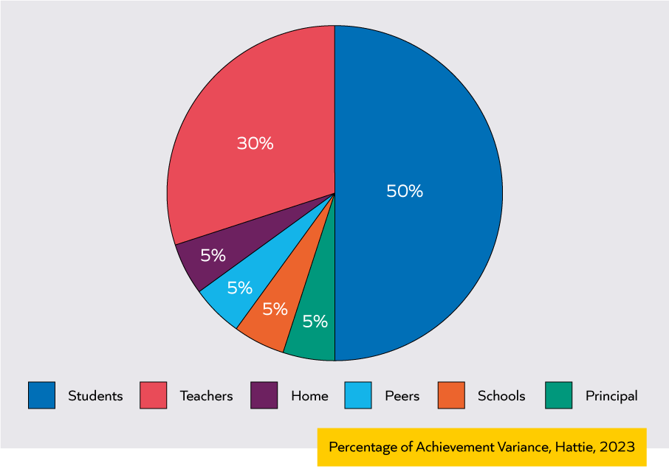
Notes:

“We cannot simultaneously believe that the decisive factor in the classroom is the teacher, and not believe that the decisive element in a classroom of teachers is the teacher educator.”
Matt Hood, former Chief Education Officer, Ambition Institute

The impact of high-quality mentoring
- Improved pupil outcomes (Villar & Strong, 2007)
- Increased teacher retention (Ingersoll & Krallik, 2004; Stanulis & Floden, 2009; Ronfeldt & McQueen, 2017)
- Improved teacher confidence and enjoyment of teaching (Hobson & Ashby, 2012)
Reflection
- Why can mentoring help improve outcomes for all pupils?
- What has been your experience of the impact of mentoring?
- Long-term goal: what do you want to achieve as a mentor?
- Immediate goal: what do you want to get out of today?
Notes:

Programme overview
The Early Career Teacher Entitlement (ECTE)
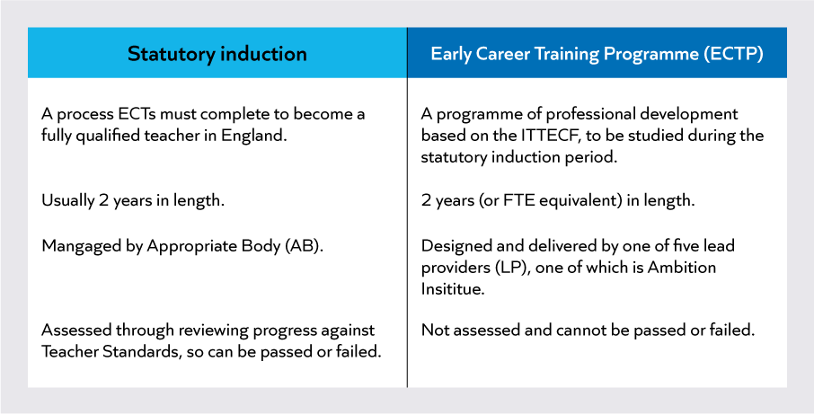
Entitlements
- Access to high quality professional development through a training programme
- A dedicated mentor and induction tutor to guide them through their training programme
- A 10% timetable reduction in year 1 and 5% off-timetable in year 2, providing ECTs with protected time for their professional development
- Assessment against the Teachers Standards, as part of the statutory induction process
Notes:

The initial Teacher Training and Early Career Framework (ITTECF)
“The ITTECF sets out the entitlement of every trainee and early career teacher (ECT) to the core body of knowledge, skills and behaviours that define great teaching, and to the mentoring and support from expert colleagues they should receive throughout the three or more years at the start of their career.”
Initial Teacher Training and Early Career Framework, 2024

A core body of knowledge and skills
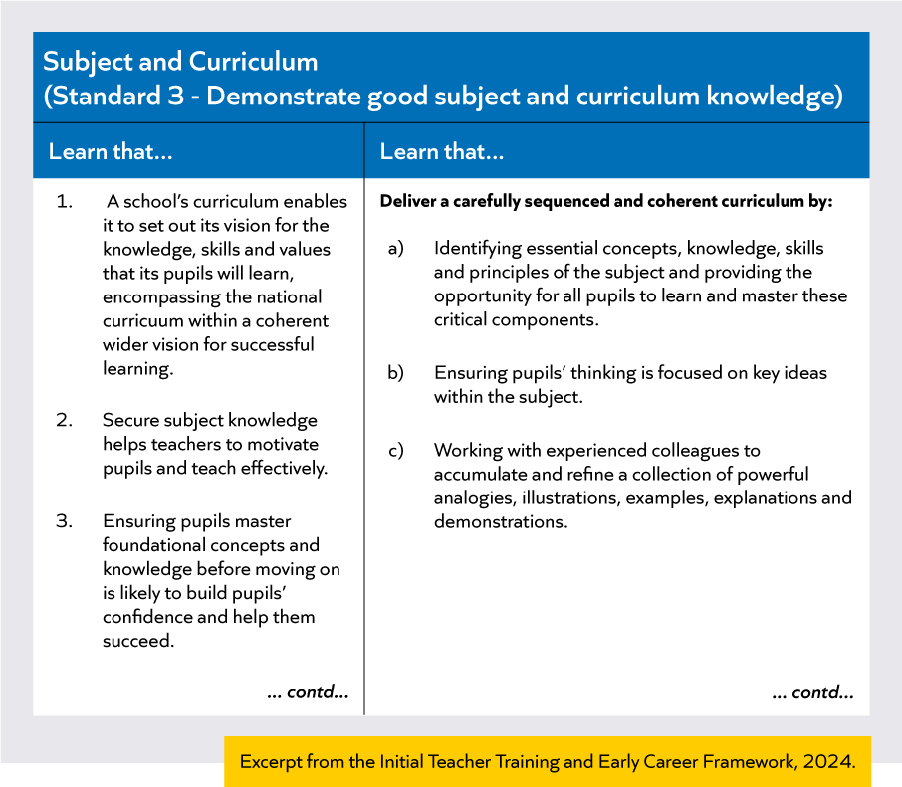
Notes:

The difference between the ITTECF and ECTP
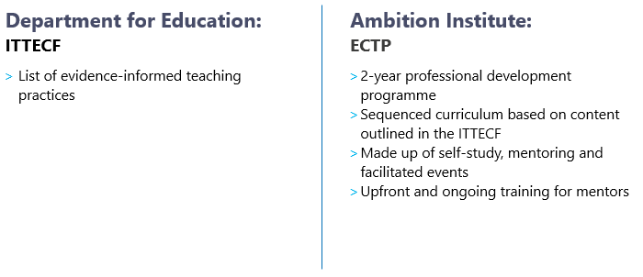
Notes:

Check for understanding
Which of the following statements are true?
- The Early Career Training Programme is a part of the Early Career Teacher Entitlement
- Early Career Teachers are assessed as part of their Early Career Training Programme
- The Early Career Training Programme lasts for three years (or part-time equivalent)
- The Early Career Training programme is based on the Initial Teacher Training and Early Career Framework

Programme Design
Programme components
- Self-study
- Mentor meetings
- Clinics and conferences

Notes:

Self-study curriculum
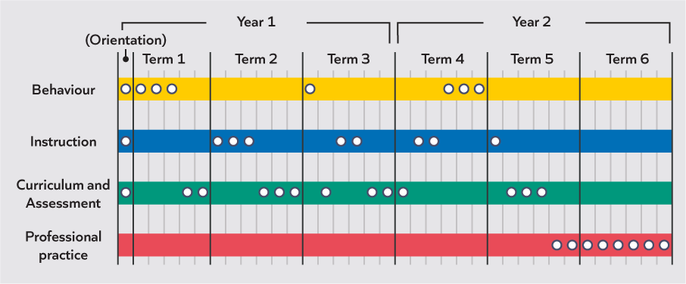
Notes:
Self-study curriculum sequencing
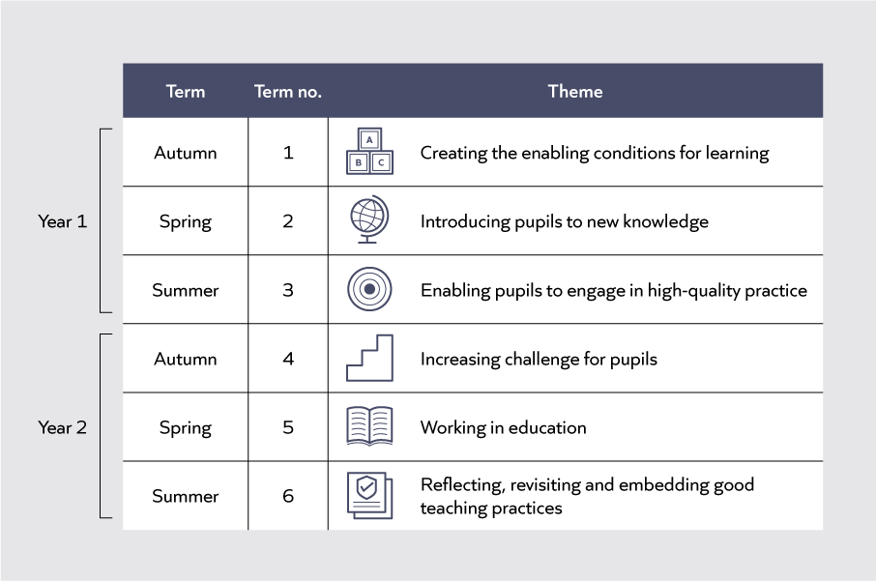
Notes:

Self-study module design
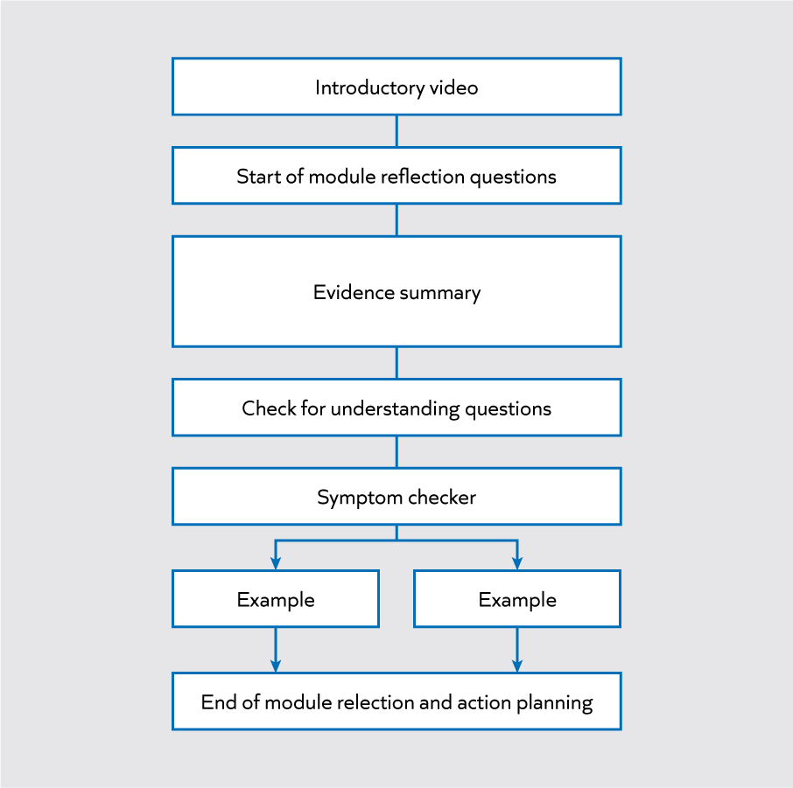
Notes:

Self-study component | Notes
Module principles
Symptom checker
Examples
End of module reflection and action planning

Mentor meetings
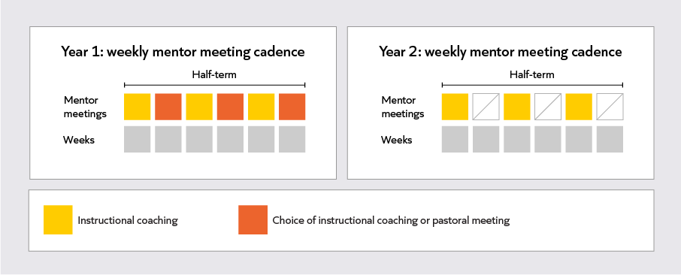
Notes:

Instructional coaching
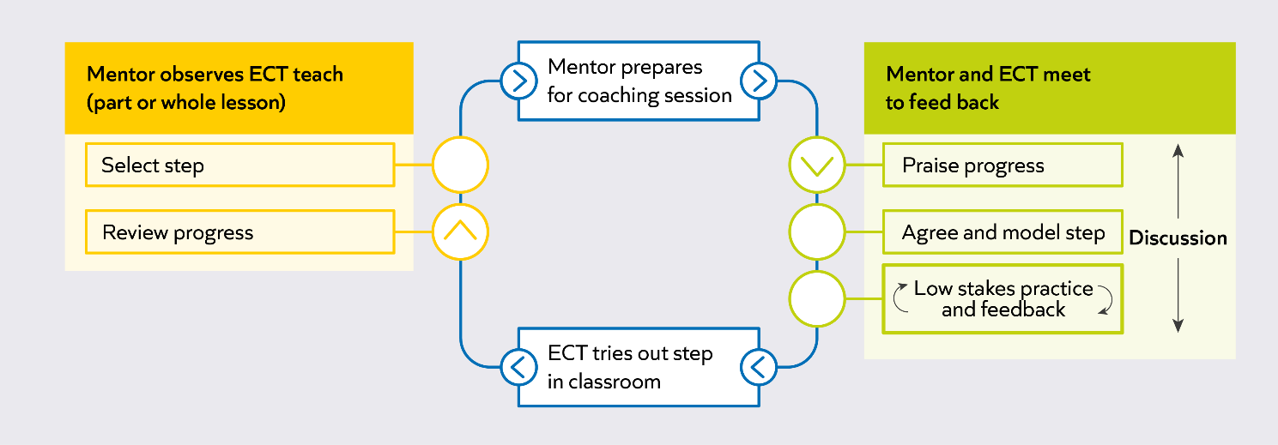
Notes:

Pastoral coaching
- Support ECTs to feel confident in managing the various demands of their role
- Optional fortnightly session
- Targeted at an area of need
- Supporting guidance is provided to mentors

Notes:

Mentor training
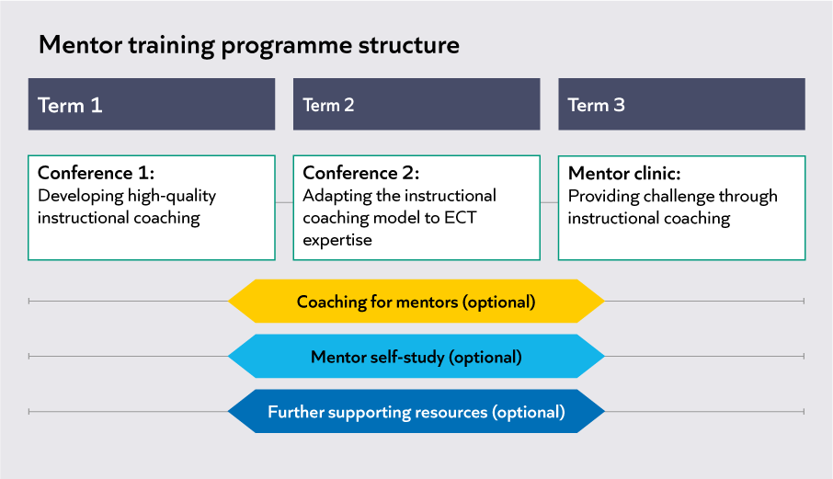
Notes:

Questions or reflections
- The Early Career Training Programme for ECTs
- The mentor training programme and wider support
Notes:
The role of the mentor
- Leads the development of an Early Career Teacher
- Provides regular, tailored support through instructional coaching and, in some instances, pastoral coaching
- Responsible for their teacher(s) engaging with the programme and supporting if they are having difficulties
- NOT responsible for assessment against the Teachers’ Standards as part of the ECT’s induction.
Developing relationships
Great mentors develop a strong relationship with their ECT.
- Being a ‘first point of call’
- Optional pastoral coaching
- Contracting the relationship

Contracting
- Agreeing how you will work together to provide clarity
- In general, and in specific situations
- A two-way conversation
Contracting questions
Professional
- What do we both want to get out of this relationship?
- What can I do that will really help you succeed?
Procedural
- What is the best way for us to communicate and when?
- Is there anything you might need additional support with?
Personal
- What do you find frustrating?
- How should we react if one of us makes a mistake?

Developing expertise
What is teacher expertise?
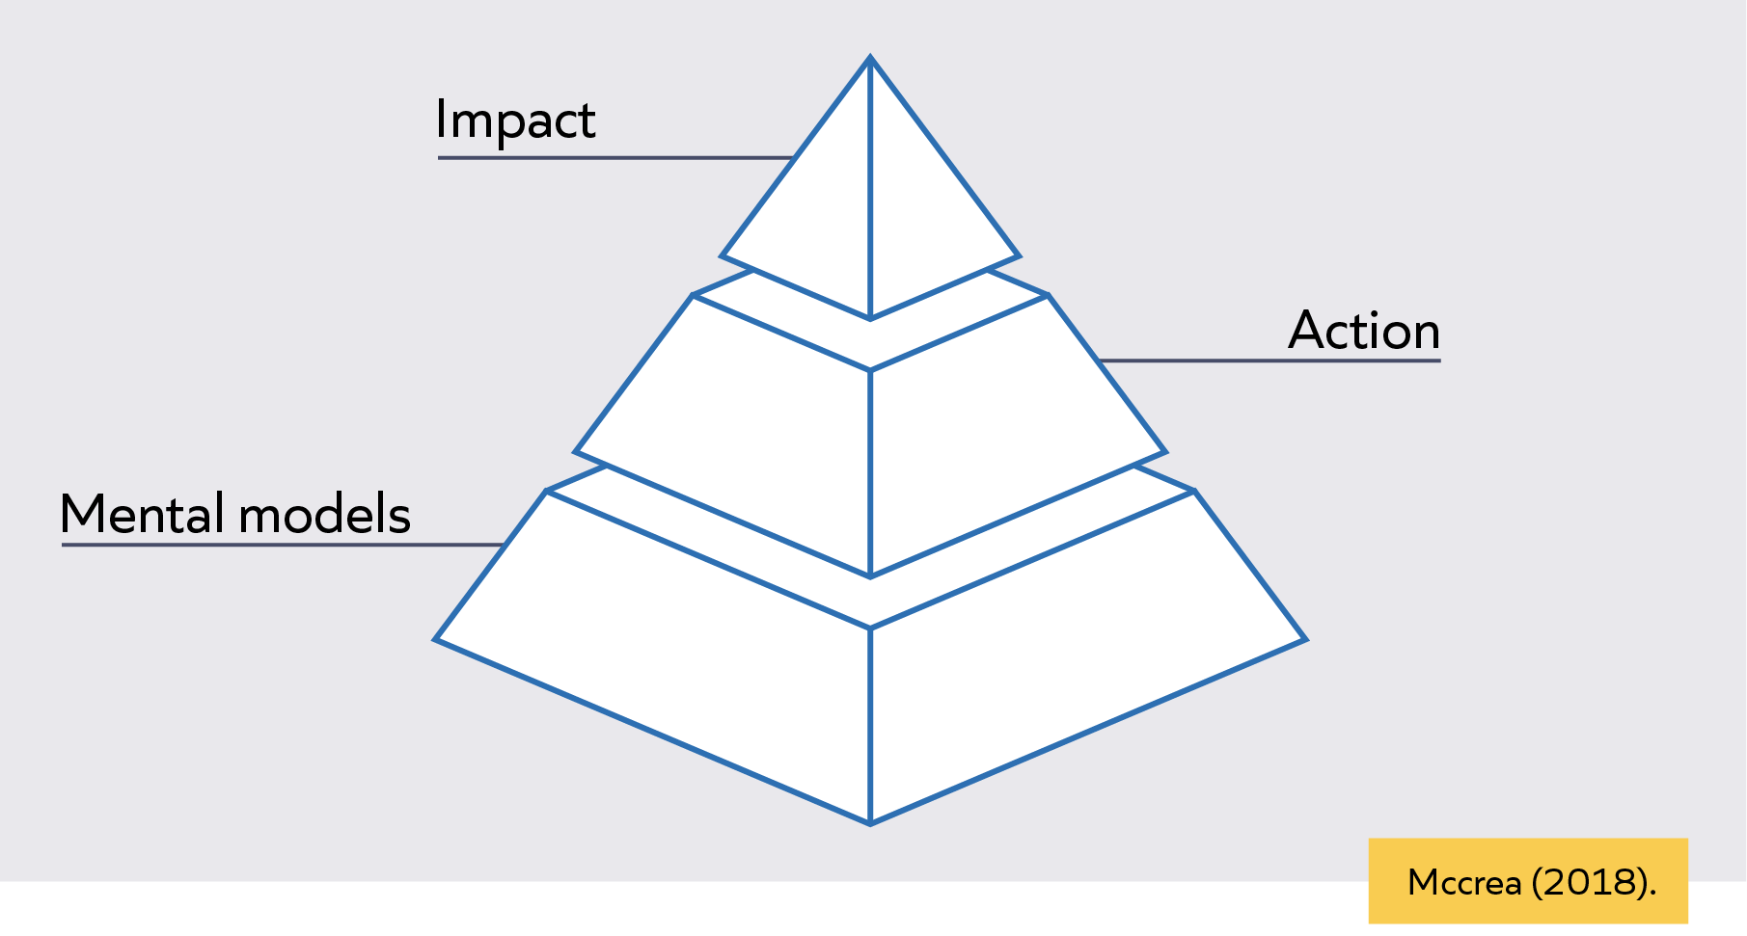

Mental models
A mental model is the knowledge you have about a particular topic and the way it is organised to guide action.
Notes:
Mental models and expertise development
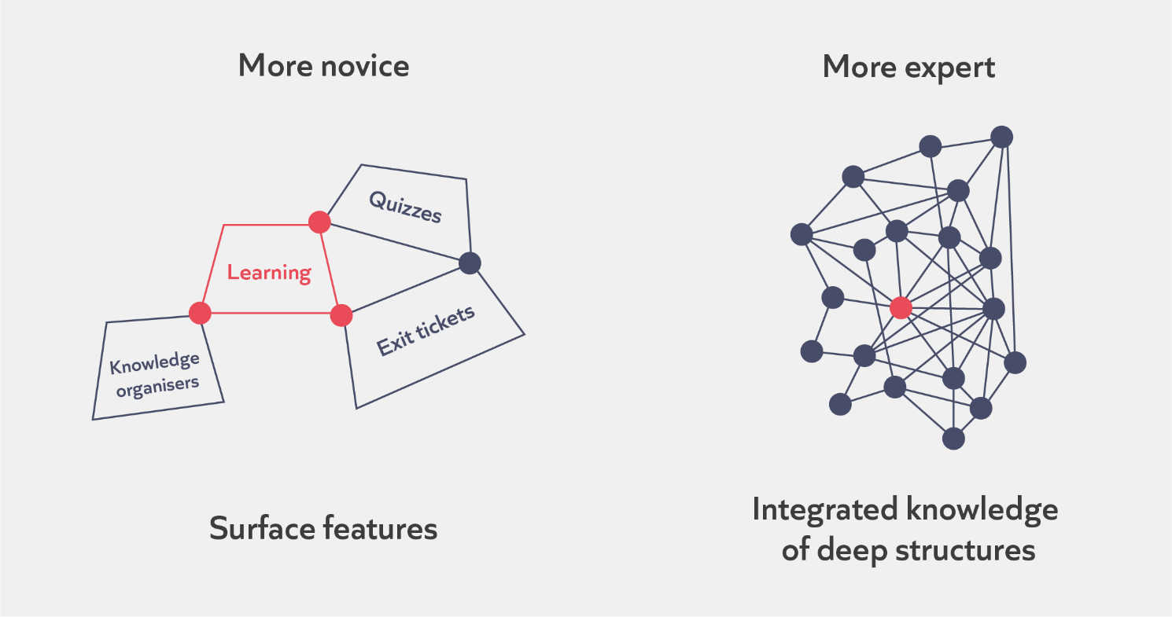
Notes:

How we learn
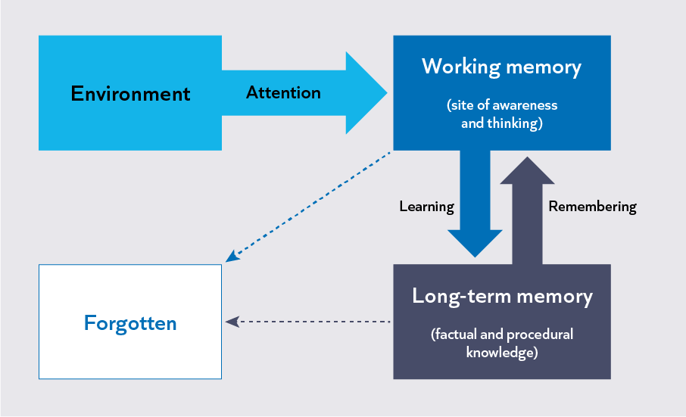
Notes:

ECTs need support to know what success looks like
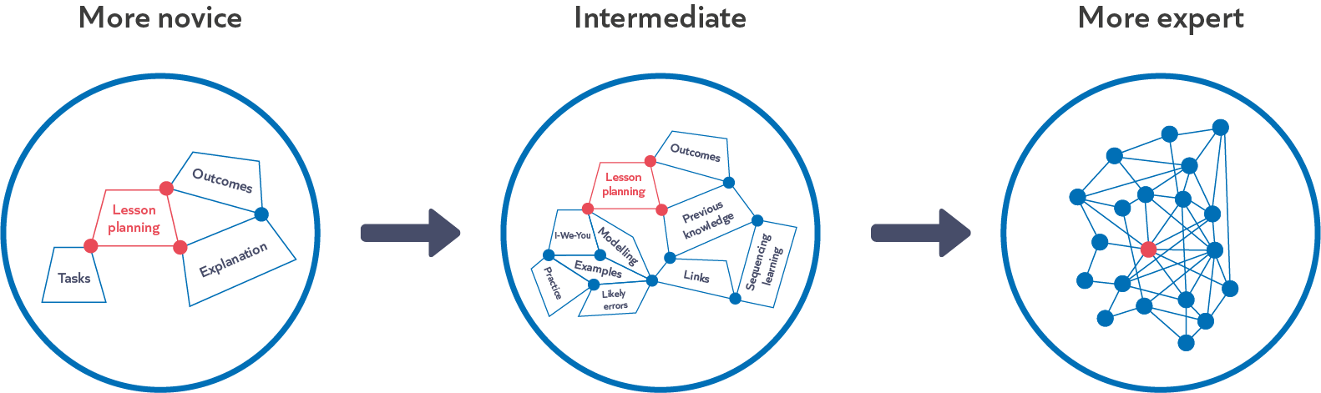

Notes:

Check for understanding
1. Mental models are:
- The knowledge stored in long-term memory
- How the knowledge in long-term memory is organised and used
- How people visualise situations

2. Which of these statements about novices and experts are true?
- Experts’ mental models contain more knowledge
- Early career teachers are novices
- Expertise is generalisable
- More novice and more expert teachers both learn best by solving problems

Notes:

The ‘knowing-doing’ gap
Notes:

Example
Knowing | Doing
Ms Evans is a first-year ECT. She knows about a range of strategies to provide scaffolding to support all pupils to access the content.  She can clearly articulate the different strategies and when they might be used. | In lessons, Ms Evans is finding it difficult to provide the appropriate amount of scaffolding for her pupils. She finds it difficult to assess their levels of understanding in the first place, to identify which scaffolds are most appropriate and when they should be introduced and removed.  This means that some pupils often struggle to access the content or aren’t challenged enough.

The ‘knowing-doing’ gap on the ECTP
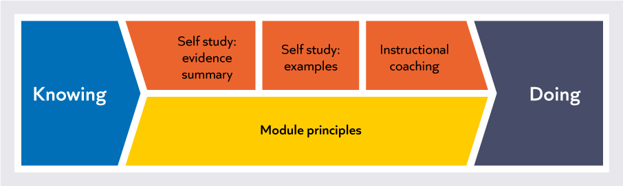
Notes:

Developing expertise
Great mentors help ECTs develop their expertise.
- Carefully selected steps for development
- Contextualised models of practice
- Opportunities for practice and feedback

Contextualised models

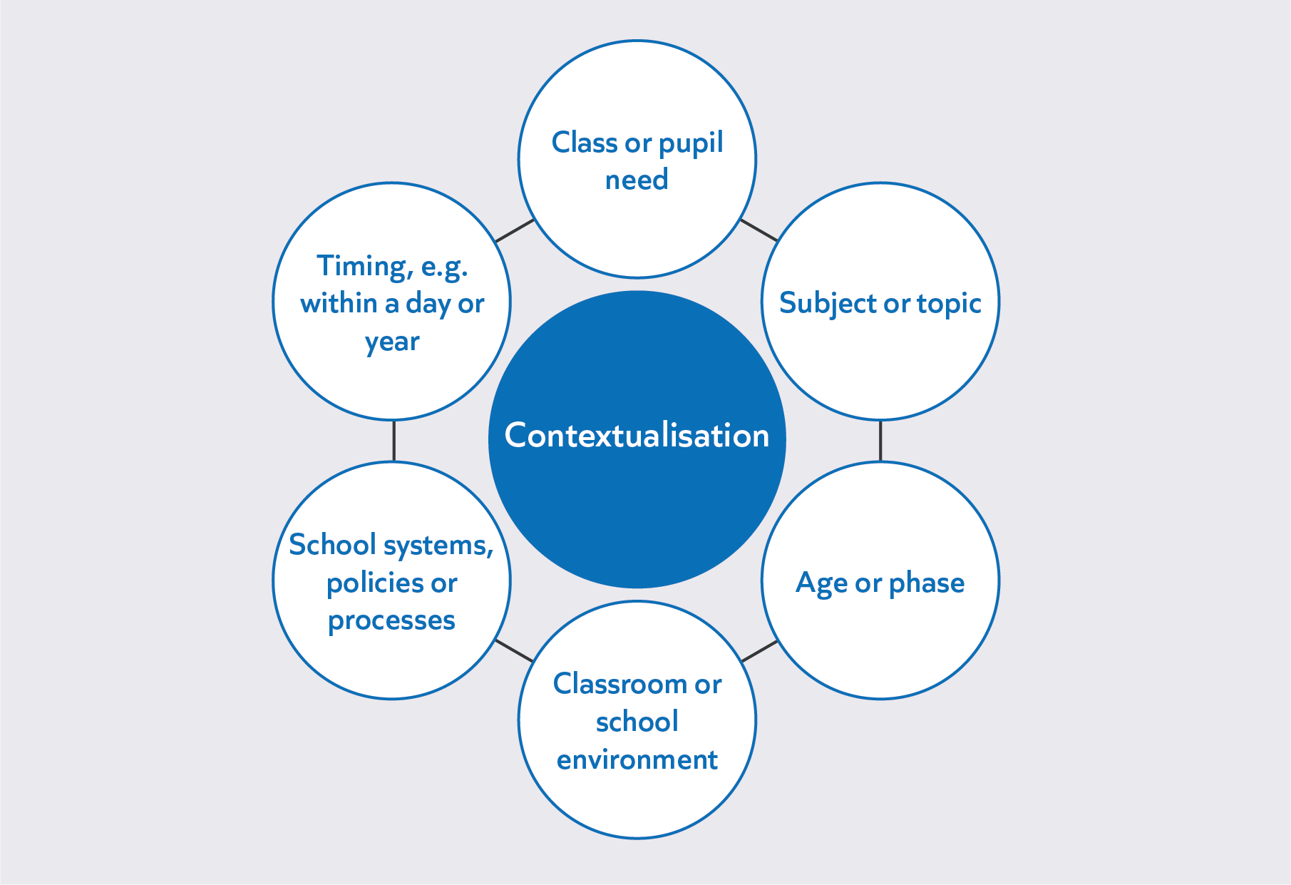

Notes:

Contextualised models: reflection
Consider the following step in light of your ECT’s context.
- What contextual factors might you need to consider, and tailor to, as part of your model of practice?
Step: Use manageable, specific, sequential instructions broken down into steps that tell pupils exactly which actions they need to take for a common routine you need them to master.
Notes:

“Theoretical knowledge becomes organised and usable through experience of practice.”
Schmidt and Rikers, 2007

Notes:

Deliberate practice
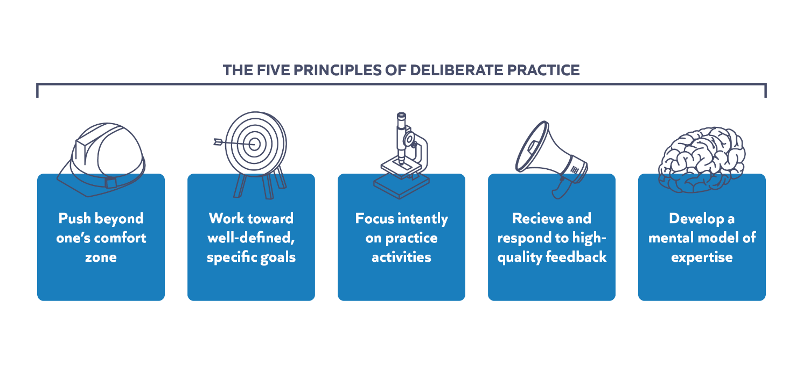
Notes:

Reflection
Consider how confident you feel with the following aspects of the mentoring role:
- Contracting the ECT-mentor relationship
- Providing contextualised models of practice
- Setting up a cycle of practise and feedback
Notes:

Instructional coaching
Instructional coaching: what?
- Frequent and ongoing cycle of observation and feedback
- Led by an instructional expert
- Focused on low-stakes practice of specific classroom skills
Purpose
- Develop ECTs’ expertise in teaching by building their mental models. This is to allow ECTs to make well-informed choices in the classroom to improve pupil learning.

Instructional coaching cycle
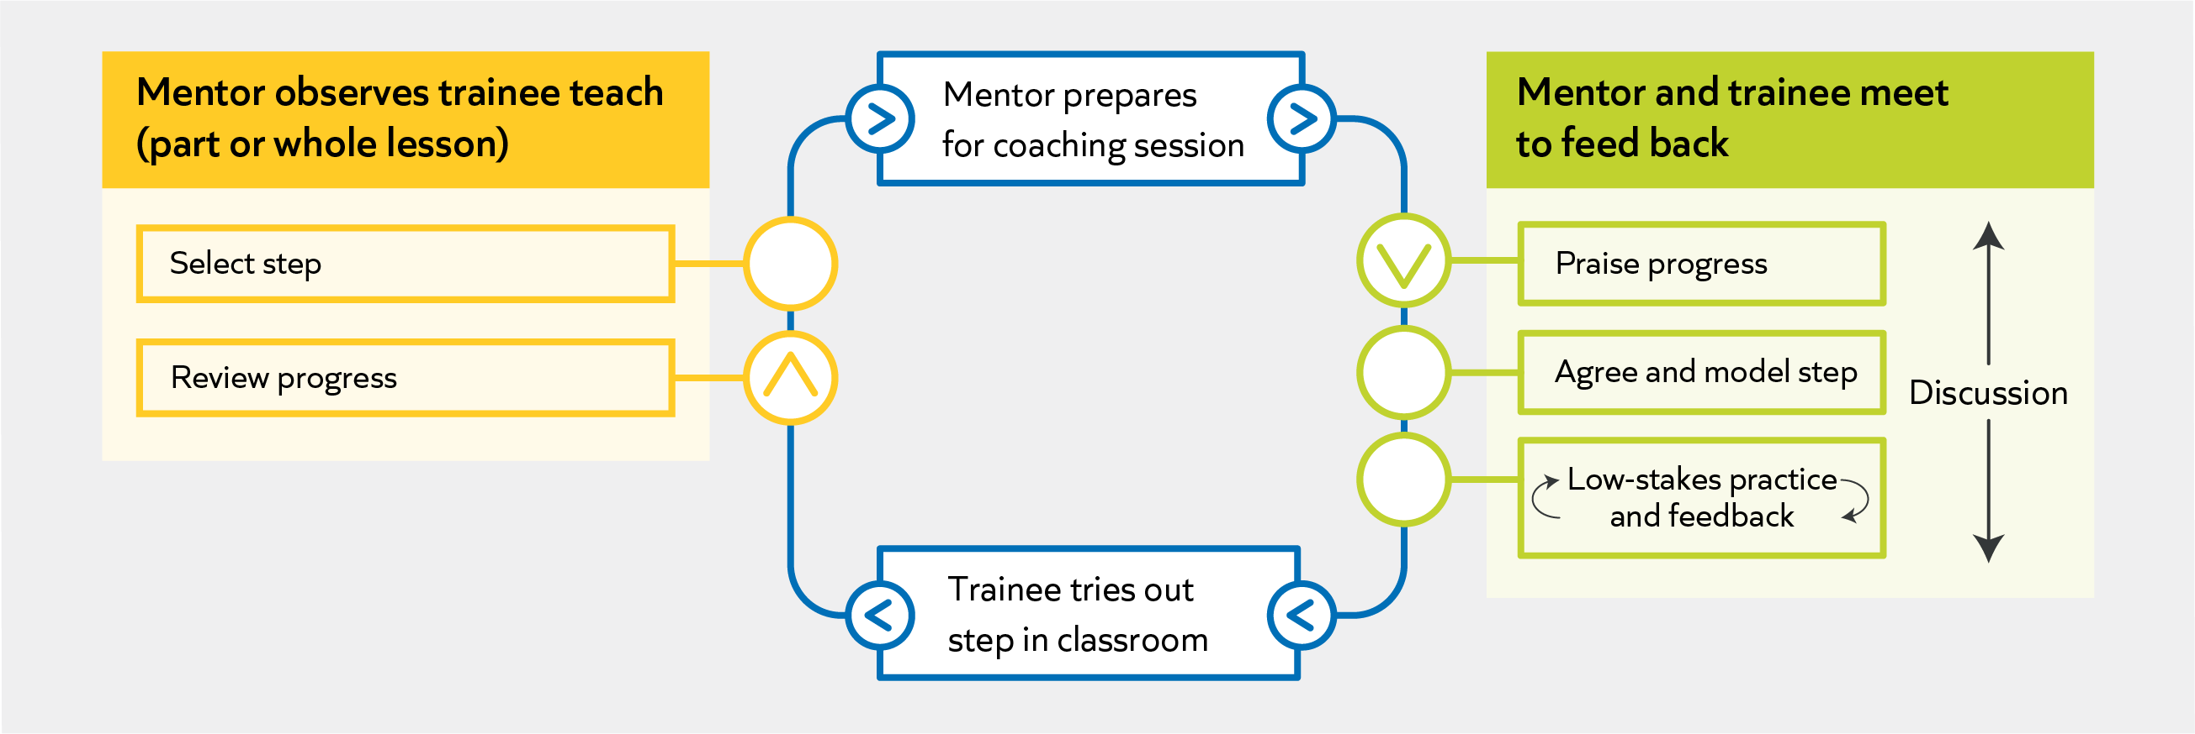

Notes:

Instructional coaching: why?
- Strong research evidence that it helps teachers develop (e.g. Kraft et al., 2018)
- Aligned with effective professional development (EEF, 2021)
- Aligned with what we know about learning and expertise (e.g. Deans for Impact, 2017)
- Likely to support teachers to develop self-efficacy (Tschannen-Moran & McMaster, 2009)

What is instructional coaching not?
- Just telling
- Focused on replicating techniques
- Entirely led by the ECT
- All that is needed
- Guaranteed to work

Support for instructional coaching
- Online coaching tool
- Steps and success criteria
- Self-study module overviews
- Viewing ECTs’ study progress

Notes:

Observe the ECT
What this looks like
- 10-15 minute observation
- Look for progress on previous step to inform the decision about next step
- Observation and timing agreed in advance
- Mentor can use laptop and takes notes into Steplab
Features
- Neutral and factual
- Keeps a detailed record of the lesson (focusing on the step)
- Non-judgemental

Notes:

Example | Non-example
 | 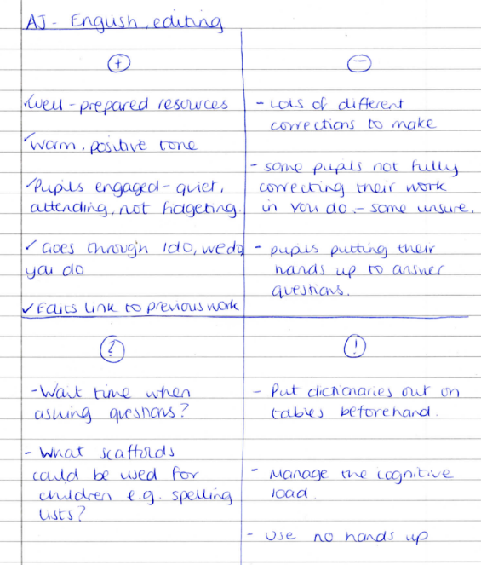

Observe the ECT: Example
Watch Jenny talking about the observation of her ECT, Katie.
- What does Jenny do to prepare for the observation?
- What broken-down aspects of the step can help to decide whether Katie has met the previous step?
- What does Jenny do to help give effective feedback?

Notes:

Observe the ECT: Practice
Priska is an ECT teacher at the end of her ECT term 1. Last week Priska's mentor set her a step on directing attention. Now her mentor is going to observe her and review her progress with the step.
- Read the step and the success criteria.
- Read the lesson observation notes that Priska’s mentor has made.
- Use what we have learned about effective note-making to identify how the notes could be improved.
- Rescript the notes.

Step and success criteria
Step: Pre-emptively reinforce the positive actions you see pupils taking to encourage everyone to stay focused at key points in the lesson when you anticipate pupils may struggle.
- Seek and reinforce the positive: teacher looks for the positive behaviours some pupils are doing, and others need to start doing and reinforces them e.g. "Everyone on the back tables are wiping down their whiteboards"
- Specific: " Jasper is sitting up straight" NOT "Jasper is sitting nicely"
- Measured: teacher shows appreciation for positive behaviour but does not treat it as an accomplishment when it is not e.g. "Front row have their pens moving, thank you" NOT "Fantastic! It is great to see the front row with their pens moving"
- Genuine: teacher's tone is natural and not forced
- Clear and confident: teacher's voice is authoritative, upbeat and can be heard from anywhere in the classroom, but it does not sound like shouting

Lesson observation notes
Well done, you made your presence felt in the classroom and monitored the pupils well. As a result, they stayed on task and there was a calm start to the lesson.
You reinforced positive behaviours, without being excessive. Your tone was clear confident and positive.

Use diagnostic tools
What this looks like
- Check for understanding questions
- End of module reflection questions
- Symptom checker
- Triangulating sources of evidence

Notes:

Select the next step
What this looks like
- Mentor decides the focus for the next round of instructional coaching
- This could be setting a new step or continuing to work on current step
- Use the observation and diagnostic tools to help select the step
Features
- Appropriate
- Builds on prior knowledge

Non-example:
When giving instructions you need to try to be more authoritative.
Example:
When delivering instructions to the class, stand still on a spot where you can see and be seen by all pupils, so that they can attend to what you are saying without being distracted by movement.

Notes:

Select the next step: example
Watch Jenny explaining how to choose the next step.
- Two potential focus areas are identified. Why is one discounted?
- Why do we need to select a small, precise step?
- Why are the steps aligned to the self-study module principles?
- How do the success criteria help to plan the model?

Notes:

Select the next step: practice
- Read the step and success criteria.
- Read the descriptions of the four ECTs’ practice: Sadia, Abdul, Kirstie and Ryan.
- Use the success criteria to decide whether you would move on to the next step for each person.
Step and success criteria
Step: Gain pupils' attention: use verbal and/or non-verbal signals to gain and maintain pupils' attention.
- Visible: teacher is standing in a spot where they can see and be seen by pupils.
- Clear, consistent signal: teacher uses the same clear signal (non-verbal and/or verbal) to gain pupils’ attention every time.
- Open and calm: teacher has authoritative and approachable body language, such as standing still with an upright posture, unfolded arms, relaxed shoulders and relaxed facial expression.
- Concise and specific: teacher uses a gesture and/or the fewest words possible to gain attention. Instructions are specific, e.g. “Legs crossed and sitting up straight. NOT “Sitting nicely.”
- Clear and confident: teacher’s voice is authoritative, upbeat and can be heard from anywhere in the classroom but does not sound like shouting.

Sadia stands still in the centre at the front every time she gives instructions. Same gesture every time, effective. Voice a bit quieter than usual today as she had a sore throat.
Abdul always stands calmly and still behind his desk, in the front right corner of the classroom. Clear voice, easily heard, warm tone to pupils. Same instructions each time.
Kirstie stood in the same place at the front to give instructions 5 out of 6 times (once from edge of room). Voice clear, almost the same wording each time to gain attention.
Ryan always stands next to board to give instructions, often leaning against it. Often looks down at the floor when speaking to class. Fiddles with pen while talking. Same phrase used.
Notes:

Praise and feedback on the previous step
What this looks like
- Mentor describes how the ECT has or has not met the step
- Using notes from the observation as well as other sources (e.g. diagnostic tools)
- Encourage the ECT to recognise what is working well and continue this
- Build a positive relationship
Features
- Action-focused
- Linked to impact
- Builds motivation and self-efficacy

Praise and feedback: impact
- Develops expertise
- Builds motivation
- Develops self-efficacy

Praise and feedback: example
Watch Jenny delivering praise to Katie for the lesson from the observation.
- How is the praise action-focused?
- How does the mentor help the praise to be linked to impact?

Notes:

Praise and feedback: practice 1
Scenario: Imagine that a mentor has just observed their ECT deliver an explanation where they used a familiar example to help pupils understand.
To what extent might each mentor’s response support the ECT’s learning?
Mentor A: “The example you chose for your explanation was familiar to pupils which helped them understand. Why do you think the familiarity helped them understand?”
Mentor B: “That explanation was really clear. Using a familiar example will have helped pupils connect it to what they know.”
Mentor C: “That explanation was great! Clear, interesting example. You sounded really engaging too. Pupils were really listening, you dealt with the visitor well too.”
Mentor D: “I really liked your explanation. Tell me about what you did.”

Notes:

Praise and feedback: practice 2
Read the step alongside the success criteria and the notes from the observation of Priska’s lesson that you rewrote in the first stage of the cycle.
Script the praise you would give Priska.
How can you make the praise action-focused, linked to impact and likely to build motivation and self-efficacy?

Notes:

Set and model the next step
What this looks like
- The mentor demonstrates the step
Features
- Focus attention on the success criteria
- Contextualised and authentic
- Expose thinking

Set and model the next step: example
Watch Jenny introducing and modelling the step.

- How does Jenny get Katie to think about the success criteria?
- How does Jenny make the model authentic?
- How does Jenny expose her thinking?

Notes:

Set and model the next step: practice 1
Script a model for the step in the workbook.
How will you:
- Use the success criteria to form the model?
- Make the model authentic and contextualised?
- Expose your thinking throughout the model?

Step and success criteria
Step: Assessing for formative purposes: Give instructions to pupils to answer diagnostic questions
- Succinct: the instructions and questions are worded simply and clearly so pupils understand what they are being asked to do
- Manageable and sequential: the steps are small enough for pupils to follow and they are ordered in the same way pupils would carry them out.

Example steps: question goes up on the board, pupils have 30 seconds to choose their answer, when you countdown 3,2,1, all pupils hold up their fingers at the same time.

Notes:

Set and model next steps: practice 2
Person A is the mentor, person B gives feedback
- Person A shares the step and success criteria, and models the step.
- Person B provides feedback to person A.
- Person A re-practises the relevant section based on the feedback to improve it.
- Swap roles.

Feedback prompts
How has your partner:
- Use the success criteria to form the model?
- Make the model authentic and contextualised?
- Expose your thinking throughout the model?

Notes:

Low-stakes practice and feedback
What this looks like
- The ECT practises the step multiple times, receiving feedback each time
Features
- Authentic
- Multiple rounds
- Clear feedback
- Develops mental models
Enabling conditions
- Low-stakes
- Trust & confidentiality
- Scaffolding

Low-stakes practice and feedback: example
Watch the video of the practice and feedback cycle.
- What did Jenny do to support Katie before she stood up to practise?
- How many times did they practise? Why?
- What do you notice about the feedback between rounds of practice?

Notes:

Instructional coaching cycle

Check for understanding
- Which of the following are features of instructional coaching?
  - Roleplay
  - Bite-sized steps for improvement
  - Open questioning
  - A regular routine
  - Low-stakes practice & feedback

- Which (if any) of the following statements are true?
  - The ECT should always decide the focus of the coaching.
  - ECTs should always work on a new step for each cycle of coaching.
  - Instructional coaching is the most important part of this programme.

Notes:

Reflection
- How does the instructional coaching cycle close the knowing-doing gap?
- How can you help to make your ECT’s practice authentic?
- What are you confident about? What are you less confident about?

Notes:

Online systems training
Watch the videos introducing MyECT and Steplab. Consider:
- How might the functionality support you in your role as a mentor?
- Do you have any questions or reflections on using these systems?
Notes:

Next steps
- Access further support and guidance on each part of the instructional coaching cycle in the Mentoring and Coaching Development Area on Steplab.
- Check your timetable has dedicated time for coaching and mentoring allocated.
- Familiarise yourself with Steplab and MyECT.
- Complete your orientation on Steplab.

Key takeaways

Networking

References
Bandura, A. (1977). Self-efficacy: toward a unifying theory of behavioral change. Psychological review, 84(2), 191.
Bandura, A. (1982). Self-efficacy mechanism in human agency. American psychologist, 37(2), 122.
Barnett, S. M., & Ceci, S. J. (2002). When and where do we apply what we learn?: A taxonomy for far transfer. Psychological bulletin, 128(4), 612.
Bereiter, C., Scardamalia, M. (1993). Surpassing ourselves: An inquiry into the nature and implications of expertise. Open Court.
Berliner, D. C. (2004). Expert teachers: Their characteristics, development and accomplishments. Bulletin of Science, Technology and Society, 24(3), 200-212.
Bryk, A. S., & Schneider, B. (2003). Trust in schools: A core resource for school reform. Educational leadership, 60(6), 40-45.
Clark, R., Kirschner, P., & Sweller, J. (2012). Putting Students on the Path to Learning: The Case for Fully Guided Instruction. American Educator, 36(1): 6-11.
Deans for Impact. (2017). Practice with Purpose: The Emerging Science of Teacher Expertise.
Department for Education. (2024). Initial teacher training and Early Career Framework.
Department for Education. (2025). Induction for early career teachers (England): Statutory guidance for appropriate bodies, headteachers, school staff and governing bodies.
Ericsson, A., & Pool, R. (2016). Peak: Secrets from the new science of expertise. Random House.
Farndon, S., & Pointer, N. (2025, February 17). How can teacher educators cultivate teachers’ expertise and professional judgement? Impact. Chartered College of Teaching.
Grossman, P., Compton, C., Igra, D., Ronfeldt, M., Shahan, E., & Williamson, P. W. (2009). Teaching practice: A cross-professional perspective. Teachers college record, 111(9), 2055-2100.
Hatano, G and Oura, Y. (2003). Commentary: Reconceptualizing school learning using insight from expertise research. Educational Researcher 32(8): 26–29.
Hattie, J. (2003). Teachers Make a Difference, What is the research evidence?. Paper presented at the Building Teacher Quality: What does the research tell us ACER Research Conference, Melbourne, Australia.
Kennedy, M. (2016). Parsing the practice of teaching. Journal of teacher education, 67(1), 6-17.
Knight B, Turner D and Dekkers J (2013) The future of the practicum: Addressing the knowing doing gap. In: Lynch DE and Yeigh T (eds) Teacher Education on Australia: Investigations onto Programming, Practicum and Partnership. Tarragindi, QLD: Oxford Global Press, pp. 63–76
Kraft, M. A., Blazar, D., & Hogan, D. (2018). The effect of teacher coaching on instruction and achievement: A meta-analysis of the causal evidence. Review of Educational Research, 88(4), 547-588.
Mccrea, P. (2018). Expert teaching: what is it and how might we develop it? Institute for Teaching.
Mccrea, P. (2025, June 8). The knowing-doing gap. Evidence Snacks.
Papay, J. P., & Kraft, M. A. (2016). The Myth of the Performance Plateau. Educational Leadership, 73(8), 36-42.
Tschannen-Moran, M., Hoy, A. W., & Hoy, W. K. (1998). Teacher efficacy: Its meaning and measure. Review of educational research, 68(2), 202-248.
Willingham, D. T. (2003). Ask the cognitive scientist: Why students think they understand—when they don't. American Educator, 27(4).
Willingham, D. T. (2009). Why don't students like school? A cognitive scientist answers questions about how the mind works and what it means for the classroom. Jossey-Bass.

Appendices
A full overview of the Early Career Training Programme structure, including a termly structure for year 1 and year 2 ECTs is provided in this section. 

