Early Career Training Programme
ECT Conference 3

Introduction
Welcome to Conference 3 on the Early Career Training Programme. This workbook will accompany the facilitated session.

Session aims
- Learn more about Year 2 of the Early Career Teachers Programme.
- Build on knowledge from ITT training (and ECT year 1) around the importance of literacy and numeracy in supporting pupil success.
- Explore further how teachers can plan for embedding literacy and numeracy across all subjects.
- Explore practical strategies for promoting positive attitudes towards literacy and numeracy in the classroom.
- Develop confidence in modelling, scaffolding and questioning when supporting literacy and numeracy for all pupils, including those with differing starting points.
Sections
- The Early Career Teacher Programme: Year 2
- Planning for embedding literacy
- Planning for embedding numerical thinking
- References
- Appendices

Year 2 of the Early Career Teacher Programme (ECTP)

In year 2, ECTs will:
  - Engage in fortnightly self-study
  - Engage in fortnightly ECT-mentor meetings
  - Attend 1 conference
  - Attend 3 clinics
Entitlements
- Year 1: 10% timetable reduction
- Year 2: 5% timetable reduction
Supports time for:
- Planning
- Observation
- Professional development
Programme components

Notes:

Curriculum and sequencing
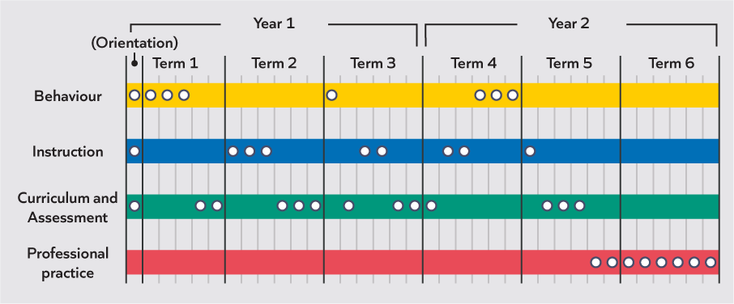
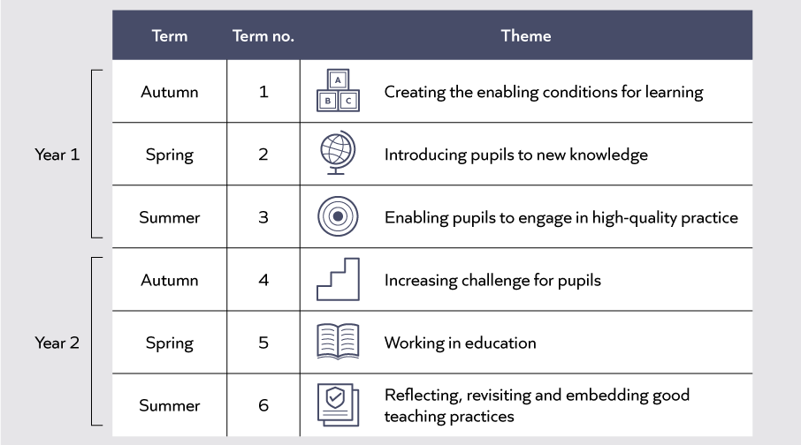
Notes:

Mentor meetings
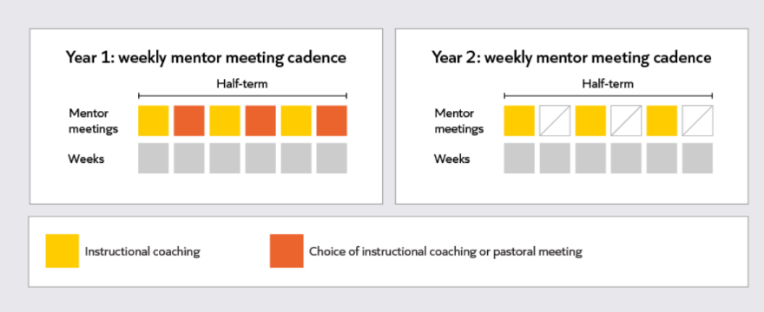

Notes:

Year 2 termly structure
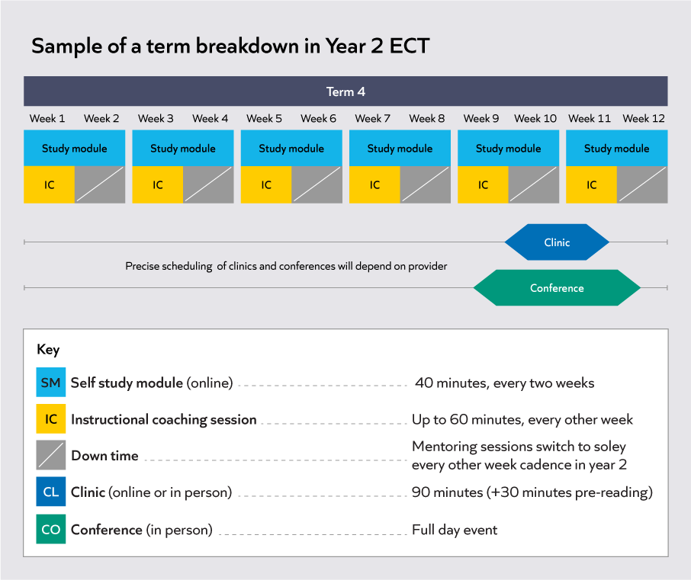

Notes:

Teaching problem
How can every teacher support all pupils to successfully develop their literacy and numerical thinking?
The disadvantage gap
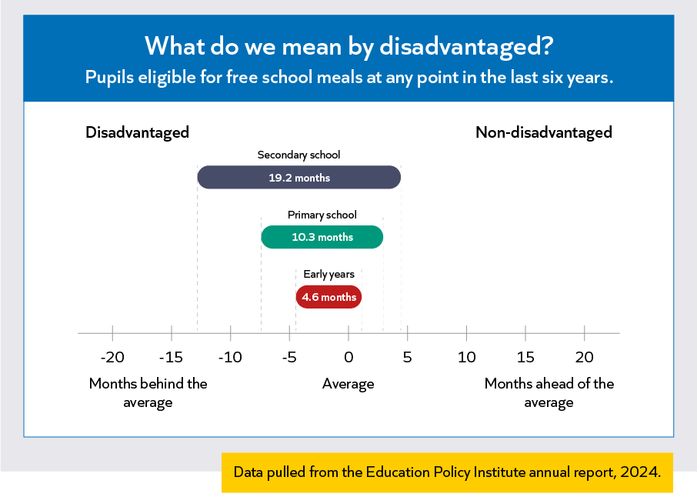
Notes:

Adapted from Nasen (2000)
Planning for embedding literacy
Reflection
Consider the phase or subject you teach.
Where are there opportunities for pupils to…
- Read?
- Write?
- Speak and listen, share ideas or take part in discussion?
- What do you currently do to support all pupils to be successful?
- Have you noticed any barriers to literacy in the pupils that you teach?

Notes:

Module principles
Module principles | Description
Understand the components of literacy | Literacy is made up of multiple, interconnected components, including reading, writing and oracy. These skills develop over time and at different rates. Build your understanding of how literacy typically progresses and consider what is required for literacy teaching in your subject or phase. Identify where pupils are in their literacy development and adapt your teaching to support their next steps.
Develop disciplinary literacy through vocabulary instruction | Every subject has its own language, vocabulary and ways of communicating. Integrate vocabulary instruction into curriculum planning to help pupils access content and express ideas effectively. Provide regular opportunities for pupils to use this language through reading, writing and class discussions.
Explicitly teach literacy | Strong literacy foundations are built through explicit teaching. Develop your knowledge of strategies that contribute to pupils’ literacy development, such as modelling and scaffolding. Use these strategies to make the processes of reading, writing and oracy clear and accessible for all pupils.

Reading
Reflection
- Reflecting on your practice so far, how have/do you support your pupils reading in your phase/subject?
- Do you feel like you have progressed in the way you support pupil reading? If so, how?
- Reflecting on your practice, what barriers do your pupils face when developing their reading skills?
- Which of these barriers have you noticed in your own context?
- How have these translated into classroom symptoms?

Notes:

Retrieval
- What are the two fundamental elements of reading?
- Which of the following is a key aspect of word recognition?
- Reading aloud
- Phonological awareness
- Verbal reasoning
- What is phonics and how can it support pupil reading?
Notes:

The Reading Rope
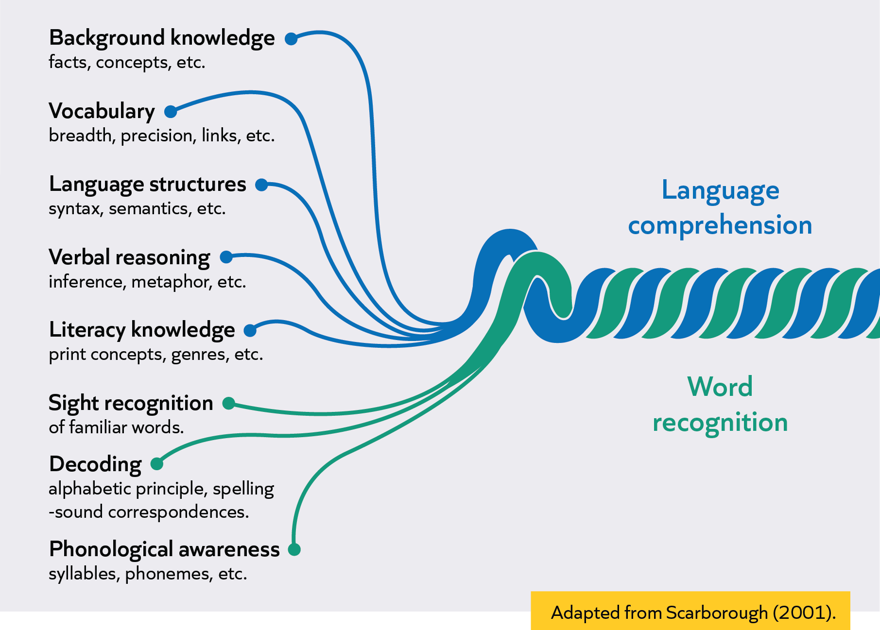
Notes:

Explicitly teach comprehension strategies
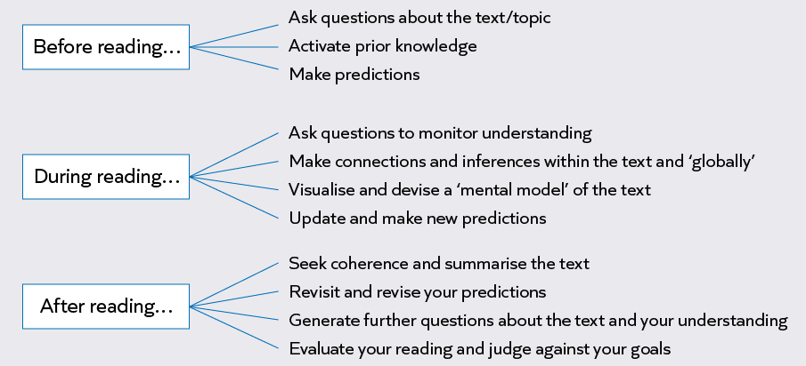

Notes:

Practice task
- Review the medium-term plan and lesson plan you have brought with you.
- Identify a short reading extract you will be using in an upcoming session (or select one from appendix B in your workbook) (2 minutes).
- Use the prompt questions to plan how you will support pupils (10 minutes).
- Discuss your plans in pairs using the prompt questions to guide your conversations. Discuss: When teaching this, how will you know that your planning has been successful? (8 minutes)

Prompt questions: How will you support pupils word recognition and comprehension? (Choose ones most relevant for your age phase and subject)
- Which key vocabulary in the extract might you want to pre-teach?
- How can you link the context of the text to pupils’ prior knowledge?
- Which words or phrases might pupils find difficult to decode? How would you explicitly teach or model reading these words?
- Which sentences might pupils find difficult to read? How might you model how to break down sentences/structures into steps/chunks?
- Which words might pupils need support in pronouncing correctly? How can you model pronunciation?
- How can you support pupils to infer meaning from words they don’t yet know?
- How can you support pupils to understand the whole meaning of the text and the most important points?

This is not an exhaustive list. Are there any other prompts which are important for your age phase or subject?

Notes:

Notes:

Writing
Reflection
- Reflecting on your practice so far, how have/do you support your pupils' writing in your phase/subject (e.g. supporting pupils when having to justify an answer in history or explain their mathematical reasoning in maths)?
- Do you feel like you have progressed in the way you support pupil writing? If so, how?
- Reflecting on your practice, what barriers do your pupils face when developing their writing skills?
- How have these translated into classroom symptoms (e.g. pupils not being able to answer a question)?
- How have you addressed these barriers in your practice so far?

Retrieval
1. What components is writing comprised of?
2. Complete the following:
Before pupils begin to write independently, they should have a good understanding of ______________. This is an important foundation for writing.
  - Concepts of print
  - Punctuation
  - Grammar

Notes:

The writing rope
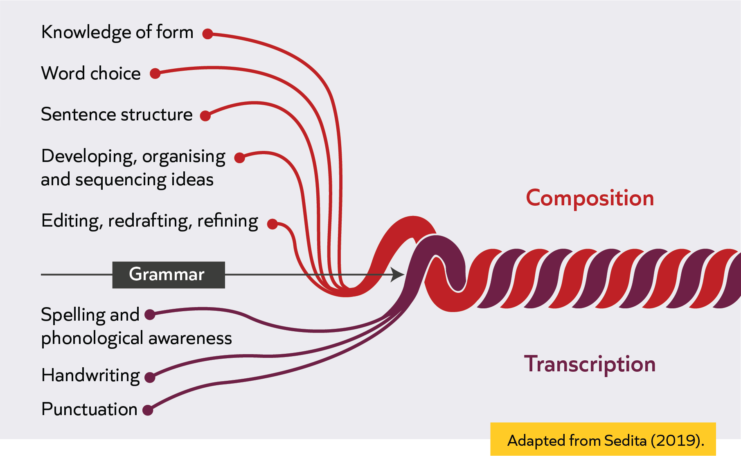

Explicitly teach writing
- Break down writing tasks (word, sentence or paragraph level).
- Provide sentence stems/starters
- Use pre-writing activities
- Model planning, drafting and editing stages
- Monitor and review writing
- Combine writing instruction with reading
- Explicitly teach spelling patterns
- Build motivation
Notes:

Maths example: supporting pupils’ writing
Writing task: In the triangle below, two angles measure 70 degrees and 50 degrees. Calculate the size of the third angle. Write a short explanation to justify your answer, using mathematical reasoning and the rule that the angles in a triangle add up to 180 degrees.

Teacher completes following written example to model to pupils:
To find the size of the third angle in the triangle, I start by adding the two given angles: 70 degrees and 50 degrees.
This gives me 120 degrees.
I know that the angles in a triangle always add up to 180 degrees.
So, I subtract 120 degrees from 180 degrees to find the missing angle: 180 − 120 = 60
Therefore, the third angle is 60 degrees.
I can justify this because the sum of all three angles (70 + 50 + 60) equals 180 degrees, which matches the rule for triangles.

Teacher notes/ annotations
- Organisation of ideas – provide writing frame (E.g. 1-To find the size of the third angle, I start by…)
2. Model how to use the writing frame.
3. Show a worked example which asks for a similar justification of working out angle size.
4. Vocabulary to check understanding- adding, subtract, sum (pupils often mix up adding and sum).
5. During writing task, monitor for correct punctuation, accurate use of vocabulary.

Practice: supporting pupils’ writing
- Review your medium-term plan and identify a task in which your pupils will need to write (e.g. a five-minute writing task). If you can’t access your plan, there are example writing prompts below.
- Write a model example yourself. What is the highest standard you would like pupils to write to in this task? (5 minutes)
- Plan a task to support pupils’ writing, using the question prompts/success criteria in your workbook. (10 minutes)
- Discuss your plans in pairs using the prompt questions to guide your conversations. Discuss: When teaching this, how will you know that your planning has been successful? (8 minutes)

Prompt questions (choose ones most relevant to your age phase and subject):
- What potential barriers might pupils face with this writing task? (e.g. vocabulary, sentence construction, punctuation, spelling, organisation of ideas).
- What pre-writing activities will be helpful to get pupils thinking about the topic?
- What sentence stems or starter words might be helpful?
- How will you model the process of writing effectively for your pupils? How will you break down your model?
- Depending on the phase/age you teach: How will you break down the writing task at word, sentence and paragraph level?
- How will you model the drafting and editing stages of writing?
- Which words might pupils struggle to spell? How will you explicitly teach spelling patterns?
- Which punctuation and grammar rules might pupils need to be reminded of? How will you explicitly teach these and model them?
- Would a word bank be helpful for this writing task? What words might you want to include?

This is not an exhaustive list. Are there any other prompts which are important for your age phase or subject?

Example writing tasks
- Write a paragraph explaining why recycling is important.
- Write some simple sentences, answering the question: What makes a good friend?
- Write simple instructions for how to make a sandwich.
- Should pupils wear school uniform? Write your reasons for and against.
- Write an explanation text about how plants grow.
Notes:

Oracy
Reflection
- Reflecting on your practice so far, how have/do you support pupil oracy in your phase/subject?
- Do you feel like you have progressed in the way you support pupil oracy. If so, how?
- Reflecting on your practice, what barriers do your pupils face when developing their oracy skills?
- Which of these barriers have you noticed in your own context?
- How have these translated into classroom symptoms?
- How have you addressed these barriers in your practice so far?

Notes:

Retrieval
- What is oracy?
- Why is oracy important for pupils?
- Is the following statement true or false?‘The quantity of classroom talk is more important than the quality’.
  - True
  - False
Notes:

Explicitly teach high-quality classroom talk
- Modelling what effective talk sounds like
- Being clear on the purpose of discussion
- Using structured approaches such as ‘talk partners’ or roles within group discussions.
- Using sentence starters and prompts
- Using open-ended questions
- Using wait time before pupils respond

Science example: supporting pupils’ oracy
Unit title | States of matter (science)
How will you organise the group task (pairs, groups, providing pupils certain roles)? | Pupils work in pairs to discuss how water changes state when heated or cooled, using examples from previous lesson investigations and everyday life.  Will also use a timer on the board for pupils to know how much time they have in their discussions.  Will provide reminders and scan the room to ensure all pupils have a chance to talk.
What vocabulary will pupils need to use in their discussions? | - Solid, liquid, gas  - Evaporation  - Condensation  - Melting  - Heating  - Temperature  - Increase  - Decrease
What barriers might some pupils face when participating? | - Some pupils may not be confident to use the key vocabulary or may hold misconceptions.  - Some pupils may feel unsure how to structure or organise their thoughts.  - Some pupils may face individual barriers. In my class, I have a pupil with a hearing impairment. Ensure that they have their hearing aid turned up/on during the classroom discussion and/or provide a quieter space for discussion if possible.
How will you model and scaffold the vocabulary needed for the discussion to support all pupils? | - Revisit key vocabulary at the start of the lesson, before the discussion task.  - Model sentences that combine scientific and mathematical language, e.g. The temperature increased as the ice melted.  - Share sentence stems, such as ‘I noticed that…’ or ‘In the experiment, the water…’ for pupils to explain patterns and reasoning in their own words.

Practice: supporting pupils’ oracy
- Review your medium-term plan and identify a classroom talk/paired talk activity. (Or choose a topic from appendix C in your workbook)
- Use the prompt questions to plan how you might structure this (10 minutes).
- Share your ideas in pairs using the prompt questions to guide your conversations. (10 minutes).

Prompt questions
This list of criteria is not exhaustive. Not all criteria is applicable for all talk tasks. This will depend on the content of the talk task. Select the prompt questions that are most relevant to your age phase, subject and task:
- What pre-teaching will need to happen to ensure that pupils are confident in the topic they are talking about?
- What barriers might some pupils face when participating?
- What vocabulary will pupils need to use in their discussions?
- How will you model and scaffold the vocabulary needed for the discussion to support all pupils?
- What sentence starters and prompts might be helpful?
- How will you model what effective talk sounds like?
- How will you model what effective discussion looks like? (E.g. turn taking)
- How will you organise the group task? (E.g. pairs, groups, providing pupils with certain roles?)
- How might you use structured approaches such as ‘talk partners’ or roles within group discussions?

This is not an exhaustive list. What other prompts might be useful for your age phase, subject or task?

Unit title
How will you organise the group task (pairs, groups, providing pupils certain roles)?
What vocabulary will pupils need to use in their discussions?

What barriers might some pupils face when participating?

How will you model and scaffold the vocabulary needed for the discussion to support all pupils?

Develop disciplinary literacy: vocabulary focus
Tiers of vocabulary
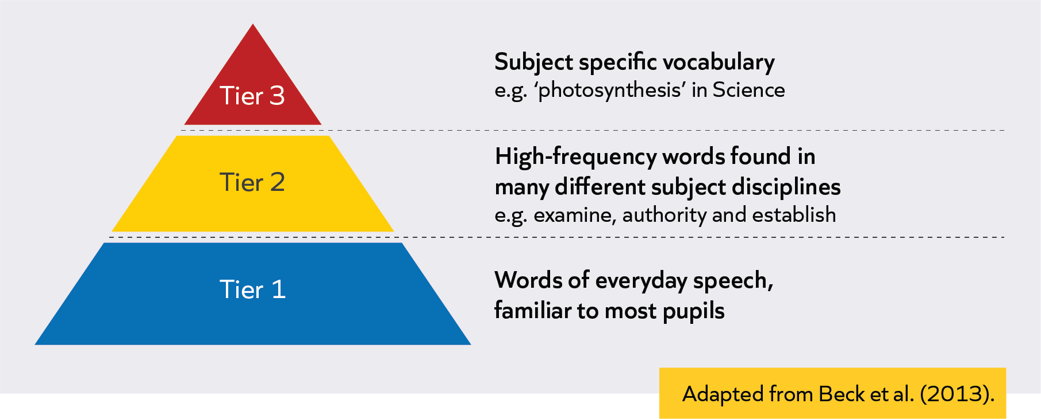t
Notes:

Revisit: teach vocabulary explicitly
- Explicitly teach subject-specific words and their meanings.
- Explore new vocabulary in context, showing how words are used within the subject.
- Model the use of key vocabulary in full sentences during explanations and discussions.
- Give pupils regular opportunities to use new vocabulary in speaking, reading and writing.
- Providing scaffolds, such as sentence starters or word banks, to help pupils use new vocabulary accurately.
- Revisit key words over time to reinforce understanding.

Reflection
How can effective curriculum planning support us to develop pupils’ disciplinary literacy?

Notes:

Plan for vocabulary development
(List not exhaustive)
How might key vocabulary be identified?  - Academic language  - High-frequency and high-utility vocabulary (Tier 2)  - Subject-specific terminology (Tier 3)  - Words with Latin and Greek roots (see workbook appendix) | What might opportunities for vocabulary development look like?  - Defining (pupil-friendly)  - Exploring (e.g. etymology and morphology)  - Engaging (examples, word associations, using words in context, talk activities)  - Revisiting over time

Subject examples
Choose one of the three examples below to review:
- Primary PSHE
- Secondary History
- Secondary DT
Read the example and make notes on the questions in each example (3 minutes).

Primary PSHE example: Plan for vocabulary development
Context: Year 1 PSHE example sequence of lessons on the topic of “Fairness”.
The teacher has made notes on the first half of the medium-term plan to identify a) key vocabulary and b) how they will teach and revisit this.
Read and make notes:
- Why has this key vocabulary been selected?
- How does the teacher plan to teach new vocabulary?
Unit title: | Fairness, empathy and cooperation
Year group | 1
End goal | Play a democratic role in school and local community and positively contribute to our global responsibilities.
Lesson number | Lesson title | Lesson objective | Starter | Main activities | Plenary | Vocabulary
1 | What is fair? | To create a set of rules which are fair. | Pupils recall classroom rules and discuss why rules exist. Teacher introduces ‘fair’ and ‘unfair’ with simple scenarios. | - Discuss meaning of ‘fair’ and ‘unfair’ in pairs.  - Explore scenarios and decide if they are fair or unfair.  - Groups create a set of fair classroom rules, justifying their choices. | Groups share their rules and explain why they are fair. Teacher revisits key vocabulary and asks pupils to use it in sentences. | Fair, unfair, rules, justify, opinion  Think about prior knowledge or assumptions pupils may have about the words. E.g. “That’s not fair” when what they may mean is “ I don’t agree with you.”  Introduce using examples and non-examples.  Include visual aids to support initial comprehension of vocabulary.  Provide pupil friendly definition (e.g. Mr Robertson says, “in this school we open the door for each other when we are on the corridors.” This is a rule.
2 | Understanding others | To understand the thoughts and feelings of others through role play. | Retrieval: give an example of a rule which you think is fair.  Revisit key vocab from previous lesson. | Role play scenarios from Farmer Duck, focusing on different characters’ feelings.  - Pupils write speech bubbles reflecting thoughts and feelings.  - Discuss why understanding others matters.  Word map of different vocabulary for thoughts and feelings. | Pupils share speech bubbles and reflect on how empathy changes their actions. Teacher revisits vocabulary and encourages pupils to use it in their reflections.  Provide sentence starters to support with key vocab. | Empathy, feelings, thoughts, perspective, character  Introduce vocab by linking back to prior knowledge from previous unit on emotions.

Notes:

Secondary History example: plan for vocabulary development
Context: Year 10 History example of a sequence of lessons on the topic of Anglo Saxons.
The teacher has made notes on the first half of the medium-term plan to identify a) key vocabulary and b) how they will teach and revisit this.
Read and make notes:
- Why has this key vocabulary been selected?
- How does the teacher plan to teach new vocabulary?

Unit title:
Year group | 10
End goal
Lesson number | Lesson title | Lesson objective | Starter | Main activities | Plenary | Vocabulary
1 | Social structure and the Anglo-Saxon king’s power | To understand the structure of Anglo-Saxon society and the powers of the king. | Retrieve: What do you remember about how Anglo-Saxon England was ruled? | Place period on timeline and discuss what will be studied.  - Read about social groups and plot a hierarchy diagram.  - Discuss and annotate reasons for king’s power.  - Complete summary questions on king’s power.  - Practise describing two key features of the Anglo-Saxons. | Label a social hierarchy diagram. | Tier 2 Vocab  social structure, power, oath, hierarchy  Use word map to define social structure and hierarchy.  Tier 3 vocab  Anglo-Saxons, king, earl,  Introduce new vocabulary by writing each word on the board, saying it aloud and providing clear definitions and examples.
2 | Limitations to king’s power | To understand the limitations of the king’s power and the role of the earls. | Discuss: What is a rebellion? Why might people rebel against their king?  Recap of key vocabulary from previous lesson. | Recap king’s power from lesson 1.  - Explore the existence of the Danelaw and the king’s reliance on earls.  - Discuss the relationship between Godwin and Edward.  - Compare king and earls’ power using a table.  - Debate: How far do you agree that earls were more powerful than King Edward? (plan and write a 16-mark response).  Provide stem sentences and writing framework to support with key vocab. | What are the three main limitations of King Edward’s power?  Sentence stems to support with key vocab. | Danelaw, rebellion, earl, power, Godwin, Edward, Witan.  Define words, using them in context. E.g. “The Danelaw was an area of England with its own laws, which limited the king’s power.”
3 | Writing practice: Power and hierarchy | To practise writing about power and hierarchy in Anglo-Saxon England. | Recap: What powers did the king and earls have? | Use model answers and sentence starters.  - Write a paragraph explaining the balance of power.  - Peer assess using clear criteria.  - Improve answers in green pen.  - Discuss common errors and how to improve.  -Share improved answers and reflect on how to link evidence to explanation. |  | Tier 2 vocabulary  power, hierarchy, (prior vocabulary) evidence, explanation, criteria

Notes:

Secondary DT example: Plan for vocabulary development
Context: Year 9 design and technology example of a sequence of lessons on the topic of building a bridge
The teacher has made notes on the first half of the medium-term plan to identify a) key vocabulary and b) how they will teach and revisit this.
Read and make notes:
- Why has this key vocabulary been selected?
- How does the teacher plan to teach new vocabulary?
Unit title: | Bridge project
Year group | 9
End goals | • To Design products that solve real world and relevant problems within a variety of contexts, considering their own and others’ needs, wants and values.  • To combine practical and technological skills with creative thinking and problem solving to make products and systems to meet human needs.  • To have and apply an understanding of a wide range of materials, being able to choose and justify their use in relation to their aesthetic, technical, economic, cultural, and physical properties.
Lesson number | Lesson title | Lesson objective (s) | Starter | Main activities | Plenary | Vocabulary
1 | Brief | To know that the project is, understanding its purpose and be able to  analyse a product | Retrieval task : Why is a brief important? What could happen if you didn’t have one? What do the terms client and designer mean? | Model example of a project focused on building a bridge, including its final outcome.  Pupils put into order the sequence of events within a project on building a bridge (brief, planning stage, production, monitoring etc). | Questions: Why is it important for a client and designer to share a brief?  What are the main stages within a project? | Tier 2 vocab  Brief, client, designer.
2 | Material sourcing metals | To know that metals come from ores.  To understand that they are purified to be useful  To be able to describe how metals are sources and processed. | Retrieval: gap fill activity- reviewing sourcing of material groups emphasis on deforestation, and over exploitation of resources. | Introduce the concept of elements and compounds.  Task: draw a diagram showing the sourcing, processing and distribution of iron.  Include sentence stems to support diagram design.  Provide a word bank with definitions on the side | Question: | Tier 2 vocab: sourcing, processing, elements and compounds, ores  Check in science how these words are defined. Check for prior understanding of words to see whether the definitions align and where they differ.  Potential visual aids: Frayer model
3 | Materials testing | To understand material strength testing and destructive testing. | Retrieval: key vocab from previous lesson. | Model different methods of testing material strength.  Explicitly teach the word “strong”.  Definition of strong, link to prior knowledge of strength.  Look at the word strong within the context of material strength.  Activity: Choose the relevant testing method for each material. | Plenary: Choose one testing method for material strength and explain why it is helpful.  Provide writing frame with sentence stems. | Tier 2. Strong, destruction, material.  Tier 3- failure point.

Notes:

MFL example: explicitly teach vocabulary
Review the example script of an MFL teacher explicitly teaching the word “cognate.” Consider the following:
What strategies are used to explicitly teach the vocabulary:
- Explicitly teach subject-specific words and their meanings (e.g. using etymology).
- Explore new vocabulary in context, showing how words are used within the subject.
- Model the use of key vocabulary in full sentences during explanations and discussions.
- Give pupils regular opportunities to use new vocabulary in speaking, reading and writing.
- Providing scaffolds, such as sentence starters or word banks, to help pupils use new vocabulary accurately.
- Revisit key words over time to reinforce understanding.

Teacher script extract
Today, we’re going to learn a really useful word for language learning: cognate. Let’s start by working out what it means.
A cognate is a word in another language that looks or sounds similar to a word in English and means the same thing. So, if you see a word in Spanish that reminds you of an English word, and it means the same thing, that’s a cognate. Last lesson we saw the word “animal” when we were looking at different pets, and we guessed that it meant “animal” in English. That is an example of a cognate.[Teacher shows visual aid to support explanation]
The word "cognate" comes from Latin. "Co-" means "together" and "gnatus" means "born". So, cognates are words that are "born together"—they come from the same origin. That’s why they look and sound similar, even in different languages.
Let’s look at some more examples. In Spanish, "familia" means "family". Both "animal" and "familia" are cognates. Let’s look at this text here. Can anyone spot another cognate?

Notes:

Practice: explicitly teach vocabulary
Identify a lesson on your medium-term plan where key vocabulary is due to be taught. Script and practise explicitly teaching the vocabulary.
- Identify whether the vocabulary is tier 2 or tier 3
- Script explicit vocabulary instruction for one or two of the words
- Identify where else on the medium-term plan you can revisit this vocabulary
- Practise delivery of this script with your partner and get feedback, using the success criteria for support

Success criteria in workbook
Has your partner thought about:
- Explicitly teaching subject-specific words and their meanings (e.g. using etymology).
- Using a strategy like the Frayer model to support understanding
- Exploring new vocabulary in context, showing how words are used within the subject.
- Modelling the use of key vocabulary in full sentences during explanations and discussions.
- Giving pupils regular opportunities to use new vocabulary in speaking, reading and writing.
- Providing scaffolds, such as sentence starters or word banks, to help pupils use new vocabulary accurately.
- Revisiting key words over time to reinforce understanding.

Practice: explicitly teaching literacy
Explicitly teach literacy
Here are some strategies you will already be using in your teaching every day:
- Modelling
- Scaffolding
- Questioning
Which of these strategies do you currently use to embed literacy in your practice and how does it support pupils?
In a moment you will be selecting an explicit teaching strategy (modelling, scaffolding or questioning) and applying it to a specific area of literacy (reading, writing and oracy).
(Secondary focus) As we go through the examples of each strategy and relevant area of literacy, consider which of these strategies are the most pertinent to your subject.
Revisit: modelling
- Reading both fiction and non-fiction texts aloud, pausing to demonstrate how to make predictions, explore meaning and summarise key ideas. Modelling reading strategies, such as breaking down words, to show how to approach complex or unfamiliar vocabulary.
- Writing a modelled sentence or paragraph on the board while verbalising your planning, drafting, revising and editing decisions, explaining why you choose certain words, sentence structures or ways to organise ideas.
- Oracy: demonstrating how to give a clear explanation, respond thoughtfully in a discussion, or build on another pupil’s idea. Teachers should also model clear and accurate sentences.
Revisit: scaffolding
- Reading: Pre-teaching subject-specific vocabulary or providing visuals to support pupils in early stages of decoding. For reluctant readers, offering a range of accessible texts can help build confidence and engagement.
- Writing: Offering sentence starters, writing frames, or checklists to help pupils structure their work. You might also break a longer writing task into manageable steps, guiding pupils through the process.
- Oracy: Setting up structured talk activities, such as ‘think-pair-share’ or debate formats and providing prompts or roles to help pupils participate effectively.
We need to gradually remove scaffolds as pupils gain confidence.

Revisit: questioning
- Reading: “What do you think will happen next?”, “What is the main purpose of the text?” “What do you think the author meant by this?”, “How does this character feel?” or “What is the main idea of this section?”. As mentioned, modelling these types of questions can support pupils’ comprehension by encouraging them to make predictions, infer meaning and summarise key ideas from the text.
- Writing: “How could we improve this sentence?” or “Why did you choose that word?”. These types of questions can prompt pupils to reflect on their choices and explore different ways to express their ideas.
- Oracy: “Can you build on your partner’s idea?” or “What evidence supports your point?”. These types of questions encourage pupils to actively listen to others and articulate their thinking.

Practice context
You will select one instruction strategy (modelling, scaffolding or questioning) and apply it to one area of literacy (reading, writing or oracy).

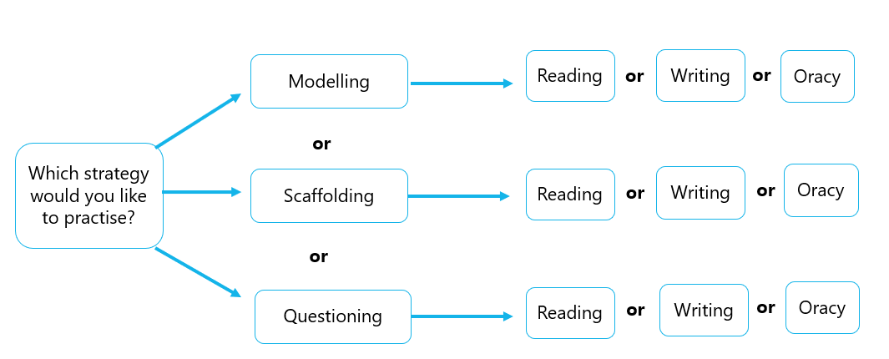
Below are the practice instructions and example extract for each practice task. Select the one practice task you want to focus on and use the space just below the examples to make notes on your planning.

Practice: modelling for reading
From the lesson plan or medium-term plan that you brought with you: identify where pupils will have to do some reading (or select an extract from your workbook).

Task: Script what you will say to model how to approach reading the task.
Before you start: Using the list below, create your own success criteria relevant to the age, phase, subject or task (this will look different, for example, if you are working with EYFS, KS1-KS5). Your success criteria should be based upon what we have discussed today along with learning from your ECT journey to date:

  - Model how to break down the word/sentence/text into manageable chunks.
  - Model fluent reading appropriate for the age/phase group (accuracy, speed, expression).
  - Draw explicit attention to the strategies you are employing to ensure your reading is fluent.
  - Model what you do when you come across a word that you cannot read (decoding strategies).
  - Model what you do when you come across a word that you don’t understand (comprehension strategies).
  - Identify barriers your pupils may have in accessing the task and model supportive strategies (e.g. barriers to decoding, fluency or comprehension).
  - Ensure pupils understand the success criteria of the task.
Stretch: what additional criteria can you add?

Once you’re finished: Practise delivering your script to your partner. Your partner will use your criteria to provide feedback

Example extract
Year 7 art
Pupils will read an extract about cubism.
Pupils will have to read the text and then answer comprehension questions on them.
Cubism was an early 20th century Western art movement pioneered by Pablo Picasso and Georges Braque. It broke away from traditional understandings of perspective, instead depicting objects from multiple angles at once on the same surface plane using fragmented geometric shapes. Adapted and taken from Oak National Academy.
Key words I want to check understanding of: pioneered, perspective, depicting, surface plane, fragmented, geometric.
Scripted model
First, I’m not going to try to read the whole paragraph at once. I’ll break it into smaller parts. Here’s the first sentence:
‘Cubism was an early 20th century Western art movement pioneered by Pablo Picasso and Georges Braque.’
I’ll pause here before moving on, so I can check we understand this part. If I am not sure how to read a word, like ‘pioneered’, I can break it into parts: ‘pi-o-neered’. I look for smaller words I know inside the bigger word, and I sound it out slowly, then blend the sounds together. What does the word pioneered mean? If I don’t understand a word, I use clues from the sentence or the words around it. For example, ‘pioneered’—I know Pablo Picasso and Georges Braque are famous artists, and the sentence says they ‘pioneered’ Cubism. That suggests they started or led this movement. If I’m still not sure, I can check a dictionary or ask someone.
Let’s try another key word: ‘perspective’. The next sentence says:
‘It broke away from traditional understandings of perspective, instead depicting objects from multiple angles at once on the same surface plane using fragmented geometric shapes.’
If I don’t know what ‘perspective’ means, I can look at the rest of the sentence. It says Cubism showed objects from ‘multiple angles at once’, so ‘perspective’ must be about the way we see or look at things. I’ve also heard of geometry from my maths lessons and I can picture the shapes in my mind. I might just draw them here to remind me.
Considering barriers and need for targeted support. I have a pupil who requires extra support with processing information when spoken aloud. I will make sure to use a word bank and, once I have modelled the meaning of the key words, I will keep a word bank on the board for all pupils to refer to.
- ‘Depicting’—to show or represent.
- ‘Surface plane’—the flat surface of the painting.
- ‘Fragmented’—broken into pieces.
- ‘Geometric’—shapes like squares, triangles, and circles.
Notes:

Practice: modelling for writing
From the lesson plan or medium-term plan that you brought with you: identify where pupils will have to do some writing (or select a writing prompt from your workbook).

Task 1: Identify and complete an example (or extract) of the written task which you expect pupils to complete.
Task 2: Script what you will say to model how to approach the writing task.

Before you start: Using the list below, create your own success criteria relevant to the age, phase, subject or task (this will look different, for example, if you are working with EYFS, KS1-KS5). Your success criteria should be based upon what we have discussed today along with learning from your ECT journey to date:
  - Model how the content of the writing links to pupils’ prior knowledge.
  - Identify barriers in accessing the task (e.g. fine motor skills) and model strategies of how to use appropriate scaffolds to access the task.
  - Model using key vocabulary and sentence structures.
  - Model what you do when planning the structure of your writing (developing, organising and sequencing ideas).
  - Model effective writing for the age/phase group/task (e.g. word choice, sentence structure, the way ideas are developed, organised and sequenced).
  - Break the model down into manageable steps.
  - Model what you do when checking over your written work (editing, drafting and refining).
  - Model what you do when you are unsure how to spell a word (e.g. use of phonics or knowledge of prefixes/suffixes).
  - Model what you do when choosing the appropriate vocabulary for the written task (word choice).
  - Ensure pupils understand the success criteria of the task.
Stretch: what additional criteria can you add?
Once you’re finished: Practise delivering your script to your partner. Your partner will use your criteria to provide feedback.

Example extract
Year 8 Computer science
Writing task
In your own words, describe what data science is and why it is useful.

Completed written task extract
Data science collect, prepare and analyse data and use that data to help make decisions. People who work in data science collect lots of facts and numbers, then use special computer programs to help them understand what the data means.
Data science is useful because it helps us make better decisions. For example, companies use data science to find out what products people like to buy, so they know what to sell in their shops. Doctors can use data science to spot patterns in illnesses, which helps them treat patients more effectively. Even sports teams use data science to improve how they play by looking at statistics from their matches. Overall, data science is important because it helps us solve problems and learn new things by looking closely at information. This means we can make smarter choices in lots of different areas, from business to health to sports.

Modelling script extract
Let’s go through together how we can approach this task.
I need to think about the steps which I take when describing something. I am going to go back to the question to see if I can get a sense of how I organise my ideas. The first part of the sentence is asking me to “describe what data science is”. So I am going to use the same words in the question to structure my opening sentence [put up sentence stem ‘Data science is’ on the board]
Then the second part refers to Why it is useful. I think that will be the second part of my text. I can, again, use the words in the question to help me structure my answer. [Put up sentence stem “Data science is useful because”].
So that is my structure. Now let’s think about the vocabulary we’ve been learning about in the past two lessons which can help us describe data science….

Notes:

Practice: modelling for oracy
From the lesson plan or medium-term plan that you brought with you: identify where pupils will have to do some speaking or discussion (or select an example talk task from your workbook).
Task: Script what you will say to model how to approach the talk task.

Before you start: Using the list below, create your own success criteria relevant to the age, phase, subject or task (this will look different, for example, if you are working with EYFS, KS1-KS5). Your success criteria should be based upon what we have discussed today along with learning from your ECT journey to date:
- Model how the content of the task links to pupils’ prior knowledge.
- Identify barriers in accessing the task and model how to use appropriate scaffolds (e.g. use of visual cues on the board).
- Model how to break down the task into manageable steps.
- Model the use of key vocabulary.
- Model effective oracy for the age/phase group –(clear purpose, appropriate vocabulary, accurate grammatical structures).
- Model appropriate tone and body language to match content of what is being spoken about.
- Model clear instructions around who will be speaking, when they speak and how they should speak (e.g. modelling turn taking, active listening and appropriate volume of voice).
- Provide appropriate scaffolds (e.g. sentence starters).
- Ensure pupils understand the success criteria of the task.
- Stretch: what additional criteria can you add?

Once you’re finished: Practise delivering your script to your partner. Your partner will use your criteria to provide feedback.
Example extract
Year 10 physical education
Context: pupils have been learning about fitness components and their importance on performance
Speaking task: pupils will discuss in pairs the benefits of fitness components for different sports

Key words I want pupils to refer to:
- Flexibility - the range of movements possible at a joint
- Power - the product of strength and speed, i.e. strength x speed
- Agility - the ability to move and change direction quickly whilst maintaining control
- Balance - the maintenance of the centre of mass over the base of support and reference can be made to whilst static (still) or dynamic (whilst moving)
- Reaction time - the time taken to initiate a response to a stimulus, i.e. the time from the initiation of the stimulus
- Cardiovascular endurance
- Muscular endurance

Modelling script extract
We have been looking at the different fitness components across different sports over the past three lessons. Let’s remind ourselves of what these components are. [ Teacher puts word bank up on the board]. Archie, can you explain what we mean by power in the context of rugby?
Great, thanks Archie. So now I want us to have a discussion about the impact of fitness components on three sports: football and sprinting
In a moment, I’ll put you in pairs. You are going to explain to each other two things. Firstly, you will talk about which fitness components are needed for the sport you have chosen. Then you are going to explain how the components affect the performance within each sport. I’m going to model an example now, so that we are all clear on what we will be talking about.
In order to play rugby well, you need a variety of fitness components. For example, rugby players need to have strength because players need strong muscles to tackle, push in scrums, and carry the ball. They also need agility because they need to often quickly change direction.
Notice that I have used whole sentences and I have made sure I am using the vocabulary for fitness components accurately.
I’m going to include a couple of sentence starters to support you in the pair task. The person who is closest to the door is partner A. Partner A, you will talk about fitness components in football and partner B, you will talk about fitness components in sprinting.
I will be coming round as you talk to check that we are all staying on topic. You will each speak for one minute on each sport. Partner A goes first.
Ahmed, can you repeat back to me what the instructions are for this paired talk task?

Notes:

Practice: scaffolding for reading
From the lesson plan or medium-term plan that you brought with you: identify where pupils will have to do some reading (or select an extract from your workbook).

Task: Script the scaffolds which you may need to include to support pupils’ reading of this extract.

Before you start: Using the list below, create your own success criteria relevant to the age, phase, subject or task (this will look different, for example, if you are working with EYFS, KS1-KS5). Your success criteria should be based upon what we have discussed today along with learning from your ECT journey to date:
Identify familiar vocabulary and link to relevant pupil prior knowledge.
Identify and pre-teach subject-specific vocabulary.
Identify barriers in accessing the task and provide support (e.g. barriers to decoding, fluency or comprehension).
Explicitly support with decoding (e.g. providing visual cues).
Break down the word/sentence/text into manageable chunks.
Provide appropriate scaffolds (e.g. checklist of steps when coming across a word you don’t know).
Consider at which points these scaffolds would need to be removed.
Ensure pupils understand the success criteria of the task.
Stretch: what additional criteria can you add?

Once you’re finished: Share your notes with your partner. Your partner will use your criteria to provide feedback.
Example extract
Context: Early years
Pupils are going to read the following extract:
The cat is on the mat.
The dog is in the box.
The cat and the dog run.
The cat and the dog have fun.

Teacher planning scaffolds
- Potential familiar language- dog, cat, box, run.
- Potential scaffold to activate prior knowledge- visual aids (pictures of dog, cat, box and run)
- Potential barrier- pupils may struggle to decode the word “the” as it is not possible to “sound out”. Pupils have seen it but they may not have automated how to read the word “the”.
- Potential scaffold could include pointing at the classroom display which shows the common exception words.
Notes:

Practice: scaffolding for writing
From the lesson plan or medium-term plan that you brought with you: identify where pupils will have to do some writing (or select a writing prompt from your workbook).
Task 1: Identify and complete an example of the written task which you expect pupils to complete.
Task 2: Plan the scaffolds which you will need to support pupils to write the task.
Before you start: Using the list below, create your own success criteria relevant to the age, phase, subject or task (this will look different, for example, if you are working with EYFS, KS1-KS5). Your success criteria should be based upon what we have discussed today along with learning from your ECT journey to date:
  - Identify pupils’ relevant prior knowledge.
  - Identify barriers in accessing the task and provide support (e.g. fine motor skills).
  - Model key vocabulary and sentence structures.
  - Choose appropriate scaffolds to support pupils (e.g. sentence stems, writing frames or checklists).
  - Break down the word/sentence/text into manageable chunks.
  - Break down the writing task into manageable steps.
  - Consider at which points these scaffolds would need to be removed.
  - Ensure pupils understand the success criteria of the task.
  - Stretch: what additional criteria can you add?
Once you’re finished: Share your notes with your partner. Your partner will use your criteria to provide feedback.
Example extract
Context: Year 8 RE lesson
Writing task
Write a paragraph explaining why some people choose to fast during religious festivals.
In your answer, describe at least one religion where fasting is important. Include your opinion on fasting during religious festivals.

Example answer
Some people choose to fast during religious festivals because it is a way to show their faith. For example, in Islam, Muslims fast during Ramadan. They do not eat or drink during daylight hours for a whole month. Fasting helps Muslims feel closer to God and reminds them to think about people who do not have enough food. It can also bring families and communities together, as they break their fast at sunset. I think fasting is a meaningful practice because it helps people focus on what is important in their religion and teaches them to be grateful for what they have.

Scaffolds for organising ideas -writing frame which breaks down the steps to completing the writing task.
- Initial idea/argument à Some people choose to fast during religious festivals because…)
- Example of a specific religionà For example, Muslims…
- Describe whyàFasting helps Muslims feel closer to God…
- Personal opinionà I think fasting is a meaningful practice because…

Notes:

Practice: scaffolding for oracy
From the lesson plan or medium-term plan that you brought with you: identify where pupils will have to do some speaking or discussion (or select an example talk task from your workbook).
Task 1: Script a model example of the spoken task
Task 2. Plan the scaffolds which you will need to support pupils to complete the task.
Before you start: Using the list below, create your own success criteria relevant to the age, phase, subject or task (this will look different, for example, if you are working with EYFS, KS1-KS5). Your success criteria should be based upon what we have discussed today along with learning from your ECT journey to date:
  - Identify how the content of the task links to pupils’ prior knowledge.
  - Identify barriers in accessing the task (e.g. hearing problems).
  - Provide targeted support to ensure all pupils can participate in the task (e.g. use of hearing aids or visual cues).
  - Provide scaffolds which help provide structure to the task (e.g. think-pair-share or debate formats).
  - Break down the task into manageable steps.
  - Ensure pupils understand the success criteria of the task.
  - Consider at which points these scaffolds would need to be removed.
  - Ensure pupils understand the success criteria of the task.
  - Consider the groupings/pairs (e.g. pairing a more confident speaker with a less confident speaker so that the more confident speaker can move the conversation on).
  - Consider any additional or more targeted support some pupils may need to access the task (e.g. a pupil with hearing difficulties may require a visual cue to signpost when to listen or when it is their turn to speak).
  - Stretch: what additional criteria can you add?

Once you’re finished: Practise delivering your script to your partner. Your partner will use your criteria to provide feedback.
Example extract
Context: year 7 history
Speaking Task Example
Work with a partner. Imagine you are both living in England just after the Norman Conquest in 1066.
One of you will take the role of a local villager, and the other will be a Norman official.
Take turns to ask and answer questions about how life has changed since William the Conqueror became king.
Think about changes to laws, language, buildings, or daily life.

Scaffolds
1. Key vocab list
Provide a list of important words and phrases, such as “Norman”, “villager”, “castle”, “laws”, “taxes”, “language”, and “changes”. This helps pupils use accurate historical language and express their ideas clearly.
2. Write down roles and keep them on the board. E.g. Partner A- local villager, Partner B-Normal official. Two pupils have vision impairment and so can be given role cards which they can keep, rather than looking at the board.
3. Class reflection on potential feelings and facts about how life has changed. Preparing pupils for the type of content and vocabulary they will need to include once they speak in pairs. This helps pupils step into their roles and gives them ideas for what to say.
4. Sentence starters and question prompts
Put up sentence starters “Since the Normans arrived, I have noticed…”, “How do you feel about…?”, or “One big change is…”. Provide question prompts to guide the conversation, such as “What is different about our village now?” or “Do you think the new laws are fair?” This structure supports pupils who may be unsure how to begin or keep the conversation going.
4. Modelled example
Demonstrate a short paired conversation with another adult or a confident pupil, showing how to use the vocabulary and sentence starters. This helps pupils understand what a successful conversation sounds like and gives them a model to follow.
5. Planning time and notes sheet
Allow pupils time to plan what they want to say, using a notes sheet to jot down key points or questions. This reduces anxiety and helps them organise their thoughts before speaking.
6. Clear success criteria
“Both partners take turns”, “Use at least three key words”, and “Ask and answer at least two questions each”. This helps pupils know what is expected and how to be successful.
Notes:

Practice: questioning for reading
From the lesson plan or medium-term plan that you brought with you: identify where pupils will have to do some reading (or select an extract from your workbook).
Task: Script the questions you want to include to support pupils’ reading of this extract.
Before you start: Using the list below, create your own success criteria relevant to the age, phase, subject or task (this will look different, for example, if you are working with EYFS, KS1-KS5). Your success criteria should be based upon what we have discussed today along with learning from your ECT journey to date:
- Identify familiar vocabulary and link to relevant pupil prior knowledge – use this to inform questions which checks pupils’ understanding.
- Identify and pre-teach subject-specific vocabulary - use this to inform questions checking pupils’ understanding of the content prior to reading.
- Identify potential misconceptions around the content and script questions to check for these misconceptions.
- Identify the reading skill you want to help develop (e.g. verbal reasoning) and identify questions which can support pupils to develop that skill (e.g. making predictions or inferring meaning).
- Script questions you want to ask to monitor understanding during the reading task.
- Script questions to check whether pupils understand the success criteria of the task before completing it.
- Consider who you will ask these questions to (e.g. individuals, a sample, whole class).
- Consider how you will gather the responses from these questions (e.g. hands up, mini-whiteboards).
- Consider your potential responses to these questions (e.g. what might I do if the pupil/s answer this incorrectly or in this way?).
- Consider any additional or more targeted support some pupils may need to access the task (e.g. a pupil with EAL may need additional support with pre-teaching more foundational vocabulary before accessing the reading text).
- Stretch: what additional criteria can you add?

Once you’re finished: Share your notes with your partner. Your partner will use your criteria to provide feedback.
Example extract
Context: Key stage 2 maths

Reading task.
Read the text below and answer the questions.
Amira is organising a school bake sale. She bakes 24 cupcakes and 18 biscuits. She wants to put the cupcakes into boxes of 6 and the biscuits into bags of 3.
Amira sells each box of cupcakes for £2 and each bag of biscuits for £1.
Questions pupils will answer:
- How many boxes of cupcakes does Amira have?
- How many bags of biscuits does Amira have?
- How much money will Amira make if she sells all the boxes of cupcakes and bags of biscuits?
- What is the total number of cakes and biscuits Amira bakes?

Planned questions to support pupils’ reading
- Can you find and underline the numbers in the text? What do they represent?
- What information tells you how to group the cupcakes and biscuits?
- What operation (add, subtract, multiply, divide) do you need to use to solve each question?
- Can you explain what you need to do first, second, and last?
- Are there any words or phrases you are unsure about? What could they mean?

Notes:

Practice: questioning for writing
From the lesson plan or medium-term plan that you brought with you: identify where pupils will have to do some writing (or select an extract from your workbook).
Task: Script the questions you want to include to support pupils’ writing.
Before you start: Using the list below, create your own success criteria relevant to the age, phase, subject or task (this will look different, for example, if you are working with EYFS, KS1-KS5). Your success criteria should be based upon what we have discussed today along with learning from your ECT journey to date:
  - Identify familiar vocabulary and link to relevant pupil prior knowledge – use this to inform questions which checks pupils’ understanding.
  - Identify and pre-teach subject-specific vocabulary - use this to inform questions checking pupils’ understanding of the content prior to writing.
  - Identify potential misconceptions around the content you want pupils to write about and script questions to check for these misconceptions prior to the task.
  - Identify the writing skill you want to help develop (e.g. punctuation) and identify questions which can support pupils to develop that skill (e.g. what punctuation do we use to show the reader we have finished a sentence?).
  - Script questions you want to ask to monitor understanding during the writing task.
  - Script questions to check whether pupils understand the success criteria of the task before completing it.
  - Consider who you will ask these questions to (e.g. individuals, a sample, whole class).
  - Consider how you will gather the responses from these questions (e.g. hands up, mini-whiteboards).
  - Consider your potential responses to these questions (e.g. what might I do if the pupil/s answer this incorrectly or in this way?).
  - Consider any additional or more targeted support some pupils may need to access the task (e.g. a pupil with EAL may need additional support with punctuation if the punctuation symbols differ in their native language).
  - Stretch: what additional criteria can you add?

Once you’re finished: Share your notes with your partner. Your partner will use your criteria to provide feedback.
Example extract
Context: year 4 science class
Writing task
Write a short paragraph explaining the journey of a drop of water through the water cycle.
In your answer, try to use the words “evaporation”, “condensation”, and “precipitation”.
Describe what happens to the water drop at each stage and how it moves from one place to another.

Questions teacher plans to ask

- What key words can we remember from the previous lesson about the water cycle?
- What is the first thing that happens to the drop of water in the water cycle?
- Can you explain what “evaporation” means in your own words?
- Where does the water go after it evaporates?
- What does “condensation” mean? What does the water look like at this stage?
- How does the water drop return to the ground? What is “precipitation”?
- What words can you use to show the order of the stages? (For example: first, next, then, finally.)
- How does the water drop move from one place to another during the cycle?

Notes:

Practice: questioning for oracy
From the lesson plan or medium-term plan that you brought with you: identify where pupils will have to do some speaking (or select an example from your workbook).
Task: Script the questions you want to include to support pupils’ oracy in this task.
Before you start: Using the list below, create your own success criteria relevant to the age, phase, subject or task (this will look different, for example, if you are working with EYFS, KS1-KS5). Your success criteria should be based upon what we have discussed today along with learning from your ECT journey to date:
  - Script questions to check pupil understanding of the relevant prior knowledge before the speaking task.
  - Identify potential misconceptions around the content and script questions to check for these misconceptions.
  - Identify the oracy skill you want to help develop (e.g. listening) and identify questions which can support pupils to develop that skill (e.g. what do we need to do when we are listening to someone speak? ).
  - Script questions you want to ask to monitor understanding during the speaking task.
  - Script questions to check whether pupils understand the success criteria of the task before completing it.
  - Consider who you will ask these questions to (e.g. individuals, a sample, whole class).
  - Consider how you will gather the responses from these questions (e.g. hands up, mini-whiteboards).
  - Consider your potential responses to these questions (e.g. what might I do if the pupil/s answer this incorrectly or in this way?).
  - Stretch: what additional criteria can you add?

Once you’re finished: Share your notes with your partner. Your partner will use your criteria to provide feedback.
Example extract
Context: Specialist setting (using show and tell with visual support)
Each pupil brings (or is given) a familiar object or picture from the classroom (for example, a favourite book, toy, or animal picture).
Task instructions:
- Take turns to show your object or picture to the group.
- Use the sentence starter: “This is my ______. I like it because ______.”
- If you want, you can answer one question from a friend or the teacher, such as “What does it do?” or “Where did you get it?”
Visual prompt cards with the sentence starters and possible questions are placed on the table to support pupils as they speak and listen.
Questions teacher plans to ask
- What is your object or picture called?
- What colour is it?
- Last lesson we looked at describing different textures. What words did we use to describe the feeling of an object?
- How does it feel? (for example, soft, hard, smooth)
- What do you like most about it?
- Where did you get it from?
- What do you do with it?
- Who gave it to you?
- When do you use it or play with it?
- Can you show us how it works?
- Would you like to tell us anything else about it?
- What do we do to show each other we are listening to each other?
- What sign do we make to show that we want to speak?

Notes:
Reflection
Reflect on your teaching of reading, writing and oracy
- What one thing will you do differently for each part of literacy (reading, writing and oracy) in your future teaching?
- How will you know that your change is having a positive impact on your pupils?

Notes:

Planning for embedding numerical thinking
Reflection
- What is numerical thinking?
- What does numerical thinking mean to you?
- Why is numerical thinking important for pupils?
- What strategies do you currently use to support pupils’ numerical thinking?
- How confident do you feel in embedding numerical thinking into your teaching?
- How has your practice in supporting pupils’ numerical thinking changed over the course of your training? If so, how?
- What potential barriers can pupils face when developing their numerical thinking skills?
- How do these barriers translate into classroom symptoms?
- For secondary non-maths teachers: Where are there opportunities for pupils to practice numeracy in your subject? (E.g. counting, drawing graphs, timings etc).

Notes:

What is numerical thinking?
Notes:

Barriers to developing numeracy
Specific needs:
  - SEND (e.g. dyscalculia, working memory difficulties)
  - EAL (language and vocabulary barriers)
General barriers:
  - Maths anxiety/lack of confidence
  - Limited opportunities to apply maths in real contexts
  - Gaps in foundational knowledge (e.g. number sense, place value)
  - Misconceptions (e.g. misunderstanding fractions, decimals)

Notes:

Embedding numeracy
We can support pupils to develop their numeracy skills by:
  - Promoting positive attitudes to numerical thinking
  - Identifying and planning meaningful opportunities for numerical thinking
  - Explicitly teaching numerical thinking

Promoting positive attitudes to numerical thinking
Reflection
Think about what mathematics was like for you at school.
  - Did you enjoy it?
  - Did you feel confident?
  - How might these experiences affect your approach to numeracy?

Promoting positive attitudes to numerical thinking
- Model confidence and curiosity
- Make numeracy relevant
- Build opportunities to practise across all subjects
- Encourage discussion and reasoning
- Celebrate effort and progress

Notes:

Identifying and planning meaningful opportunities for numerical thinking

- Look for numeracy in everyday classroom activities
- Use concrete resources
- Reinforce vocabulary
- Focus on mathematical thinking
- Make connections

Notes:

Practice: identifying opportunities for numerical thinking
1. Review the same medium-term plan/sequence of lessons chosen earlier.
2. Use the prompt questions below to plan your approach. (10 minutes)
- What opportunities might there be within this unit to meaningfully teach numeracy?
- What prior knowledge will pupils need?
- What mathematical language and resources might be used?
- Is there a consistent way that this numerical thinking is taught in my school or setting? (For a secondary non-maths teacher you may want to speak to maths colleauges)
- How might you make connections where relevant?
- How could you promote positive attitudes towards numeracy in this unit?

3. Share your ideas in pairs, using the success criteria below to support your reflections. (10 minutes)
Have you thought about:
  - Identifying key content.
  - Identifying what mathematical goals and activities are included.
  - Considering how this thinking is developed over time (e.g. across a sequence of lessons).
  - How the numerical thinking is meaningfully integrated into the content.

Notes:

Explicitly teach numerical thinking

Reflection
- What explicit instruction strategies covered in this session, as well as in the ECT programme so far, can be helpful in explicitly teaching numerical thinking?

Notes:

English example: explicitly teaching numerical thinking
Context: Pupils are reading a non-fiction text on climate change.
In your workbook, read the extract of the text, as well as the scripted models the teacher uses.
Consider how they:
  - Link new learning to their prior knowledge
  - Model numerical thinking
  - Provide appropriate scaffolding
Global warming is no longer a distant threat; it is a reality that affects us all today. Scientists agree that the Earth’s temperature is rising at an alarming rate, mainly because of human activities such as burning fossil fuels and cutting down forests. According to the Intergovernmental Panel on Climate Change (IPCC), the average global temperature has already increased by about 1.1 degrees Celsius since the late 1800s (IPCC, 2021). This might sound small, but it has already led to more extreme weather, rising sea levels, and devastating wildfires. For example, the World Meteorological Organization reported that the number of weather-related disasters has increased fivefold over the past 50 years.
Visual 1: Line graph showing increase in temperatures

Despite the clear evidence, some governments are still slow to act. It is not enough to simply talk about climate change—we need strong political decisions and urgent action. In 2019, global carbon dioxide emissions reached a record 36.7 billion tonnes (Global Carbon Project, 2020).
Young people around the world are already demanding change. In 2019, more than four million students in over 150 countries took part in climate strikes, calling for urgent action from their leaders. They understand that their future is at risk. It is time for politicians to listen and take responsibility. By working together, governments can create laws that protect the planet and encourage businesses to go green. The cost of inaction is far greater than the cost of making changes now.
In conclusion, global warming is a political issue as much as a scientific one. We must hold our leaders to account and push for real action. The future of our planet depends on the choices we make today.

Example script extracts
Linking to prior knowledge
“I have spoken to Ms Carlisle and she mentioned that in maths you have been looking at how to interpret line graphs. Today, you’ll see a graph in this article that we will be reading about global warming. Can anyone remember what we look for first when we read a graph? That’s right—we check the axes and see what’s changing.”

Modelling numerical thinking
“When I read this text, I see there is a lot of information so I want to break it down into steps to help me. First, I take each paragraph at a time and try to summarise it before moving onto the next one. I think, what is the author trying to communicate here? So for example, for the first sentence in the text, I see they have used a dramatic statement because they have used the word “threat” and “reality for us all”. This makes me think that the author wants to shock the reader into paying attention."

Providing appropriate scaffolding
Sentence starter to support pupils to accurately identify what the line graph is showing, using complete sentences.
What the teacher says:
“Here’s a sentence starter you can use: ‘The line graph shows ____________ from ____ to 2020. This suggests that…
Let’s fill in the blanks together.”

Practice: explicitly teaching numerical thinking
1. Using the medium-term plan/lesson plan you have used in the session, identify a lesson task which requires numerical thinking.

2. Script what you would say to model the numerical thinking.

3. Using the list below, create your own success criteria relevant to the age, phase, subject or task (this will look different if you are working with EYFS, KS1-KS5). Your success criteria should be based upon what we have discussed today along with learning from your ECT journey to date:
  - Link new learning to prior knowledge.
  - Model pattern spotting.
  - Ask questions to monitor how to interpret data.
  - Narrate thought process used to hypothesise what comes next.
  - Model how to interpret information.

Discuss your plan with a partner. Use the success criteria in your workbook to support your discussions.

Next steps
- Login to steplab/ECT platform
- Check handbook for further information
- Speak to your mentor or induction coordinator for further advice.

Notes:

References
Beck, I. L., McKeown, M. G., & Kucan, L. (2013). Bringing Words to Life: Robust Vocabulary Instruction (2nd ed.). New York: Guilford Press.
Education Endowment Foundation. (2017). Improving mathematics in Key Stages 2 and 3. Guidance report.
Education Endowment Foundation. (2020). Improving mathematics in the Early Years and Key Stage 1. Guidance report.
Education Endowment Foundation (2021). Preparing for Literacy: Improving Communication, Language and Literacy in the Early Years. Guidance Report.
Education Endowment Foundation. (2021). Improving Literacy in Key Stage 1. Guidance Report.
Education Endowment Foundation. (2021). Improving Literacy in Key Stage 2. Guidance Report.
Education Endowment Foundation. (2021). Improving Literacy in Secondary Schools. Guidance Report.
Education Endowment Foundation (2021). EEF Guide to the Pupil Premium.
Education Policy Institute. (2024). Annual report 2024: Disadvantage.
Department for Education and Department for Health and Social Care (2015). Special educational needs and disability code of practice: 0 to 25 years.
Department for Education (2012). Research Evidence on Reading for Pleasure. Available from:
Department for Education. (2024). Initial teacher training and Early Career Framework.
Jussim, L., & Harber, K. D. (2005). Teacher Expectations and Self-Fulfilling Prophecies: Knowns and Unknowns, Resolved and Unresolved Controversies. Personality and Social Psychology Review, 9(2), 131–155.
Law, J., Charlton, J., Dockrell, J., Gascoigne, M., McKean, C., & Theakston, A. (2017).
Early Language Development: Needs, Provision, and Intervention for Preschool Children from Socio-economically Disadvantaged Backgrounds. London: Education Endowment Foundation.
Mercer, N., & Dawes, L. (2014). The value of exploratory talk. In Oracy Cambridge: Deeper learning through dialogue. Oracy Cambridge.
Mercer, N., Wegerif, R., & Dawes, L. (2017). Children’s talk and the development of reasoning in the classroom. British Educational Research Journal, 23(1).
Muijs, D., Kyriakides, L., van der Werf, G., Creemers, B., Timperley, H., & Earl, L. (2014). State of the art – teacher effectiveness and professional learning. School Effectiveness and School Improvement, 25(2), 231–256.
National Association for Special Educational Needs (NASEN). (2000). Supporting SEN – Universal Provision.
National Literacy Trust. (n.d.). What is Literacy?
National Literacy Trust (2022). Literacy and Life Outcomes.
National Literacy Trust (2023). Oracy and Literacy: Evidence and Impact.
Pashler, H., McDaniel, M., Rohrer, D., & Bjork, R. (2008). Learning styles: Concepts and evidence. Psychological Science in the Public Interest, 9(3), 105–119.
Scarborough, H. S. (2001). Connecting Early Language and Literacy to Later Reading (Dis)abilities: Evidence, Theory, and Practice. In S. B. Neuman & D. K. Dickinson (Eds.), Handbook of Early Literacy Research (Vol. 1, pp. 97–110). New York: Guilford Press.
Sedita, J. (2019). The Writing Rope: A Framework for Explicit Writing Instruction in All Subjects.
The Oracy Education Commission [OEC], (2024). Oracy in Schools: Final Report.
Stanovich, K. E. (1986). Matthew effects in reading: Some consequences of individual differences in the acquisition of literacy. Reading Research Quarterly, 21(4), 360–407.
Sutton Trust (2019). Social Mobility and the Classroom: The Role of Literacy.

Appendices
Appendix A
Evidence summary from module 3.2 on Developing pupils’ literacy
Introduction
In education, it is often said that every teacher is a teacher of literacy. However, knowing how to support pupils’ literacy can feel challenging, especially when barriers arise or persist. Developing literacy is not just about teaching these skills in isolation; it is about weaving reading, writing, and communication into all aspects of your teaching, so that pupils can access and engage with the curriculum fully.
This module will guide you through the principles and strategies that can help you develop and teach literacy effectively in your classroom, regardless of the phase or subject you teach. We will build on previous learning about the importance of explicit instruction including strategies such as modelling and scaffolding.
What do we mean by the term ‘literacy’?
Literacy is the ability to read, write, speak and listen in order to communicate effectively and make sense of the world around us (National Literacy Trust, n.d.). In schools, literacy is not just part of English lessons. It underpins learning in every subject and aspect of school life. Pupils use literacy skills in a range of situations, such as understanding a range of texts, recording their ideas, taking part in classroom discussions, listening carefully to explanations and following instructions or routines. Therefore, all teachers, regardless of their subject or phase, play an important role in developing pupils’ literacy.

Why is literacy important?
Literacy is a foundation for success in school and beyond. Research shows that secure literacy skills are closely linked to higher academic achievement, improved life chances and greater wellbeing (Education Endowment Foundation 2018a; 2018b; 2020; 2021). In contrast, pupils with weaker literacy skills may find it more difficult to access the curriculum, make progress in their learning and access future opportunities. High-quality, explicit literacy teaching is essential for all pupils. It can help to reduce attainment gaps, particularly for pupils from disadvantaged backgrounds (EEF, 2018a; 2018b; 2020; 2021).
Language development is one of the strongest predictors of future educational success, making it a crucial focus from the earliest stages of learning (EEF, 2018a). Pupils’ phonological skills and vocabulary at age five are strong predictors of later reading and writing success, such as reading ability at age seven and how well pupils comprehend more complex reading tasks at age eleven (Evangelou, et al., 2009; EEF 2018a).
Beyond this, strong literacy skills have a range of wider benefits, including:
- Opportunities for future success: Literacy supports achievement in further education, employment and everyday tasks, such as understanding information and completing forms and enables pupils to take an active role in society (Organisation for Economic Co-operation and Development [OECD], 2019).
- Enjoyment and wellbeing: Reading and writing can foster a love of learning, boost confidence and support social and emotional development (EEF, 2021; National Literacy Trust, n.d.).
- Communication and relationships: Literacy enables pupils to express themselves clearly, work with others and build positive relationships (Law, et al., 2017).
- Critical thinking and participation: Secure literacy skills help pupils analyse information, form opinions and make informed decisions (EEF, 2018b, Quigley, 2020).

How can all teachers meaningfully teach literacy?
Developing pupils’ literacy involves thoughtful planning and explicit teaching, so that reading, writing and oral language skills are woven into everyday lessons. This matters because literacy supports learning across all subjects. When teachers share responsibility for developing pupils’ literacy, pupils can access the curriculum more easily, express their ideas and make connections between new concepts (EEF, 2018b).
Through the following module principles, we will explore the key components of literacy and reflect on what this means for the pupils and curriculum you teach. We will then look at familiar strategies that can support all teachers to plan and teach literacy effectively.
Module Principle | Description
Understand the components of literacy | Literacy is made up of multiple, interconnected components, including reading, writing and oracy. These skills develop over time and at different rates. Build your understanding of how literacy typically progresses and consider what is required for literacy teaching in your subject or phase. Identify where pupils are in their literacy development and adapt your teaching to support their next steps.
Develop disciplinary literacy | Every subject has its own language, vocabulary and ways of communicating. Integrate vocabulary instruction into curriculum planning to help pupils access content and express ideas effectively.  Provide regular opportunities for pupils to use this language through reading, writing and class discussions.
Explicitly teach literacy | Strong literacy foundations are built through explicit teaching. Develop your knowledge of strategies that contribute to pupils’ literacy development, such as modelling and scaffolding. Use these strategies to make the processes of reading, writing and oracy clear and accessible for all pupils.

Understand the components of literacy
As teachers, we often work with pupils at different stages of their literacy journey. Some may still be developing foundational skills, while others are fluent readers and writers. Understanding how literacy develops, including what comes before and after the phase you teach, is key to identifying gaps and supporting pupils’ progress.

Reading
The ability to read depends on two key components: word recognition and language comprehension. There are many different models of reading. For example, you might have previously encountered the simple view of reading as part of your ITT study. On this programme, we use Scarborough’s ‘Reading Rope’ (2001) as this illustrates how components are woven together to develop fluent reading skills.

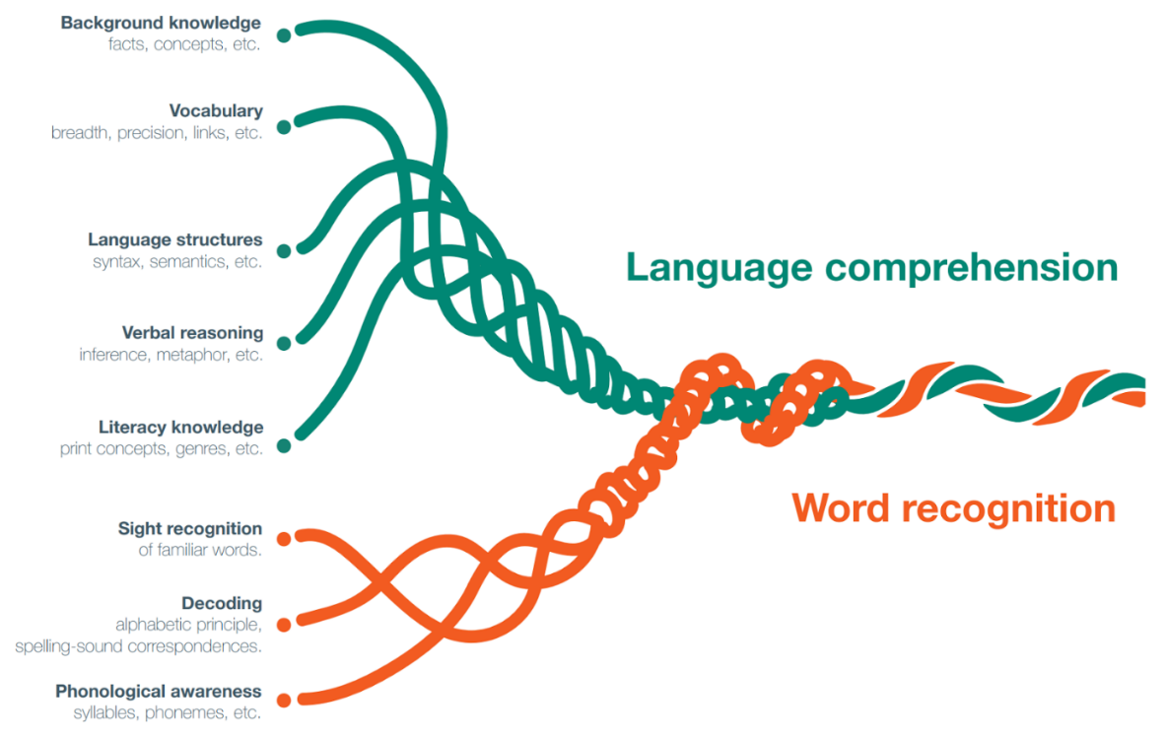
A key part of word recognition is learning to decode words using known relationships between letters and sounds. To do this successfully, pupils need to build phonological awareness - the ability to hear, identify and use the sounds in spoken language. This is most effective when explicitly taught through a systematic, synthetic phonics programme.
In the early stages of reading, pupils learn to identify the smallest units of sound in spoken language (phonemes) and match them to the letters or groups of letters (graphemes) that represent those sounds. Pupils then blend these sounds together to read whole words accurately. The aim is to systematically teach pupils the relationship between these sounds
Example:
When reading the word ‘cat’, a pupil may sound out /c/ /a/ /t/ and blend them together to say the whole word.
Each phoneme (sound) is represented by a single grapheme (a letter of set of letters representing a phoneme): ‘c’, ‘a’ and ‘t’. The word ‘cat’ has three phonemes and three graphemes.
The word ‘sheep’ also has three phonemes and three graphemes.
In this word, two of the sounds are each represented by two letters: ‘sh’ for /sh/ and ‘ee’ for /ee/. This shows that sometimes a single phoneme in a word is represented by more than one letter.
Phonemes may also be spelled using alternative graphemes. For example, the sound /ee/ can also be represented by ‘ea’ as in team, or ‘ey’ as in monkey.

Whilst phonics is typically taught in the Early Years Foundation Stage (EYFS) and Key Stage 1, older pupils may also benefit from explicit phonics teaching, particularly where there are gaps in their foundational reading skills or if they are new to the English language. Regardless of the phase or subject you teach, it is important to be aware of the pupils who require further support with their reading to ensure that they are able to access curriculum content.
Language comprehension develops alongside word recognition. In the early stages of reading, pupils’ understanding of a text may be limited by the effort needed to decode words. As decoding becomes more fluent and automatic, pupils are able to focus more on making meaning from what they have read. By the time pupils enter secondary school, they are expected to read with greater fluency and apply further comprehension skills such as evaluation, analysis and comparison. Teachers should be aware that pupils of any age or phase may need support with comprehension, especially when reading unfamiliar or complex texts. We’ll explore how to do this later in the module when we explore the concept of disciplinary literacy.

Writing
Writing is often considered the most challenging component of literacy (Quigley, 2020; Ofsted, 2022). Even before pupils write independently, they need an understanding of the basic concepts of print. This includes knowing that print carries meaning and that English text is written from left to right. The difficulty of writing arises from the need to coordinate several skills and cognitive processes at the same time. The ‘writing rope’ model helps to illustrate this complexity, showing the many ‘strands’ that contribute to fluent, skilled writing (Sedita, 2019).

You may notice that some components from the ‘Reading Rope’ are also present within this model, which highlights the interconnected nature of literacy skills. For example, phonological awareness is foundational to both early reading and writing.
Transcription is the physical skills of writing, including handwriting and spelling. In the early stages of writing, pupils focus on forming letters, learning to spell simple words using their phonics knowledge and developing their fine motor skills to hold a pencil correctly. As pupils progress, they develop greater fluency and accuracy in handwriting and spelling, which allows them to write more efficiently and focus on accurately expressing their ideas.
Composition is the process of generating, organising and communicating ideas into written language (Quigley; 2020). This starts with pupils using their phonics knowledge to write simple words or short sentences. Over time, pupils learn to plan, structure and extend their writing, using paragraphs, varied sentence types and a range of vocabulary. Effective instruction also builds pupils’ grammatical knowledge, enabling them to construct sentences and communicate clearly.
Writing across the curriculum helps pupils consolidate subject knowledge, which in turn supports vocabulary development and reading comprehension (EEF, 2018b). It is important that all teachers support pupils’ writing development, recognising that it depends on their understanding of subject content, stage of learning, and individual needs. For example, in a science experiment, all pupils need to observe or take part in the process, know relevant vocabulary and be able to organise their ideas in a logical sequence. Early writers might label diagrams or record simple observations, while more proficient writers may be expected to write structured reports using subject-specific language. Some pupils may need additional support with writing, such as sentence starters, vocabulary banks, or assistive technology, particularly where communication and language, or motor skills, are a barrier to learning.

Oracy
Oracy is fundamental to all aspects of learning. It involves “articulating ideas, developing understanding and engaging with others through speaking, listening and communication” (Oracy Education Commission [OEC], 2024).
Progress in reading and writing relies on strong spoken language development. In the EYFS, emphasis is placed on developing pupils’ communication and language skills through high-quality interactions, explicit vocabulary teaching and activities such as storytelling.
Pupils of all ages benefit from high-quality adult input and interaction to support their spoken language (Law et al., 2017; O’Grady, 2005; Zimmerman, 2009). As pupils encounter more complex texts and tasks, the demands on their spoken language also increase. Therefore, every teacher has a role in encouraging purposeful talk and providing opportunities for pupils to practise and extend spoken language.
High-quality classroom talk is a powerful tool for learning. The quality of classroom talk is more important than the quantity. Over time, this helps pupils to explain their ideas, consolidate understanding, collaborate with others, and adapt their language for different purposes and audiences (Mercer & Littleton, 2007; Law et al., 2017).
Teachers should recognise and plan to support pupils with speech, communication and language needs (SLCN). This can be achieved by working alongside colleagues, such as the SENCO, to ensure all pupils can access the curriculum.
Develop disciplinary literacy
Disciplinary literacy is an approach that recognises that each subject has its own language, conventions and ways of communicating (EEF, 2018b). To access the curriculum, pupils need to learn subject-specific vocabulary and use it accurately. Beck et al. (2013) offer a helpful model that shows the pupils different types of language that pupils use in the classroom.

Pupils often start with everyday language (Tier 1) but need explicit teaching and practice to use technical vocabulary (Tiers 2 and 3). This involves examining what successful communication looks like in a subject and breaking this down to the procedural aspects of reading, writing and speaking. To do this, we might ask ‘How can we support pupils to analyse text like historians?’ or ‘How can we support pupils to write like geographers?’ (EEF, 2018b).
As pupils move through school, they encounter more complex texts and subject-specific language. For example, in science, pupils may progress from saying “the water went into the air” to “the water evaporated”. The transition from primary to secondary school can increase the challenges some pupils face with literacy, contributing to a wider ‘literacy gap’. This is why it is important for all teachers to consider the complexity of vocabulary within and across subjects. For instance, in mathematics, words like ‘factors’, ‘mean’ and ‘prime’ have precise meanings that differ from their everyday use. Words such as ‘volume’, ‘scale’ and ‘key’ also holds different meanings across different subjects. For example, a ‘key’ can be a button on a keyboard in computing, a legend on a map in geography, or a group of notes that form the basis of a piece of music. Without explicit vocabulary teaching, pupils can easily develop misconceptions.
To address this, teachers can:
- Explicitly teach subject-specific words and their meanings.
- Explore new vocabulary in context, showing how words are used within the subject.
- Model the use of key vocabulary in full sentences during explanations and discussions.
- Give pupils regular opportunities to use new vocabulary in speaking, reading and writing.
- Providing scaffolds, such as sentence starters or word banks, to help pupils use new vocabulary accurately.
- Revisit key words over time to reinforce understanding.
By focusing on disciplinary literacy, we can help pupils engage more deeply with subject content and develop confidence in expressing their ideas across the curriculum.

Explicitly teach literacy
Explicitly teaching literacy means making the processes of reading, writing and oracy visible in every classroom. This means drawing on effective strategies that are often used by teachers, such as modelling, scaffolding and questioning, which we have explored in previous modules.
Modelling
Effective modelling breaks down complex literacy tasks and shows pupils what success looks like. It gives them a clear example to follow before they try the skill independently. This may involve:
- Reading both fiction and non-fiction texts aloud, pausing to demonstrate how to make predictions, explore meaning and summarise key ideas. Modelling reading strategies, such as breaking down words, to show how to approach complex or unfamiliar vocabulary.
- Writing a modelled sentence or paragraph on the board while verbalising your planning, drafting, revising and editing decisions, explaining why you choose certain words, sentence structures or ways to organise ideas.
- Oracy: demonstrating how to give a clear explanations, respond thoughtfully in a discussion, or build on another pupil’s idea. Teachers should also model clear and accurate sentences.
Additionally, modelling and promoting reading for pleasure, by using a range of whole class reading approaches and regularly sharing high quality texts, can motivate pupils and help them see these activities as meaningful and enjoyable (EEF, 2018a).

Scaffolding
Scaffolding is about providing temporary support to help pupils tackle new or challenging literacy tasks. This support is gradually reduced as pupils gain confidence and independence. This may involve:
- Reading: Pre-teaching subject-specific vocabulary or providing visuals to support pupils in early stages of decoding. For reluctant readers, offering a range of accessible texts can help build confidence and engagement.
- Writing: Offering sentence starters, writing frames, or checklists to help pupils structure their work. You might also break a longer writing task into manageable steps, guiding pupils through the process.
- Oracy: Setting up structured talk activities, such as ‘think-pair-share’ or debate formats, and providing prompts or roles to help pupils participate effectively.
Support for pupils’ reading and writing needs to be adapted to the subject, phase and individual needs. For example, younger pupils might use props or imaginative play to retell stories, while older pupils may benefit from planning formats or collaborative tasks to develop their ideas.

Questioning
Purposeful questioning helps pupils deepen their understanding and practise literacy skills. Use open-ended questions to prompt discussion, ask pupils to explain their reasoning, and support their comprehension. For example:
- Reading: “What do you think will happen next?”, “What happened in the story?” “What do you think the author meant by this?”, “How does this character feel?” or “What is the main idea of this section?”. As mentioned, modelling these types of questions can support pupils’ comprehension by encouraging them to make predictions, infer meaning and summarise key ideas from the text.
- Writing: “How could we improve this sentence?” or “Why did you choose that word?”. These types of questions can prompt pupils to reflect on their choices and explore different ways to express their ideas.
- Oracy: “Can you build on your partner’s idea?” or “What evidence supports your point?”. These types of questions encourage pupils to actively listen to others and articulate their thinking.
By applying these familiar approaches, we can make literacy accessible for all pupils. When every teacher sees themselves as teachers of literacy, we help close attainment gaps and support all pupils to progress.

Nuances and Caveats
Motivation and engagement are essential for literacy progress. Pupils are more likely to persist and improve when they enjoy reading and writing and see these skills as meaningful.
While pupils need subject knowledge to write effectively, this does not mean writing tasks should always be limited to familiar content. Writing can be a valuable tool to help pupils build broader knowledge of the world, which in turn supports vocabulary development, reading comprehension and written expression (EEF, 2018b; 2021).

Appendix B
Reading extract examples, if you don’t have your own planning materials.
Extract 1: Sam and the cat
Sam had a red hat.
He saw a big cat.
The cat sat on the mat.
Sam ran to the cat.
Sam said, ‘can you play big cat?’
‘Yes’ said big cat.
Sam put the hat on the cat.
Sam and the cat had fun.

Extract 2: Polar bears
Habitat
Polar bears live in the Arctic, which is a very cold and icy place. They spend most of their time on the ice, near the sea.

Appearance
Polar bears look white, but their fur is actually transparent. Their fur reflects light, so they appear white and can blend into the snowy environment. Under their thick fur they have a layer of fat called blubber to keep warm in freezing temperatures. Their white fur helps them hide in the snow, which is called camouflage. Their big paws help them walk on ice and hunt for food.

Extract 3: World War II: An Evacuee’s story
The train pulled slowly out of the station, its whistle echoing through the smoky air. Anna pressed her face against the cold window, trying to spot her mother on the crowded platform. She caught sight of a handkerchief waving above the heads, and for a moment her throat tightened.
The carriage was full of children, all with brown labels tied to their coats. Some chatted nervously, others sat in silence, clutching small suitcases.
Fields and villages blurred past as the train headed into the countryside. Finally, the train stopped. One by one, names were called, and children stepped forward to meet the families who would take them in. Anna’s heart raced when she heard her name. She looked up into the kind eyes of a woman who said gently, “You’ll be staying with us, dear. Don’t worry, we’ll look after you.”

Extract 4: Mount Vesuvius
In 79 AD, a dramatic event happened in the Roman Empire. Mount Vesuvius, a large volcano near the Bay of Naples in Italy, erupted. The eruption of Mount Vesuvius was very powerful, it covered the city of Pompeii with ash and pumice. For almost 1,700 years, Pompeii remained preserved in time until it was rediscovered by archaeologists.
Volcanoes like Vesuvius are where hot, melted rock called magma comes out from under the ground. When a volcano erupts, it is because the pressure from the magma becomes too strong, and it bursts out. This can send out ash, gases, and lava, which can be very dangerous.
Some people think that volcanoes erupt only once and then stop. But this is not true. Volcanoes like Mount Vesuvius can erupt many times over thousands of years. Mount Vesuvius has erupted many times since 79 AD, the most recent eruption was in 1944. Today, scientists monitor it closely, because millions of people live nearby. This makes Vesuvius one of the most dangerous volcanoes in the world.

Extract 5: William Shakespeare
William Shakespeare is one of the most famous playwrights in history. He was born in 1564 in a town called Stratford-upon-Avon. Over his lifetime, he wrote 37 plays and 154 sonnets, exploring themes of love, power, jealousy, and betrayal. His works are categorised into tragedies, comedies, and histories. Some of his most famous plays include ‘Romeo and Juliet’, ‘Macbeth’ and ‘Hamlet’.
Shakespeare's plays were performed at the Globe Theatre in London. This theatre was open-air, meaning it didn't have a roof. People from all over came to watch his plays.
Shakespeare's writing changed the English language. He invented many words and phrases that we still use today, like 'break the ice' and 'heart of gold'. Shakespeare's plays and poems continue to be celebrated worldwide.

Extract 6: Ada Lovelace
Ada Lovelace, born in 1815, was a pioneering mathematician and writer. She is best known for her work on Charles Babbage's Analytical Engine, an early mechanical general-purpose computer.
The Analytical Engine was a complex machine that used punched cards to input data and instructions. Lovelace's role was crucial in explaining how the machine could be used beyond simple calculations. She wrote extensive notes on the Engine, including a detailed algorithm. Lovelace's contributions to this project have earned her the title of the first computer programmer, a remarkable achievement for her time.
Today, Ada Lovelace is celebrated as a pioneer in computing. She imagined a future where machines could perform tasks beyond arithmetic, such as composing music or creating art. Her work laid the foundation for modern computer science, and her insights continue to inspire generations of mathematicians and computer scientists.

Extract 7: Fuel for your body
Eating well is about giving your body the right fuel. When you choose balanced meals, you’re supporting both your physical health and your mental wellbeing, helping you stay focused, energized, and confident.
The Eatwell Guide gives us a simple picture of what a healthy plate looks like: lots of fruit and vegetables, some starchy foods like bread, rice or potatoes, and a portion of protein such as beans, fish or chicken. It also shows that we need some dairy or alternatives for strong bones, a little healthy fat, and to mostly drink water instead of sugary drinks.
Remember: eating well is just as important as the choices you make during training, on the pitch, or in the classroom.

Extract 8: Music and religious festivals
Music has always been an integral part of religious festivals across the world. Each religion has its own unique musical traditions that reflect its beliefs and values.
In Hinduism, music plays a vital role in festivals such as Diwali and Holi. During Diwali, people sing devotional songs (called bhajans) to celebrate and give thanks. At Holi, lively folk songs and drumming help people enjoy the colourful celebrations. Traditional Indian instruments, like the sitar (a string instrument) and the tabla (a type of drum), are also part of Hindu musical traditions. Another important feature is chanting. These are repeated phrases, often in Sanskrit, which are thought to bring peace and harmony.

Appendix C
A list of units for practice tasks, if needed when practising supporting pupils’ oracy:
Plants
Ancient Greece
My Local Area
Traditional tales
Rhythm
Dance
Poetry
Weather and climate
Forces
Industrial revolution
Online safety
Materials and their properties

Extra space for reflection/notes
Extra space for reflection/notes
Extra space for reflection/notes
Extra space for reflection/notes

