Science of learning and effective planning

Welcome to the Early Career Teachers Training Programme Launch Conference workbook. This workbook will accompany the facilitated session and help you build on your learning from the orientation which you should have completed online via Steplab.

Session aims
To revisit:
- Key information about the Early Career Teachers Programme
- How the Early Career Teachers programme will support you to develop your expertise
- Key principles from the science of learning
To understand:
- The implications of the science of learning on our role as teachers and learners on this programme
- The underlying features supporting effective planning

Today’s session
Section 1: Programme Overview
Section 2: The power of effective teaching
Section 3: The science of learning
Section 4: Experiencing a clinic
Section 5: Action planning
Section 6: Reflection
Bibliography

Programme overview
Terminology
- Pupils
- Mentor
- ECF = Early career framework
- ECT = Early career teacher
- ECT Programme= Early career teachers Programme
- Orientation is the online introduction (via Steplab) to Ambition’s early career programme.
- Induction refers to your (two-year) entitlement to training as a new teacher.

Retrieval: Early career framework
- The early career framework is:
  - A curriculum of learning to develop early career teacher’s expertise.
  - A second assessment framework from which to evaluate early career teachers.
  - A suggested set of content which early career teachers may find helpful for their context.
Notes:

Key ideas
- Teachers are the foundation of the education system – there are no great schools without great teachers.
- Teachers deserve high quality support throughout their careers, particularly in those first years of teaching when the learning curve is steepest.
- This two-year induction is the bridge between initial teacher training and a career in teaching.

Your entitlements
- Access high quality professional development, including attending conferences and clinics.
- A dedicated mentor to support your practice and guide you through the programme.
- A continued additional 10% timetable reduction for first year of induction and a newly funded 5% off-timetable in second year, providing you protected time for your professional development.

Retrieval: Early career teachers programme
- The early career teachers programme is designed to:
  - Support the professional development of ECTs and provide a framework with which to assess the quality of newly qualified teachers across the country.
  - Support early career teachers to develop expertise in key areas of teaching and learning through engaging with a curriculum of learning which is based on the Early Career Framework.
  - Develop early career teachers’ ability to develop expertise in all aspects of their role as teachers, through a professional development programme.
Notes:

Ambition’s approach to developing teacher expertise
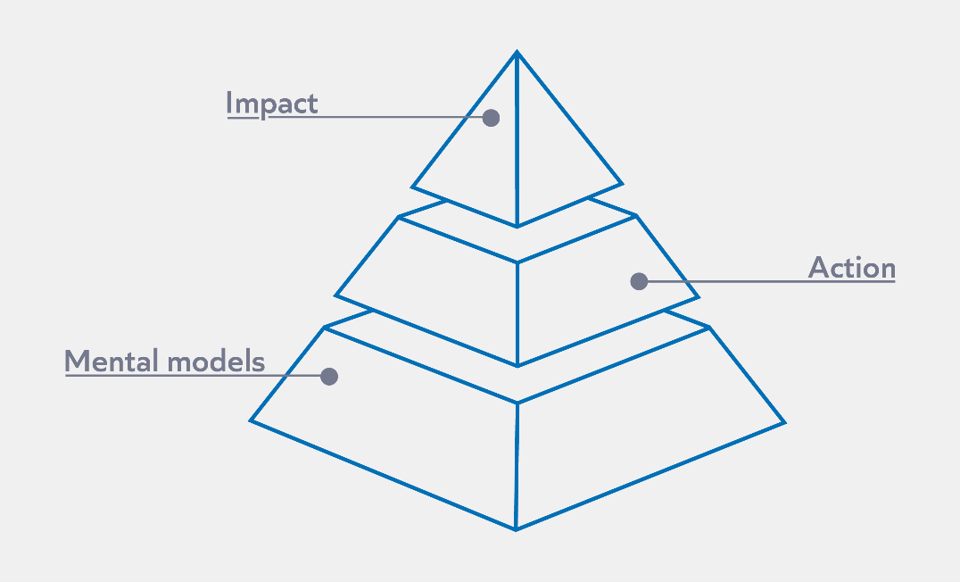

Notes:

How is teacher expertise developed on the programme?
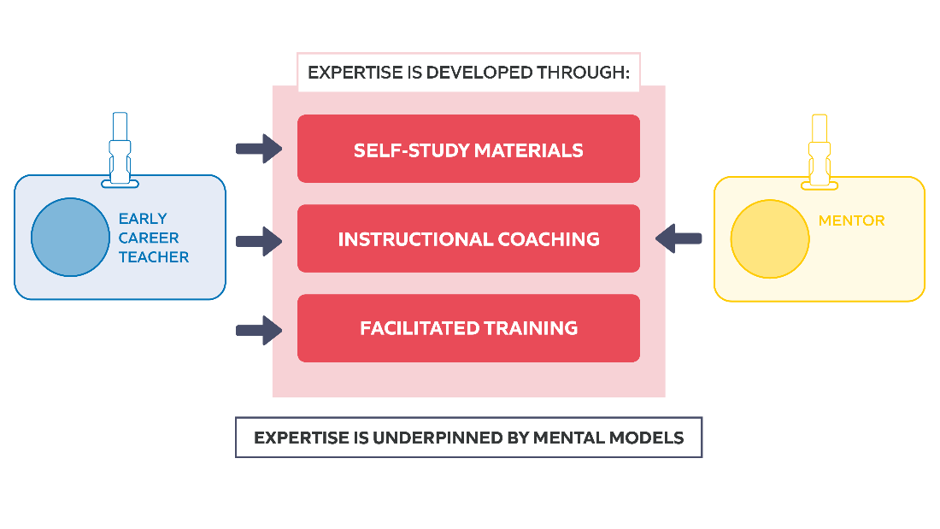
Core Content (ITT) Framework |  | Early Career Framework
Learn that teachers have the ability to affect and improve the wellbeing, motivation and behaviour of their pupils. | Learn how to Communicate a belief in the academic potential of all pupils, by:  - Receiving clear, consistent and effective mentoring in how to set tasks that stretch pupils, but which are achievable, within a challenging curriculum. | Learn that teachers have the ability to affect and improve the wellbeing, motivation and behaviour of their pupils. | Learn how to Communicate a belief in the academic potential of all pupils, by:  - Using intentional and consistent language that promotes challenge and aspiration.  - Setting tasks that stretch pupils, but which are achievable, within a challenging curriculum.  - Creating a positive environment where making mistakes and learning from them and the need for effort and perseverance are part of the daily routine.  - Seeking opportunities to engage parents and carers in the education of their children (e.g. proactively highlighting successes).

Programme principles
Revisit the programme principles and consider the following:
- How might the programme principles support you to manage your workload and develop expertise?
- How can the programme principles support you to engage regularly with professional development?

- Key learning broken down into small, manageable chunks ​
  - In Year 1 of the programme, each week, you will work on a bite-sized aspect of your teaching (known as a step) with your mentor. An example would be looking at a specific strategy to help you to ask effective questions to your pupils.
- Underlying features​
  - Each example provided will have underlying features – these maybe referred to as key ideas(self-study), underlying features (clinics/conferences/stretch) or success criteria (steps). These are the fundamental elements that underpin the concept (e.g. of concept high expectations to manage low level disruption) and will remain the same, no matter what context this learning is put into. For example, if we look at giving clear instructions – an underlying feature will be that the instructions are manageable and sequential – this would be the same if delivering instructions to an early years class or an A level Psychology class. ​
- Clear modelling of effective practice​
  - During your instructional coaching session, your mentor will model what the bite size aspect (step) looks like before you practise applying the step yourself. ​
  - Clinics will also provide models of effective practice in the form of classroom-based scenarios. In each clinic, scenarios will exemplify how teachers might overcome a common teaching problem. Scenarios will cover a range of age and subject contexts, but will all explore how the same underlying features are used by the teacher. The use of common underlying features will support you to transfer your understanding of how to approach the common problem in each of your individual contexts.​
- Multiple opportunities to return to key learning ​
  - The aim of this programme is for you to develop mastery of key teaching practices and, to do that, it is important to revisit and build on key learning. You will have the opportunity to revisit and deepen understanding of key learning through the self-study you carry out, as well as the clinics and conference. For example, in your ITT year, you may have learnt about the importance of giving clear instructions and you will revisit this content when looking at self-study modules on routines. You will then return to these ideas when thinking about how to break down content when modelling content to your pupils. ​
- Practice and feedback​
  - Within the instructional coaching session, you will deliberately practise, and receive formative feedback on, a bite sized aspect of your teaching so that you have an opportunity to practise the step before deploying it “live” in your classroom. ​
- Contextualised​
  - Through the models your mentor shows you during your instructional coaching sessions, they will help you to see how the learning in your self-study modules translate into practice. ​
  - The scenarios exemplified during clinics will be set in classrooms across the age and subject range. Focusing on how the same underlying features support the teachers in each scenario to overcome the teaching problem they are facing, will better enable you to transfer these ideas to your own context.
- Familiar routines​
  - Each week, you will engage in weekly self-study and the weekly (fortnightly in year 2) instructional coaching, to help both you and your mentor get into the routine of engaging in your professional development on the programme.​
​
Notes:

Programme inputs
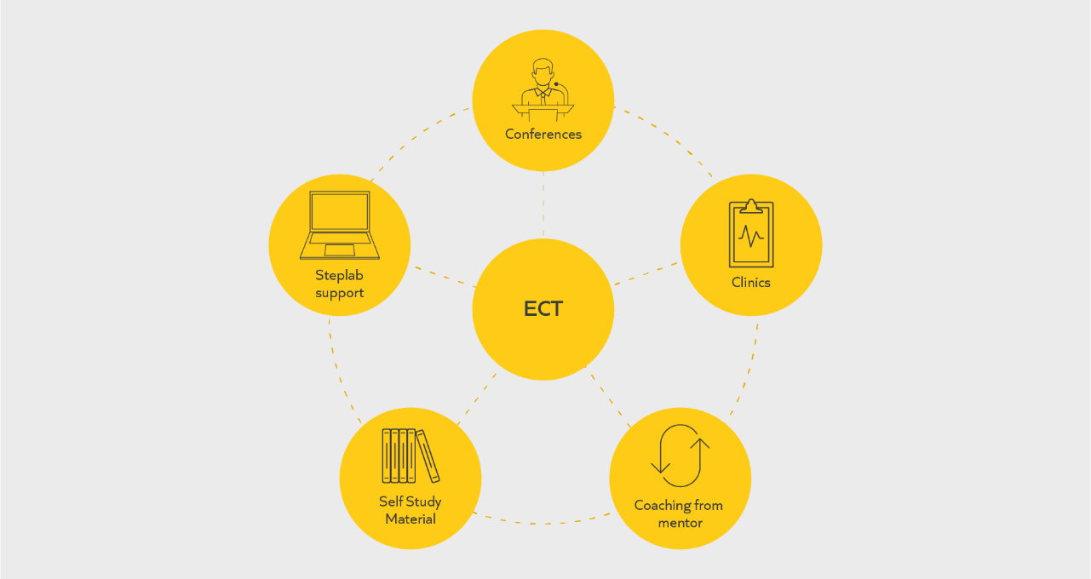

Notes:

Programme journey
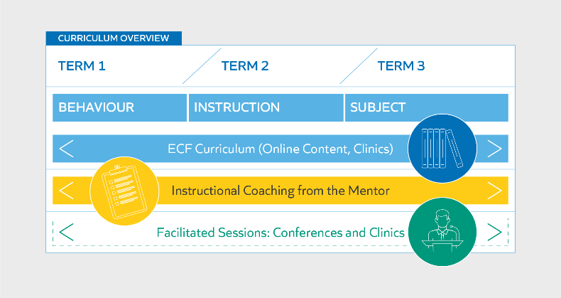

Behaviour strand: at a glance
- Fundamentals
- Routines
- Instructions
- Directing attention
- Low-level disruption
Building in complexity
- Consistency
- Positive learning environment
- Structured support of learning
- Challenge
- Independent practice
- Pairs and groups
- Upholding high expectations

Retrieval: Early Career Teacher Programme inputs
- Clinics and conferences for ECTs are designed to:
- Revisit and build upon content which is also addressed in the weekly study modules.
- Cover content which is not as "coachable" as other content (e.g. managing workload and wellbeing).
- Cover content which isn't covered in the ECF but which at Ambition Institute we feel is important for ECTs to know.

Notes:

Self-study and coaching
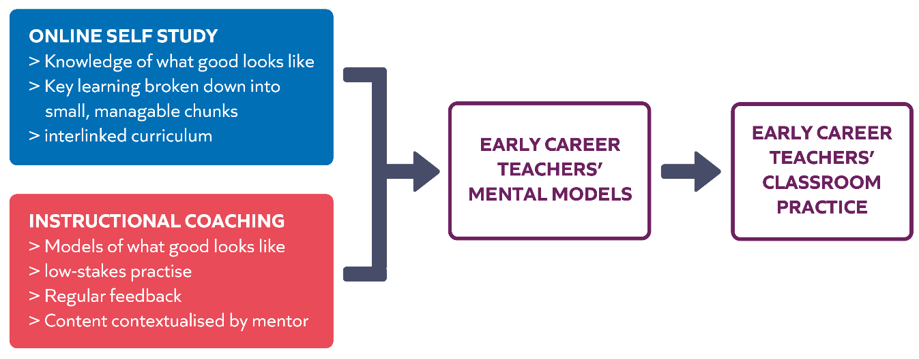
Instructional coaching: Key features 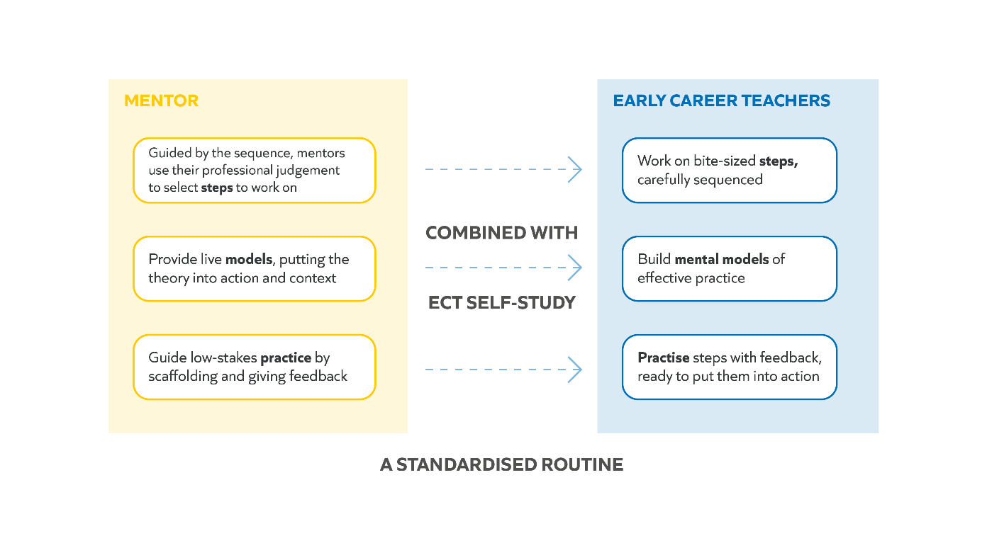

A typical week

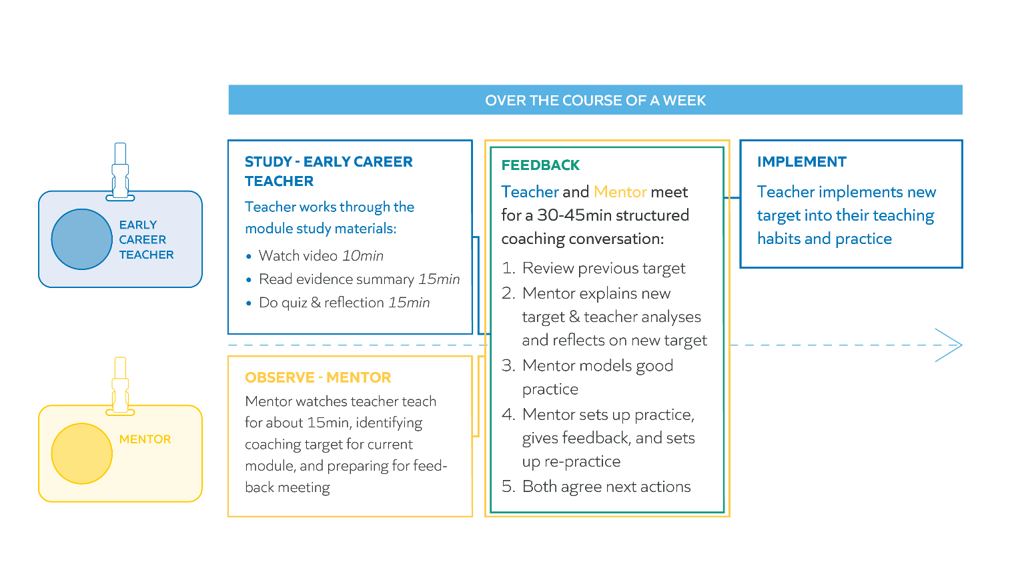

Clinics and conferences
- Support and build on understanding of key curriculum content
- Address certain key ideas which you may not be coached on (e.g. pupil wellbeing)
- Provide an opportunity to network with peers

Suggested training sequence
Year | Half-term 1 | Half-term 2 | Half-term 3 | Half-term 4 | Half-term 5 | Half-term 6
Y1 | Conference 1 |  | Conference 2
Y1 |  | Clinic 1 |  | Clinic 2 |  | Clinic 3
Y2 | Conference 3
Y2 |  | Clinic 4 | Clinic 5 |  | Clinic 6

Where can I find out more?
Steplabà Libraryà ECT 2023-2025 Teacher Key Programme Resources

Journey so far
Notes:

Reflection
- What are you most looking forward to?
- Any questions so far?
Notes:

Recap: self-regulation
Practising self-regulation allows you to have:
- a greater understanding of your strengths and weaknesses.
- a greater awareness of strategies that will help you learn.
- the ability to motivate yourself towards personal learning goals.
Recap: metacognition
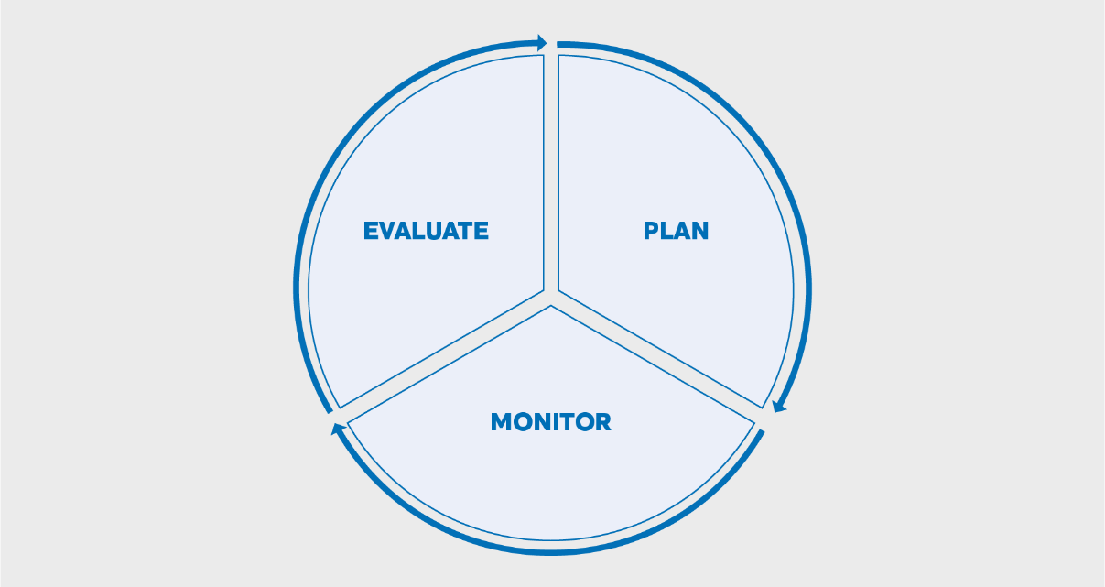
Adapted from EEF, 2018. Metacognition and self-regulated learning

Metacognition example
Planning | I’m going to ensure that I really engage with my self-study time and make sure I make the most of this time. I have decided to use the intervention room which is usually free on a Wednesday afternoon.
Monitoring | The room I wanted to use was busy last week, so it took me 10 minutes before I found somewhere quiet to work, which meant that I lost out on some time as I am teaching straight after. I will talk to my mentor about finding a suitable space, where I can work and the time slot when I need to use it can be protected.
Evaluation | After changing where I carry out my self-study, I am now able to work more efficiently and concentrate on my self-study. I will continue to do this throughout this term as it works well.

Self-regulation in practice
Read the text around potential barriers and examples of how to respond to them.
Given the barriers, which do you think may be the biggest potential challenge for you getting the most out of the programme this year?
We anticipate a few common barriers teachers may face when engaging with the 40-minute weekly study component of the ECT programme. A non-exhaustive list might include:

- Time: Schools are busy places. ECTs tend to take longer to do things than experienced colleagues (and we all underestimate how long tasks take). We might have good intentions to complete our weekly study, but find it just falls off the bottom of our to do list and is forgotten.
- Context: We all teach different subjects and phases. The study materials have been written to be accessible to a general teaching audience. There will be times when you may think ‘I would do this differently in my subject’, ‘our school policy doesn’t allow this’ or ‘in my phase we don’t do that’ and write the materials off as not relevant to your context.
- Motivation: You might engage with weekly study and think ‘I already do that’ or ‘I’ll never be able to do that’ and decide you’re not going to try and implement it in your classroom.
- Technology: You will need to access weekly study through our Steplab platform. You may come to your planned time to study and find your classroom computer is in use, you’ve forgotten your headphones and the staffroom is full, or you can’t connect to the WiFi, leading to you to run out of allocated time.

Self-regulation in practice (context)
Stage | Possible solution/response
Plan (start) | I want to ensure that I keep an open mind when watching development area videos and try to understand different contexts and phases.
Monitor (1-3 weeks) | The focus in the self-study module this week was on a secondary English lesson. Although this is not my subject or phase, I was able to observe how instructions might be implemented with older pupils. I then discussed adapting this for the pupils that I teach with my mentor.
Evaluate (end of half term) | I have been concentrating on the focus of the videos even if they do not relate to my setting or subject - my mentor has helped me to do this in our coaching sessions. My next step for Spring term would be to observe other members of staff who work across different phases during my study time to see what this looks like in their practice.

Self-regulation in practice (Time/workspace)
Stage | Possible solution/response
Plan (start) | I’m going to ensure that I really engage with my self-study time and make sure I make the most of this time. I have decided to use the intervention room which is usually free on a Wednesday afternoon.
Monitor (1-3 weeks) | The room I wanted to use was busy last week, so it took me 10 minutes before I found somewhere quiet to work, which meant that I lost out on some time as I am teaching straight after. I will talk to my mentor about changing my self-study time to a slot when I can work in my classroom instead.
Evaluate (end of half term) | After changing my self-study time, I am now able to work and concentrate on my self-study in my classroom, I will continue to do this throughout this term as it works well.

Power of effective teaching

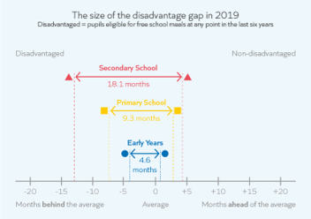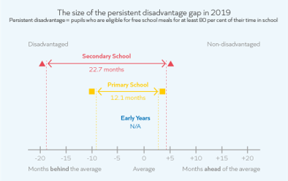

Notes:

“Teaching quality is important. It is arguably the greatest lever at our disposal for improving the life chances of the young people in our care, particularly for those from disadvantaged backgrounds.”
McCrea (2016)

Teacher impact
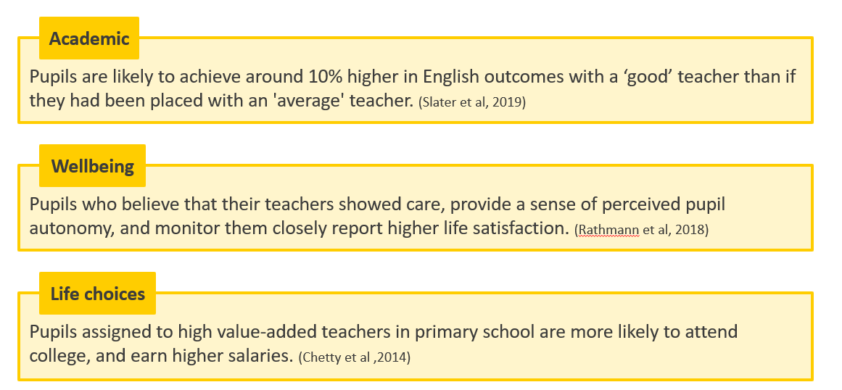

Motivation
Reflect and discuss the following:
- Where does your inspiration for being a teacher come from?
- What drives your motivation to teach?
Notes:

“..data modelling indicates that expectations for success have a unique and positive impact on [pupil] performance every year..”
Centre for Education Statistics and Evaluation (2019)

High Expectations
When reflecting on high expectations we can ask ourselves:
- How do I articulate/communicate my high expectations to pupils?
- How do I know if students have high expectations of themselves?
- How do I model to pupils that I have high expectations of myself and of them?

Why is professional development important?
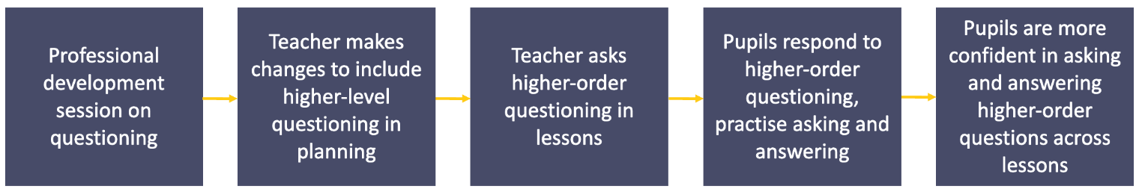

The science of learning

“Understanding a bit about how thinking happens will help you understand what makes thinking hard. That, in turn, will help you understand how to make thinking easier for your students, and therefore help them enjoy school more.”
Willingham (2009)

“Learning involves a lasting change in pupils’ capabilities or understanding.”
ECF, p.10, 2019

Learning not performance
- Performance: Immediate change in behaviour or knowledge that can be observed and measured.
- Learning: Lasting change in capabilities and understanding, which happens over time and is hard to observe.

Why is this challenging for schools?
- Learning cannot be ‘seen’, it is an internal process.
- We can only make inferences about learning based on performance.
- Performance can differ based on classroom environment, pupils needs & emotions and complexity of a task.
- A pupil may answer correctly in lesson, but this information may not be ‘learnt’ or embedded and can be forgotten.

Lasting change: implications
Your learning
After reading about a new topic in her weekly study module, Ms. Gray knows the value of revisiting these ideas in the instructional coaching session with her mentor, as well as in clinics and conferences.

Pupil learning
When trying to gauge what pupils have learned, Ms. Gray knows she needs to look at data over time from a range of sources. She knows what she sees in a single lesson is pupil performance, not necessarily learning.

Recap: simple model of memory
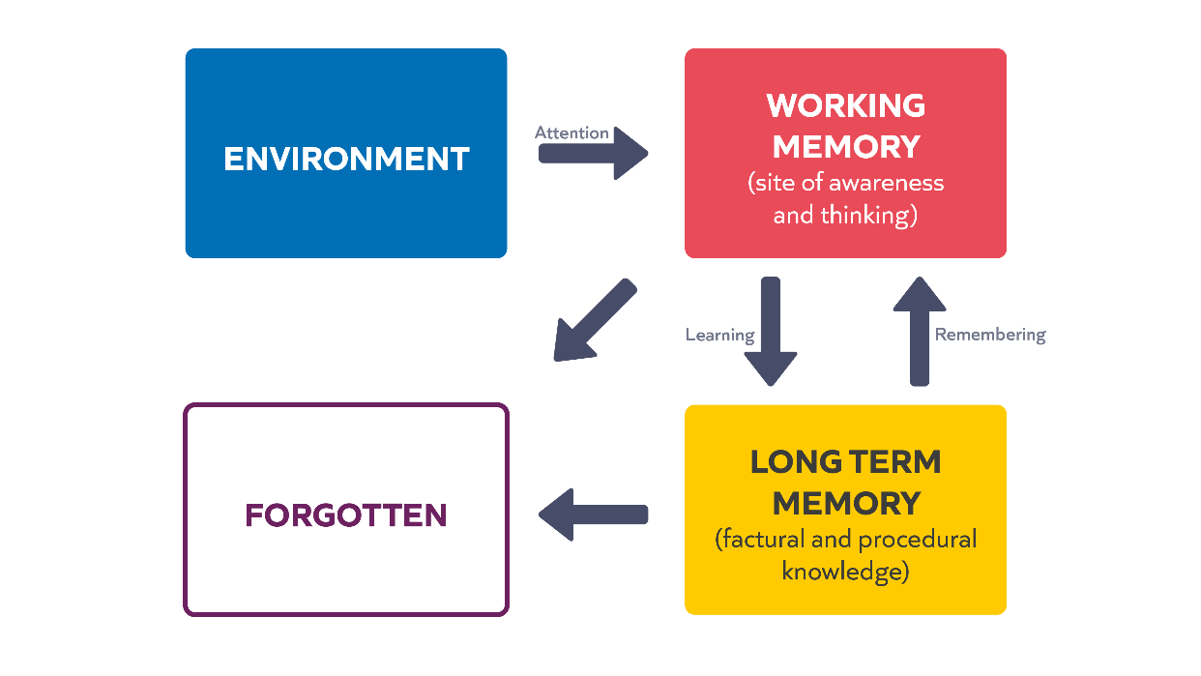
Adapted from Willingham, 2009

Working memory
Notes:

Learning happens over time
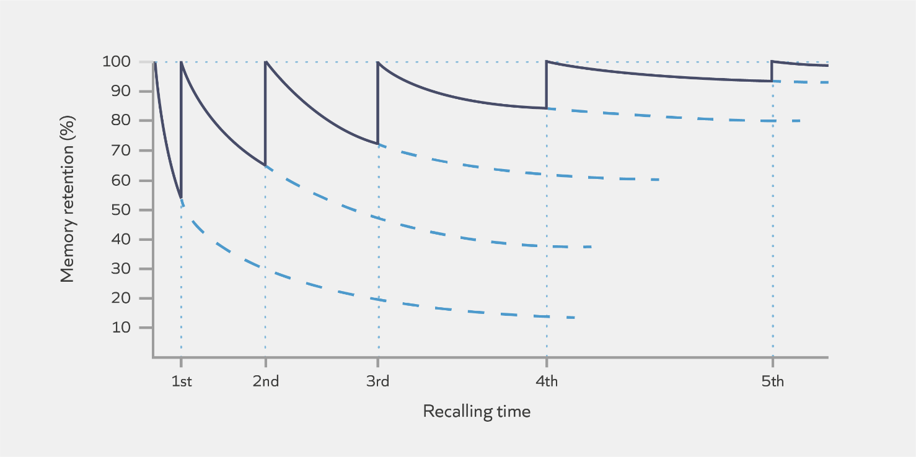
Adapted from Ebbinghaus, 1885

Learning and remembering: implications
Your learning
Mr Amo understands the importance of having opportunities to retrieve key learning from self- study modules and coaching sessions so uses the checks for understanding quizzes in the weekly self-study, clinics and conferences to retrieve this learning.

Pupil learning
Mr. Amo knows that he needs to build in opportunities within his lessons for pupils to retrieve prior learning from previous lessons.

Check for understanding
- Which of these statements are true?
  - Learning is a lasting change in the learner's capabilities or understanding.
  - Building knowledge in long-term memory is important because the better our prior knowledge, the more easily we can make sense of new information.​
  - Learners will struggle to build knowledge in long-term memory if they are cognitively overloaded.​
  - It is possible to make direct inferences about both learning and performance, but it is easier to measure performance.
Notes:

Common misconceptions
- People have different learning styles
- People are preferentially right or left brained
- Humans use 10% of their brains
Notes:

Mental models
The way information is organised in long term memory.
Y7 History Example
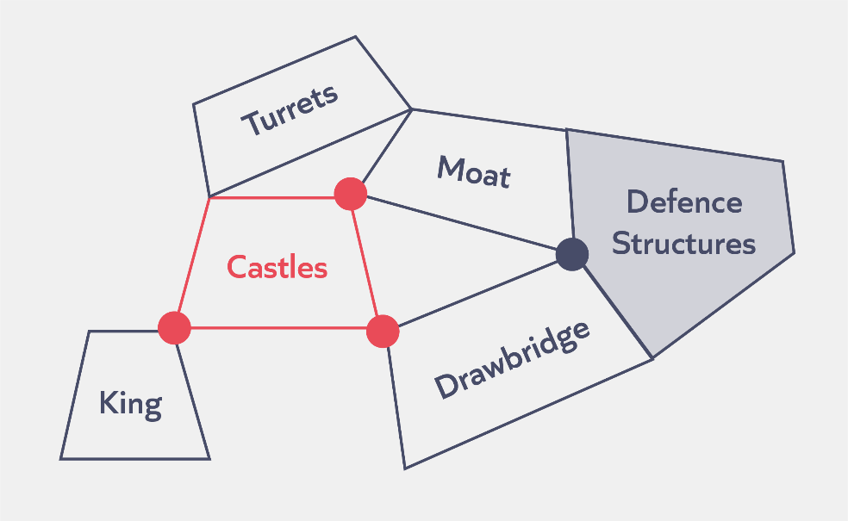
SEND Example
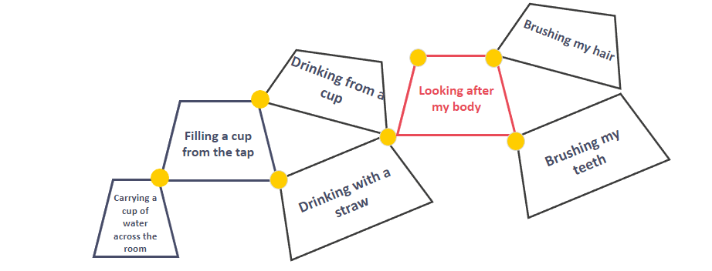
EYFS Example
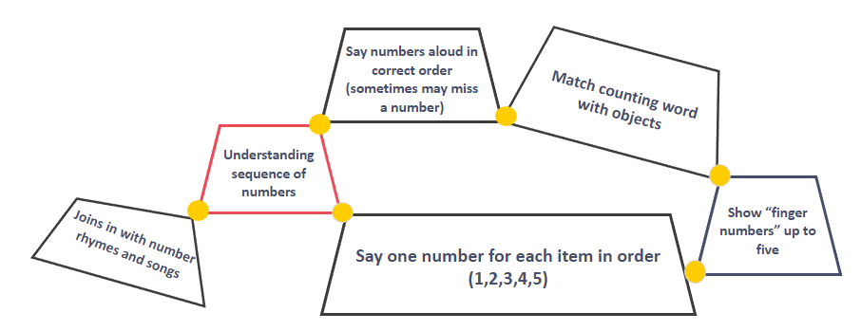
Notes:

Building mental models





Efrat Furst, 2018

Check for understanding
- Which of these statements are true?
  - A teacher’s mental model represents all knowledge they know about teaching and learning.
  - Content should be broken down for novice learners because their mental models are not yet highly connected and developed.
  - Retrieval and practice helps to prevent knowledge being forgotten from our working memory.

Prior knowledge: reflection
Read the scenario and consider the following:
- How does understanding the science of learning help Mr Tam decide about how much content to check/how to review pupil prior knowledge?
- Think of an upcoming lesson that you are teaching, what do pupils need to know before they can engage in the content?

Scenario
Mr Tam is teaching a lesson on time to his year 2 class. He needs to consider pupils’ prior knowledge, including what was taught in Year 1. There are many things he could list here. He chooses a few things to check before starting his unit on time:
- To understand that the clock gives us the time of day
- Pupils’ knowledge of half (to understand half past)
- Pupils’ knowledge of o’clock
- Knowledge of the 5x table or counting in 5s.

Notes:

“Where prior knowledge is weak, pupils are more likely to develop misconceptions, particularly if new ideas are introduced too quickly.”
Early Career Framework (2019)

How novices and experts learn
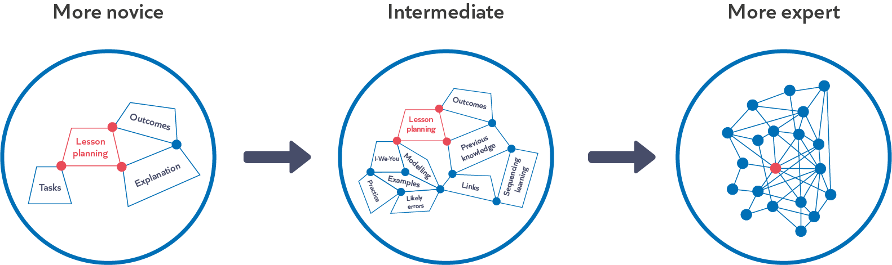
Minimal guidance with occasional corrective feedback.

Mix of guided instruction, modelling and practice, alongside reflection.

Fully guided instruction; modelling and practice with feedback.

Mental models: implications for teaching
- Can you think of an example of a specific schema for an area of learning or unit that your teach?

- What strategies would you use to support development of this schema?
- Why is this important?
Notes:

Mental models: implications as learners on the programme
- How does what we know about developing schemas link to how the programme is designed?
Notes:

Experiencing a clinic

Purpose of a clinic
Clinics will:​
- Build on content covered in self-study modules​
- Cover statements set out in the ECF​
- Provide the opportunity to look at content which isn’t as “coachable”​
- Provide the opportunity to discuss with peers and develop networks​
- Use a range of fictional but realistic scenarios to explore how the same 4-5 underlying features might be used in all contexts to overcome a typical teaching problem

Structure of a clinic
Clinics will last 1.5 hours and will follow the structure below:
- Introduce typical teacher problem​
- Briefly review relevant research/evidence​
- Introduce underlying features​
- I do scenario​
- We do scenarios​
- Non-example scenario​
- Reflections and close

Typical teaching problem

How can teachers plan lessons that support pupils to understand key content, apply knowledge and make progress over time?

Reflection
Reflect on your experiences of planning so far:​
- What was your experience of planning during your ITT year? ​
- Think back to a lesson or sequence of lessons you planned that you feel went well. What do you think made them successful?​
- What did you find challenging when planning individual lessons and lesson sequences?​

Notes:

Challenges when planning
“The Curse of Knowledge: when we are given knowledge, it is impossible to imagine what it’s like to lack that knowledge.”
Heath (2007)

Read the extract below from Peps Mccrea's book ‘Lean Lesson Planning: a practical approach to doing less and achieving more in the classroom’ (2016)
- What are the key messages?
Backwards Design
I have worked with many teachers who have become frustrated by the planning habits they’re developed over time. In some cases, this is because they have fallen unawares into one or both of the following classic traps.
- Activity-focused planning starts by trying to find a good activity, and then reverse engineering the lesson intentions to match the likely outcomes of the activity. Over time, this approach can end up becoming an exercise in keeping students busy.
- Coverage-focused planning begins with a set of lesson intentions that have been crafted by someone else (e.g. a colleague or a textbook), rather than taking the time to construct aims around your student needs. Over time, teaching can become an exercise in getting through the curriculum.
It is possible to experience some short-term gains with both of these approaches. They offer easy and compelling solutions to the problem of planning. However, they are economically flawed, and over time, are likely to stifle professional creativity and generate poor levels of return on student learning.

Starting with the end in mind
In his recent meta-analysis, John Hattie argues that one the best ways to optimise learning is to use backwards design. In the context of lean lesson planning this means two things.
- Start your planning with the question: what do I want my students to have learnt by the end of the lesson?
- Spending more time on this activity than you think you should.
Doug Lemov observed that effective teachers spend more time identifying outcomes and less time selecting activities than their colleagues. The clearer you are about where you want to go, the better chance you have of getting there. This logic may seem obvious, but in practice, it is frequently prone to abuse.
Backwards design is about striving for excessive clarity about what you want your students to be able to do as they progress through the lesson. This involves mapping out, breaking down and thinking hard about how the various parts of the learning trajectory hang together.

Extract from Mccrea, Peps. Lean Lesson Planning: a practical approach to doing less and achieving more in the classroom (2016)

Notes:

Underlying features of effective planning

Identify knowledge | Establish the declarative and procedural knowledge pupils need by the end of the lesson. This will include identifying the desired outcomes for the lesson sequence and considering where the lesson sits within this. Plan backwards from this.
Sequence knowledge | Sequence knowledge so that it builds on content previously taught and is sequenced within the lesson according to the ‘logic of the subject matter’ (William, 2013). Move from the simple to the complex and from the concrete to the abstract. Ensure that knowledge is broken down into its chronological parts before approaching the whole and that pupils have acquired the necessary knowledge before applying it.
Check pupil understanding | Consider potential misconceptions and gaps in learning and plan for when and how to assess pupil understanding.
Secure knowledge | Plan activities which ensure that pupils have multiple opportunities to think hard about critical knowledge.
Support transfer of knowledge | Develop pupils' mental models in a variety of ways, such as analysing examples and non-examples. Give pupils opportunities to apply this knowledge in varied contexts.

Scenario 1
I do
Ms Riaz is a secondary English teacher. This half term, she is teaching Romeo and Juliet to year 9.
Ms Riaz has already familiarised herself with the department’s mid-term plan for the unit. Pupils are to focus of the theme of relationships in the play and the mid-term plan identifies several key scenes that are to be covered across the unit. The mid-term plan also sets out the details of the end of unit assessment, which will take the form of an analytical essay.
Ms Riaz is currently planning the fourth lesson of the unit. In lesson three, pupils read, discussed and annotated the second key scene of the unit: Act 1 Scene 3. In lesson four, Ms Riaz would like pupils to write an analytical paragraph, building the knowledge and skills they will need for their final assessment. She therefore starts by considering what pupils need to know to write a successful paragraph.
Ms Riaz knows that pupils will have written analytical paragraphs in years 7 and 8 and so should have plenty of prior knowledge to draw on for this task. However, as the last time pupils will have completed a similar task was in the summer term of year 8, it is some time since this knowledge has been applied in practice. Ms Riaz therefore understands that prior knowledge will first need to be reviewed and activated and that the writing process will then need to be carefully modelled and scaffolded.
As she is new to the school this year, Ms Riaz is not yet familiar with how the department teaches analytical writing. She therefore speaks to a colleague to establish exactly what prior knowledge pupils might hold for this task. Ms Riaz learns that, whilst the department does not prescribe exactly how analytical writing must be taught, most pupils should be familiar with the ‘what, how, why’ paragraph structure.
Ms Riaz plans a retrieval activity for the start of the lesson. She will frame her question by reminding pupils of their year 8 poetry unit and the analytical responses they completed at the end of it. She will then ask pupils what they think an analytical paragraph needs to include. By prompting pupils to think of a previous unit, Ms Riaz connects past and current learning. By asking an open-ended question, Ms Riaz hopes to gain a better insight as to where her pupils have gaps in knowledge, or misconceptions about what they have learnt on paragraph writing so far. She will then be able to address these both during the discussion and as she models the writing task later in the lesson.
After the retrieval activity, Ms Riaz plans for pupils to deconstruct a model paragraph. She decides to use a pre-prepared model, to ensure that all the components of an analytical paragraph are included. Ms Riaz will ask pupils to identify the components discussed during the retrieval activity. This will encourage pupils to think hard about how generalised components identified earlier in the lesson - such as ‘unpicking the connotations of language’ - might look in the context of this specific play.
Ms Riaz then plans to write a live model with the help of the class, prompting pupils to share ideas for the content of the response as she writes under the visualiser. She will use a combination of cold call and interrogative questioning to gather input from the class. This will help her to both assess what pupils have understood and to stretch their thinking.
After this, Ms Riaz plan for pupils to write their own paragraph independently. As this is the first time they have written analytically this year, Ms Riaz plans some sentence starters for pupils to use should they need support. Pupils will also use the quotations that they selected, discussed and annotated in the previous lesson, to ensure that their focus remains on constructing the paragraph.
After the lesson, Ms Riaz will read these paragraphs and use them to inform her planning for the following week. This lesson, Ms Riaz has planned to only use ‘good’ examples during the modelling process, as she would like pupils to build a secure understanding of what makes a good paragraph. Next week, she will provide non-examples and ask pupils to identify how paragraphs could be improved, before supporting them to this with their own work. This will deepen their understanding of the components of a successful paragraph.

Underlying feature | Where can you see this underlying feature in the scenario? | What impact do the underlying features have on pupils' understanding of key content and application of knowledge?
Identify knowledge
Sequence knowledge
Check pupil understanding
Secure knowledge
Support transfer of knowledge

Scenario 2
We do
Mr Oliver has just started a unit on time with his year 2 class. Before teaching the first lesson, Mr Oliver met with the KS1 maths lead, to discuss what pupils will likely have covered on this topic in year 1 and to talk through the mid-term plan for the upcoming unit. From this, he learnt that most pupils should know that an hour is made up of 60 minutes and should be able to tell and write the time to an hour and half an hour. This half term, they will therefore be focusing on telling and writing the time to five minutes. By the end of the unit, pupils should be confident comparing and sequencing intervals of time.
Having retrieved and consolidated last year’s learning in the first lesson of the unit, Mr Oliver is now planning lesson two. By the end of the lesson, he would like pupils to know that each number of the clock face represents an increment of 5 minutes, up to a total of 60, and be able to apply this knowledge by independently telling the time on multiple clock faces.
Mr Oliver knows that to access the new content, pupils will need to know their 5x tables. Whilst most of the class can recite their tables confidently, Mr Oliver is not sure that they will be able to immediately apply their knowledge to this new context without prompting. He therefore starts by planning a 5x tables retrieval activity for the beginning of the lesson.
Mr Oliver then plans to model telling the time to five minutes with pupils sitting on the carpet. He will explain that each segment represents five minutes of time and use call and response to practise saying the time as the minute hand moves to each five-minute increment. Mr Oliver knows that one likely misconception for pupils will be confusing the numbers marking each hour (1, 2, 3...) with the number of minutes (5, 10, 15...). For this lesson, he therefore plans to keep the hour hand at 12, so that pupils can focus on the movement of the minute hand.
After this initial exposition, Mr Oliver will ask pupils to identify the time on the clock face independently, as he moves the minute hand to different places. Pupils will have 20 seconds to think about their responses before writing them on their mini whiteboards. By surveying the mini whiteboards, Mr Oliver will be able to assess which pupils seem to be feeling more and less confident and address any misconceptions they have.
For the final section of the lesson, Mr Oliver creates a worksheet for pupils to work through independently. The worksheet includes several clock faces, each displaying a different time for pupils to identify. Knowing that some pupils will quickly feel confident with this, there are also some blank clock faces for pupils to fill in according to the time stated above each one. This stretch task will encourage pupils to deepen their understanding of this new content if they are ready, by encouraging them to apply their knowledge flexibly.
Scenario 3
We do
Mrs Danquah teaches at a specialist school for pupils aged 14 to 19 with moderate learning difficulties. This year, she has been working with a pupil in her class, Daniel, on one of his preparing for adulthood targets: ‘to be able to cross the road independently’.
It is the start of the summer term and Mrs Danquah is planning her lesson with Daniel for the week. Over the course of the year, Daniel has built his knowledge of where and when to cross the road and, last week, Mrs Danquah covered the etiquette for waiting to cross when another pedestrian is present. Building on this, in their upcoming lesson, Mrs Danquah would like to start teaching Daniel how to respond if the fellow pedestrian crosses the road without following the guidelines for safe crossing Daniel has learnt so far. It is likely that they will spend at least two lessons on this, or as long as it takes for Daniel to demonstrate a secure understanding consistently.
Mrs Danquah starts by considering which bits of prior knowledge she will need Daniel to draw on to access this new knowledge. She decides that it would be beneficial for Daniel to retrieve his learning from the last two lessons so that he gains a clear understanding of the full sequence of events, from arriving at the crossing to find another pedestrian present, to preparing for his own crossing uninfluenced by the behaviour of the other person. Mrs Danquah feels that this knowledge would be best retrieved in its real-life context, rather than in the classroom. They will return to the same road and crossing point they have used throughout the unit so far, a location Mrs Danquah has selected for its quietness and good visibility.
Before this, Mrs Danquah plans to introduce the new learning for the lesson in the classroom, rather than at the roadside. This will ensure that Daniel is fully focused on the new content. She will explain to Daniel that in today’s lesson, they will be covering how to respond if a fellow pedestrian crosses the road before him. Mrs Danquah knows that a likely misconception for Daniel will be to assume that it is safe for him to cross just because he can see another pedestrian doing so. She will therefore start by explaining to Daniel that if another pedestrian decides to cross the road in front on him, this does not necessarily mean that he should follow. If this happens, Daniel should follow the guidelines they have practised, regardless of how the other pedestrian is behaving.
Earlier in the unit, Mrs Danquah prepared a tick list of actions for Daniel to complete before stepping from the pavement onto the crossing. The laminated tick list uses words and images to identify steps such as waiting at the crossing without becoming distracted (such as by a mobile phone), looking left and right, using body language to indicate his intention to cross and waiting for cars to stop. After she has introduced the focus of the lesson, she will review the tick-list with Daniel and explain that they will be using this at the road to identify why following another pedestrian might be dangerous.
When in location, Mrs Danquah will start by prompting Daniel to retrieve his learning from last week. Daniel will enact a real-life scenario, in which he approaches a second pedestrian, played by Mrs Danquah’s teaching assistant (TA), at the crossing. This will give Mrs Danquah the chance to check that Daniel has understood and remembered the guidelines set out for this situation, such as ensuring that he stands an appropriate distance from the other pedestrian, before moving on to the new content.
Mrs Danquah will then explain to Daniel that the TA – in role as the pedestrian – will now prepare to cross the road. Each time he approaches, he is to watch the TA’s actions and use his tick-list to assess whether she has completed all preparatory actions before crossing. In role, the TA will model dangerous behaviours, such as playing with her phone, or not looking both ways, to see whether Daniel can identify the steps she is missing and explain why these might be problematic. Mrs Danquah will ask Daniel to approach the TA 3-4 times so that she can model a different non-example of good road crossing practice each time. Through this activity, Mrs Danquah plans for Daniel to secure his understanding of safe road crossing behaviours, so that he understands thoroughly why he is not to blindly follow the lead of another pedestrian.
For the final activity, Mrs Danquah plans for Daniel to practise how he should act when another pedestrian starts to cross. This will involve ignoring the behaviour of the other pedestrian and carrying out the actions on the tick list as he would if he were alone.

Reflections
- Where can you see the underlying features in the scenarios?​
- What impact do the underlying features have on pupils' understanding of key content and application of knowledge?

Underlying feature | Scenario 2 | Scenario 3
Identify knowledge
Sequence knowledge
Check pupil understanding
Secure knowledge
Support transfer of knowledge

Action planning

Reflection
Reflect on your planning so far in relation to the underlying features we have just been discussing.​

- Which of the features do you feel you are already considering when you plan your lessons?​
- Which of the features do you currently feel less confident on? Why do you feel this might be more challenging?

Notes:

UF1: Identify knowledge

Prompt questions:
- What would you like pupils to know and be able to do by the end of the lesson sequence?
- What would you like pupils to know and be able to do by the end of the lesson?
Notes:

UF2: Sequence knowledge

Prompt questions:
- What do pupils already know?
- Where does this learning fit into what pupils have covered in previous years?
- How is the knowledge sequenced within the lesson so it logically builds?
- If content is new, how can it be simplified? If content has already been covered, how can you make it more complex?
- If content is abstract, how can it be introduced in a more concrete way?
Notes:

UF3: Check pupil understanding

Prompt questions:
- What misconceptions might pupils have about the lesson content?
- What gaps in knowledge might pupils have?
- When and how will you check for these?
- How will you address these?
Notes:

UF4: Secure knowledge

Prompt questions:
- How will pupils apply the knowledge they have acquired?
- How will pupils practise the knowledge to securely acquire it?
- What activities are planned which prompt pupils to think about the critical knowledge?
Notes:

UF5: Support transfer of knowledge

Prompt questions:
- What opportunities are planned for pupils to develop their knowledge ready for application to different contexts?
- What activities are planned which prompt pupils to apply the knowledge to different contexts?
Notes:

Reflection
Which of the features do you feel most confident applying to your planning?​
Which of the features do you still feel less confident on? What actions could you take over the coming weeks to build your confidence in this area?

Notes:

Reflection and key takeaways

Reflection
Reflect on what you have covered today. Consider the following:

- What impact will this have on your teaching?
- What impact will this have on your pupils?
- What is your main takeaway from today’s session?

Bibliography
Centre for Education Statistics and Evaluation. How high expectations and engagement in primary school drive student learning. Accessible here: https://education.nsw.gov.au/about-us/educational-data/cese/publications/research-reports/how-high-expectations-and-engagement-drive-student-learning#Download0
Clark, R., Kirschner, P. & Sweller, J. (2012). Putting students on the path to learning: The case for fully guided instruction. American Educator, 36(1): 6-11. Accessible here: https://www.aft.org/sites/default/files/periodicals/Clark.pdf
Department for Education, Early Career Framework, 2019. Accessible here: https://assets.publishing.service.gov.uk/government/uploads/system/uploads/attachment_data/file/978358/Early-Career_Framework_April_2021.pdf
Ebbinghaus H (1885) Über das Gedächtnis. Leipzig: Dunker.
Education policy institute, 2020. Accessible here: https://epi.org.uk/publications-and-research/education-in-england-annual-report-2020/
Furst, E. (2018, April) Learning in the brain. Accessible here: https://sites.google.com/view/efratfurst/learning-in-the-brain
Heath, C., & Heath, D. (2007). Made to stick: Why some ideas survive and others die. Random House.
McCrea, P. 2018. Expert Teaching What is it, and how might we develop it? Accessible here: https://s3.eu-west-2.amazonaws.com/ambition-institute/documents/What_is_Expert_Teaching_-_Peps_Mccrea_1.pdf
Roediger, H.L. & Karpicke, J.D. (2006). Test-enhanced learning: Taking memory tests improves long-term retention. Psychological Science, 17, 249-255.
Sims, S., Fletcher-Wood, H., O’Mara-Eves, A., Cottingham, S., Stansfield, C., Van Herwegen, J., & Anders, J. (2021). What are the Characteristics of Teacher Professional Development that Increase Pupil Achievement? A systematic review and meta-analysis. London: Education Endowment Foundation. Accessible here: https://d2tic4wvo1iusb.cloudfront.net/documents/guidance/EEF._Systematic_Review_of_Professional_Development._Dr_Sam_Sims._Protocol.pdf
Quigley, A., Muijs, D., & Stringer, E. (2018). Metacognition and self-regulated learning: guidance report. Accessible here: https://d2tic4wvo1iusb.cloudfront.net/eef-guidance-reports/metacognition/EEF_Metacognition_and_self-regulated_learning.pdf?v=1635355221
Rose, N. (2017, October 23) Are these the 7 pillars of classroom practice? Accessible here: https://www.tes.com/magazine/archived/are-these-7-pillars-classroom-practice
Rose, N. (2018, April 20) The role of forgetting as we learn. Accessible here: https://www.ambition.org.uk/blog/why-forget/
Willingham, D. (2009) Why don’t students like school? Accessible here: https://www.aft.org/sites/default/files/periodicals/WILLINGHAM%282%29.pdf
Willingham, D. (2017) A mental model of the learner: Teaching the basic science of Educational psychology to future teachers. Accessible here: http://www.danielwillingham.com/uploads/5/0/0/7/5007325/willingham-2017_mental_model_of_the_learner.pdf

