Name: ………………………………………………………………………………..
Session date: ………………………………………………………………………
Teaching problem 4
I Do 7
We Do 11
Option A: Non-example 16
Option B: Practice task 20
Option C: I Do (2) 24
Close 27
Appendix 28
Alternative I Do (1) 28
Alternative I Do (2) 30
Alternative We Do (1) 32
Alternative We Do (2) 34
References 36

Teaching problem

In today’s session we will consider the following typical teaching problem:

How can teachers give timely and effective feedback that supports pupil progress and is considerate of workload?

ECT Clinic 3 outcomes
- To understand the underlying features of effective feedback.
- To understand how effective feedback can support adaptive teaching.
- To know how different forms of feedback can look in a classroom context.
Paired discussion
Task: In your pair, discuss the following questions
- What is the purpose of giving pupils feedback?
Notes:
- What forms can this feedback take?
Notes:

Adaptive teaching
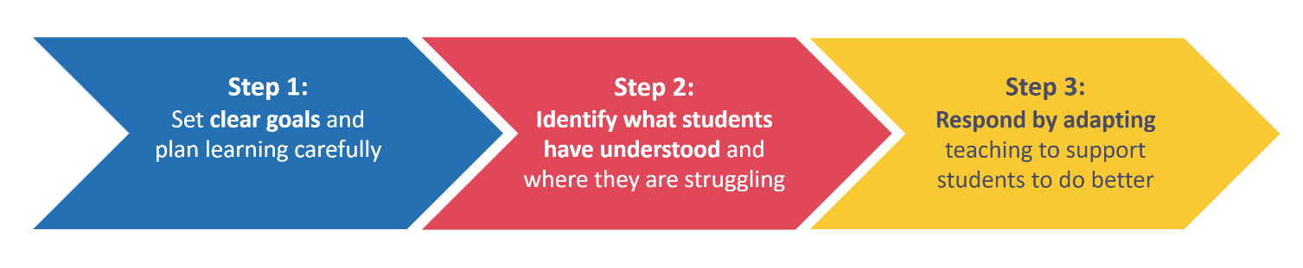
Self-regulated learning
“The concept of self-regulated learning is based on the premise that students should take responsibility for their own learning and should play an active role in the learning process.”
Zimmerman (2001) cited in Mujis & Bokhove, (2020: 5)

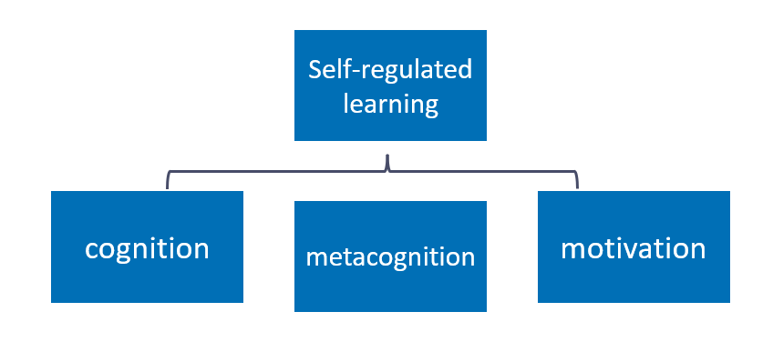
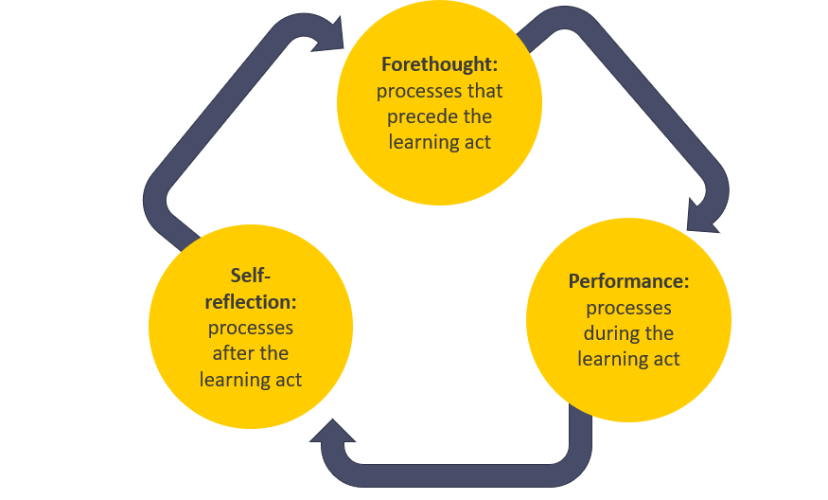
Feedback supports self-regulation

- Where am I going? What does success look like in this problem or area?
- How am I doing? Relative to success, where am I?
- Where to next? What practical steps can I take to close the gap?
(Hattie & Timperley, 2007)
What are underlying features?
Underlying features are the components of an approach that can be applied across all subjects, phases or settings. They serve as a guide for what good practice is likely to look like.
Underlying features in this clinic
Underlying feature | Description
Accurate and clear | Use simple, consistent and concise language, and where appropriate use visual cues, to provide praise and specific guidance on how to improve. Communicate precise next steps to pupils by focusing on specific actions.
Considerate and sensitive | Be aware of the social and emotional factors that can affect pupils’ responses to feedback. For example:  - The age/ needs of the pupil  - Praise can be difficult for some pupils to accept  - Some pupils receive feedback as criticism  Therefore, adapt feedback according to the needs of the pupil. For example, be considerate about how next steps are communicated with a focus on evaluation of pupil outputs and acknowledgement of pupil effort where appropriate.
Encourage further effort | Give pupils the time and support to process and respond to purposeful feedback which requires them to think hard.
Encourage progress in the long term | Ensure feedback develops pupil understanding in the long-term and prioritises critical knowledge and addressing misconceptions. Therefore, ensure feedback goes beyond the single output, is linked to pupils' progression and, where relevant, linked to their long-term goals.
Consider workload | Ensure feedback strikes a balance between the benefit it has on pupil learning and the resources and time dedicated to providing it, reducing the opportunity cost of giving feedback. Ensure the onus is on the progress pupils make as a result of the feedback as opposed to the work the teacher does to provide the feedback.

I Do

Task: Read the scenario.

Scenario 1
Mr Patel has been working on single digit addition with his year 2 class. They have progressed to using the ‘make the next ten’ strategy to solve problems which bridge ten. This strategy involves pupils using ten frames and counters to represent the sum. The pupils have been using the strategy over a series of lessons and are consistently answering questions which bridge ten correctly. Now, they are learning to transfer their working out from the ten frames to a written representation in their books. For the final 15 minutes of the lesson Mr Patel has given his pupils five questions to complete. Pupils can use the ten frames and counters to support them. They are expected to work through these questions independently and to write their working out in their books. At the end of the lesson, Mr Patel asks them to pile up their books on the end of each table, open on the page they have done the questions on. This makes it quicker and easier for him to mark the books as he does not need to find the page he is intending to mark in each book.
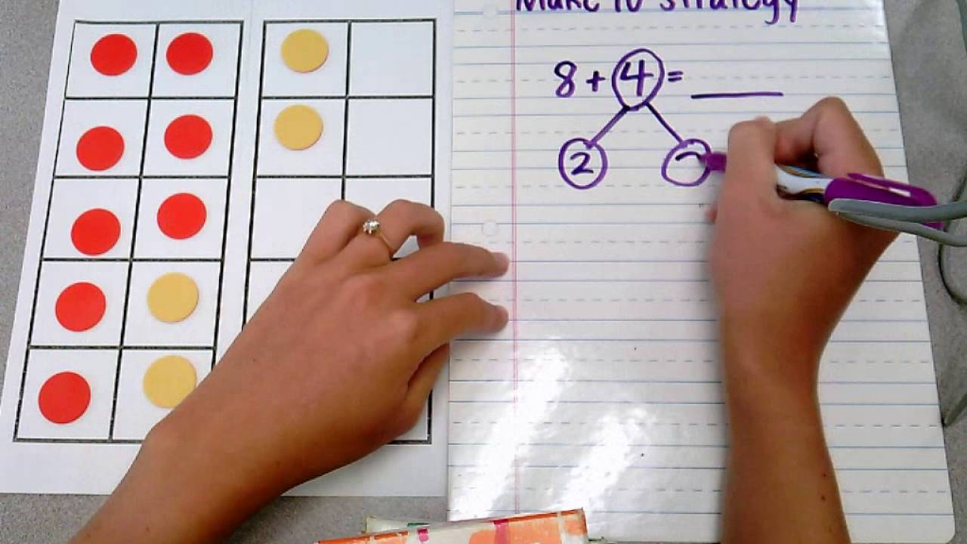

After school, Mr Patel has planned in 20 minutes to mark the five questions in each of his 30 pupils’ books and then 20 minutes to plan his feedback portion of his next maths lesson. Mr Patel selects 5 books as a starting point; two pupils who he knows grasped this quickly when they started working on it, two pupils who he knows struggle to remember mathematical processes and a final book at random. He reviews these books without adding written feedback, reading the working out and answers, scanning for common errors. He finds he can divide the work he has seen into three categories of next steps and common errors.
- Pupils who got both the working out and the answers wrong on three or more of the questions.
- Pupils who got all the questions correct with the correct working out
- Pupils who got all the final answers correct, but their working out isn’t consistently correct. When they were writing their working out, they split the second number into two parts where the first part didn’t always add up to ten.
Now he is confident that he has excavated the common errors that pupils are making in their work, he marks all the pupils’ books by using the following marking codes:
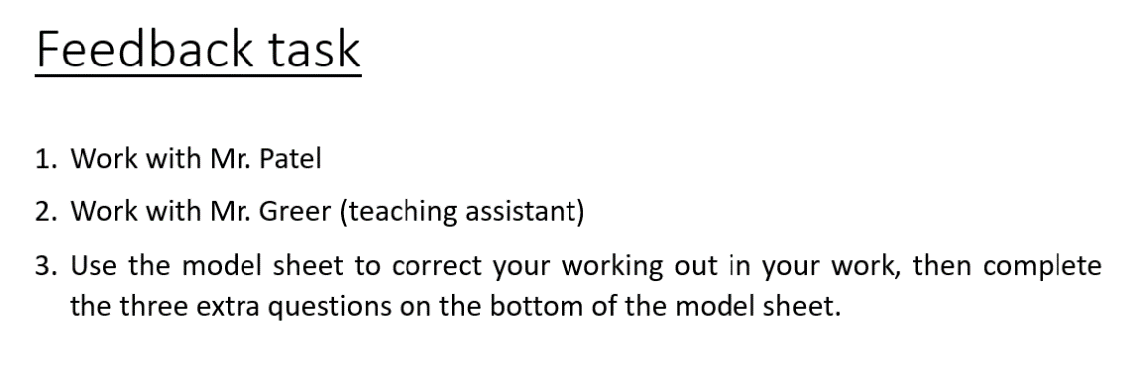
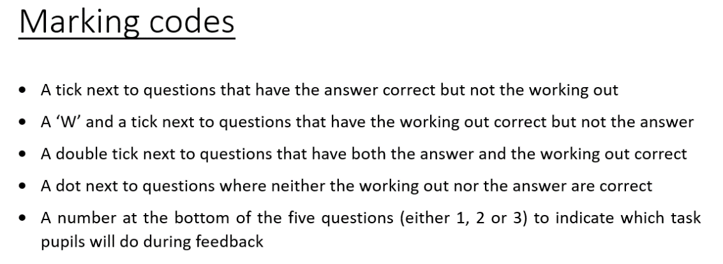
This approach to marking is familiar to pupils as it is routine in the way they receive feedback. While the pupils are responding to his feedback, he puts the marking codes on the board along with three different instructions for each of the three groups of feedback.
At the beginning of the next maths lesson Mr Patel sets up the feedback task:
“Thank you all for your hard work yesterday on those five addition problems. We are doing a great job of using our ten frame to add to make the nearest ten. We are going to respond to feedback now to support us to move to our long-term learning goal: subtracting through ten. In your books I have used the marking codes that we normally use in maths to let you know where you got the working out correct and where you got the answer correct. You will see that I have put a number on your page. You need to follow the instruction for your number, but don’t move until after I have given you the instruction. If you have a 1 on your page you will be working with me. If you have got a two on your page you are going to move to the back to work with Mr. Greer. If you have a three on your page, then you need to use the model sheet which shows you the correct answers and working out to correct anything incorrect in your work. Then you need to complete the three additional questions in your book. Off you go.”
Question:
- Where can you see the underlying features in the scenario?
- Accurate and clear
- Considerate and sensitive
- Encourage further effort
- Encourage progress in the long-term
- Consider workload
- What difference do you think the underlying features make the effectiveness of the feedback? What impact do they have on pupil progress?

Task: Take notes while the facilitator models how the underlying features appear in the first scenario.

Underlying feature | Response/suggestion
Accurate and clear
Considerate and sensitive
Encourage further effort
Encourage progress in the long-term
Consider workload
Other notes:

We Do

Read and analyse

Underlying features for scenario 2 and 3
The underlying features you need to have in mind as you read these scenarios are below. They are the same as for scenario 1:
Underlying feature | Description
Accurate and clear | Use simple, consistent and concise language, and where appropriate use visual cues, to provide praise and specific guidance on how to improve. Communicate precise next steps to pupils by focusing on specific actions.
Considerate and sensitive | Be aware of the social and emotional factors that can affect pupils’ responses to feedback. For example:  - The age/ needs of the pupil  - Praise can be difficult for some pupils to accept  - Some pupils receive feedback as criticism  Therefore, adapt feedback according to the needs of the pupil. For example, be considerate about how next steps are communicated with a focus on evaluation of pupil outputs and acknowledgement of pupil effort where appropriate.
Encourage further effort | Give pupils the time and support to process and respond to purposeful feedback which requires them to think hard.
Encourage progress in the long term | Ensure feedback develops pupil understanding in the long-term and prioritises critical knowledge and addressing misconceptions. Therefore, ensure feedback goes beyond the single output, is linked to pupils' progression and, where relevant, linked to their long-term goals.
Consider workload | Ensure feedback strikes a balance between the benefit it has on pupil learning and the resources and time dedicated to providing it, reducing the opportunity cost of giving feedback. Ensure the onus is on the progress pupils make as a result of the feedback as opposed to the work the teacher does to provide the feedback.

Task: Read both of the following scenarios.

Scenario 2

Ms Jama Y8s are working on a unit on athletic field events. Today’s focus is perfecting the technique required for long-jump. Ms Jama has broken the technique down into three parts (run, launch and landing) and modelled these to pupils, who then practised each part individually. Next, pupils practise their full long jump by putting the three parts together. As her pupils work in small groups, Mrs Jama circulates with a clipboard, noting down feedback on technique and common errors. This method allows her to easily see patterns in pupil performance. As she watches one group, she notices an error that she wants to correct immediately. She stops the group and intervenes: “I’d like us to just take a closer look at our launching foot. Should we be launching from a flat foot, or on our toes?”
Ms Jama selects a pupil that she saw launching with toes, as she wants to establish whether this is a misunderstanding or an incorrect application of knowledge. The pupils responds that the launch should be from a flat foot, which is correct. Ms Jama moves to another pupil. “Why are we launching with a flat foot?”. They respond correctly. Ms Jama says, "okay, so we know that we are launching with a flat foot because it helps our hips to move forward quicker, enabling us to jump further. Keep practising with that flat launch foot in mind.” She holds back the pupil who she had seen jumping from their toes; “Your run up has a good rhythm to it now, but you are losing momentum because of the angle of your foot when you launch. Watch my foot here as I launch”. Ms Jama demonstrates the launch. “Now you show me.” The pupil attempts the flat-footed launch. “That’s much better. For your next few practices, I want your focus to be on keeping that foot flat. Well done”.
Ms Jama continues to circulate. She notices a few pupils shifting their strides into longer steps too early in their run up and can see that no pupils are yet able to launch themselves forward with both their arms and legs in front of their body, to stop them from putting their hands behind their body when they land. Ms Jama brings the class together and tells them what she has noticed. In response to her observations, she has reshuffled the small groups and allocated a specific phase of the long jump for each group to focus on. Each group has a tablet with a pre-loaded video that models the phase of the long jump they are working on. As Ms Jama moves around the groups, she continues to give tailored feedback where appropriate to support pupils to refine their techniques.

Scenario 3
Miss Smith’s Y11 English Literature class are practising a poetry comparison question. The class has worked on this question across this unit of work and are now at a point where they are practising independently. However, Miss Smith has found when she has taught this in the past that although pupils do understand all the success criteria they need to incorporate in their extended answers to this question, they often forget or struggle to apply at least one of them to their answers. She is confident from formative assessment in previous lessons that pupils in this class do understand the success criteria and have been able to apply it to their writing in small chunks. However, she feels they probably haven’t yet developed the automaticity in using the criteria in their answers without any support. Therefore, she is going to use a set of marking codes to live mark pupil work whilst they are writing to ensure that her feedback can act as a scaffold for pupils as they work. This is something that she has done with this class since they began the GCSE course with her in Y10.

“As you are writing I am walking the room, on this first circulation I am looking at your introductions and looking for an insightful and accurate similarity between your two poems. If I see you are missing a similarity in your introduction I will put a dot in your margin, if I see that your similarity isn’t accurate, I will put a dash in your margin and if I see that your similarity meets the insightful and accurate criteria, I will put a tick in your margin. You will need to ensure you make any necessary changes based on my feedback.” As Miss Smith circulates, she annotates pupil books with these marking codes, she notices that most pupils are including an accurate similarity between the poems but that the comparison is not insightful enough to meet the criteria at the top end of the mark scheme that she wants her pupils to be aiming for.

“I am just stopping you here as I want to discuss something that I think is missing from our introductions. We know to hit the top end of the mark scheme we need to be insightful in the similarity we identify between the poems. Which similarities might not be considered insightful between these two poems, but would still be considered accurate? I will give you two minutes to come us with a list of at least two similarities with your partner that are accurate but not insightful.”

She cold calls a pupil that she knows had an accurate similarity in their introduction: “I think saying that both poems are written in an alternative (ABAB) rhyme-scheme is accurate but not insightful”.
Miss Smith: “Okay, great, I would agree but why isn’t it insightful and what could we do to make that an insightful comparison?”.

She now moves to a pupil who she knows had an insightful and accurate similarity in their work; “Maybe you could say the impact of the similar rhyme scheme on the meaning of the poem, or on the reader?”

Miss Smith: “Yes, I think that would make it more insightful. Can someone give me an example of how that would sound in your writing?”.

She selects a pupil with their hand up: “In both poems there is an alternative rhyme-scheme which mirrors the patterns that are found in nature, which both poems are emphasising.”

Miss Smith: “Fantastic, that example is really insightful and accurate because it gives us a similarity right at the beginning of the writing that we can use as a theme and argument throughout the rest of the essay. Really impressed with the thoughtfulness I am seeing in the similarities you are drawing between the poems and how hard we are working to get this right, take three minutes now to re-read your introduction and make any changes you need to to ensure that you are drawing insightful and accurate similarities.”
Task: Respond to the following questions independently.
Question:
- Where can you see the underlying features in the scenarios?
- Accurate and clear
- Considerate and sensitive
- Encourage further effort
- Encourage progress in the long-term
- Consider workload
- What difference do you think the underlying features make the effectiveness of the feedback? What impact do they have on pupil progress?

Underlying feature | Response/suggestion
Accurate and clear
Considerate and sensitive
Encourage further effort
Encourage progress in the long-term
Consider workload
Task: share in pairs.
Notes:
Task: share with the group.
Notes:
Reflect and record
Take a few minutes to reflect on the group discussion and record your final thoughts on scenarios 2 and 3.
Notes:

Option A: Non-example

Read and analyse

Underlying features for scenario 4
The underlying features you need to have in mind as you read these scenarios are below. They are the same as the previous scenarios:
Underlying feature | Description
Accurate and clear | Use simple, consistent and concise language, and where appropriate use visual cues, to provide praise and specific guidance on how to improve. Communicate precise next steps to pupils by focusing on specific actions.
Considerate and sensitive | Be aware of the social and emotional factors that can affect pupils’ responses to feedback. For example:  - The age/ needs of the pupil  - Praise can be difficult for some pupils to accept  - Some pupils receive feedback as criticism  Therefore, adapt feedback according to the needs of the pupil. For example, be considerate about how next steps are communicated with a focus on evaluation of pupil outputs and acknowledgement of pupil effort where appropriate.
Encourage further effort | Give pupils the time and support to process and respond to purposeful feedback which requires them to think hard.
Encourage progress in the long term | Ensure feedback develops pupil understanding in the long-term and prioritises critical knowledge and addressing misconceptions. Therefore, ensure feedback goes beyond the single output, is linked to pupils' progression and, where relevant, linked to their long-term goals.
Consider workload | Ensure feedback strikes a balance between the benefit it has on pupil learning and the resources and time dedicated to providing it, reducing the opportunity cost of giving feedback. Ensure the onus is on the progress pupils make as a result of the feedback as opposed to the work the teacher does to provide the feedback.

Task: Read the following scenario.

Mr Patel has been working on doing single digit addition with his Year 2 class, they have progressed to doing this addition where the number problem ‘bridges ten’ using the ‘make the next ten’ strategy. To do this his pupils have been using ten frames and counters to represent the sum to support them to find the answer. His pupils have been working on this for a while and are all able to consistently get to the correct answer most of the time in this way. Now, they are learning to transfer their working out from the ten frames to a written representation in their books. Maths is the last lesson of the day today, so for the final 15 minutes of the lesson Mr Patel has given his pupils five questions to complete. Pupils can use the ten frames and counters to support them, but they are expected to work through these questions independently and to write their working out in their books. Once pupils have completed their questions and are ready to pack up, Mr Patel asks them to pile up their books on the end of each table open on the page they have done the questions on. This makes it quicker and easier for him to mark the books as he does not need to find the page he is intending to mark in each book.
His pupils have gone home, he sits down to mark their work. He ticks and crosses answers where pupils are answering correctly and incorrectly. He spots that about half of pupils have been splitting up the second number in the problem incorrectly and it appears to be inhibiting them from reaching to correct answer. He stops marking the books halfway through the set of 32 and decides that he will need to re-teach the written working out method which pupils are clearly struggling to grasp.
At the beginning of the next maths lesson Mr Patel addresses pupils before he re-teaches the process of representing their working out in written form.

“I have marked some books and think we need to have a look together at how we can write our working out so we can move away from using out ten-frames. We are going to look at this question on the board together.”

Mr Patel has re-modelled the working out process, breaking it down into smaller steps and exposing his thinking at each point to pupils. He then uses mini whiteboards to give pupils a few practice questions that they hold up and he checks. By the third practice question all pupils appear to have written the working out and the answer correct. He then puts a further five practice questions on the board for pupils to attempt independently. He circulates whilst pupils are completing their work and for the pupils whose books he didn’t mark yesterday, he quickly ticks or crosses their answers. He finds that around 10 of these books contained all correct answers and working out. For these pupils he decides that when they have finished doing the five questions that he had set everyone to do today he will give them an extension task which focuses on begin to work backward to ‘subtract through ten’.
Task: Respond to the following questions independently.
Question:
- Which of the underlying features were not present in this non-example?
- Accurate and clear
- Considerate and sensitive
- Encourage further effort
- Encourage progress in the long-term
- Consider workload
- What is the impact of the feedback not having all the underlying features (on pupil learning)?

Underlying feature | Response/suggestion
Accurate and clear
Considerate and sensitive
Encourage further effort
Encourage progress in the long-term
Consider workload
Task: share in pairs.
Notes:
Notes:
Task: share with the group.
Reflect and record
Take a few minutes to reflect on the group discussion and record your final thoughts on scenario 4.
Notes:

Option B: Practice task

Action planning

Reflection:
- Spend a minute thinking about the lessons you have planned, or are yet to plan, for the coming week.
- Identify a lesson in which you will need to provide feedback in response to some work that has been completed.

- What have pupils done well?
- What knowledge do they still need to acquire or apply effectively?
- What are pupils’ next steps?
- How will you use the information you have gathered to move on pupil learning?
- What form will feedback take?
- What would you like pupils to know or be able to do by the end of the lesson?
- Where do these aims fit within the wider sequence of learning?

Notes:

Applying the underlying features

Underlying feature | Question prompts:
Accurate and clear | What knowledge do you need to impart during your feedback? What do pupils need to do to improve and how can you communicate these next steps concisely? Are there any visual aids that might help you to communicate these next steps more clearly?
Considerate and sensitive | How can you use praise to acknowledge pupil effort and progress so far? Are there any pupils with specific needs that need to be considered in the feedback process? If so, how will you respond to these needs?
Encourage further effort | What activities will pupils complete during, or in response to, your feedback? How do these activities encourage pupils to think hard about critical knowledge? How will they apply the knowledge you have imparted?
Encourage progress in the long term | What critical knowledge are pupils acquiring or applying? What misconceptions are you addressing? How will this feedback support pupils to achieve their wider learning goals?
Consider workload | What resources will you need to create to deliver your feedback and support pupils to respond to it? Are any resources created directly impacting pupil progress?

Task:
Plan your feedback task in the table below. Use the question prompts above to ensure that you are addressing all the underlying features of effective feedback. Refer to the model beneath the notes table for further support.

Underlying feature | Question prompts:
Accurate and clear
Considerate and sensitive
Encourage further effort
Encourage progress in the long term
Consider workload

Model: Ms Jama

Underlying feature | Question prompts:
Accurate and clear | I need some pupils to work on their stride length during their run up and others to work on using their arms and legs to launch themselves forward when jumping. I will explain that pupils have been organised into small groups to work on one of these two phases of the jump. I will give pupils a recorded version of their phase to support them when practising.
Considerate and sensitive | I will emphasise that each phase of the long jump is challenging and praise pupils for their progress with stages one and two so far. I will place pupil X with pupil Y, as I know that pupil Y has previously worked well with pupil X to build his confidence.
Encourage further effort | Before pupils break off into their new groups, I will ask them to recall the key components of the phases they are working on. I will then explain that these components are identified in the videos they will be using to support them. This will ensure that pupils are focusing on the underlying features that will support them with their run up and launch.
Encourage progress in the long term | When pupils have recalled the key components of the phases they are working on, I will use questioning to prompt them to consider why these components are important and how they contribute to the overall success of the jump. This links the specific skill they are working on to their wider aim of completing a successful long jump.
Consider workload | The only physical resource I will need is the recordings of each phase of the long jump, which I already have from previous lessons. This resource can be used across the sequence of lessons and in following years, so was a useful investment of time.

Reflection and next steps
- Of the underlying features we have looked at today, which do you already feel most confident with?
- Which underlying features do you find more challenging and why?
- What are you next steps in response to this clinic? What or who will support you to achieve these?

Notes:

Option C: I Do (2)

Task: Read the scenario.

Scenario 5
Mr Carchek teaches a Year 7 Religious Studies class with a small number of pupils. Since last week he has managed to read of all their written work about how the parables in the Bible have been interpreted in different ways by Christians. He didn’t write comments in books as he just wanted to establish how successful this writing activity had been and to check for any misconceptions he can address in the next lesson. He notices a common misconception that pupils often have when studying the Bible in this Christianity unit: Jesus wrote the Bible. Although this group have been taught the difference between the New and Old Testaments, this misconception clearly still pervades. When pupils were writing, they were using a writing frame to support them as this is a scaffold that they all needed to enable them to complete this longer piece of writing. This writing frame didn’t give a sentence starter for how they should quote from the Bible but just said ‘add evidence from the Bible’ and consequently pupils have written phrases like: “In the Bible Jesus says…”.
This class needs lots of support when working independently but Mr Carchek knows that if he breaks the task down into small, guided steps they will be able to correct their own work.
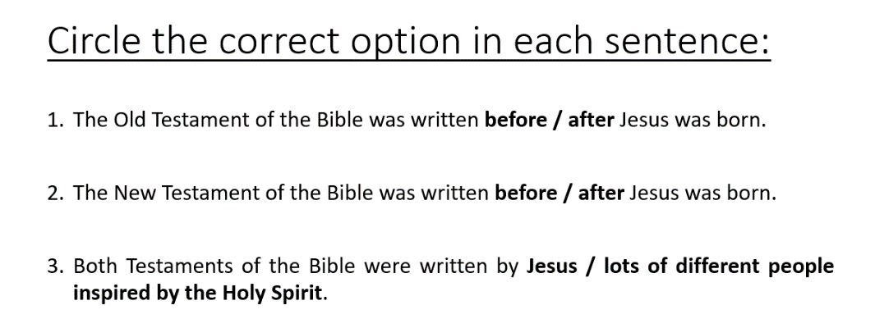
Mr Carchek has created a quiz which he has printed for pupils to complete when they enter the classroom where they need to select the correct answer by circling one of the two options within the sentence.
At the beginning of the lesson pupils complete this quiz independently and they mark it as a class. Mr Carchek uses a hands up strategy to establish how many pupils answered correctly. He discovers that nearly all pupils answered all three questions correctly. He thinks that it is likely when given a 50/50 answer option pupils can more easily and successfully retrieve and connect what they have been taught previously about the Bible than when they needed to apply it to their writing. So, he moves the focus of the lesson to correcting the common errors in pupils’ writing from last lesson:
“I noticed when I read our work we had written things like this when you were quoting the bible:
In the Bible Jesus says that ‘For God loved the world so that he gave his one and only Son.’
Why is it incorrect to use the phrase ‘Jesus says’?”
Pupils raise their hands, keen to answer the question. Mr Carchek cold calls a pupil:
“Because Jesus wasn’t alive until after the Old Testament so he couldn’t have said it”
Mr Carchek responds:
“You’re right, that’s one reason that we can’t say ‘Jesus says’ when writing about the Old Testament. But the other reason is that we already know who wrote the Bible…who was it? Use your quiz from the beginning of the lesson to help you”
He cold calls a pupil:
“Lots of different people inspired by the Holy Spirit”.
Mr Carchek: “Exactly, I am going to ask you a question you can all answer aloud together. If I say ‘Jesus says in the Bible’ would I be correct or incorrect?”
Pupils respond ‘incorrect’ in unison.
Mr Carchek: “Why would I be incorrect?” He holds his hand up to signal to pupils that this time he isn’t looking for an answer in unison.
He cold calls a pupil: “Because the Bible was written by lots of different people inspired by the Holy Spirit”.
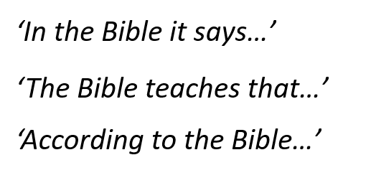
Mr Carchek: “Great stuff Y7, I have got three phrases on the board that you can use when you want to quote the Bible. I want you to go through your work. Anywhere you have written ‘Jesus says’, change it to one of these phrases. Off you go.”

Question:
- Where can you see the underlying features in the scenarios?
- Accurate and clear
- Considerate and sensitive
- Encourage further effort
- Encourage progress in the long-term
- Consider workload
- What difference do you think the underlying features make the effectiveness of the feedback? What impact do they have on pupil progress?

Task: Take notes while the facilitator models how the underlying features appear in the first scenario.

Underlying feature | Response/suggestion
Accurate and clear
Considerate and sensitive
Encourage further effort
Encourage progress in the long-term
Consider workload
Other notes:

Close

Reflection:
- Of the underlying features, which do you already use to help you to use effective feedback?
- Which of the underlying features will you use more in order to support you to:
  - Give effective feedback
  - Manage your workload
  - Support your pupils to develop self-regulation
- Know when your next clinic takes place.​
- Any questions?
Record your next steps

Appendix

Alternative I Do (1)

  - Scenario 6
Mr Ridge’s reception class are sat on the carpet practising forming the letter ‘b’ in both capital and lower case on their whiteboards. Mr Ridge has modelled the letter formation for pupils and is now circulating while they are forming their own letter ‘b’s. As is circulates he notices that a small number of pupils are forming their lowercase ‘b’ with the semi-circle to the left of the line instead of the right of the line, so it appears more like a ‘d’. He quickly moves round the room and puts a small blue card with a star on the carpet next to every pupil that he sees making this error. Pupils haven’t all finished the task, but he can see which pupils are consistently forming the letter correctly, and which are not. Mr Ridge gets his pupil’s attention using a call and response clap, as per his classroom routine.
‘I have had a look at the letter ‘b’s on our whiteboards and I am really impressed with how we have picked this up! Just like my model I am seeing a lot of nice long straight lines down from the top of our handwriting line, we have then brought our pen back up to the middle and drawn a curved line to the bottom of our long line.’ He models this with his pen on the flipchart paper as he speaks, looking over his shoulder and scanning the room to ensure pupil’s attention is on his paper. ‘If I put a blue card next to you, when I say go, head over to the yellow table with your whiteboard and pen to work with Miss Thom. Go.’
Mr Ridge has asked Miss Thom to re-model the letter formation to the five pupils who had a blue card, highlighting how to correct the persistent error in their letter formation. For the pupils that have remained on the carpet Mr Ridge moves them on to practicing writing the letter ‘b’ on paper with pencil. He had noticed that one pupil in this group was making a small error when forming their letter so as the pupils practice, Mr Ridge moves to this pupil, bends to their level, and corrects the error:
‘You have been getting the shape right on this letter, with a nice wide loop at the bottom. Well done. Be careful when you are drawing your long line down, it needs to be straight. Practise for me on the whiteboard now, draw me 5 long straight lines nice and spaced out. Take your time, don’t rush them.’
The pupil practises the line, and it is much straighter than in the previous practice.
‘Fantastic, those lines are so much straighter! Make sure they stay super straight when you are practising in your book with pencil. You can do that now.’
Question:
- Where can you see the underlying features in the scenario?
- Accurate and clear
- Considerate and sensitive
- Encourage further effort
- Encourage progress in the long-term
- Consider workload
- What difference do you think the underlying features make the effectiveness of the feedback? What impact do they have on pupil progress?

Task: Take notes while the facilitator models how the underlying features appear in the first scenario.

Underlying feature | Response/suggestion
Accurate and clear
Considerate and sensitive
Encourage further effort
Encourage progress in the long-term
Consider workload
Other notes:

Alternative I Do (2)

  - Scenario 7
Mrs McKay is a teacher at a specialist school. She is currently working with her Year 11 GCSE history group, which is made up of 8 pupils. In a previous lesson, pupils practised some questions from a GCSE paper. Mrs McKay has marked these, and so today’s lesson is focused on reviewing and improving their responses. The class are used to having verbal feedback from the adults in the class but understand that for GCSE practise the teacher will have marked their work and will provide written feedback. This is now part of their end of topic routine.
In her preparation for this lesson, Mrs McKay was mindful of pupils’ individual needs. When she marked pupils’ responses, she wrote short, concise comments to allow pupils to process and understand her feedback. She then identified five pupils who would need verbal feedback alongside written feedback. She was also mindful that this verbal feedback would need to be one-to-one, as whole class feedback could cause anxiety and impact pupil confidence.
In the feedback lesson, Mrs McKay starts by giving pupils an independent revision task. This is a familiar routine, so pupils are quick to start. This gives Mrs McKay time to set all pupils up for the lesson. The three pupils who are able to respond independently to written feedback are directed to move onto this when they finish their first task. Mrs McKay and her support staff then begin working with individual pupils to provide them focused, verbal support.
Mrs McKay works with Reece. She starts by highlighting where he has answered well. She then verbally gives Reece two specific, actionable next steps to improve his responses that she knows will require him to think hard. While doing this, she intentionally uses the same phases that she has written on his paper. Mrs McKay then live models an example to show Reece her thought process for writing an improved response using this feedback. Finally, she checks Reece’s understanding of what she has said by prompting him to briefly explain how he is going to improve his responses and why. When she is confident that he has understood, she asks him to read her written feedback as a reminder and prompt, and to attempt improve one question. She explains that she will work with Reece again before the end of the lesson to give him verbal feedback on his improvements, and moves to work with another pupil who is finishing her independent revision task.
Before the end of the lesson, Mrs McKay goes back to work with Reece to review his improvements. He has been able to improve a question based on the feedback Mrs McKay provided. Mrs McKay is confident he has developed his understanding of these two areas for improvement, though she knows that these are areas to monitor when Reece completes similar questions. Finally, Mrs McKay knows that Reece responds well to praise so she invites over the teaching assistant to celebrate his work.
Question:
- Where can you see the underlying features in the scenario?
- Accurate and clear
- Considerate and sensitive
- Encourage further effort
- Encourage progress in the long-term
- Consider workload
- What difference do you think the underlying features make the effectiveness of the feedback? What impact do they have on pupil progress?

Task: Take notes while the facilitator models how the underlying features appear in the first scenario.

Underlying feature | Response/suggestion
Accurate and clear
Considerate and sensitive
Encourage further effort
Encourage progress in the long-term
Consider workload
Other notes:

Alternative We Do (1)

Task: Read the scenario.

Scenario 8
Mr Edmunds is a teacher in a complex needs school. He is currently teaching science to his year 4 class. In this lesson, he is teaching the pupils about properties of materials, specifically, the difference between the feeling of rough and smooth. Mr Edmunds has a range of items and materials for pupils to manipulate and investigate. Pupils then need to organise them into two groups depending on whether they think the item is rough or smooth.

Mr Edmunds has asked his support staff to work with individual children while he works with the group of pupils who use signing to communicate. This means that all pupils can receive focused support, and, where needed, additional feedback on how to progress.

The pupils in his group are engaging in the task; they are picking up the items to explore them independently. Mr Edmunds praises the students by saying and signing: “well done, I can see you are thinking hard about these items”. Mr Edmunds encourages the pupils to begin grouping the items, by modelling the activity of feeling the item and placing it in the correct group. As he places the item in the correct group, he signs and says the words rough and smooth.

Mr Edmunds notices that one pupil, Oskar, is mixing the two descriptions and placing smooth items under the word rough and vice-versa. He can see that Oskar needs some additional support to correct this misconception. While the rest of the group continue independently, he signs and says to Oskar directly: “Well done Oskar. You have tried hard to sort these items. Feel for bumps to help you find rough items.” Mr Edmunds knows that using visuals as well as signs helps Oskar, so he provides two visuals from Communication in Print that show the concepts of ‘rough’ and ‘smooth’. To reinforce this feedback, he models exploring one more rough item, placing it in the correct group, and signing the word ‘rough’. Mr Edmunds knows that he may need to remodel identifying rough and smooth items if Oskar continues to struggle, but is aware that this may be enough support for Oskar to progress.

Mr Edmunds then gives Oskar time to process and respond to this feedback. He gives Oskar four items, one at a time, to manipulate and place into the correct group. Oskar practises this and puts the items in the correct groups. Mr Edmunds reinforces this by saying and signing “Yes, that one is rough/smooth. Well done, Oskar.”

The following week, Mr Edmunds gives pupils a new set of items to sort into ‘rough’ and ‘smooth’ groups. During this task, he can see that Oskar is accurately and more confidently sorting items. Mr Edmunds knows that it is important to revisit new ideas in increasing intervals to support learning over time. However, he is increasingly confident that Oskar and the class securely understand the distinction between these two concepts.
Question:
- Where can you see the underlying features in the scenarios?
- Accurate and clear
- Considerate and sensitive
- Encourage further effort
- Encourage progress in the long-term
- Consider workload
- What difference do you think the underlying features make the effectiveness of the feedback? What impact do they have on pupil progress?

Task: Respond to the following questions independently.

Underlying feature | Response/suggestion
Accurate and clear
Considerate and sensitive
Encourage further effort
Encourage progress in the long-term
Consider workload
Other notes:

Alternative We Do (2)

Scenario 9
Ms Jama is a teacher in a specialist school. Her year 8s are working on a unit on athletic field events. Today’s focus is perfecting the technique required for long-jump. Ms Jama has broken the technique down into three parts (run, launch and landing) and modelled these to pupils. Pupils have then practised them individually. Now, they are practising their full long jump by putting the three parts together. As they do this one by one, Ms Jama is watching each individual with a focus on each of the three parts. As she watches, she notices an error that she wants to correct immediately so stops the practice of pupils: “I want to just take a closer look at our launching foot. How should our foot be when we launch: flat or on our toes?”

She selects a pupil that she saw launching with toes as she wants to establish whether this is misunderstanding or lack of correct application of knowledge. They respond that the launch should be from a flat foot - this is correct. Ms Jama moves to another pupil: “why are we launching with a flat foot?”. They respond correctly. Ms Jama says: “Okay, so we know we are using a flat foot to launch with because it helps our hips to move forward quicker, helping us to jump further. Keep practising with that flat launch foot in mind.”

Ms Jama monitors again but when she notices a pupil still jumping from their toes, she decides to provide some targeted support. She knows that the pupil presents with demand avoidant behaviours, so is intentional in how she frames her feedback: “Your run up has a good rhythm to it now, I wonder if you would have more momentum if the angle of your foot was different, could we try that together”. Ms Jama then demonstrates the launch, then gives the pupil an opportunity to practise: “Would you like to have another go” The pupil attempts the flat-footed launch. Ms Jama makes sure to acknowledge this improvement: “You changed the angle of your foot, and I noticed you had much more momentum. If you keep practising, I wonder how far you could jump?”

She continues to circulate and notices a few pupils shifting their strides into longer steps too early in their run up. She can also see that no pupils are yet able to launch themselves forward with both their arms and legs in front of their body to stop them from putting their hands behind their body when they land – this is something that will lower their score.
She therefore decides to structure her next lesson with this group around these areas for development. She makes a note of which areas of development individual pupils have. At the start of the following lesson, she places them into three groups based on her observations and tells each group what she noticed. She gives each group one specific area of development. Her and her teaching assistants work with a group each to re-model the specific area of development within the group, and then continue to give tailored feedback where appropriate to support pupils to refine their technique.
Question:
- Where can you see the underlying features in the scenarios?
- Accurate and clear
- Considerate and sensitive
- Encourage further effort
- Encourage progress in the long-term
- Consider workload
- What difference do you think the underlying features make the effectiveness of the feedback? What impact do they have on pupil progress?

Task: Respond to the following questions independently.

Underlying feature | Response/suggestion
Accurate and clear
Considerate and sensitive
Encourage further effort
Encourage progress in the long-term
Consider workload
Other notes:

References

Barker, J. and Rees, T. (2020). Developing School Leadership. In: S. Lock, ed., The ResearchEd Guide to Leadership, 1st ed. John Catt Educational.
Dinsmore, D., Alexander, P. & Loughlin, S. (2008). Focusing the Conceptual Lens on Metacognition, Self-regulation, and Self-regulated Learning. Educational Psychology Review, 20(4), 391-409.
Hattie, J. and Timperley, H., 2007. The power of feedback. Review of educational research, 77(1), pp.81-112.
Kennedy, M., (2016) Parsing the Practice of Teaching. Journal of Teacher Education. Los Angeles, CA: SAGE Publications, 67(1) pp. 6–17.
Muijs, D. and Bokhove, C. (2020). Metacognition and Self Regulation: Evidence Review. London: Education Endowment Foundation. The report is available from: https://educationendowmentfoundation.org.uk/evidence-summaries/evidence-reviews/ metacognition-and-self-regulation-review
Zimmerman, B. (2000). Self-efficacy: An essential motive to learn. Contemporary Educational Psychology, 25(1), 82–91.
Zimmerman, B. J. (2001). Becoming a self-regulated learner: an overview. Theory Into Practice, 41(2), 64-70

