© Ambition Institute 2022

EARLY CAREER TEACHERS:
MENTOR TRAINING
Conference One | Workbook

Structure of the Mentor Induction

Welcome to the Early Career Teachers Mentor Training Programme Mentor Conference 1 workbook. This workbook will accompany the facilitated session and help you build on your learning from the orientation.
Title | Platform | Time
Orientation | Steplab | 45 – 60 minutes
Mentor Conference 1 | Face-to-face | 1 day
Elective post-conference learning | Steplab | Choice of short modules
The Mentor Induction is the start of the training and support for mentors. The induction is split into the following sessions.
The induction is the start of a longer journey of mentor development on the programme, building on your expertise as a teacher and mentor.

Mentor Conference 1: session aims

The induction is the start of a longer journey of mentor development on the programme, building on your expertise as a teacher and mentor.
To understand:

- The importance of Early Career Teacher Development
- How the Early Career Framework and Early Career Programme will help support you and your Early Career Teacher
- The principles underpinning Ambition Institute’s Early Career Teachers programme
- Your role as mentor within the programme
- The basics of instructional coaching

Today’s session

Section 1: High-quality mentoring and the Early Career Framework Page 3
Section 2: Developing teacher expertise Page 8
Section 3: Instructional coaching and mental models Page 15
Section 4: Practising instructional coaching Page 27
Section 5: Implementation Page 42
Bibliography Page 46
Appendices Page 49

Section 1: High-quality mentoring and the Early Career Framework

Reflection: mentoring
- Why can mentoring help improve outcomes for all pupils?
- What has been your experience of the impact of mentoring?

- Long-term goal: what do you want to achieve as a mentor?
- Immediate goal: what do you want to get out of today?

The Early Career Framework

What is the Early Career Framework?
The Early Career Framework is based on a combination of the best available research evidence, and expert guidance from teachers, school leaders and academics. It sets out what all new teachers need to know and be able to do in order to have the greatest possible impact on their pupils. The framework forms part of the Department for Education’s ‘golden thread’ of professional development, from initial teacher training to the National Professional Qualifications (NPQs).
- The Early Career Framework covers five core areas of teaching:
  - behaviour management
  - pedagogy
  - curriculum
  - assessment
  - professional behaviours
- The framework provides an entitlement to training; it is not a tool for assessment
- The content reflects the complex nature of teaching – it is designed to be a set of statements to be mastered over time, not standards to be ticked off. For this reason, there is considerable overlap between the Initial Teacher Training Core Content Framework and the Early Career Framework. Teachers will have studied much of the content during training, but they are likely to still be progressing towards mastering the ideas and skills.
What are the wider reforms?
Teaching is as complex as many jobs that have a much longer training period. The framework provides two years of support to newly qualified teachers in recognition of this complexity. By providing Early Career Teachers (ECTs) with an extra 5% non-teaching time in their second year, schools will ensure that time is protected for ECTs to continue receiving the training and support they deserve.
The reforms also provide a clear direction for this training, crucially including the mentoring that ECTs will receive, this reduces the risk of teachers in different places receiving different levels of support. Specifying the number of hours of self-study and mentor support that ECTs are entitled to helps to ensure this consistency. The reforms also prioritise time and space for mentors to develop and reflect on their own practice, including funding time for mentors to attend high-quality training.
Do mentors need to know the Early Career Framework by heart?
While mentors need to be aware of what Early Career Teachers are entitled to as a result of the Early Career Framework, Ambition Institute’s Early Career Teachers’ Programme will provide you with an in-depth understanding of the framework and statements as these are all covered as part of the programme. Whilst mentors may be interested in using the framework to further their understanding, for example. by reading some of the papers referenced within the framework, mentors do not need to memorise the statements in the framework.
Although the framework sets out the content that ECTs are entitled to, it is not a curriculum. Ambition Institute’s programme sequences the content so that it builds carefully over time, helping you as mentors to work with ECTs to build knowledge and expertise. The Early Career Framework is a framework setting the evidence base of what teachers need to learn, whereas the Early Career Teachers programme sets the progression through the content – what ECTs should learn, in what order, and guidance on how they might do so.
It is important to emphasise that the programme is there for you to adapt to the needs of your teacher. To provide stretch and challenge or additional support, exactly as you do with pupils every day when adapting the content that they need to learn.

Learn that… and learn how to…

Below are three ‘learn that’ and three ‘learn how to’ statements taken from the ‘Subject and Curriculum’ section of the Early Career Framework. Choose one ‘learn that’ and one ‘learn how to’ statement and think about:

- What a surface level understanding of that statement might involve (including what it might look like in classroom practice)
- What a teacher with an expert knowledge and understanding of that statement might do in their classroom

Learn that:

- Anticipating common misconceptions within particular subjects is also an important aspect of curricular knowledge; working closely with colleagues to develop an understanding of likely misconceptions is valuable.
- In all subject areas, pupils learn new ideas by linking those ideas to existing knowledge, organising this knowledge into increasingly complex mental models (or “schemata”); carefully sequencing teaching to facilitate this process is important.
- Pupils are likely to struggle to transfer what has been learnt in one discipline to a new or unfamiliar context.

Learn how to:

- Deliver a carefully sequenced and coherent curriculum, by:
Identifying essential concepts, knowledge, skills and principles of the subject and providing opportunity for all pupils to learn and master these critical components.
- Support pupils to build increasingly complex mental models, by:
Drawing explicit links between new content and the core concepts and principles in the subject.
- Help pupils apply knowledge and skills to other contexts, by:
Interleaving concrete and abstract examples, slowly withdrawing concrete examples and drawing attention to the underlying structure of problems.

Programme overview

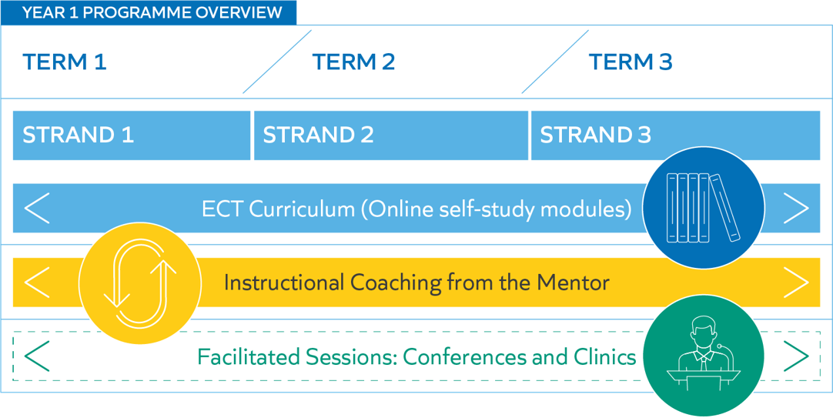

Optional reflection
- What are you excited about in introducing the framework to your teacher(s)?
- What might be challenging about the new framework?
- How can the framework be an opportunity for you to develop your practice as a mentor?

Check for understanding

Which of the following statements about the Early Career Framework are true?
- The induction period lasts for 2 years
- The Early Career Framework is a 2-year programme
- Passing induction depends on completing the Early Career Framework
- The Early Career Framework is additional support and is optional
- The Early Career Framework includes funded support

Section 2: Developing teacher expertise

Simple Memory Model

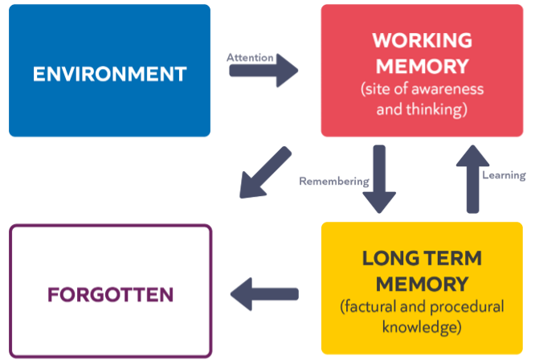

(Willingham, 2009)

Mental Models
- The knowledge you have and how that knowledge is organised
- Novices’ and experts’ mental models differ.
- Novices and experts learn differently.
- Expertise is domain specific.
- We learn new ideas by linking those ideas to existing knowledge and organising this knowledge into increasingly complex mental models.

Check for understanding

- Mental models are:
  - The knowledge stored in long-term memory
  - How the knowledge in long-term memory is organised and used
  - How people visualise situations
- Which of these statements about novices and experts are true?
  - Experts’ mental models contain more knowledge
  - Early career teachers are novices
  - Expertise is generalisable
  - Novice and expert teachers both learn best by solving problems

- Describe the relationship between working memory and long-term memory.

The principles of deliberate practice

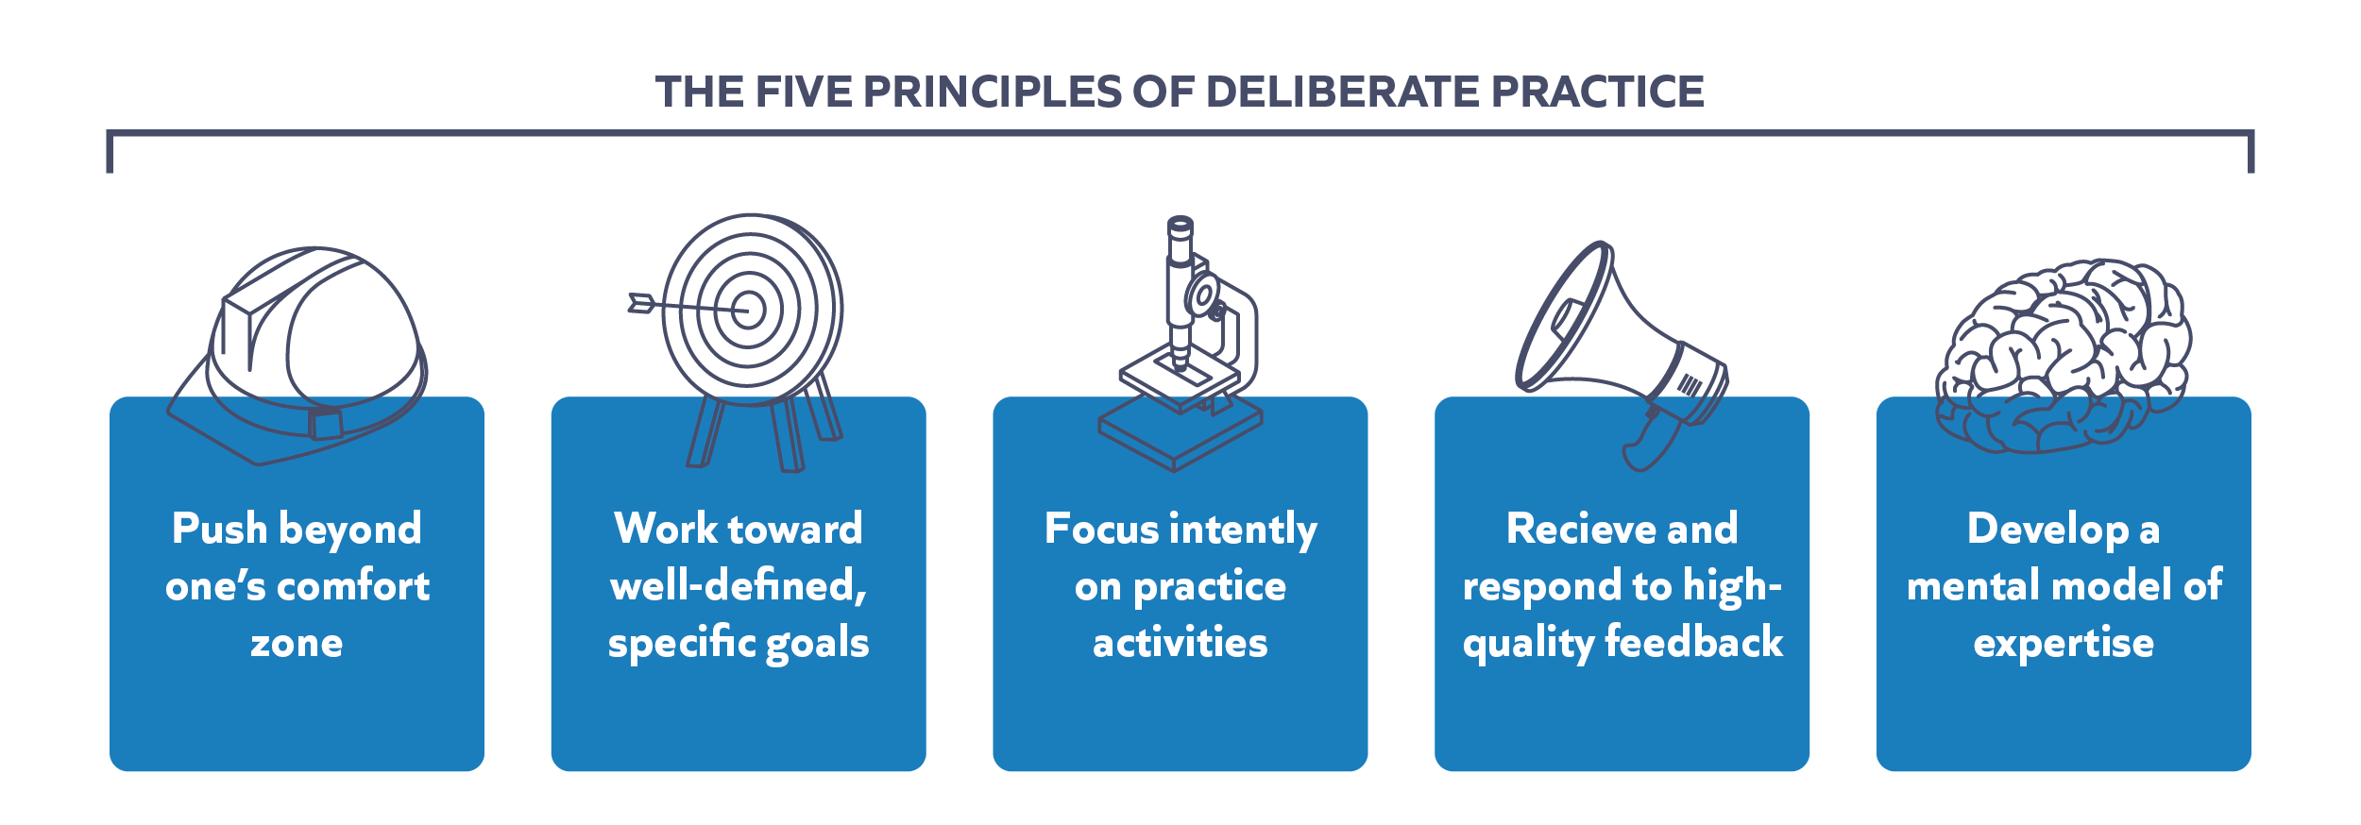

For more information read Deans For Impact, Practice with Purpose
(https://deansforimpact.org/resources/practice-with-purpose/)

Optional check for understanding

Which of the following statements about deliberate practice are true?

- Deliberate practice is repeated practice until something is automatic
- Deliberate practice is a practice + feedback
- Deliberate practice should be done live in front of pupils
- Deliberate practice involves a repeated cycle of practice and feedback
- Teachers should always get into the practice as soon as possible
- Deliberate practice should stop as soon as the practice is good enough
- Deliberate practice is all we need to help teachers develop

Roles and support

Make a note of your delivery partner below:

______________________________________________________________________________________

Person | Role
Early Career Teacher | Engage with self-study materials  Practise and embed steps into their teaching
Mentor | Build and maintain a strong relationship  Lead weekly instructional coaching sessions  Monitor engagement with self-study materials  Contextualise the resources  Promote good habits
Induction coordinator | Support mentors and Early Career Teachers  Advocate for the programme  Additional training (if needed)  Main point of contact for delivery partner  Often responsible for assessment
Delivery partner | Implement the programme across multiple schools  Facilitate clinics and conferences  Provide administrative support
Ambition Institute | Design the programme and training materials
Steplab | Online platform hosting the materials  Scaffolds coaching sessions

How does the programme build expertise?
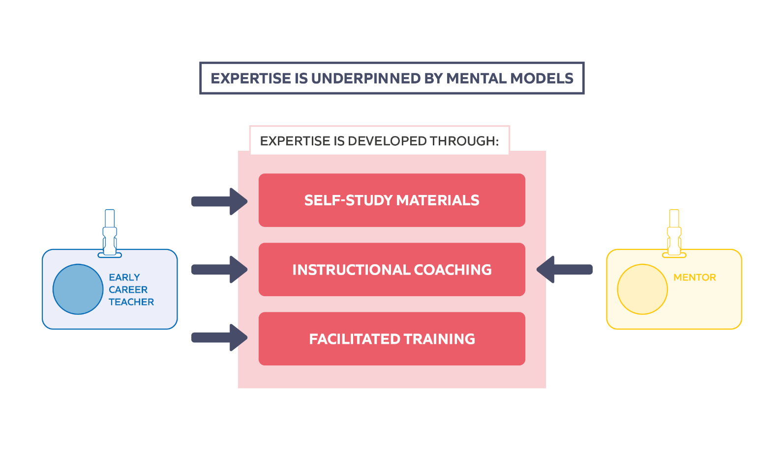

Programme principles

“Knowledge guides action which influences impact.”
Mccrea (2018)

Mental models, what people know and how this knowledge is organised in long-term memory, form the foundation on which teacher practice and therefore teacher impact is based.
Therefore, the first consideration of CPD should be what do the teachers need to know in order to make a change to their practice? The Early Career Framework provides the 'what' teachers need to know for the programme. 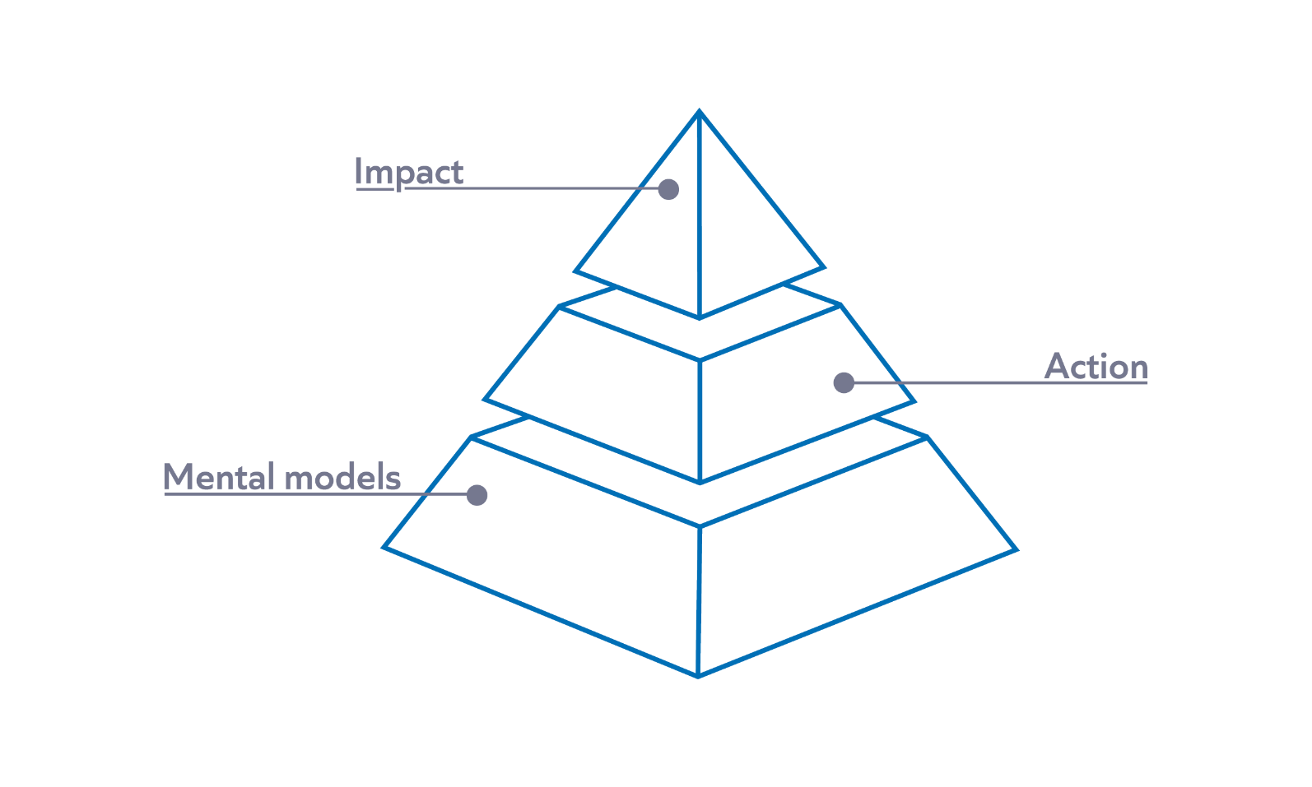
However, as more novice teachers less well-developed mental models, their working memories are easily overwhelmed with new information. It also means that they are less likely to be able to process and remember new information. It is therefore critical that for any training aimed at novice teachers to have the desired impact, it must be designed in a way that is not going to overload their working memory. The principles below guide the design of the Early Career Teachers programme.

Key learning broken down into small, manageable chunks​
Teaching is a complex activity, with lots of interacting components. This makes for a steep learning curve. However, breaking down knowledge and skills into small, manageable chunks means that more novice teachers are more likely to be able to understand and process new ideas without overwhelming working memory (Sweller, 1988). This allows new knowledge to be integrated into long-term memory, building their mental models by linking to what they already know.
On the programme, this can be seen in the way in which the termly strands have been broken down into 12 sections, and in the focus on practising and embedding one bite-sized step per week.

Clear modelling of effective practice
Expert teachers have well-developed mental models of what things should look like in the classroom. This ranges from how the pupils should enter the classroom to what an explanation of a complex idea should look like. More novice teachers benefit from being shown what effective practice looks like, including having this broken down and explained (Deans for Impact, 2018).
Each module includes video examples of what the techniques described look like. Live modelling by you as the mentor is a key element of each instructional coaching session for example, demonstrating how a teacher might pause before selecting a pupil to answer a question.

Multiple opportunities to return to key learning
Like anyone else, new teachers are very unlikely to remember and embed new ideas and skills into their practice from one exposure to new information. Therefore, it is critical that key concepts and ideas are revisited over time, viewing them through a new lens as a teacher’s practice develops (Pashler et al, 2007).
For example, teachers might consider the importance of clear instructions as part of classroom management during the Behaviour strand, returning to this idea from the lens of providing clear models and examples during the Instruction strand.

Practice and feedback
Practice with regular, focused feedback as part of instructional coaching is vital in helping teachers put their new learning into practice. Opportunities to isolate skills, practise them in a safe environment and receive feedback before transferring them into the classroom have been shown to have a significant and positive impact on teachers' practice, particularly teachers who are new to the profession (Allen and Sims, 2018).

Contextualised
Expertise is context specific. Only you as mentors will have the expertise on your school context and on your early career teacher’s needs. This means that a core element of your role as a mentor is to adapt this to your own setting – you are the person with the greatest expertise of this setting. For example, the video model of breaking down teacher exposition might be from an early years setting and you might teach key stage 5. Your job is to take the example and your own understanding of your context to provide a model of good in your setting. This is similar to a teacher using an externally produced resource – no matter how good this is it will need adapting to their own context, whether through the explanation beforehand or adjusting the content.

Familiar routines
The life of an early career teacher is intense. To ensure this programme doesn’t add unnecessary complexity, we have designed the programme around a set of simple, repeating professional development patterns. This means everyone can spend less time thinking about the process and more time thinking about great teaching.
For example, the format of the instructional coaching session is the same every week: mentors will work with early career teachers to review their previous step, before modelling the next step and supporting the teacher to practise.

A typical week

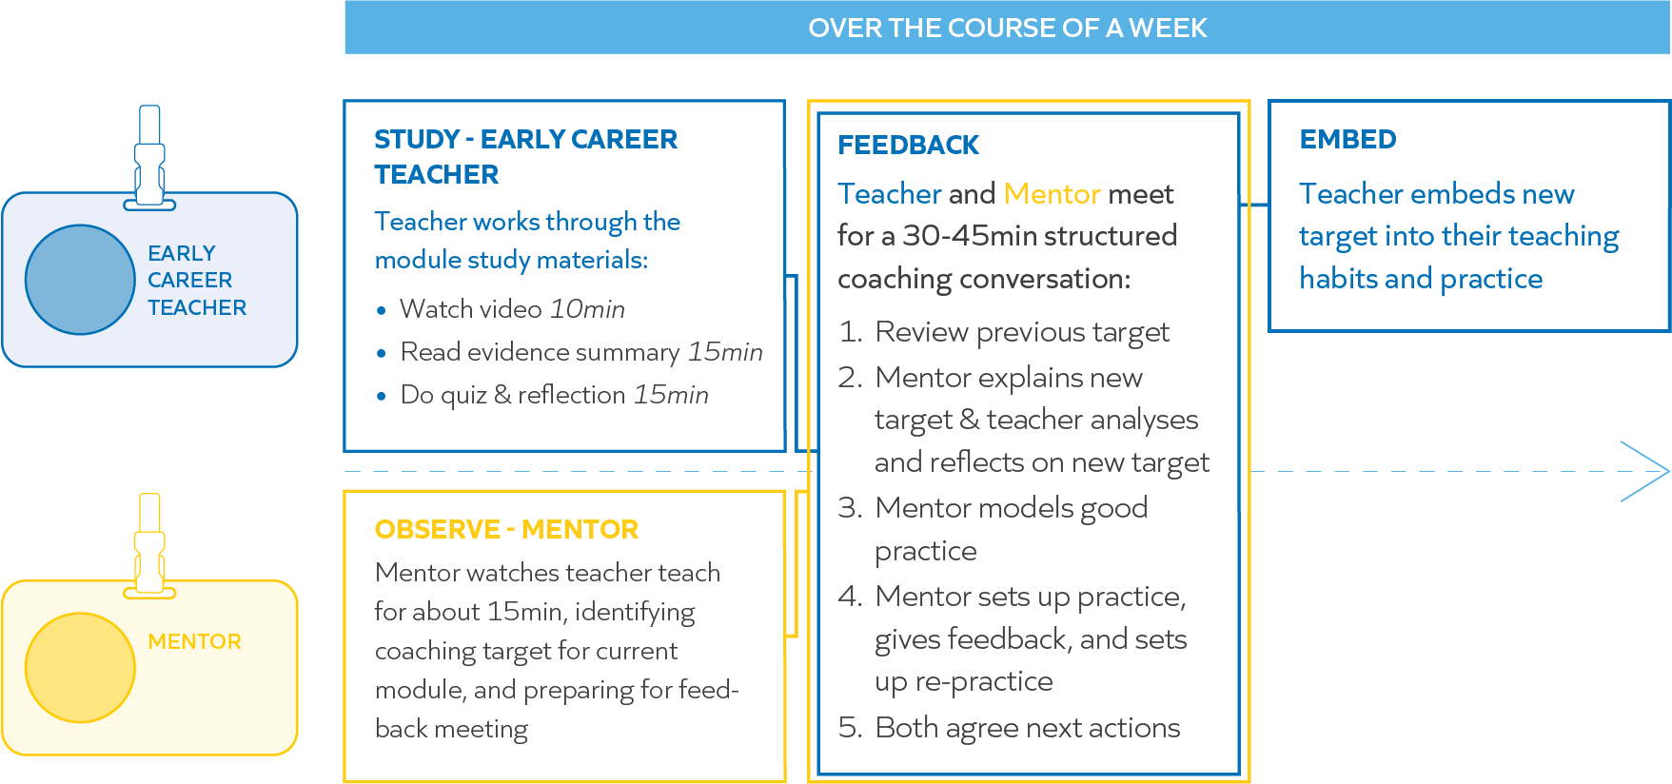

Check for understanding

- Which of these components of the programme are compulsory each week for teachers?
  - Reading the evidence summary within the self-study
  - Watching the video within the self-study
  - Keeping a log of the teacher standards that have been met
- Which of these components of the programme are compulsory each week for mentors?
  - Reading the evidence summary within the self-study
  - Watching part of an ECT’s lesson
  - Running an instructional coaching session
  - Moving onto a new step with their ECT

Reflection

- How do the way novices learn have implications for how we support novice teachers?
- Does this differ from the way in which you were supported in your early career or in the way you have supported others? If so, how?

Section 3: Instructional coaching and mental models

Reflection

In your experience, what do Early Career Teachers find difficult about beginning their teaching careers?

What is instructional coaching

An observation and feedback cycle in which instructional experts work with teachers to discuss their practice in a way that is:
- Individualised
- Recurring
- Sustained
- Classroom/practice-based
- Focused on specific skills

In this guide, instructional coach and Ambition Fellow Steve Farndon gives an introduction as to what instructional coaching is, why it's different to the coaching you've seen before, and how it can have an enormous impact.

In terms of impact on student outcomes, instructional coaching has a better evidence base than any other form of CPD.
The principles of instructional coaching are linked to the principles of developing expertise in any domain through the use of deliberate practice. The first step is to identify a destination or outcome, often called the target performance.
Teachers can move from their current performance towards this target performance by practising a sequence of sub-goals with the aid of a coach. This allows them to overcome existing ingrained habits and adopt new behaviours. The input of the coach is in observing the practitioner’s current performance, setting precise sub-goals and designing practice.
This is in sharp contrast with current practice in many schools, where observations are largely about judging the effectiveness of a teacher.
Where feedback is given it is often highly generic, specifying what needs to change but not how the change can happen. Feedback like ‘You need to improve your questioning’ is equivalent to a footballer being told ‘You need to score more goals’ or a surgeon being told ‘You need to heal more patients’!
Instructional coaching is also in contrast to a more traditional coaching model where the coach asks a series of open questions in order to draw out the answer that the practitioner is already aware of. Instructional coaching assumes that there are some areas where the teacher being coached is more novice and that the coach, being more expert, will be able to guide their improvement in those areas.
This doesn’t only apply to new teachers – all teachers have areas in which they can improve, and the most efficient way of doing this is to undergo direct, explicit instruction.
We can draw a parallel here with other performance professions: these are jobs which involve significant preparatory work and planning but in which the final outcome is determined to a greater extent by a high stakes final performance – such as acting, surgery, sport or law.
In these cases, coaching looks quite different from the current dominant model in teaching, in these cases coaches:
- identify, and clearly define, the target performance
- identify the biggest gap between target and current performance
- break this down into components which can be practised
- design practice
- facilitate practice in controlled conditions
- give feedback and increase complexity of practice

It might be that a footballer knows that they want to score more goals, but, in the heat of a game, they struggle to work out what is holding them back.
A skilled coach will identify an area which can be worked on – a better first touch when receiving the ball in the final third of the pitch for example. They would then break this down into an element that can be practised: improving weight distribution to give better balance when receiving the ball.
This is then translated into drills that build up in complexity – practising whilst static, then whilst moving, then in a practice game, then in a real game – all whilst receiving corrective feedback. In doing so the footballer tackles a previous weakness in manageable steps and embeds it.
Instructional coaching of teachers seeks to fulfil a similar function: coaches observe lessons and select the area which they think will most improve the teacher’s practice. They then identify how the teacher can improve in this area, creating manageable, bite-sized steps for improvement.
Vitally, they design practice for teachers and give them feedback in controlled conditions before the teacher attempts the new technique in their classroom, helping them to overcome their existing classroom habits.
One example of this process might be a teacher whose students struggle to link prior and new learning and see the relevance of lesson activities. A coach may diagnose this as being an issue with the teacher’s lesson introductions which are over-long and unfocused. The coach would set a next step of scripting out a lesson introduction that links past, current and future learning, offering a model example and getting the teacher to practise this particular aspect of their delivery with feedback.
These bite-sized steps might seem relatively minor, and unlikely to improve student outcomes, however instructional coaching sessions usually form part of a longer trajectory of improvement. For example, a coach may work on the design and implementation of retrieval practice with a teacher whose students are struggling to recall key information over time.
By taking a long-term, incremental approach to improvement, teachers are supported to make sustainable changes to their classroom practice, whilst simultaneously developing the mental models needed to use these new techniques appropriately. This is what makes instructional coaching such a powerful form of professional development.
Successful instructional coaching requires a number of features:
- teachers must be invested in the process
- coaches must possess strong inter-personal skills to develop relationships of trust
- coaches need to be disciplined in terms of setting bite-sized steps for improvement and getting their teachers to practise these
More important than all of these, however, is the expertise of the coach.
In a similar way as coaches in other performance professions, this doesn’t necessarily mean that they need to be expert practitioners of the craft, however they do need to have a broad knowledge of teaching that is declarative rather than tacit i.e. they know what is done, why it is done and how it is done.
Instructional coaching has the impact that it does because of its specificity and incremental nature. It also acknowledges that teachers need high levels of support to adopt new habits in the complex environments of their classrooms.

Space for reflection:

Programme elements
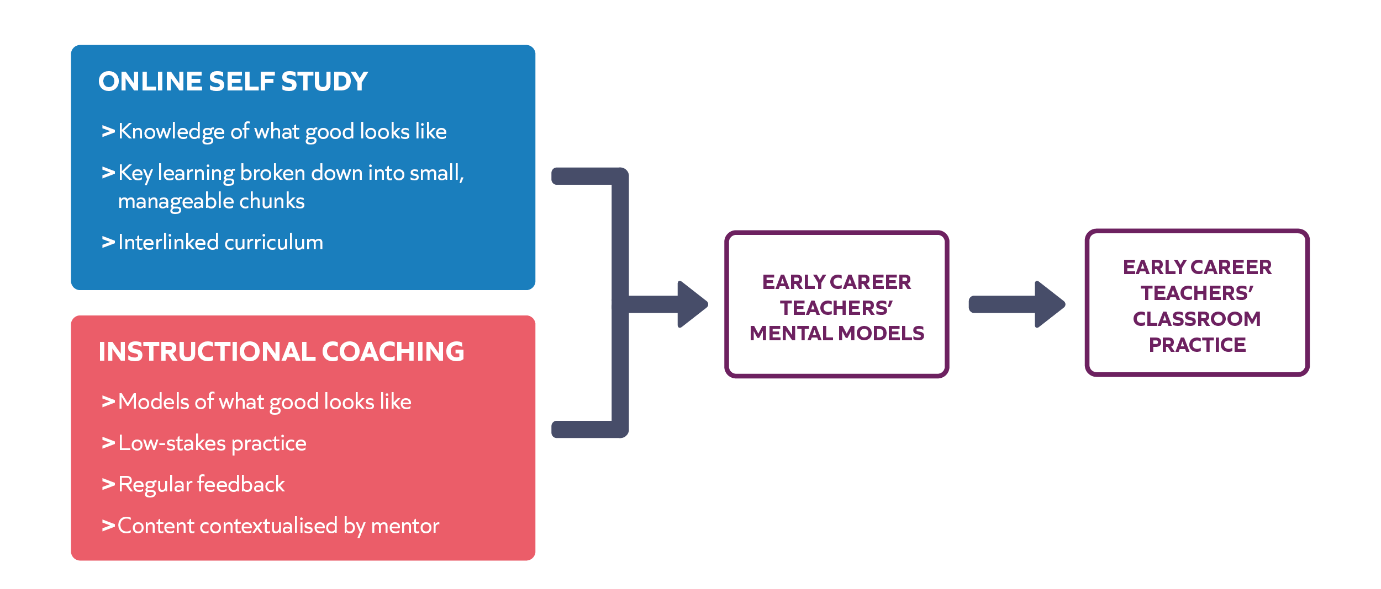

Instructional coaching: key features

The key features of instructional coaching are the elements which make instructional coaching effective. Every instructional coaching session should include the following, otherwise the impact of the session will be less.

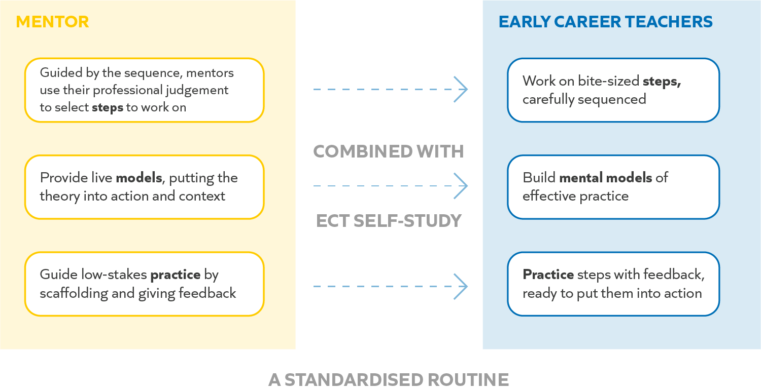

Check for understanding

- Which of the following are key features of instructional coaching?
  - Roleplay
  - Bite-sized steps for improvement
  - Open questioning
  - A regular routine
  - Low-stakes practice & feedback
- Which (if any) of the following statements are true?
  - The ECT should always decide the focus of the coaching
  - ECTs should always work on a new step each week
  - Instructional coaching is the most important part of this programme

Curriculum diagram

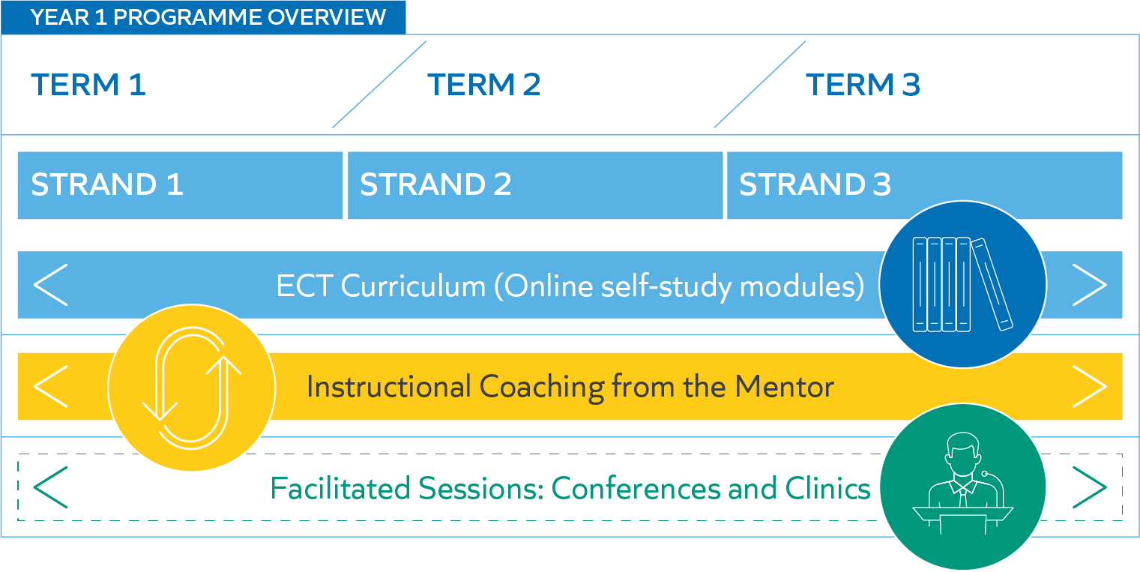

Reflection

Briefly review the curriculum on the next four pages.

- How does the sequencing of the curriculum support Early Career Teachers to build their expertise?
(You might consider the order of the strands, the order of the modules in a strand, or both)
- What challenges or concerns (if any) might the order present for you in your context?

Behaviour strand
Week | Study and coaching (weekly) | Training
1 | B1 Strand fundamentals and re-contracting  Introduces foundational elements of behaviour and supports teachers and mentors to set up effective ways of working. | Kick-off conference  Provides teachers with an overview of the science of learning and habits of planning.  Programme induction  Explains the programme and the ECF, and introduces teachers to aspects of self-regulation.
2 | B2 Routines  Explores effective routines, the role of classroom environment and its connection learning. | Clinic 1
3 | B3 Instructions  Shares role of high-quality instructions and how to plan and reinforce them.
4 | B4 Directing attention  Examines monitoring and reinforcing expectations with praise, voice and movement(s).
5 | B5 Low-level disruption  Focuses on managing low-level disruption to learning and how to maintain a positive environment.
6 | B6 Consistency  Explores how teacher consistency builds a positive learning environment. | Clinic 2
7 | B7 Positive learning environment  Focuses on the classroom culture required for pupils to learn effectively
8 | B8 Making learning manageable  Shares the link between success, behaviour and grain size.
9 | B9 Challenge  Explores the role challenge plays in pupil behaviour.
10 | B10 Independent practice  Considers the link between successful independent practice and expectations, routines and feedback.
11 | B11 Pairs and groups  Focuses on how to make paired and group work successful through expectations, routines and culture.
12 | B12 Upholding high expectations  Examines how to continually reinforce established foundations.

Instruction strand
Week | Study and coaching (weekly) | Training
1 | I1 Strand fundamentals and re-contracting  Introduces foundational elements of instruction and supports teachers and mentors to set up effective ways of working. | Clinic 3
2 | I2 Identifying learning content  Focuses on identifying essential concepts and considering their role in planning and assessment.
3 | I3 Instruction for memory  Considers how teaching can support lasting change in pupils.
4 | I4 Prior knowledge  Examines the implications prior knowledge and misconceptions have on instruction.
5 | I5 Teacher exposition  Explores the challenge(s) when introducing new information and how modelling, explanations and scaffolds can help.
6 | I6 Adapting teaching  Focuses on how effective instruction requires adapting teaching to support and challenge all pupils.
7 | I7 Practice, challenge and success  Examines what constitutes purposeful practice and how practice is an integral part of effective teaching. | Clinic 4
8 | I8 Explicit teaching  Explores explicit teaching across a lesson/unit of learning.
9 | I9 Scaffolding  Focuses on how scaffolds and worked examples can help pupils and how to gradually remove them.
10 | I10 Questioning  Looks at how effective questions can deepen and extend pupil thinking.
11 | I11 Classroom talk  Explores how classroom talk can help to develop pupils’ mental models.
12 | I12 Feedback  Examines the link between teacher questions, feedback for pupils and responsive instruction.

Subject strand
Week | Study and coaching (weekly) | Training
1 | S1 Strand fundamentals and re-contracting  Introduces foundational elements of subject and supports teachers and mentors to set up effective ways of working. | Clinic 5
2 | S2 Planning backwards from learning goals  Focuses on the importance of subject excellence and starting with what teachers want pupils to learn.
3 | S3 Types of knowledge  Looks at the differing nature of subjects, the importance of mental models, knowledge and identifying core knowledge within subjects.
4 | S4 Gaps and misconceptions  Explores the need to identify and respond to gaps in pupil knowledge and pupil misconceptions.
5 | S5 Acquisition before application  Explores the role secure relevant knowledge can play prior to application and how to build and check for high success rates.
6 | S6 Promoting deep learning  Focuses on ensuring deep, hard thinking about key ideas that develops pupil mental models and flexible knowledge.
7 | S7 Developing pupils’ literacy  Explores the varying nature of literacy across and within subjects/phases and the important role of vocabulary, comprehension and oral literacy. | Clinic 6
8 | S8 Sharing academic expectations  Examines the links between challenging academic expectations, purposeful planning and breaking down and modelling content.
9 | S9 Assessing for formative purposes  Examines the link between learning goals, formative and summative assessments.
10 | S10 Examining pupils’ responses  Looks at drawing inferences, identifying misconceptions and getting pupils to elaborate as part of formative assessments.
11 | S11 Adapting lessons to meet pupil needs  Explores the ways formative assessments can provide inferences to adapt teaching to meet the needs of pupils.
12 | S12 Feedback  Focuses on aspects of effective feedback so that pupils can put it into action to improve their understanding.

Content covered across clinics:
- Supporting all pupils: overview of SEND code of practice, and working with SENCO/Safeguarding Lead and TAs
- Responding to challenging behaviour: exploration of challenging behaviour, bullying and the impact on emotional safety
- Building effective relationships with parents and carers: examination of what effective relationships might look like and how they can impact pupil motivation, behaviour and academic success
- Adapting teaching for pupils: focus on resources, grouping and working with other adults
- Teacher wellbeing and workload: consideration of teacher wellbeing, support available and ways to manage and reduce workload
- Early literacy 1: focus on systematic synthetic phonics, high-quality texts and early reading

Example module: B3 – Instructions

Teaching challenge
For Ms Silva, the most challenging pupil behaviour occurs during ‘transition’ parts of her lessons - for example, when she moves from giving an exposition to asking her pupils to do some independent work. At these times they often take a while to settle, and sometimes even do the wrong things. She also finds herself having to repeat her instructions multiple times which can take up valuable learning time. How can Ms Silva best manage these transitions to help her pupils get on with their learning quickly and independently?

Key idea
Setting high expectations and providing clear instructions are powerful ways to foster good behaviour and create an effective learning environment.

Teacher expectations matter
Setting and communicating clear expectations has a strong influence on pupil behaviour (Murdock-Perreira & Sedlacek, 2018). For example, conveying low expectations can generate a ‘self-fulfilling prophecy’ where pupils end up behaving according to the expectations we have set, rather than what they are capable of (Tsiplakides & Keramida, 2010). Sometimes teachers can communicate low expectations without realising. This can happen when we ask certain pupils more questions than others, or when we permit pupils to call out when they shouldn’t.
To mitigate this, Ms Silva should be intentional about holding and communicating high expectations for her pupils. This means:
- Continually assuming that all her pupils are capable of behaving well and making progress in their learning.
- Relentlessly communicating to pupils that she knows they are capable and that she expects nothing less than exemplary behaviour and learning from them.
- Regularly providing clarity to her class about the kind of classroom culture that she values.

Clear instructions can make a huge difference
Giving instructions is a great opportunity to embed high expectations into your lesson. Delivering instructions effectively can help make lesson transitions go smoothly and foster a purposeful and effective learning environment (IES, 2008). Effective instructions can reduce challenging behaviour, reinforce desirable behaviour, and make the classroom more structured and predictable for pupils (Kern & Clemens, 2007). For example, directing pupils to sit in a seating plan and giving them clear instructions for how to begin the starter activity increases the chances of an orderly entrance and successful start to the lesson.
Instructions are powerful because they act as a reference point that pupils use as a guide for what to do and how to do it. However, giving effective instructions is not always easy to do well. In particular, there are two features of how pupils think that can thwart our efforts:
- Limited working memory: People can only think about so many things at once. If we give our pupils too many instructions to hold in their heads, it is likely that they will be unable to retain any of them.
- Forgetting: People forget things. This is especially true when instructions are overly lengthy or for unfamiliar classroom activities (Gathercole et al., 2006).
Both of these situations are exacerbated by the mental demands of the classroom. During our lessons, we often ask pupils to both hold instructions in their heads and think hard about lesson content - for example, when we expect pupils to remember our instructions for conducting a paired discussion while also considering complex questions about Caesar’s invasion of Britain. To make it feasible for our pupils to meet high expectations, we must make sure our instructions are easy to understand and put into practice.

Issuing effective instructions
Bearing in mind the above features of how pupils think, classroom instructions are likely to be more effective when they are:
- Stepped: The best instructions are broken down into a clear sequence of manageable steps (Gathercole et al., 2006).
- Brief: They include as few steps as possible and get straight to the point, especially when giving instructions for new or unfamiliar activities. If you are struggling to achieve a low number of steps, it may be worth looking at making the task itself less complex.
- Visible: Displaying instructions in addition to communicating them verbally means that pupils won’t have to remember them while also thinking about the lesson content.
- Checked: Pupils can easily misunderstand initial instructions. Checking that pupils have understood the steps before letting them get on with the task can increase the chances that they do the right thing (Rosenshine, 2012). This also increases the chances of them remembering the instructions.
- Supported: Consistent language and non-verbal actions for common classroom directions also make them more likely to be memorable.

Nuances and caveats
It is important to think about how we communicate instructions. Timing, tone of voice and how we model instructions can all make a difference to how well they are taken on board. Providing clear instructions is beneficial to all pupils but it can be especially important for younger pupils, those with Special Educational Needs and those with lower working memory capacity (Gathercole et al., 2006).

Key takeaways
Ms Silva can improve pupil behaviour and learning by understanding that:
- Holding and communicating high teacher expectations can improve pupil behaviour.
- Effective instructions can both prevent problems occurring and reinforce desired behaviours.
- Delivering effective instructions involves a concise ‘what’ and a clear ‘how’.
- Checking that pupils understand instructions before letting them start increases the chances of success.

Further reading
Gathercole, S., (2008) Working memory in the classroom, The Psychologist. bit.ly/ecf-gat

References
- Gathercole, S., Lamont, E., & Alloway, T. (2006). Working memory in the classroom. Working memory and education, 219-240.
- IES (2008). Reducing Behavior Problems in the Elementary School Classroom. bit.ly/ecf-ies
- Kern, L., & Clemens, N. H. (2007). Antecedent strategies to promote appropriate classroom behavior. Psychology in Schools, 44, 65–75.
- Murdock-Perriera, L. A., & Sedlacek, Q. C. (2018). Questioning Pygmalion in the twenty-first century: the formation, transmission, and attributional influence of teacher expectancies. Social Psychology of Education, 21(3), 691–707.
- Rosenshine, B. (2012). Principles of Instruction: Research-based strategies that all teachers should know. American Educator, 12–20. Bit.ly/ecf-ros
- Tsiplakides, I. & Keramida, A. (2010). The relationship between teacher expectations and student achievement in the teaching of English as a foreign language. English Language Teaching, 3(2), 22-26. Bit.ly/ecf-tsi
Two further examples of study modules can be found on in the appendix on page 52 of the workbook. If you have additional time, please do read these.

An example of a video and evidence summary

- In your experience, how do new teachers struggle with giving clear instructions?

- What would it look like if a teacher:
- Was beginning to successfully give clear instructions?
- Had mastered this teaching skill, demonstrating great expertise?

Section takeaways

- What are your three key takeaways from the last section (on instructional coaching and the curriculum)?

Section 4: Practising instructional coaching

Recap: instructional coaching – key features

The key features of instructional coaching are the elements which make instructional coaching effective. Every instructional coaching session should include the following, otherwise the impact of the session will be less.

Bite-sized steps

Working on one small, clear step each week allows teachers to practise and receive feedback on the step. This ensures that the teacher is not overwhelmed, and the behaviour or skill is more likely to be embedded into their practice.
Based on a weekly lesson observation, mentors use their professional judgement to select steps which build on the ECT’s prior learning. The structured sequence of self-study supports mentors to select steps which balance building expertise over time and addressing current classroom needs.
During the coaching session, reviewing the last step provides mentors with an opportunity to provide encouragement and feedback on the ECT’s progress.

Steps: examples and non-examples

Example | Non-example
When delivering instructions to the class, stand still on a spot where you can see and be seen by all pupils so that they attend to what you are saying and are not distracted by movement. | When giving instructions, you need to try and be more authoritative.

Example | Non-example
Plan questions you will use to assess pupils for formative purposes that enable you to check pupils' understanding of key knowledge, skills and concepts and deliberately targets a common misconception. | Check for pupils’ misconceptions in your lessons.

Effective steps are:
- Bite-sized
- Observable and specific
- Builds habits

On Steplab, steps are:
- Pre-planned
- Scaffolded
- Clear success criteria
- Editable

Choosing a focus

Example

The lesson | Prior learning
Katie mentors Sol, a Year 4 teacher.  In Sol’s lesson, Katie notices that several pupils are looking out of the window when Sol is explaining the work.  Katie also notices that Sol is trying to cover too much content in one lesson.  Sol has recently been working on steps on classroom management. | Sol has studied content on ‘routines’, ‘instructions’, ‘directing attention’ and ‘low level disruption’.  He has not yet studied modules on ‘identifying learning content’ or ‘planning backwards’.

A suggested focus

Working with Sol to ensure that pupils are paying attention to his explanations is likely to be effective because this is an area that builds on Sol’s prior knowledge, both in terms of his previous study and his recent steps.
Directing pupils’ attention is foundational, if pupils aren’t paying attention they won’t learn – this is another reason for focusing on this before focusing on planning.

Maintaining the current broad focus on classroom management is also likely to help Sol see the difference in his practice, helping develop his sense of self-efficacy in this area – his belief that the actions he takes will be successful. Greater teacher self-efficacy is associated with improved teacher retention.

Practice

The lesson | Prior learning
Sabrina mentors Ella, a secondary History teacher.  In Ella’s lesson, Sabrina notices that the independent practice that Ella has set is not directly related to what she has modelled.  Several pupils call out during Ella’s explanation, and Sabrina notices that Ella is clearly frustrated about this.  Ella has recently been working on steps related to providing effective models and explanations. | Ella has studied content from the behaviour strand, including:  - Routines  - Low-level disruption  - Positive learning environment  - Independent practice  She has also studied content from the instruction strand including:  - Identifying learning content  - Prior knowledge  - Teacher exposition  She has not yet studied modules on ‘scaffolding’ or ‘gaps and misconceptions’.

Notes

The lesson | Prior learning
Ali mentors Claire. Claire has been working on scaffolding pupils’ learning, particularly preparing them for independent practice.  In Claire’s lesson, Ali notices that during paired talk tasks, one pupil often dominates the conversation.  He also notices that when checking for understanding, Claire doesn’t always pick up on key pupil misconceptions. | Claire has studied content from the behaviour strand, including:  - Routines  - Positive learning environment  - Independent practice  - Pairs and groups  She has also studied content from the instruction strand including:  - Teacher exposition  - Practice, challenge and success  - Adapting teaching  - Scaffolding  - Questioning  She has not yet studied modules on ‘types of knowledge’ or ‘developing pupils’ literacy’.

Notes

Case study
Vicky is in the second month of her 1st year of induction. She has made a positive start but is struggling with some low-level disruption in her classroom. During September, Tania (her mentor) met with Vicky to set out the ways that they will work together, including how and why they will use instructional coaching to improve her practice. Tania also dropped into her lessons informally to see how she was progressing.
Last week, Tania observed Vicky and, based on what she saw in the classroom and on the self-study Vicky has engaged with so far, focussed the instructional coaching on B2 – Routines. Vicky had some good classroom routines in place, including welcoming pupils into the classroom, routines to support pupils move around the classroom and handing out resources. However, Tania noticed that while she had a routine in place for what pupils should be doing during the starter activity, she did not ensure that pupils were aware that she was looking to see if they were meeting her expectations, and therefore this became the focus of her step and instructional coaching session.
In the instructional coaching session following the lesson, Tania and Vicky worked on the step “actively show that you are scanning and monitoring the pupils during the starter activity”. Tania demonstrated what this step would look in Vicky’s class, with her pupils, and then supported Vicky to practise doing the same skill, providing feedback to help her improve.
Tania and Vicky agreed that Tania would come and watch the beginning of Vicky’s lesson on Tuesday afternoon so that she could see the step in action.
During this week’s observation Tania will be looking at how Vicky is getting on with the last step, whilst also thinking about whether to continue to focus on routines (whether the same step or a related one), or to move onto a different area of the behaviour strand.
Here are the success criteria for the last step. Tania will use these to guide her during the lesson observation.
- Body language is in a formal register
- You are positioned so that every pupil can see you
- You scan the room to check all pupils
- You include non-verbal gestures to reinforce monitoring

Support with selecting steps

When selecting steps, mentors should consider:
- The ECT’s last step:
  - Does this need repeating?
  - What might come next?
- The broad area that ECTs are currently working on (e.g. classroom management, modelling, etc.):
  - Maintaining a focus on an area can help build teachers sense of self-efficacy
- ECTs’ prior knowledge – which self-study modules have they worked on so far.

Trust your own judgment, but if in doubt, select something from the current study module.
Further support in selecting steps will be available in the post-conference online support.

Recap: instructional coaching – key features

The key features of instructional coaching are the elements which make instructional coaching effective. Every instructional coaching session should include the following, otherwise the impact of the session will be less.

Clear model of effective practice

The teacher’s mental model of the skill of behaviour that is being focussed on may be incomplete or contain misconceptions. It is therefore critical that the teacher is given a clear model of what this looks like in practice.
In the coaching session, this involves the mentor providing a live demonstration of what a technique looks like in the context of the ECT’s subject, phase and pupils. It is the mentor’s role to translate the content from Steplab (the steps and the self-study) into the ECT’s phase and subject.
It is also important to explain why the step is effective, why it will improve the teacher’s practice and what the impact will be on student learning as well as when and why it might be used. This will support the teacher buy into the process. Key to building this understanding is asking the ECT probing questions such as “how is the model different to your current practice?”.
Note that although for more expert or experienced teachers, instructional coaching might involve a co-constructed model, as ECTs are likely to be relatively novice in the area they are working on, they will benefit from the mentor providing a model.

Characteristics of an effective model

- Focuses the teacher’s attention – The model is concise and focused on the key elements. It avoids unnecessary additional information.
- Builds the teacher’s mental model – The model involves making the mentor’s thinking visible. It provides explicit links between theory and the practice being demonstrated.
- Puts the action step into the teacher’s contexts – The model is tailored to the teacher’s particular class or subject content as well as their year group/phase.

Model step
Example: success criteria for the model

Step | Success criteria | Met (P) or not met (X)
Sharing the step | You share the new step with the teacher and link it to the module
Delivering the model | Demonstration: You provide a demonstration of the technique/strategy
 | Authentic: You model as though delivering to the class, without ‘breaking out’ of role
 | Exposes thinking: You use a ‘whole-part-whole’ structure: first you share the whole model, then break it down to show the success criteria, the model the whole step
The model itself | All criteria: The model exemplifies all the success criteria for the step (below)
 | Nothing extra: The model does not contain unnecessary additional information
 | Manageable: pupils remember what to do because there are not too many instructions.
 | Broken-down: instructions are broken into steps, so they are easy to remember.
 | Concise and familiar: the teacher uses the fewest words possible and ensures they are words pupils will understand.
 | Sequential: teacher states the instructions in the order in which pupils need to carry them out.
 | Clear and confident: teacher’s voice is authoritative, upbeat and can be heard from anywhere in the classroom but does not sound like shouting.
 | Open: teacher has authoritative and approachable body language, such as an upright posture, unfolded arms, relaxed shoulders and relaxed facial expression.
What went well:
Next time try:

Practise: model step

Step
Break down and deliver instructions in manageable steps that are ordered sequentially for pupils.

Plan the model in the space below
There is a pre-planned example on the following page which you can use to guide you as you wish.
You model should be tailored to your phase or subject.
Use the success criteria below to help you create your model

Space for planning your model

Success criteria for your model:
- Manageable: pupils remember what to do because there are not too many instructions
- Broken-down: instructions are broken into steps, so they are easy to remember
- Concise and familiar: the teacher uses the fewest words possible and ensures they are words pupils will understand
- Sequential: teacher states the instructions in the order in which pupils need to carry them out.
- Clear and confident: teacher’s voice is authoritative, upbeat and can be heard from anywhere in the classroom but does not sound like shouting.
- Open: teacher has authoritative and approachable body language, such as an upright posture, unfolded arms, relaxed shoulders and relaxed facial expression

Optional challenge for expert mentors: Write your own step and prepare a model for this instead.

Pre-planned example model
“Look and listen class, thank you.

Right, I'm going to give you some instructions.
- Get out your green pen, ruler and workbook placing them on the desk
- Remove anything else from the desk and put it into your bag
- Turn your workbook to page four
- Fold your arms and look to me so I know that you are ready
Off you go”

Practise: Model step

Step
Break down and deliver instructions in manageable steps that are ordered sequentially for pupils.

The model
Use the model you planned above.

How will you practise?
Timing: maximum of 6 minutes per round
- 3 minutes: Person A as the mentor shares the action step and the model
- 1 minute: Person B provides feedback to person one based on the success criteria
- 2 minutes: Person A re-practises the relevant section based on the feedback to
- improve it
- Swap roles
Repeat the cycle if time

Section | Success criteria | Put a tick in this box if the success criteria has been met and a cross if it has not
 |  | Round 1 |  | Round 2 |  | Round 3 |  | Round 4
Sharing the step | You share the new step with the teacher
Delivering the model | Demonstration: You provide a demonstration of the technique/strategy
Delivering the model | Authentic: You model as though delivering to the class, without ‘breaking out’ of role
 | Exposes thinking: You use a ‘whole-part-whole’ structure: first you share the whole model, then break it down to show the success criteria, then model the whole step.
The model itself | All criteria: The model exemplifies all the success criteria for the step (below)
 | Nothing extra: The model does not contain unnecessary additional information
 | Manageable: pupils remember what to do because there are not too many instructions.
 | Broken-down: instructions are broken into steps, so they are easy to remember.
 | Concise and familiar: the teacher uses the fewest words possible and ensures they are words pupils will understand.
 | Sequential: teacher states the instructions in the order in which pupils need to carry them out.
 | Clear and confident: teacher’s voice is authoritative, upbeat and can be heard from anywhere in the classroom but does not sound like shouting.
 | Open: teacher has authoritative and approachable body language, such as an upright posture, unfolded arms, relaxed shoulders and relaxed facial expression.
What went well:
Next time try:

Recap: Instructional coaching: key features

The key features of instructional coaching are the elements which make instructional coaching effective. Every instructional coaching session should include the following, otherwise the impact of the session will be less.

Practice and feedback
Providing the opportunity for low-stakes practise and feedback on a small element of their teaching in a controlled environment (deliberate practice), helps overcome the knowing-doing gap and start to embed effective habits.
This allows teachers to receive early feedback before trying something for real, helping avoid mistakes. This can help build teachers’ confidence and make it more likely that they will be successful in trying their new step.
In the instructional coaching session, this follows the model. The mentor’s role is to support the ECT to practise, e.g. by helping them script or plan before standing up and trying a step out, as well as providing precise feedback, using the success criteria to help.

Example: Practise

Success criteria

Section | Success Criteria | Put a tick in this box if the success criteria has been met and a cross if it has not
Setting up the practice | The mentor explains how the practice will run.
 | The mentor provides the success criteria that they will provide feedback on the basis of.
During the practice | The mentor scaffolds the practise, firstly by asking the teacher to script and read out the script and then asking the teacher to stand up and practise.
 | The mentor provides feedback related to the success criteria and asks the teacher to re-practise.
What went well –

Next time try –

Practise: Practise

How will you practise?

2 minutes to familiarise yourself with format of the practice and the suggested script, below.

Timing: 10 minutes per round
- 6 minutes: Person A will run the practise. For the purpose of the practise when asked by the mentor to write down your instructions, as the teacher, please just say completed, in order to save time.
- 1 minute: Person B will provide feedback based on the success criteria
- 3 minutes: person A will re-practise a relevant section based on the feedback
- Swap roles

Suggested mentor script for practice:
“Firstly, you are going to script your instructions. After that I will ask you to read through them and check them against the success criteria. Then I will ask you to deliver them in role as a teacher.
I will then give you feedback based on the success criteria and you will re-practise based on the feedback.
The success criteria are:
- Manageable: pupils remember what to do because there are not too many instructions
- Broken-down: instructions are broken into steps, so they are easy to remember
- Concise and familiar: the teacher uses the fewest words possible and ensures they are words pupils will understand
- Sequential: teacher states the instructions in the order in which pupils need to carry them out.
- Clear and confident: teacher’s voice is authoritative, upbeat and can be heard from anywhere in the classroom but does not sound like shouting
- Open: teacher has authoritative and approachable body language, such as an upright posture, unfolded arms, relaxed shoulders and relaxed facial expression
Now take a moment to script out what the instructions you are going to practise with.”

Vicky’s instructions (to be played by the person being the teacher)
When I say go, I want you to
- Leave your books on your tables open at today’s work
- Everything else into your bag
- Stand behind your desk ready to be dismissed

Space for any edits you wish to make to the practice, e.g. to tailor the instructions to your phase or context

Success criteria

Section | Success Criteria | Put a tick in this box if the success criteria has been met and a cross if it has not
 |  | Round 1 | Round 2 | Round 3 | Round 4
Setting up the practise | The mentor explains how the practise will run
 | The mentor provides the success criteria that they will provide feedback on the basis of
During the practise | The mentor scaffolds the practise, firstly by asking the teacher to script and read out the script and then asking the teacher to stand up and practise
 | The mentor provides feedback related to the success criteria and asks the teacher to re-practise
What went well:

Next time try:

Key takeaways
- What are the three parts to the programme, that build teachers’ knowledge?

- What is instructional coaching?

- What do you need to do when observing your ECT?

- What are the key features of each instructional coaching session?

Reflection
- Think about selecting steps, modelling and providing time for low-stakes practice and feedback.
- Which elements of this are similar to what you do already:
  - When mentoring teachers?
  - When working with pupils?
- What aspects of your current mentoring practice can you use?
- What might you change?
- How do the features of instructional coaching help to build expertise?

Further support
This conference is designed to be a step on the journey to developing your skills as an instructional coach. We will continue to provide you with opportunities to develop your practice across the programme, and you will also be able to call on your induction coordinator and delivery partner to provide ongoing support.
Following this conference, you will have access to online materials to support you in deepening your understanding of the following areas.
- Selecting and setting steps
This will also be the focus of mentor clinic 3
- Modelling
This will also be the focus of mentor clinic 1
- Low-stakes practice and feedback
This will also be the focus of mentor clinic 2

Section 5: Implementation

Enabling conditions

 | Definitely in place | if not, action needed
Has time been protected for you and your ECT to meet each week?
Is this on both your timetables?
What are your first steps towards embedding coaching as a habit?
For you?
For your ECT?
What previous experience as a teacher or mentor will be particularly useful for the year ahead?
Are you aware of any additional support your ECT is likely to need, such as additional subject knowledge support?
When can you complete the online contracting module?

Further notes if needed:

Instructional coaching: tight but loose

Component |  | Tight? | Loose?
Mentor meetings | Weekly, 45 mins + | ✔ *
 | Includes instructional coaching (modelling, practice and feedback) | ✔
Observation | Weekly | ✔
 | In-person |  | ✔
Steps | Bite-sized (achievable in one-week) | ✔
 | New step each week |  | ✔
 | Build on ECTs’ prior knowledge, Early Career Framework-aligned | ✔
 | Based on observation |  | ✔

Steplab training

Practice tasks

- Log-in to Steplab and access the coaching simulator.
Select “Simulator (unguided)”
- Click on ‘Observe’ (within the simulator).
Work through the observation (no need to type any notes into the boxes), making the following decisions:
  - Mark the existing step as “achieved”
  - Choose a step from within “Behaviour à B2: Routines à Key transitions à Teacher clearly communicates the transition routine including what to do and how to behave”
  - Click finish
- Click on “Give feedback” (within the simulator)
Click through the parts of the meeting until you get to “Plan & practise next step”:
  - Select 3 rounds of practice
OPTIONAL: click on “Launch practice engine” to do the practice
  - Type in a time for the next observation and select a section of the lesson.
  - Click finish
- Work through the full cycle again (within the simulator).
  - Start with “Observe”; again, mark the step as achieved, but this time select any new step you wish.
  - Type some made-up notes into the observation notes box
  - During “Give feedback” notice that if you click on “see observation notes if needed” during step 2, your notes from earlier appear.
- Free exploration of Steplab simulator.
Suggested possible tasks:
  - Try marking the step as “not achieved” during “Observe”.
  - Investigate the buttons
  - Edit the pre-existing questions
  - Investigate what happens if you try and complete a coaching cycle without doing any rounds of practice.

Mentor checklist

Weekly:
- Observe ECT teach
- Meet and provide ECT with feedback in instructional coaching session
Termly:
- Book and attend mentor professional development sessions
Induction coordinators, not mentors:
- Write reports, submit assessments

Action planning

- When and where will you meet for coaching?
  - If you can’t decide this yet, when will you decide?
- What barriers might there be to the programme being successful in your school?
  - What can you do about these, and who can help?
- What areas do ECTs in your school find easiest/most challenging?
(If you have worked with your ECT before, this can be more specific)
  - What can you do to provide challenge or support here?

Reflection

- Which of these statements about observations are true:
  - Mentors need to select a different step each week
  - Each step should be linked to the current self-study
  - Mentors should observe ECTs once per half-term
  - Observations can be completed in person or via video
- Which of these statements about instructional coaching are true:
  - ECTs should decide on the step they will focus on
  - Instructional coaching should include modelling, practice and feedback
  - Instructional coaching is the only important part of mentoring
  - For ECTs, reflecting on a lesson is as effective as instructional coaching
- Explain the following to your partner
- Use the ideas of working memory and mental models to explain why people who are more novice in an area benefit from careful guidance.
- What do mentors need to do each week?
- What should mentors consider when choosing a step for their ECT? And what should they do if they are unsure what to set?
- What makes an effective model in an instructional coaching session for an ECT?

Bibliography

Introduction to the Early Career Framework
Allen, R. and Sims, S., 2018. The Teacher Gap. 1st ed. Abingdon: Routledge.
Darling-Hammond, L. and Sykes, G., 2003. Wanted, A National Teacher Supply Policy for Education: The Right Way to Meet The "Highly Qualified Teacher" Challenge. education policy analysis archives, 11, p.5.Hanushek (2011:467)
EEF. 2019. Staff Deployment & Development. [online] Available at: <https://educationendowmentfoundation.org.uk/school-themes/staff-deployment-development/> [Accessed 22 May 2020].
Fletcher-Wood, H. (2018) Between novice and expert: complex tasks and intermediate learning. Available here: https://improvingteaching.co.uk/2018/03/11/between-novice-to-expert-complex-tasks-and-intermediate-learning/
Foster, D., 2019. Teacher Recruitment And Retention In England. [online] House of Commons Library. Available at: <https://commonslibrary.parliament.uk/research-briefings/cbp-7222/> [Accessed 22 May 2020].
Garet, M. S., Heppen, J. B., Walters, K., Parkinson, J., Smith, T. M., Song, M., Garrett, R., Yang, R., & Borman, G. D. (2016). Focusing on mathematical knowledge: The impact of content-intensive teacher professional development (NCEE 2016-4010). Washington, DC: National Center for Education Evaluation and Regional Assistance, Institute of Education Sciences, U.S. Department of Education.
Hanushek, E., 2011. The economic value of higher teacher quality. Economics of Education Review, 30(3), pp.466-479
Hollis, E (2018). Early career framework; what might this mean for recruitment and retention? Available here: https://edexec.co.uk/early-career-framework-what-might-this-mean-for-recruitment-and-retention/
Sharples, J., Albers, B. and Fraser, S., (2018) ‘Putting Evidence to Work’ [online] Dera.ioe.ac.uk. Available at: <https://dera.ioe.ac.uk/31088/1/EEF-Implementation-Guidance-Report.pdf> [Accessed 13 June 2020].
Timperley, H. (2008). Teacher professional learning and development. Educational Practices (18). International Academy of Education
Wiliam, D. (2007). Content Then Process: Teacher Learning Communities in the Service of Formative Assessment. In: Reeves, D., ed. 2007. Ahead of the Curve: The Power of Assessment to Transform Teaching and Learning. Bloomington, IN: Solution Tree. pp.183-204.

How people learn
Berliner,D. (1988). The development of expertise in pedagogy. American Association of Colleges for Teacher Education, Washington, D.C. Available at: https://files.eric.ed.gov/fulltext/ED298122.pdf
Berliner,D. (2004). Expert Teachers: Their Characteristics, Development and Accomplishments Article. Available at: https://www.researchgate.net/publication/255666969_Expert_Teachers_Their_Characteristics_Development_and_Accomplishments [Accessed 06 May 2021]
Clark, R., Kirschner, P. & Sweller, J. (2012). Putting students on the path to learning: The case for fully guided instruction. American Educator, 36(1): 6-11. Available at: https://files.eric.ed.gov/fulltext/EJ971752.pdf
Clarridge, P.B. & Berliner, D.C. (1991) Perceptions of student behaviour as a function of expertise. Journal of Classroom Interaction, 26, p. 1–8.
Deans for Impact (2017) Practice with Purpose: The Emerging Science of Teacher Expertise. Available at: https://goo.gl/jh8N4Z
Deans for Impact (2018). Building Blocks. [online] Available at: https://deansforimpact.org/wp-content/uploads/2017/11/Building-Blocks_Framework.pdf [Accessed 22 May 2020].
Findell, C.R. (2009) What Differentiates Expert Teachers from Others? The Journal of Education, 188(2), p. 11–24.
Loewenberg Ball, D., Thames, M. and Phelps, G., 2008. Content Knowledge for Teaching. Journal of Teacher Education, 59(5), pp.389-407.
Mccrea, P. (2018). Expert Teaching What is it, and how might we develop it? Peps Mccrea. Available here: https://www.researchgate.net/publication/324759008_Expert_Teaching_What_is_it_and_how_might_we_develop_it_Peps_Mccrea/download
Pashler, H., Bain, P. M., Bottge, B. A., Graesser, A., Koedinger, K., McDaniel, M., & Metcalfe, J. (2007). Organizing Instruction and Study to Improve Student Learning. IES Practice Guide. NCER 2007-2004. National Center for Education Research
Schempp, P., Tan, S. & McCullick, B. (2002) The practices of expert teachers. Teaching and Learning, 23(1), p. 99–106.
Sternberg, R.J. & Horvath, J.A. (1995) A prototype view of expert teaching. Educational Researcher, 24(6), p. 9–17.
Sweller, J. (1988). Cognitive load during problem solving: Effects on learning. Cognitive Science, 12(2), 257-285
Westerman, D.A. (1991) Expert and Novice Teacher Decision Making. Journal of Teacher Education, 42(4) p. 292–305.
Deans for Impact (2015) The Science of Learning. Available at: https://goo.gl/VpUw1y
Wiliam, D. (2007). Content Then Process: Teacher Learning Communities in the Service of Formative Assessment. In: Reeves, D., ed. 2007. Ahead of the Curve: The Power of Assessment to Transform Teaching and Learning. Bloomington, IN: Solution Tree. pp.183-204.
Willingham, D., 2009. Why Don't Students Like School?. San Francisco, CA: Jossey-Bass.
Wolff, C.E., Jarodzka, H. & Boshuizen, H.P.A. (2017) See and tell: Differences between expert and novice teachers’ interpretations of problematic classroom management events. Teaching and Teacher Education, 66, p. 295–308

Instructional Coaching
Allen, R. and Sims, S., 2018. The Teacher Gap. 1st ed. Routledge
Deans for Impact (2017) Practice with Purpose: The Emerging Science of Teacher Expertise. Available at: https://goo.gl/jh8N4Z
Glei, J., 2013. Maximize Your Potential: Grow Your Expertise, Take Bold Risks Build An Incredible Career. 1st ed. Amazon publishing
Higgins, S. and Katsipataki, M. and Kokotsaki, D. and Coleman, R. and Major, L.E. and Coe, R. (2013) 'The Sutton Trust - Education Endowment Foundation Teaching and Learning Toolkit.', Manual. Education Endowment Foundation, London
Hill, Heather & Charalambous, Charalambos & Kraft, Matthew. (2012). When Rater Reliability Is Not Enough: Teacher Observation Systems and a Case for the Generalizability Study. Educational Researcher. 41. 56-64. Available at https://www.researchgate.net/publication/254088727_When_Rater_Reliability_Is_Not_Enough_Teacher_Observation_Systems_and_a_Case_for_the_Generalizability_Study [Accessed 06 May 2021]
Hobbiss, M., Sims, S., & Allen, R. (2020). Habit formation limits growth in teacher effectiveness: A review of converging evidence from neuroscience and social science. Review of Education
Joyce, B. R. , & Showers, B. (1981). Transfer of training: The contribution of coaching. Journal of Education , 163(2), 163–172. https://doi.org/10.1177/002205748116300208
Kraft M.A., Blazar D., Hogan D. The Effect of Teacher Coaching on Instruction and Achievement: A Meta-Analysis of the Causal Evidence. Review of Educational Research [Internet]. 2018;88 (4) :547-588.
Lally, P., Van Jaarsveld, C., Potts, H. & Wardle, J. (2010) How are habits formed: Modelling habit formation in the real world. European Journal of Social Psychology 40, p. 998–1009
samsims1, V., 2019. Four Reasons Instructional Coaching Is Currently The Best-Evidenced Form Of CPD. [online] Sam Sims Quantitative Education Research. Available at: https://samsims.education/2019/02/19/247/ [Accessed 20 August 2020].

Reflection and planning
Glei, J., 2013. Maximize Your Potential: Grow Your Expertise, Take Bold Risks Build An Incredible Career. 1st ed. Amazon publishing.

Appendices

Appendix 1: Mentor support

Support with… | From… | How… | Where
Getting started with mentoring, including instructional coaching | - Ambition Institute  - Your delivery partner | - Mentor conference 1  - Post-conference optional study | - Face-to-face – now!  - Steplab (online, asynchronous)
Building knowledge of instructional coaching techniques |  | - Mentor clinics | - Zoom (Online, synchronous)
Personalised, one-to-one developmental feedback on instructional coaching | - An expert coach, assigned through your delivery partner | - Coaching on coaching (two in year 1, one in year 2) | - Online (Zoom) or face-to-face
Early Career Framework content for teachers | - Ambition Institute | - Teacher self-study content | - Steplab (online, asynchronous)
In school challenges, including logistics | - Your school  - Your delivery partner | - Induction coordinator  - Early Career Framework Lead (for your delivery partner)
Technical difficulties, including with Steplab | - Your school  - Your delivery partner  - Steplab | - Induction coordinator  - Early Career Framework Lead (for your delivery partner)  - Steplab

Support for mentors
Below is a table that shows the support for mentors across the programme.
Term  1 | Input | Time | Mode of delivery | Content
 | Mentor  Conference 1 | 1 day | Face-to-face | - Introduction to the ECF  - Introduction to the Early Career Teachers Programme  - Introduction to instructional coaching  - Science of learning: how learners learn
 | Optional online content |  | Online content on Steplab  Modules last 15-30 mins each | Modules including:  - Setting steps  - Modelling  - Effective practice  - ECT Assessment
 | Clinic 1: Modelling | 1.5 hrs | Seminar on Zoom (1 hour) + online self-study (30 mins) | Deliberate practice – modelling  - Focus on the importance of modelling in deliberate practice  - Features of a high-quality model  - Practice with feedback on designing and delivering a high-quality model
 | Coaching on coaching 1: Modelling | 1.5 hrs | Tailored support from an experienced instructional coach over Zoom (1 hour) + online self-study (30 mins) | - A one-to-one conversation and instructional coaching session
Term  2 | Elective self-study | 2 hrs | Online content on Steplab | Coaching fundamentals:  - Setting up ‘task-based’ practice including the importance of maintaining a culture of practice  - A deeper look at the stages of the coaching model (detail and video exemplification, example/non-example, quizzes)
 | Clinic 2: Deliberate Practice & Providing Feedback | 1.5 hrs | Seminar on Zoom (1 hour) + online self-study (30 mins) | Deliberate practice – providing feedback  - Recap on why we use deliberate practice as a tool throughout the teacher’s journey  - Focus on the importance of the quality of feedback during deliberate practice  - Features of high-quality feedback  - Practice with feedback on writing and providing high quality feedback
 | Coaching on coaching 2: Deliberate practice | 1.5 hrs | Tailored support from an experienced instructional coach over Zoom (1 hour) + online self-study (30 mins) | - A one-to-one conversation and instructional coaching session
Term  3 | Mentor  Conference 2 | 1 day | Face-to-face | - Year 2 on the programme  - Further science of learning: how learners learn  - Teacher change: how to help teachers keep getting better  - Increasing the challenge for your ECT  - Adapting the coaching model as expertise builds  - Building self-regulation
 | Elective self-study | 2 hrs | Online content on Steplab | - Teacher expertise – what does it look like and how do we build it  - Providing challenge within the programme
Year 2 | Clinic 3: Steps and adaptations | 1.5 hrs | Seminar on Zoom (1 hour) + online self-study (30 mins) | Steps and adaptations  - Reviewing the characteristics of an effective step  - Adapting steps to suit your context and the expertise of your ECT
 | Coaching on coaching 3: Developing perception | 1.5 hrs | Tailored support from an experienced instructional coach over Zoom (1 hour) + online self-study (30 mins) | - A one-to-one conversation and instructional coaching session
 | Elective self-study | 2 hrs | Online content on Steplab | - Promoting transfer

Appendix 2: Further examples of evidence summaries from study modules
Module I4: Prior Knowledge

Teaching challenge
Ms McShane finds it hard to ensure all pupils understand the new ideas she teaches. She has noticed that many have gaps in prior knowledge, even if they have covered related topics in previous years, or the topic is one she taught them herself. Others struggle to link new ideas to their existing knowledge. How can she check and build upon pupil prior knowledge to help them understand new ideas?

Key idea
Pupil learning is more successful if teachers check, activate and build on pupil prior knowledge.

Prior knowledge helps us make sense of new material
“The most important single factor influencing learning is what the learner knows already” (Ausubel, 1968 in Simonsmeier et al., 2018). This is because pupils “come to understand new ideas by relating them to old ideas” (Willingham, 2009). Existing knowledge (stored in long-term memory) is what makes new ideas meaningful.
We can illustrate this by looking at sentences we might ask pupils to understand. As you read the sentences below, consider what pupils need to know to make sense of each one:
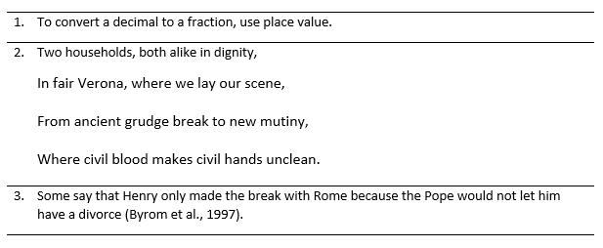
For example, if pupils don’t know who Henry was, who the Pope was and why a divorce mattered to him, the sentence – and the topic – will make little sense.
Teachers can help pupils to learn by linking new ideas to prior knowledge. This makes it easier to process those new ideas. For example, if pupils have studied stories about adventures previously, they know what to expect in encountering a new adventure story. This then makes it easier to remember them, by connecting the new ideas to existing knowledge. The greater pupils’ prior knowledge, the easier learning becomes for them: “it is easier to learn new information… [and] to solve new problems when one has a rich, well-connected body of knowledge and strong ties and connections” (Rosenshine, 2012). Well-organised prior knowledge makes it even easier for pupils to learn new ideas.

Weak prior knowledge can cause pupils to misunderstand
For prior knowledge to help pupils, it needs to be complete and accurate: if pupil prior knowledge is weak, pupils can misunderstand new material. If pupils hold misconceptions or lack correct knowledge, they can form misconceptions. For example, knowing that the surface of the Earth appears flat may lead pupils to conclude that the Earth is a disc (Simonsmeier et al., 2018). If Ms McShane tries to introduce a new idea which does not fit into a pupil’s current mental model – particularly if the pupil’s mental model is inaccurate – that pupil may misunderstand or reject this idea (Chi, 2009).

Activating prior knowledge can help pupils to succeed
An effective starting point for teachers is to identify what pupils already know, and any gaps in their knowledge. Having done so, Ms McShane can seek to introduce new material in small enough chunks to be comprehensible, and to make explicit links between prior knowledge and the new ideas. Where pupils have missing or incomplete knowledge, adding new concepts will help pupils to develop more sophisticated mental models. However, where Ms McShane’s pupils already hold beliefs which happen to be wrong, she must focus on changing old concepts (Chi, 2009). When introducing new material, Ms McShane needs to develop pupils’ mental models by taking small steps and posing lots of questions which explicitly link pupil prior knowledge with the concepts being taught.

Nuances and caveats
If pupils have lots of prior knowledge and are reminded of this, it can prevent them from looking for new or better problem solutions (Simonsmeier et al., 2018) – like a driver going into autopilot: they stop thinking hard and therefore don’t develop their mental model.

Key takeaways
Ms McShane can begin to improve her instruction by understanding that:
- Drawing on existing mental models helps us to learn new information and solve new problems more effectively.
- Weak prior knowledge can lead to misconceptions. Ms McShane must make the effort to diagnose what her pupils do know, don’t know and misunderstand.
- Ms McShane can build on this by reviewing pupil prior knowledge and introducing new material in steps while asking lots of questions.
- By carefully activating pupil prior knowledge and challenging pupils’ incorrect beliefs, she can support pupils to develop accurate mental models.

Further reading
Simonsmeier, B. A., Flaig, M., Deiglmayr, A., Schalk, L., & Schneider, M. (2018). Domain-Specific Prior Knowledge and Learning: A Meta-Analysis Prior Knowledge and Learning. bit.ly/ecf-sim

References
- Byrom, J., Stephens-Wood, P., Riley, M., & Counsell, C., (1998). Changing Minds: Britain 1500-1750. Oxford: Pearson.
- Chi, M. T. (2009). Three types of conceptual change: Belief revision, mental model transformation, and categorical shift. International handbook of research on conceptual change. 89-110. Routledge.
- Rosenshine, B. (2012). Principles of Instruction: Research-based strategies that all teachers should know. American Educator, 36(1), 12–20.
- Simonsmeier, B. A., Flaig, M., Deiglmayr, A., Schalk, L., & Schneider, M. (2018). Domain-Specific Prior Knowledge and Learning: A Meta-Analysis Prior Knowledge and Learning. bit.ly/ecf-sim.
- Willingham, D. T. (2009). Why don’t students like school? San Francisco: Jossey-Bass.
Module S3: Types of knowledge

Teaching challenge
Mr Jones has reviewed the curriculum for his next topic: he is confident about the learning goals, has refreshed his knowledge of the key ideas and has talked to colleagues about how pupils can best learn them. However, the amount and range of content appears huge. He is unsure how he will find time to cover everything in depth. What should he prioritise teaching?

Key idea
Teachers can develop pupils’ mental models by identifying and ensuring they understand and retain critical subject content.

Mental models
Mr Jones is using guidance from the school curriculum, colleagues and curricular resources to build up an increasingly sophisticated mental model of the subject. A mental model is a structured body of knowledge. It is a collection of concepts, knowledge, skills and principles which fit together to provide an overall understanding of an idea (Sweller et al., 1998). For example, most adults have a mental model of a restaurant: this means they know what to do (more-or-less) in a new restaurant or an unfamiliar country (Sweller et al., 1998). Similarly, Mr Jones has a mental model of the topics he is teaching: both the content that he is going to teach about and how to teach it in a way that links to a subject – what makes this content historical or mathematical? He knows the key ideas, the underlying principles and how they fit together. For example, he knows the key events of the English Civil War, how they are linked and different ways in which they can be interpreted.
To achieve curricular goals, he must use his subject mental model to motivate pupils to develop increasingly complex mental models of the subject. The more complex a pupil’s mental model, the better they can apply it to skills such as answering questions, solving problems or learning new ideas (Willingham, 2009). For example, a pupil whose mental model did not include the word “monarch”, or the concept of “Parliament” would struggle to make sense of a text describing the causes of the Civil War. In contrast, a pupil with a complex mental model would move from attempting to understand the story of the Civil War to using historical reasoning as to which cause was most significant.

The importance of knowledge
When pupils learn, they gain – and retain – deeper and more sophisticated knowledge in their mental models. Developing pupil knowledge is important as the more pupils know (and the better organised their knowledge), the better they can understand a new idea (by connecting it to their existing knowledge) and the better they can solve problems (by applying their knowledge). Their existing knowledge reduces the burden on pupils’ working memory (Deans for Impact, 2015; Willingham, 2006).
Therefore, if Mr Jones is to help pupils achieve ambitious learning goals, his priority is teaching pupils knowledge in order to also develop their skills (Willingham 2009). He should focus on what he wants his pupils to know and be able to do. For example, a wide vocabulary will help pupils understand unfamiliar texts, while knowledge of long multiplication gives pupils the capability to solve previously unseen maths problems.
To develop pupils’ mental models, Mr Jones must first identify their constituent parts: exactly what he wants pupils to know. This helps him to reduce his sophisticated knowledge into comprehensible building blocks for pupils: doing so reduces the risk of overestimating pupils’ knowledge and underestimating how hard they will find new ideas (Wiliam, 2013). If he wants pupils to explain the causes of the Civil War, he can identify what he wants them to know about each cause, for example: “to know that King Charles I believed he ruled by Divine Right.” If he wants pupils to complete long multiplication, he can identify that he wants them to know that a number can be partitioned into tens and hundreds.

Prioritising subject content
Having identified everything he wants pupils to know about a topic, Mr Jones is left with a problem: there is a huge amount of relevant and interesting knowledge. He can address this by identifying the essential concepts, knowledge, skills and principles – the ‘critical’ subject content that pupils need to remember in order to have a complete mental model (Counsell, 2018; Sweller et al., 1998). Critical content is what he hopes pupils will recall in one, three, or perhaps even ten years: Iago’s jealousy, the causes of the English Civil War and how to design an experiment.
Mr Jones could also identify how he wants his pupils to organise what they remember. For example, concepts are organising ideas that allow us to categorise knowledge (Chi, 2009). Critical concepts, then, are important subject ideas Mr Jones will want to return to many times to help pupils develop organised mental models of his subject. Therefore, he can introduce the idea of the tragic form in English literature and teach Othello as an example of this. In science, he could teach the scientific method in biology, chemistry and physics and use experiments as examples of these. This content also will influence how he sequences what he teaches. He can plan how a new idea can be linked to previous and future learning (Wiliam, 2013) by asking: which content is foundational and why? Where relevant, he might also identify subject principles (Chi, 2009). Subject principles are rules or theorems that serve to apply across a whole field. They can be used to transcend specific examples. For example, in physics he might teach the Law of Conservation of Energy or Newton’s Second Law (F=MA) and highlight when these principles are returned to, to help pupils organise their mental models. In an Early Years setting, teachers might return to the principle of synthetic phonics at different times as they teach reading.
The National Curriculum also calls for a ‘broad and balanced curriculum’. So, in addition to ‘critical’ content, Mr Jones should select ‘supporting’ content: further examples, stories and illustrations that he won’t necessarily expect his pupils to remember, but which will bring his teaching to life and support pupils to remember and understand the critical content. It is particularly effective if these examples explicitly link to pupils’ knowledge and experiences. This supporting content helps pupils make sense of critical content: Othello wouldn’t make sense without all its characters; getting the equipment wrong means an experiment will not work. So, while Mr Jones is teaching these topics, he wants pupils to know, understand and recall supporting content as well as the critical content. However, after teaching the topic, he will accept that he does not need to revisit supporting content (since not every item of information can be recalled and his time is limited); but he will want to ensure critical content is revisited to strengthen it.

Nuances and caveats
Developing pupils’ knowledge does not just mean teaching isolated facts: mental models are organised collections of concepts, knowledge, skills and principles.
While it is important that supporting content brings critical content to life and makes it meaningful, teachers need to be careful that it does not distract from pupils remembering critical content.

Key Takeaways
Mr Jones can help students to develop their mental models and think more effectively about his subject by:
- Focusing on developing pupil knowledge in order to ultimately develop pupil capabilities and understanding.
- Developing his mental model using available resources and reflecting on what this implies in terms of the important knowledge he wants to teach.
- Prioritising types of knowledge and identifying which is critical subject content – concepts, knowledge, skills and principles – that he wants pupils to retain, while teaching enough supporting content to give pupils access to a broad and balanced curriculum.

Further reading
Deans for Impact (2015). The Science of Learning. bit.ly/ecf-dea

References
- Chi, M. T. (2009). Three types of conceptual change: Belief revision, mental model transformation, and categorical shift. International handbook of research on conceptual change, 89-110. Routledge.
- Counsell, C. (2018). The indirect manifestation of knowledge. The dignity of the thing [blog]. bit.ly/ecf-cou
- Deans for Impact (2015). The Science of Learning. bit.ly/ecf-dea
- Sweller, J., van Merrienboer, J. J., & Paas, F. G. (1998). Cognitive Architecture and Instructional Design. Educational Psychology Review, 10(3), 251–296.
- Wiliam, D. (2013). Principled curriculum design. Redesigning Schooling 3, SSAT. bit.ly/ecf-wil4
- Willingham, D.T. (2006). How knowledge helps. American Educator. bit.ly/ecf-wil2
- Willingham, D. T. (2009) Why don’t students like school? San Francisco, CA: Jossey Bass.

Appendix 3: One-page coaching summary

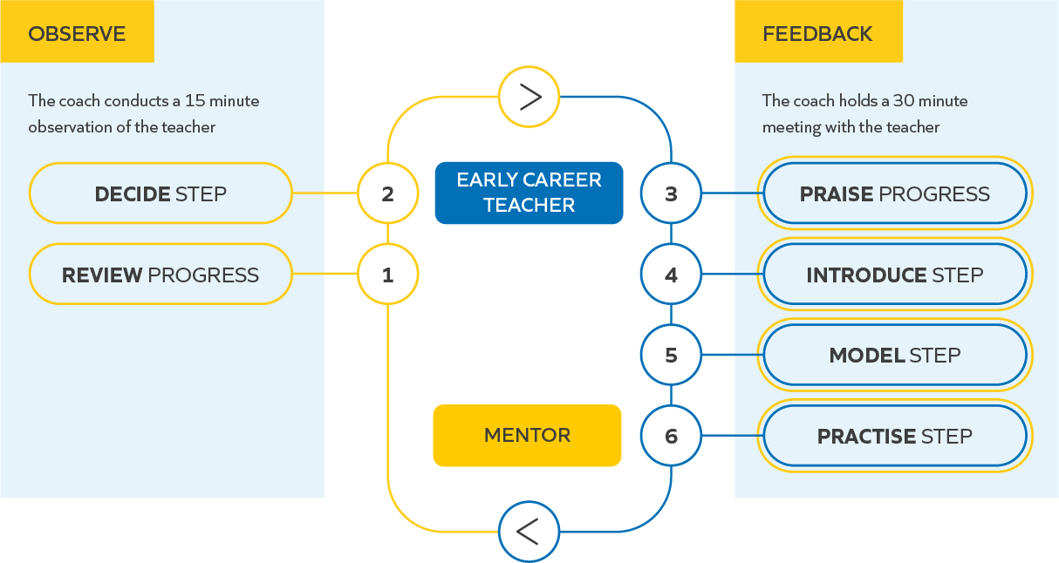

Note: the brief feedback meeting sits within the longer weekly mentor meeting, leaving time for mentors to provide other support, such as with using school systems.

